What’s Include in This Handout
Making Sure Your Device and Browser Will Work with Blackboard and Logging into Blackboard 1
What You May Need on this Screen and How to Enter Your Blackboard Course and Stay on the “Path” 2
What You See Once You Click on Your Course 2
What Your Instructor (and Hopefully a Volunteer) Will Show You 2

Making Sure Your Device and Browser Will Work with Blackboard and Logging into Blackboard
Caution: If you want to use your own laptop or tablet, you must do step 1 about the “Computer Requirements.”
Note on 9/24/2107. The link to Computer Requirements looks different that resources I have seen in presentations. I will go check with WCJC’s Blackboard and make sure this is the right link. I will update this accordingly.
- If you are on your own computer (not one at WCJC’s Open Computer Labs) you need to prepare your computer to match the current requirements of Blackboard. See the center of the screen below.
- Log into Blackboard. You’ll need your Banner ID (@######## twice). See the left side of the screen below.
- Do change your password. See the left side of the screen below.
Tip: If your browser is not listed in the lower right hand corner, then you need to try another one.
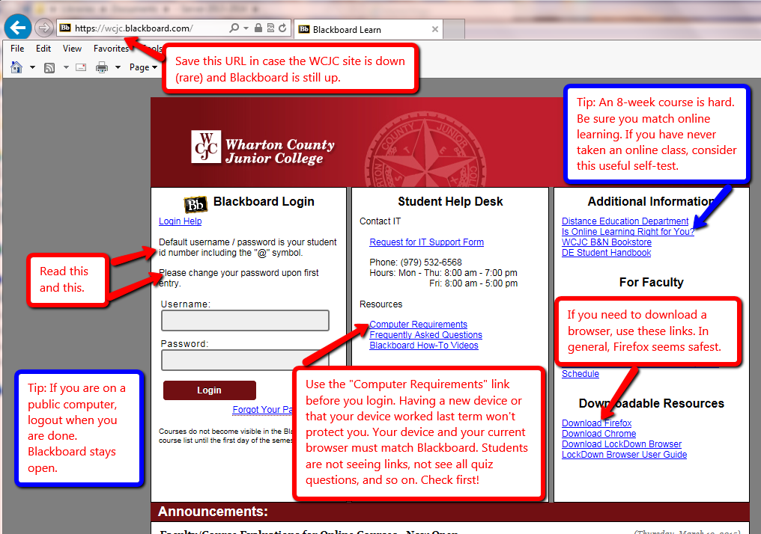

What You May Need on this Screen and How to Enter Your Blackboard Course and Stay on the “Path”
The green and yellow arrows identify 2 things you may need.
The blue box identifies the Course List, the only way to enter your course in Blackboard and stay on the “path.”
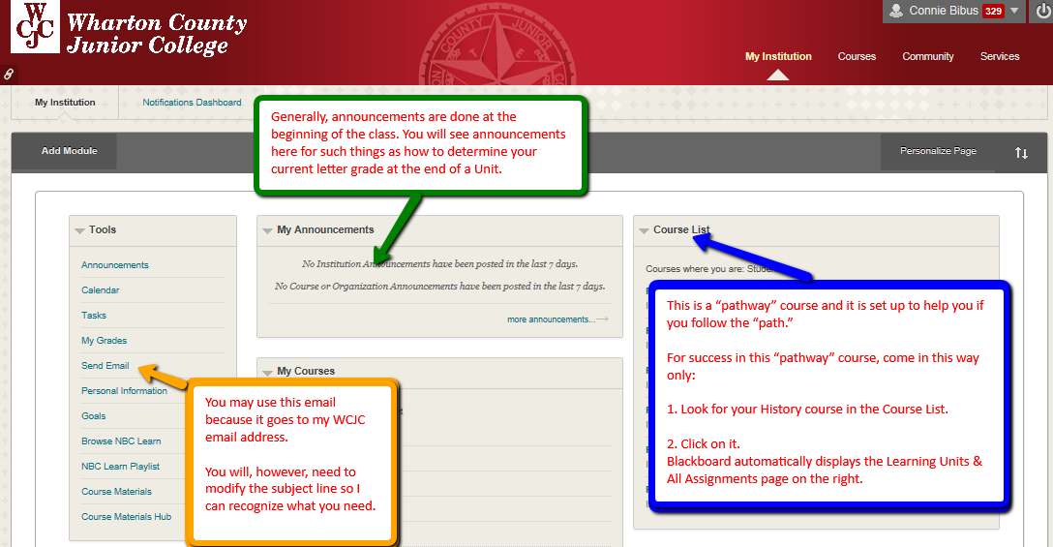

What You See Once You Click on Your Course
When you are first in the course, Blackboard automatically displays the work we will be doing in the course. On the right side of the screen, you see labels for all of the parts of the course listed in your Course Schedule.

What Your Instructor (and Hopefully a Volunteer) Will Show You
- The parts of the course all visible on Lesson Units
- The Learning Quizzes and how Self-Tests and Full-Tests work
- Evidence Quizzes that you should begin and how Self-Tests and Full-Tests look on Evidence Quizzes
- What happens when you take a quiz (like the Full-Tests) for a second time
- A demonstration for submitting your plan to Turnitin

WCJC Department: | History – Dr. Bibus
Contact Information: | 281.239.1577 or bibusc@wcjc.edu
Last Updated: | 2017
WCJC Home: | http://www.wcjc.edu/

