If you will use WCJC computers in the computer lab ignore this section

Logging into Blackboard – You’ll need your Banner ID (@######## twice). Do change your password.

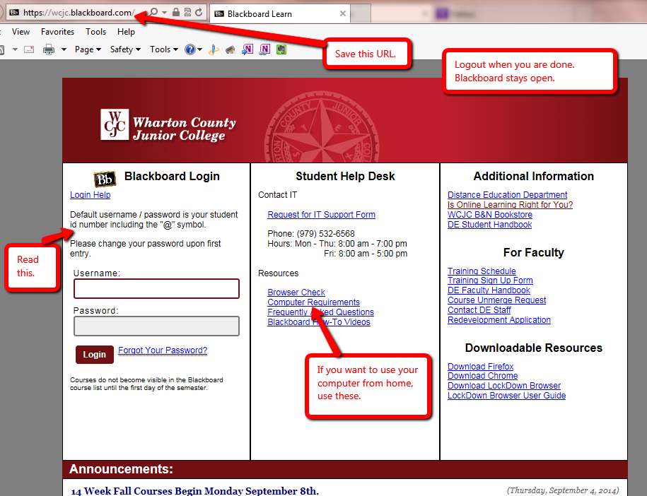

Once in Blackboard
- Find the Course List on the right side of the screen.
- Click on the name of your course. On the left, you see the Course Menu below and Getting Started on the right.

Course Menu on the left– Blackboard opens with the Learning Units + the rest.

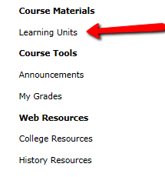

Using a quiz password – a Demo from your instructor with a Blackboard Acknowledgement Quiz
Be sure you write down the exact password for today.

Layout of a Unit – All Units are organized in the same way.
You will not see the Comparison folders shown below until after you do what is in the Course Schedule with the Good Habits for Evidence and after I enter its 20 points.
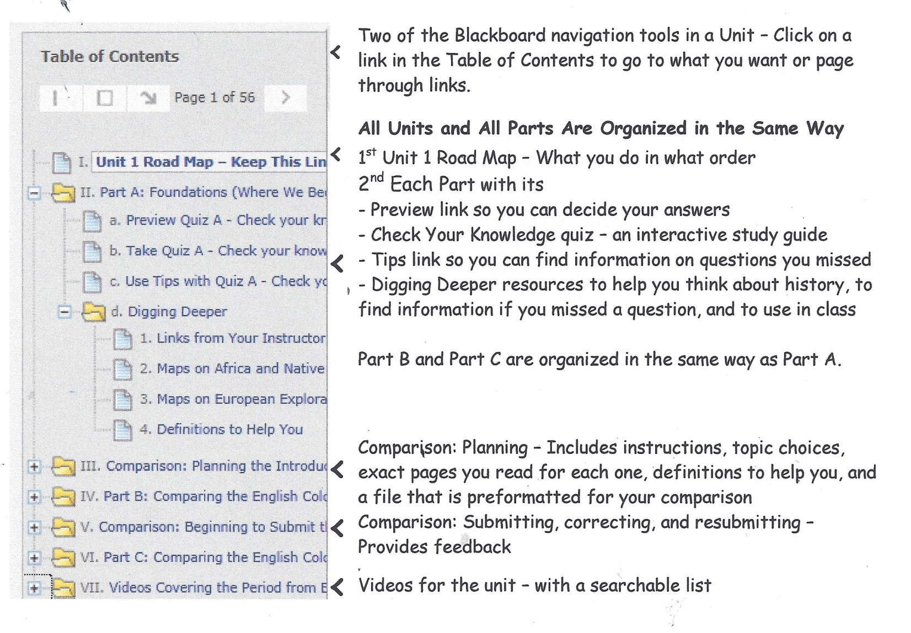

Using the Check Your Knowledge quizzes – the things that have puzzled students.

- Click on a Check Your Knowledge quiz .
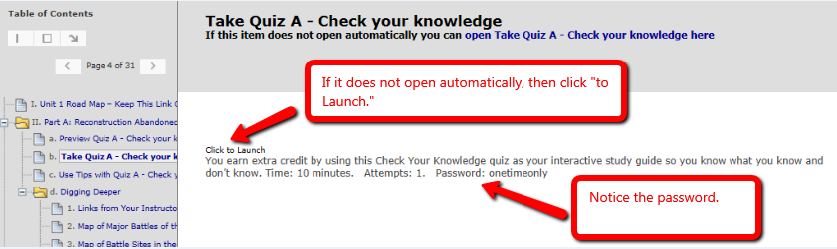

- Click Begin and enter the password. Notice no spaces between the words.

- Enter exactly what you planned when you listed your answers on that piece of paper

- When you first take the quiz, you press the OK button to see which ones you missed and got right.
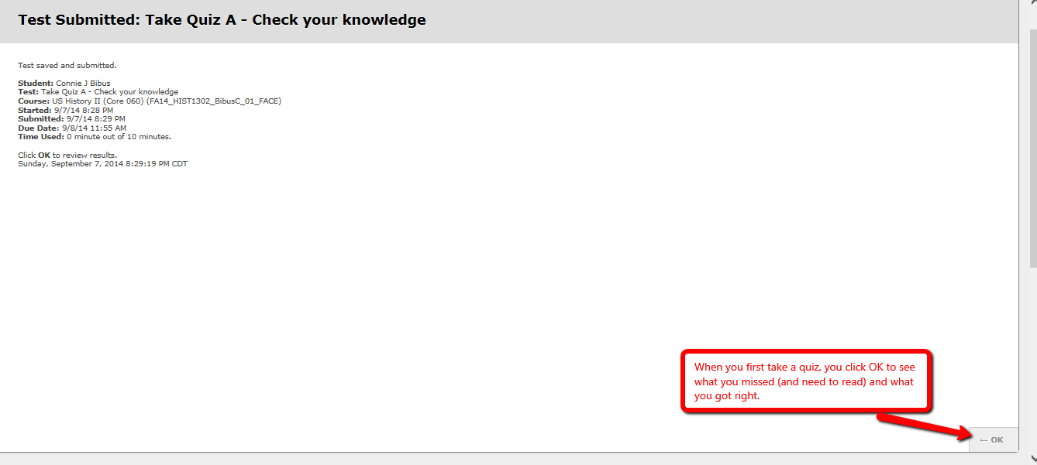

- If you decided you need to check on something and go back to see your completed quiz, you eventually see this screen.

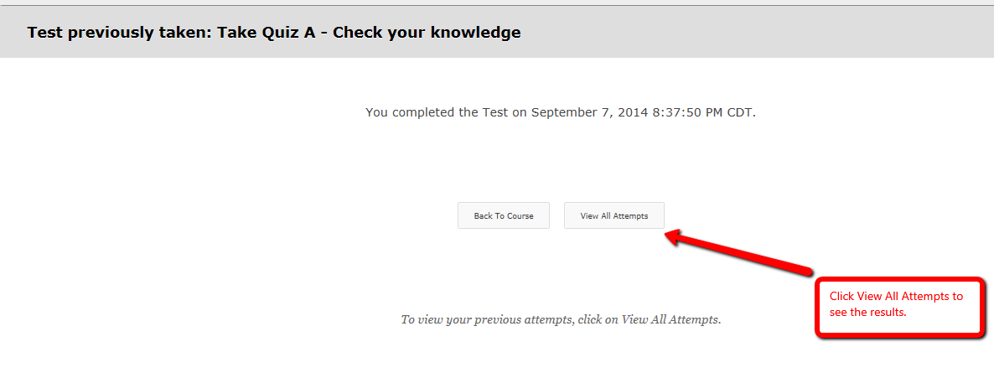
- Clicking on View All Attempts results in this screen. The red arrow shows what you click.
