What’s Include in This Handout
Making Sure Your Device and Browser Will Work with Blackboard and Logging into Blackboard 1
What You May Need on this Screen and How to Enter Your Blackboard Course and Stay on the “Path” 2
What You See Next 2
What You Do and See – Once you have the password to the quiz. 2
What You Watch As a Demonstration and Then Do 2

Making Sure Your Device and Browser Will Work with Blackboard and Logging into Blackboard
Caution: If you want to use your own laptop or tablet, you must do step 1 about the “Computer Requirements.”
- Use the “Computer Requirements” link before you log in. If you are in WCJC’s Computer Lab, skip this step.
- Log into Blackboard. You’ll need your Banner ID (@######## twice).
- Do change your password.
Tip: If your browser is not listed in the lower right hand corner, then you need to try another one.
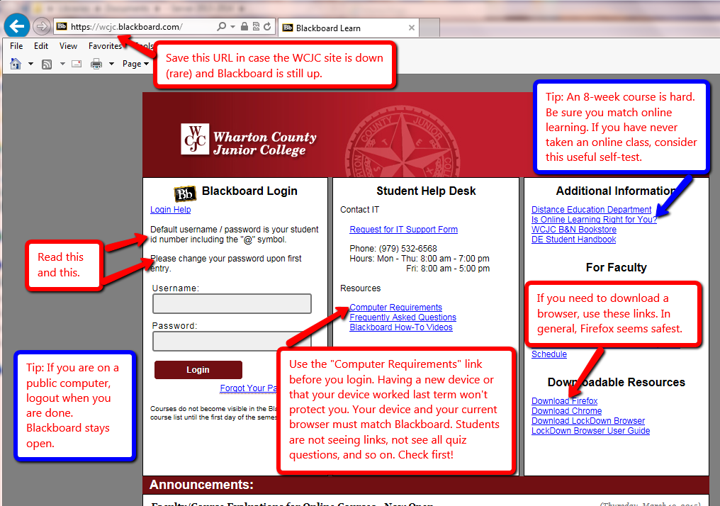

What You May Need on this Screen and How to Enter Your Blackboard Course and Stay on the “Path”
This course is one of the two ways that WCJC supports for Blackboard courses. This is a “pathway” model and its purpose is to keep students on a “path” with everything they need for each task they do.
The green and yellow arrows identify 2 things you may need. The blue box identifies the Course List, the only way to enter your course in Blackboard and stay on the “path.”
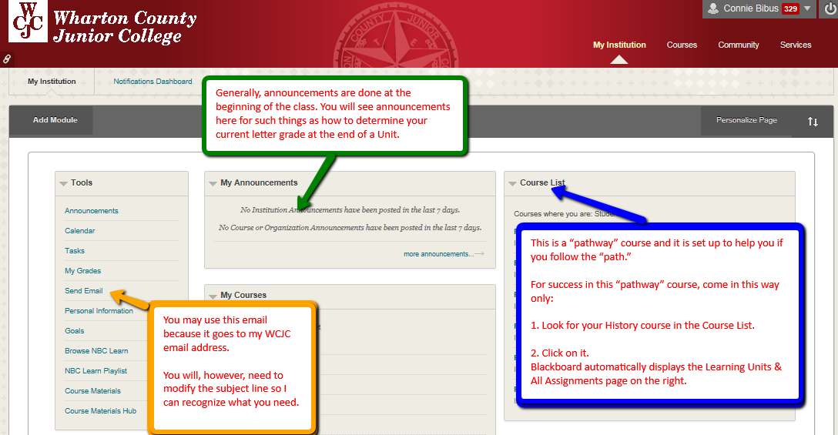

What You See Next on the Left Side of the Screen
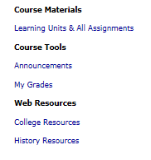
You can also click on the Course Menu for:
- Announcements – Information everyone may need
- My Grades – Your grades (so do log off when you leave a public computer)
- College Resources – Quick access to resources that WCJC provides to students
- History Resources—Information about the discipline of history and access to reference tools for history

What You See Next on the Right Side of the Screen
The opening screen on the right is always Learning Units & All Assignments. When you first come into the course, you see
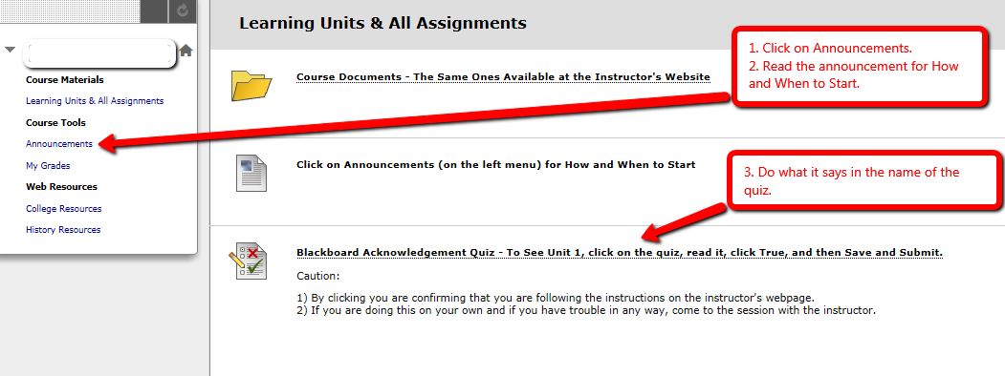

What You See Once You Click True on the Blackboard Acknowledgement Quiz and Then Save and Submit
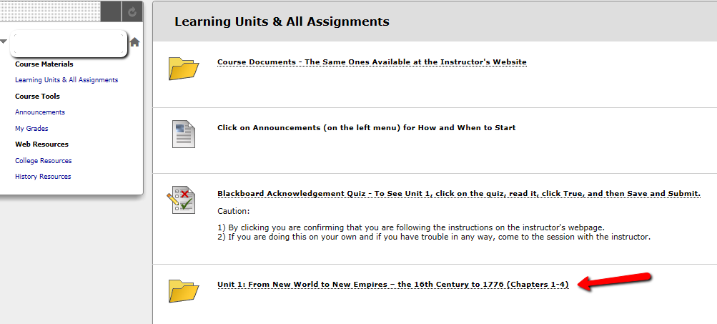

Organization of Each Chapter
Each of the 15 chapters in the course is organized in exactly the same way:
- Figuring It Out (Learning is More Than Memorizing), which also includes the Chapter InQuizitive.
- Primary Documents from the Era, documents which are covered as questions on the objective test.
- Optional Resources from the Textbook Authors and the Norton Publishers

Organization of the 1st Chapter in the Course
The 1st chapter in the course also has the STEPs you follow to register InQuizitive and make it begin to enter the percentages you get right in the grades at Blackboard.

What Do You Do in Chapter 1
- Purple box explains the STEPS you do to register InQuizitive and make the grade show up in Blackboard
- Black box explains how you use the instructor’s quizzes
- Red box explains how you use the primary source
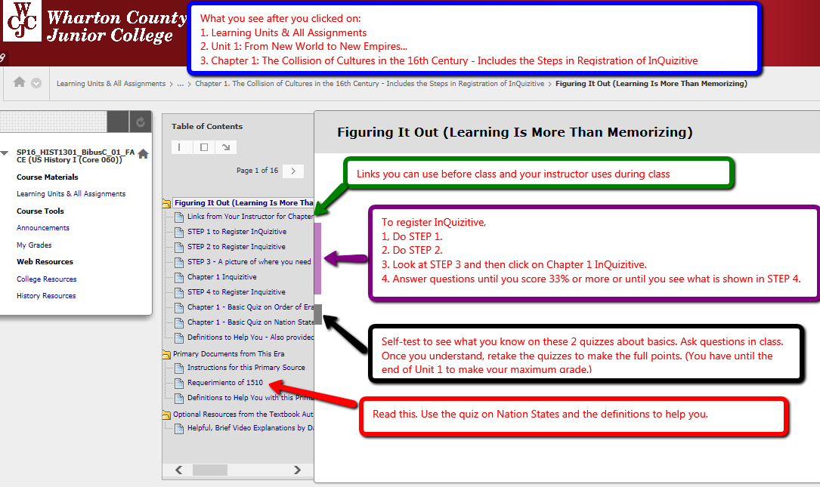

WCJC Department: | History – Dr. Bibus
Contact Information: | 281.239.1577 or bibusc@wcjc.edu
Last Updated: | 2016
WCJC Home: | http://www.wcjc.edu/

