Caution: This was built from old quizzes from several prior textbooks. Do not memorize words. Test yourself and then grade yourself to see which ones you don’t know. Then go read.

Review Quiz A-1301

Match the British legislation and the correct description. Write the correct letter to the left of the description.

A. Coercive Acts (or Intolerable Acts) and Quebec Act
B. Stamp Act and Declaratory Act
C. Sugar Act (or Molasses Act) and Stamp Act
D. Townshend Duties (or Townshend Revenue Acts) and Tea Act

 | 1. | These two British laws reflect the British misunderstanding of the colonists. The first law was a tax demanding a seal on all documents, a tax the British later rescinded in response to colonial boycotts. The second law was a statement by the British Parliament that it was sovereign (that it had the right to legislate for the colonies “in all cases whatsoever”).
 | 2. | The first of these two British laws was an attempt to get around the colonial rejection of taxes collected within the colonies by collecting taxes at the port for commonly used imports. The second law dealt with one of these imports, was meant to save a financially vulnerable private British company, reduced the price of that import, and angered colonial merchants.
 | 3. | These two British laws reveal the widening gap between the British and the colonists. The first law was the British attempt to force Massachusetts and Boston to back down following the Boston Tea Party by such measures as calling for the quartering of troops by the colonists, reducing the powers of self-government in Massachusetts, and called for royal officers accused of crimes to be tried in Britain. The second law extended Canadian boundaries into the Ohio Valley and recognized civil rights for Roman Catholics. The colonists believed (incorrectly) these laws were interconnected.

Match the location and the description. Write the correct letter to the left of the description.

A. New Orleans
B. Philadelphia
C. Saratoga
D. Washington, DC
E. Yorktown

 | 4. | The American victory that brought about the French alliance occurred at this location.
 | 5. | In the American south, the battle at this location involved the French fleet, combined the French army and American army, and resulted in the Patriots' successful end of the war for independence.
 | 6. | The result of the War of 1812 was no real change from the way things were before the war; however, it did result in the United States gaining its national anthem “The Star Spangled Banner” and a hero, Andrew Jackson, who will dominate the coming era. This victory against the British occurred after the war was over in this city.

Match location and the description. Write the correct letter to the left of the description.

A. England (later called Great Britain)
B. France
C. Portugal
D. Spain
E. the Netherlands

 | 7. | At the end of the 1400s, which European country had the most powerful monarchy and seemed to be the most powerful nation? The papacy echoed this nation’s superiority with such actions as the Line of Demarcation (Treaty of Tordesillas) dividing the new world between it and another Catholic nation.
 | 8. | What western European country was the preeminent maritime power in the 1400s? The nation's exploration in the late 1400s concentrated on finding a route to the Orient by sailing east (around Africa).
 | 9. | The focus in North America of this country was mainly fur trading and trapping.
 | 10. | Henry VIII of this country broke with the Roman Catholic Church because he desired an annulment from his Catholic, Spanish queen so that he could marry again.

Review Quiz B-1301

Match the person and the description. Write the correct letter to the left of the description.

A. John Quincy Adams  B. Susan B. Anthony  C. John Brown  D. Frederick Douglass  E. William Lloyd Garrison  F. George I  G. George II  H. George III  I. U.S. Grant  J. Alexander Hamilton  K. Henry VIII  L. Rutherford B. Hayes  M. Anne Hutchinson | N. Andrew Jackson  O. John Jay  P. Thomas Jefferson  Q. Andrew Johnson  R. Abraham Lincoln  S. James Madison  T. Tom Paine  U. William Penn  V. Dred Scott  W. Elizabeth Cady Stanton  X. Harriet Beecher Stowe  Y. John Winthrop

 | 1. | This Republican candidate in 1876 had fewer votes than the Democratic candidate, and there were disputes over electoral ballots in four states. In return for the Democrats accepting his victory in the Compromise of 1877, he and Republican Party ended Reconstruction.
 | 2. | The first Secretary of State for the United States, appointed during the Washington administration, was this individual who had been central in the American Revolution and who was central in the development of the Democratic-Republican Party during the Adams administration. He was also President for two terms. He is best known as the person who wrote the draft of the Declaration of Independence:
 | 3. | Sometimes called the “Father of the Constitution,” this individual was one of the authors of the Federalist Papers, a set of publications explaining the Constitution and the principles behind the organization of the new government.:
 | 4. | This person was the leading black abolitionist. He was born into slavery, ran away, and later bought his own freedom. He spent years lecturing in England against slavery, wrote a respected autobiography, and founded the newspaper The North Star:
 | 5. | The book Uncle Tom's Cabin was both an indicator and a cause of the growing division between North and South. It sold over 300,000 copies in 1852, its first year, and spread the message of abolitionism to an enormous new audience. Its author was:
 | 6. | What former Democrat from Tennessee who remained loyal to the Union was put on the Republican Party ticket in 1864 as a token. He became President and the initial controller of Reconstruction (or Restoration as he called it) in the seven months following the assassination of the prior President and the next session of Congress.
 | 7. | This individual was the King of Great Britain at the time of the American Revolution. As a Hanover, he tried to reassert the power of the monarchy that had been lost by his grandfather and father.
 | 8. | This colonist offended the powers of Massachusetts Bay Colony in varied ways and was deported from the colony. This colonist challenged the prevailing Puritan assumptions of the proper role of women in society, argued many clergy were not among the "elect" and had no spiritual authority, and was judged guilty of both heresy and sedition.
 | 9. | This looser in the election of 1824, an election he and his followers considered a “corrupt bargain,” was able to win the Presidency in 1828.
 | 10. | The Supreme Court found in 1857 that this individual could not bring suit to prove he was a free person because he was not a citizen of the United States. The Court further found that slaves were property and the Missouri Compromise was unconstitutional, a decision that the South viewed as a vindication of slavery.

Review Quiz C-1301

Find the letter (A, B, C, D, or E on the map where the described event happened. Then write that letter to the left of the description

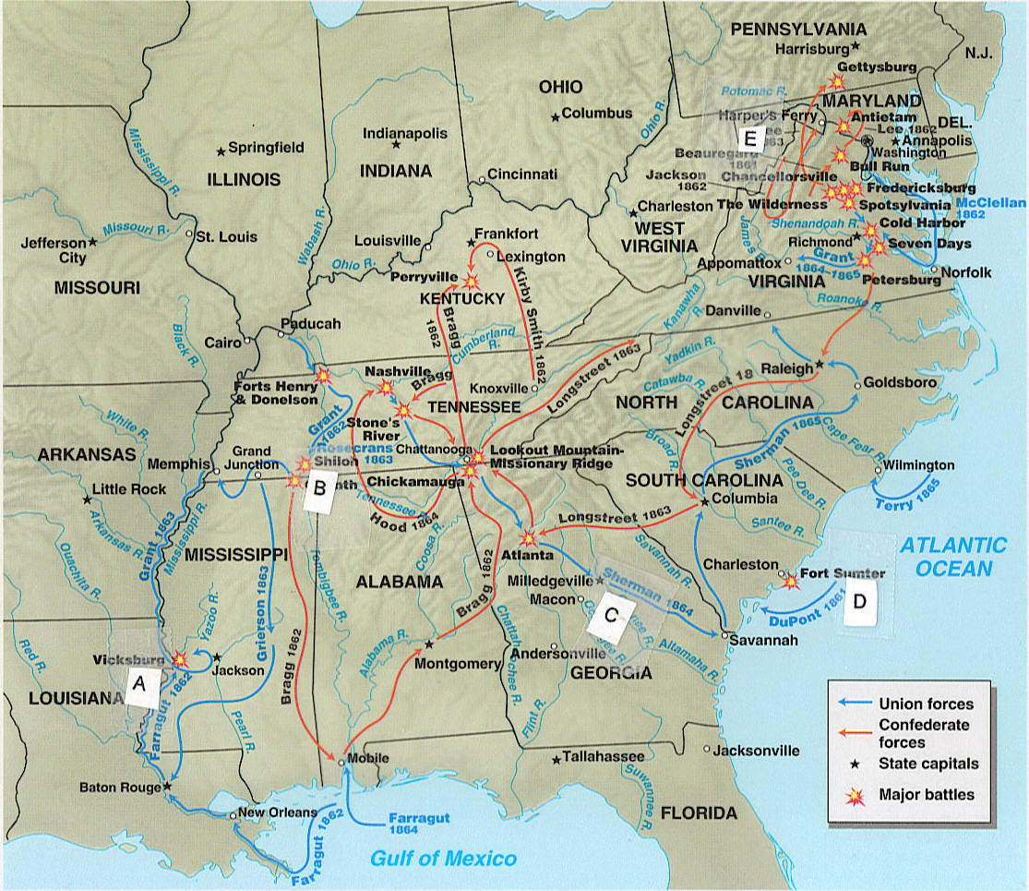

 | 1. | This engagement brought the war to the civilian population in the South and divided the South into small portions, with the victory also uniting the Republican Party behind Lincoln in 1864.
 | 2. | In 1863 two battles occurred that moved the Union forward to complete victory over the Confederacy. One of the two occurred in the west. Following six weeks of siege and near starvation the city fell, completing the Union control of the Mississippi River. With this victory by U.S. Grant, the Mississippi River now divided the Confederacy and united the North with the Gulf of Mexico.
 | 3. | The Western campaign was crucial to victory for the Union because it would enable the North to reach into the interior of the South. In April 1862, the South seemed to be winning over the North at this battle, but the Union received 25,000 reinforcements overnight and pushed back the Southern forces with heavy losses on both sides.  :
 | 4. | John Brown, when in Kansas, and his followers murdered and mutilated five pro-slavery settlers in retaliation for pro-slavery forces’ “sack of Lawrence.” In 1859, he led a raid on the arsenal at this location, a raid that led the South to assume that the North was dominated by people intent on destroying the South  :
 | 5. | Following this engagement in April 1861, four more slave states left the Union. Lincoln informed the South he would send supplies (but not troops or munitions), but the South bombed the federal installation in the harbor for two days until it surrendered:
\

Review Quiz C-1301 Continued

Match the country and the description. Write the correct letter to the left of the description.

A. Barbary States
B. France
C. Great Britain
D. Haiti
E. Mexico
F. Spain

 | 6. | The war with this nation resulted in the United States gaining new territory in the 1840s.
 | 7. | The United States being able to buy the vast Louisiana Territory from Napoleon Bonaparte was in part the result of the trend of many revolutions against monarchy that began with the United States revolution against the British monarchy and the result of the trend against slavery. These trends of revolution and anti-slavery combined in this new nation of former slaves, under the leadership of Toussaint L’Ouverture, who fought the French, causing them to retreat from the plan to revitalize their empire in the Americas.
 | 8. | Because of our treaty commitments from the American Revolutionary War and because of our demand for rights of a neutral nation during a prolonged war, the new nation faced repeated problems with this nation throughout the early years.
 | 9. | This struggle occurred with states that had made demands for payment for safe passage, payments that European nations had made. The Democratic-Republican administration of President Jefferson was successful in dealing with them during the war from 1801 to 1805. This was the result of the American naval blockade of those nations, the burning of a ship, and the rescue of hostages.
 | 10. | The war of 1812 was fought with this country.

Review Quiz D-1301
Find the letter (A, B, C, D, or E on the map where the described event happened. Then write that letter to the left of the description
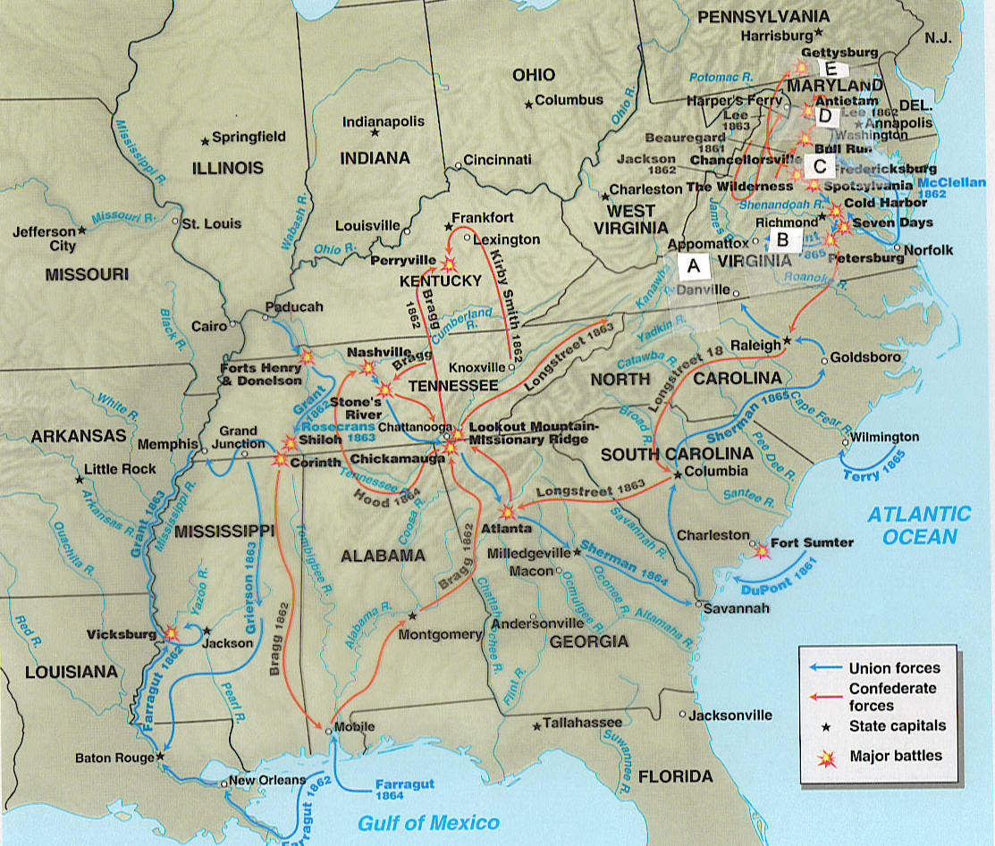
 | 1. | In 1863 two battles occurred that moved the Union forward to complete victory over the Confederacy. One of the two occurred in the east. This battle, led by General Robert E. Lee, included a deadly and disastrous charge in which the Confederates were mowed down and few survived to engage the Union force, with total losses at 23,000 men (about one third of their force). The South had hoped to have a major victory in the North so that it could gain British and French support and would have a victory to balance a probable defeat in the West.
 | 2. | This 1862 battle was among the bloodiest engagements, it was indecisive militarily, and the North lost an opportunity to destroy much of the Confederacy. It was, however, technically a Union victory. President Lincoln, therefore, used the technical victory as a justification for issuing the Emancipation Proclamation.
 | 3. | The surrender of Robert E. Lee's worn-down forces occurred here. The surrender took place before Lincoln was assassinated.
 | 4. | This city in this state was the location of the capital of the Confederacy.
 | 5. | In July 1861, this battle, the first major battle of the war, was a Confederate victory close to Washington, DC. Spectators came to observe the expected Union victory, but instead they became part of a disorderly retreat.

Review Quiz D-1301 Continued

Match the item to its description.

A. Emancipation Proclamation
B. Freedman’s Bureau
C. 13th Amendment
D. 14th Amendment
E. 15th Amendment

 | 6. | This measure, ratified in 1865, meant that slavery was no longer legal in the US.
 | 7. | This method was the Radical Republicans' way to help the blacks and later was one of the methods to deal with the South's actions, such as passage of black codes. It provided food relief to poor blacks (and whites), established schools, provided legal help, and helped some blacks find work or land.
 | 8. | With this document in 1862, Lincoln freed the slaves in the rebellious territories. (In other words, he freed no one.) With this document, however, he regained control of the political competition of abolitionists in Congress, in the military, and in the popular press while not giving the border slaveholding states a reason to leave the Union and further provided sympathy for the Union in England (particularly among the lower class and the middle class) and France. This document is:
 | 9. | This measure, ratified in 1868, was a response to the new state legislatures in the South passing black codes. The measure defined citizenship as being born in the US or naturalized in it, and forbade states from denying "due process" to citizens. It also required Congressional approval for amnesty for those who had taken an oath to support the Constitution and then violated it. It further forbade payment of debts related to the rebellion:
 | 10. | This measure stated that federal and state governments could not abridge the right of a citizen to vote on account of race, color, or previous condition of servitude. (In other words, voting could not be denied to ex-slaves.)

Review Quiz E-1301

Match the term and the description. Write the correct letter to the left of the description.

A. Articles of Confederation
B. Confederacy
C. Constitution
D. Declaration of Independence
E. Enlightenment
F. Impressment
G. Great Awakening
H. Manifest destiny
I. Monarchy
J. Popular sovereignty
K. Protestant Reformation
L. Reconstruction
M. Republic

 | 1. | During the French and Indian War, the British had seized supposed British sailors from colonial ports or merchant ships for service on British ships. The British resumed this practice during its wars with France and seized supposed British sailors from United States merchant ships, a practice that was one of the issues leading to the War of 1812. This practice is called by what term?
 | 2. | Sir Isaac Newton and John Locke challenged traditional notions that humans had no role in determining their fate and were part of a movement known as the _____________________.
 | 3. | The period following the Civil War until the Compromise of 1877 is called by what term?
 | 4. | The movement leading to waves of religious revivals beginning in the 1730s and spreading throughout the English colonies was _____.
 | 5. | This word was central to citizens in the late 1700s. The BEST definition of the word is a government without monarchy or aristocracy, one with the power in the hands of the citizens who vote for representatives.
 | 6. | The ______________ expressed these "self-evident truths" previously expressed by Enlightenment authors:  - "All men are created equal."  - The "Creator" endows them with "unalienable rights," including "life" and "liberty."  - The reason for the existence of government is to "secure these rights"--rights that were given by the Creator and not by the government.  - If a government does not secure these rights, the contract between the people and the government is broken and the people have a right and duty to replace it.
 | 7. | The new Constitution of the seceding South prohibited protective tariffs, guaranteed slavery, and protected slavery in any new territories, and protected the dominance of sovereign states over a central government. The form of government and the key word in its name for its new nation was this term.
 | 8. | The term ________________________ can be defined as the view that the United States was justified by God and history to expand its land. This movement became national policy with the election of President Polk in 1844 and his campaign for acquisition of both Oregon and Texas.
 | 9. | The political position that the people should, by their votes, be the ones to decide on the matter of slavery in the territories was called ___________________________. This position became a national issue because of expansion into the Kansas-Nebraska territories.
 | 10. | Martin Luther and John Calvin advocated ideas of religious reform of the Roman Catholic Church and influenced many groups including the Puritans. They are both associated with this movement in the 1500s.

Review Quiz F-1301
Find the letter (A, B, C, D, or E) on the map where the described event happened. With rivers, the letter is placed immediately below the blue box marking the river.
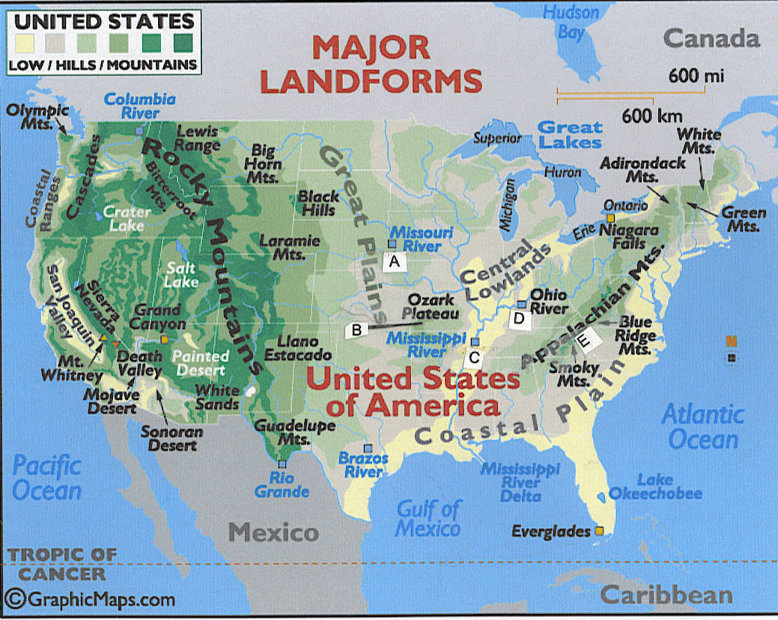
 | 1. | The French and Indian War included a battle at Fort Duquesne, an area where two rivers merged to create the ____ River. The battle represented some of the assumptions, alliances, and goals of the war itself:  - British generals were concerned about their ability to defeat the French and the Native Americans in a frontier war.  - Native Americans, such as the Algonquians, supported the French as a way to drive out the British colonists.  - Virginia colonists, including George Washington, were involved because the colony’s charter included the land in this fertile valley.
 | 2. | This area was the barrier following the end of the French and Indian War (the Seven Years War) with the Proclamation Line of 1763.
 | 3. | This area was the barrier at the end of the American Revolution. It was the boundary set by the British at the peace treaty.
 | 4. | The era before 1776 and after focused on the new lands for settlement in one fertile river valley. Another famous river opened up the newly purchased Louisiana Territory to the exploration of the Lewis and Clark Expedition. This river was__________.
 | 5. | Among the decisions on slavery in the early 1800s was the _________ Compromise. With the exception of this state, this 1820 legislation prohibited slavery north of the 36 30' parallel, the lower boundary of the state. (It also used admission of an equal number of slave and free states as the solution to the nation's sectional divisions.)

Review Quiz F-1301 Continued

Use the letter A, B, or C for the colonial region where the described event happened. You may use the letters more than once.
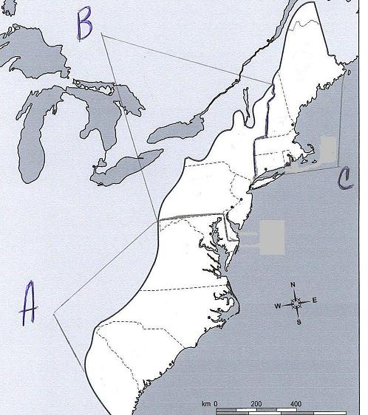
 | 6. | This colonial region included a colony requiring towns to financially support basic education. The region developed the colleges of Harvard and, later, Yale to educate clergymen, with Yale being formed by conservatives concerned about the religious liberalism of Harvard.
 | 7. | This colonial region is predominantly associated with the Anglican religion, but is later influenced by religions such as Methodism.
 | 8. | This colonial region is predominantly associated with diverse religions, with diverse agriculture and trades, with export of wheat, and with having the largest ports in the colonies (as well as other cities).
 | 9. | In the town of Salem in this region, charges of witchcraft caused considerable turmoil in the late 1600s and reflected the disruptions in the region.
 | 10. | This colonial region also exported wood and naval stores (products used when building or maintaining wooden ships), but it is predominantly associated with export of commercial crops that relied on slave labor (crops of tobacco and rice in the colonial era and of cotton later). One of the colonies in this region was the location of Bacon’s Rebellion in the late 1600s, a rebellion reflecting the disruptions in the region.

Review Quiz G-1301

Find the letter on the map where the described event happened. If this map is not visible, click here.

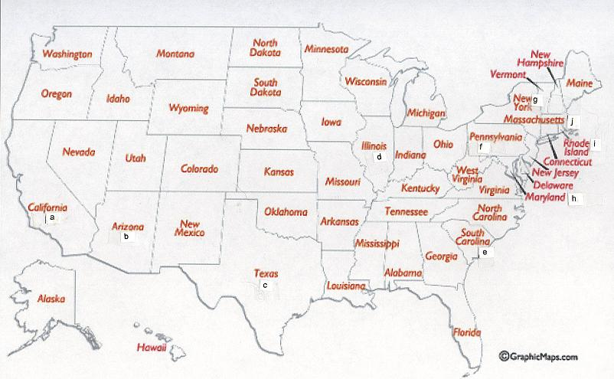

 | 1. | This area revolted from its mother country, Mexico, in the mid-1830s. For almost 10 years, it was a reluctant independent republic because United States administrations hesitated to add to national tensions with the admission--the annexation--of a large slave state. The Lone Star Republic became the Lone Star State.
 | 2. | In addition to California, this area was acquired by the United States with the treaty that ended the Mexican War in 1848.
 | 3. | The gold rush in 1849 in this new territory resulted in the area quickly meeting the population requirement for statehood and therefore forcing a reluctant Congress to once again deal with the lethal combination of slavery and expansion.
 | 4. | The location of this state and the desire to connect its chief city with the west and the transcontinental railroad had earlier encouraged Democratic Senator Stephen Douglas in the mid-1850s to push through legislation to organize the Kansas-Nebraska Territory and to argue for the doctrine of popular sovereignty. In 1858, the state’s senatorial contest resulted in debates between Douglas and the Republican Abraham Lincoln over slavery and popular sovereignty especially given the new Dred Scott decision. Although Lincoln lost in the senatorial position in this state, he gained recognition that made him a presidential candidate in 1860.
 | 5. | This state was a volatile area since the 1830s and lost in a confrontation with President Andrew Jackson and the Congress. It was the first to secede and the first to fire a shot in the Civil War:
 | 6. | This state began as a colony established as a religious sanctuary for Quakers.
 | 7. | This state began as a colony that contained two groups of English Calvinists, Separatists (Pilgrims at Plymouth) and Puritans (Massachusetts Bay).
 | 8. | This state began as a colony established as a religious sanctuary for Roman Catholics.
 | 9. | In 1636, authorities in Massachusetts Bay banished Roger Williams because of his defense of Native American rights and demand for separation of church and state. He launched a new colony that became the state of _____________________.
 | 10. | This state began as a colony that was initially a grant from King Charles II to his brother. The grant was challenged by the Netherlands military because that nation also had colonies in the region, but its unpopular Dutch governor Peter Stuyvesant had to surrender. The proprietor did not grant a representative assembly, but did set up a governor and council.

Review Quiz H-1301

Mark the letter of the correct answer.
1. | What factor is believed to have dramatically reduced Indian populations after contact with Europeans?  a. War  b. Disease  c. Starvation  d. Enslavement
2. | Which statement about slavery in Africa is true?  a. Slavery was generally permanent.  b. Children inherited their parents' condition of bondage.  c. Slavery was introduced by Europeans.  d. none of the above
3. | The Appalachian Mountains had been a geographic barrier to settlement of the Ohio Valley; the French and the Indians, the military barrier. With the defeat of the French, which of the following prohibited colonial settlement west of the Appalachian Mountains?  a. Proclamation of 1763  b. Relocation Act of 1764  c. Navigation Act of 1772  d. Townshend Acts of 1767
4. | The period when the new nation governed itself under the Articles of Confederation can BEST be described as:  a. A period of the establishment of many of the basic institutions set up in the Constitution, including Congress passing laws that set up the executive departments and the judiciary and that dealt with financial vulnerabilities of the new nation  b. A period when the nation became involved in the struggles between France and Britain, when the Congress passed laws restricting freedom of the press and speech, and when organization of political parties developed, including with grassroots organization of the Democratic-Republicans  c. A period when the central government could not tax or effectively make treaties
5. | This individual was one of the authors of the Federalist Papers. He was also the first Secretary of Treasury for the United States and set the financial policies of the United States. He advocated a national bank, assumption of state war debts, paying all debts the United States made under the Articles of Confederation, and a protective tariff. This individual was:  a. James Madison  b. Thomas Jefferson  c. Alexander Hamilton  d. John Jay  e. Benjamin Franklin
6. | The Western frontier was secured not just by battles with the Indians, but also by treaty, one of the two major treaties of the New Republic period. Pinckney’s Treaty of 1795 (or the Treaty of San Lorenzo) with Spain gave the United States:  a. The right to navigate the Mississippi River to its mouth  b. The freedom to use the port at New Orleans  c. A desired fixed northern boundary of Florida  d. All of the above
7. | The Supreme Court's ruling in the case of Marbury v. Madison established the legal principle of judicial review. It:  a. Stated that Congress had no authority to expand the power of the Supreme Court (Congress had in the 1791 legislation said the Supreme Court could issue the type of writ that Marbury needed.)  b. Stated that the Supreme Court had the power to nullify an act of Congress  c. Both of the above  d. Neither of the above
8. | The Monroe Doctrine announced to the world that  a. France would not be allowed to fill the vacuum left by Spain's withdrawal from the Americas.  b. Latin American countries had asked for, and would receive, assistance from the United States.  c. the United States and Great Britain would henceforth work together to quell uprisings in Latin America.  d. the American continents were no longer subjects for future colonization by European powers.  e. the United States would intervene in Latin American affairs if people in countries there seemed unable to handle their own governments.
9. | About half of the African Americans experiencing slavery worked  a. in small southern towns.  b. in mines and small factories.  c. on farms.  d. on plantations.
10. | During the first half of the 1800s, the white South:  a. Moved from seeing slavery as a necessary evil to defending it as a "positive good"  b. Moved from defending slavery as a "positive good" to seeing it a necessary evil  c. Could not get beyond seeing it as little more than a necessary evil
11. | During Andrew Jackson’s term, these people had their own written language and Constitution; however, they were subjected to a deadly forced march to what is now Oklahoma. The "Trail of Tears," as this force march was called, resulted in the death of about ¼ of these people.  a. Cherokee Indians  b. Iroquois Indians  c. Mexicans in Texas  d. Seminole Indians
12. | The Church of Jesus Christ of Latter-Day Saints was founded in the 1820s by Joseph Smith. Its funds were communal; its members also practiced polygamy. Its members migrated repeatedly to try to avoid the intense hatred of local citizens and created a paramilitary group to protect its members. Its members eventually settled in the Great Salt Lake region of Utah and increased its communal organization to survive there. The group is also known as:  a. Moravians  b. Mormans  c. Oneida settlers  d. Shakers  e. Washingtonians
13 | This election brought to a head the sectional divisions over slavery. Abraham Lincoln was elected; the secession of the South followed the:  a. Election of 1828  b. Election of 1840  c. Election of 1860  d. Election of 1876
14 | Which of the following is not descriptive of Reconstruction period in the South?  a. The Freedman’s Bureau and black northerners came South to help educate former slaves, and ambitious southern blacks presented themselves as natural leaders of the race.  b. White southerners sneered at white northern "carpetbaggers" who supported the Republican cause.  c. White southern Republicans were called "scalawags" and were ostracized by other white southerners.  d. African Americans were the clear majority in most southern legislatures elected under Reconstruction.  e. Black southerners formed their own churches instead of continuing to worship with whites.

Copyright C. J. Bibus, Ed.D. 2003-2016

WCJC Department: | History – Dr. Bibus
Contact Information: | 281.239.1577 or bibusc@wcjc.edu
Last Updated: | 2016
WCJC Home: | http://www.wcjc.edu/

