Videos from 1302
yates | Levitttown | https://www.youtube.com/watch?v=_WJUVPoCP78
Later siddiqui | McCarthy and Welch | https://youtu.be/oc6Yo3A7CC8
mashhood | McCarthy and Welch | https://www.youtube.com/watch?v=K1eA5bUzVjA  USE THIS
https://www.youtube.com/watch?v=p9JFVoQQXuk

CHECK THIS OUT LATER
ross Mitchell
Published on Aug 5, 2016
SUBSCRIBE 22
While Attorney Joseph Welch’s famous "Have you no decency" accusation to Senator Joseph McCarthy during the Army-McCarthy hearings of 1954 is very well known, far less known, but equally powerful, is this interaction near the end of the hearings between Senator Stuart Symington, the former (and first) Secretary of the Air Force, and McCarthy. Among other things, during the interchange, McCarthy calls Symington “Sanctimonious Stu.” Symington responds “You better go to a psychiatrist.” A little later, a frustrated McCarthy tells Symington “You’re not fooling anyone.” Symington responds prophetically, “Senator, let me tell you something. The American people have had a look at you for six weeks. You’re not fooling anyone either.” What follows shows the beginning of the end for McCarthy, as one watches the meeting adjourn with McCarthy continuing to speak in emphatic terms as no one in the room listens. This is a powerful moment, as the country begins to awaken from its long nightmare. The full documentary from which this clip is taken can be found here: https://youtu.be/wJHsur3HqcI

whitley | Lucy is one | https://www.youtube.com/watch?v=8NPzLBSBzPI&list=PLP14CuXhP41yf8GdraZTP72p3tKVryM_i&index=2
Whitley | Pressley is one | https://www.youtube.com/watch?v=sGZm7EOamWk
wilson | lucy | https://www.youtube.com/watch?v=8NPzLBSBzPI&feature=youtu.be
 | E r murrow | https://www.youtube.com/watch?v=d2h4O5NRQzc

Emails
Hello Dr. Bibus, this is Basim Siddiqui from your Tuesday and Thursday 10:30 am class. This link is a video of Joseph Welch asking McCarthy, "have you no decency?" This is for the extra credit you mentioned in class.

https://youtu.be/oc6Yo3A7CC8

https://www.youtube.com/watch?v=8NPzLBSBzPI&list=PLP14CuXhP41yf8GdraZTP72p3tKVryM_i&index=2

https://www.youtube.com/watch?v=sGZm7EOamWk

I Love Lucy "dingbat" and Elvis Presley Ed sullivan

https://www.youtube.com/watch?v=8NPzLBSBzPI&list=PLP14CuXhP41yf8GdraZTP72p3tKVryM_i&index=2
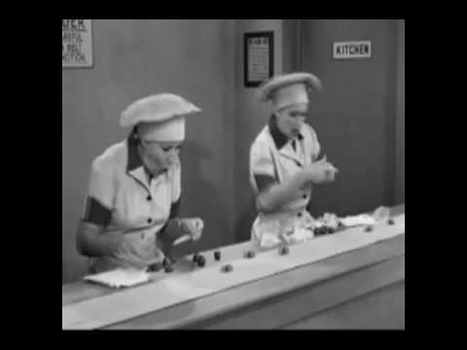 | Lucy's Famous Chocolate Scene - YouTube  www.youtube.com  Here is the famous Chocolate scene from I Love Lucy, an illustrious tv series in the 1950's

https://www.youtube.com/watch?v=sGZm7EOamWk
