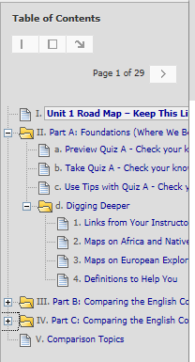 | <  <  <  <  <  < | Two of the Blackboard navigation tools in a Unit – Click on a link in the Table of Contents to go to what you want or page through links.  All Units and All Parts Are Organized in the Same Way  1st Unit 1 Road Map – What you do in what order  2nd Each Part with its  - Preview link so you can decide your answers  - Check Your Knowledge quiz – an interactive study guide  - Tips link so you can find information on questions you missed  3rd Digging Deeper resources to help you think about history  and to find information if you missed a question.  Part B and Part C are organized in the same way as Part A.  Shortcuts to Comparison Topics and to Videos

