What You Do with the Practice Essay Feedback AND How Grading Works with All Unit Essays

What’s on This Webpage:
Making Sure I Try to Be Clear about the Limits of What I Am Saying
Making Sure I Stress My Positive View Toward Each of You and Why I Use Extra Credit for This Assignment
Before You Look at Your Feedback with the Evidence Rubric, Let’s Look at How the Rubric Works
First, Let’s Look at the Evidence Rubric If the Student Were Absolutely Perfect (100% on Every Row) with the Practice Essay
Second, Let’s Look at Evidence Rubric If the Student Did Not Do Well on the Practice Essay
What Do You Do in Step 2 (and Get the Extra Credit)?
Questions You May Have
If You Are Really Puzzled about Plagiarism or “Half-copy” Plagiarism Being Marked, Read This
If You Are Confused about What Words in the Author’s Textbook Require Quotation Marks in Your Writing
What is the Goal for Writing in This Course? – Think about it as teaching some section of history to your smart cousin.
How Does Your Instructor Grade Your Writing?
What Is the Evidence Checklist?

Click here to hear a voice explanation of the main points in next heading.

Making Sure I Try to Be Clear about the Limits of What I Am Saying
I stress what works based on learning history. I stress what is necessary:
- For academic standards when you are doing work about something that is real (such as biology, business, or history)
Tip: If you think these things are not standards, then we need to talk. I can make pages from The Bedford Handbook (WCJC’s chosen standard) visible to you and we can talk them through.
- For jobs that pay well in the workplace. – As the first lines of each of the standards in the Evidence Checklist say, no workplace will pay for anything else. (Click here to see the Evidence Checklist.)
- For decisions that have consequence on your success and your life

HOWEVER, if bosses or professors say to do the opposite, then do that for them. That is the right thing to do.

Click here to hear a voice explanation of how grading works and how this process works.

Making Sure I Stress My Positive View Toward Each of You and Why I Use Extra Credit for This Assignment
- My goal is not to zap you, but to make sure you are forewarned so someone else does not zap you.
- I look at these issues as accidental misunderstandings that you have. In my surveys of my students for the last 4 (now more than 4) terms, over 50% of students had a misunderstanding of most of these things, including plagiarism and “half-copy” plagiarism but especially factual accuracy.
I have no problems with your brains or your ethics!
I am concerned you have a misunderstanding that can get you zapped in your future.
- As proof of my positive position toward you:
- I record a real grade for your work on the Practice Essay (History Changes Essay).
Why? So you can tell the percentage you will make on the 50-point assignments (2 essays each at 25 points) if you keep working as you are. If you made a 4 on the 10-point Practice Essay and did the same manner of working on the 50-point essays, you would get only 20 points (40% of 50 = 20).
- If you do the instructions below, I record all of the extra credit I have promised. If you cannot tell what to do, talk to me. I am glad to help you.
Why? Because I do not think people should be zapped for having a misunderstanding. That is why you can get extra credit to cover any low grade.
- If you change how you work in the future, you will not only learn history a lot better (my goal for all this), but practice skills to help you for your entire life. Practice being the person you want to be.

Before You Look at Your Feedback with the Evidence Rubric, Let’s Look at How the Rubric Works

Click here to hear a voice explanation of How the Evidence Rubric Works with the Practice Essay—and essay on a single topic (a single part) but you have to understand all the other parts if you are going to make sense.

First, Let’s Look at the Evidence Rubric If the Student Were Absolutely Perfect (100% on Every Row) with the Practice Essay
I will talk about these things in the order listed:
- Notice the Concept column and notice what is worth 60% of the entire grade (or 6 out of 10 points for a 10-point essay)—Reading for Evidence. Also notice what’s worth 30% of the entire grade (or 3 out of 10 points for a 10-point essay)—Writing with Evidence.
- Notice the headings that start with “A” Paper Criteria, “B” criteria and so on. Notice what the big deal (the “A” Paper Criteria for Writing with Evidence. If you want to learn, try to teach it.
- Lastly, notice that 100 Scale Grade and the Point Scale and next we are going to look at what happens when I enter something in that column.

If you do not see the rubric with perfect scores, click here.
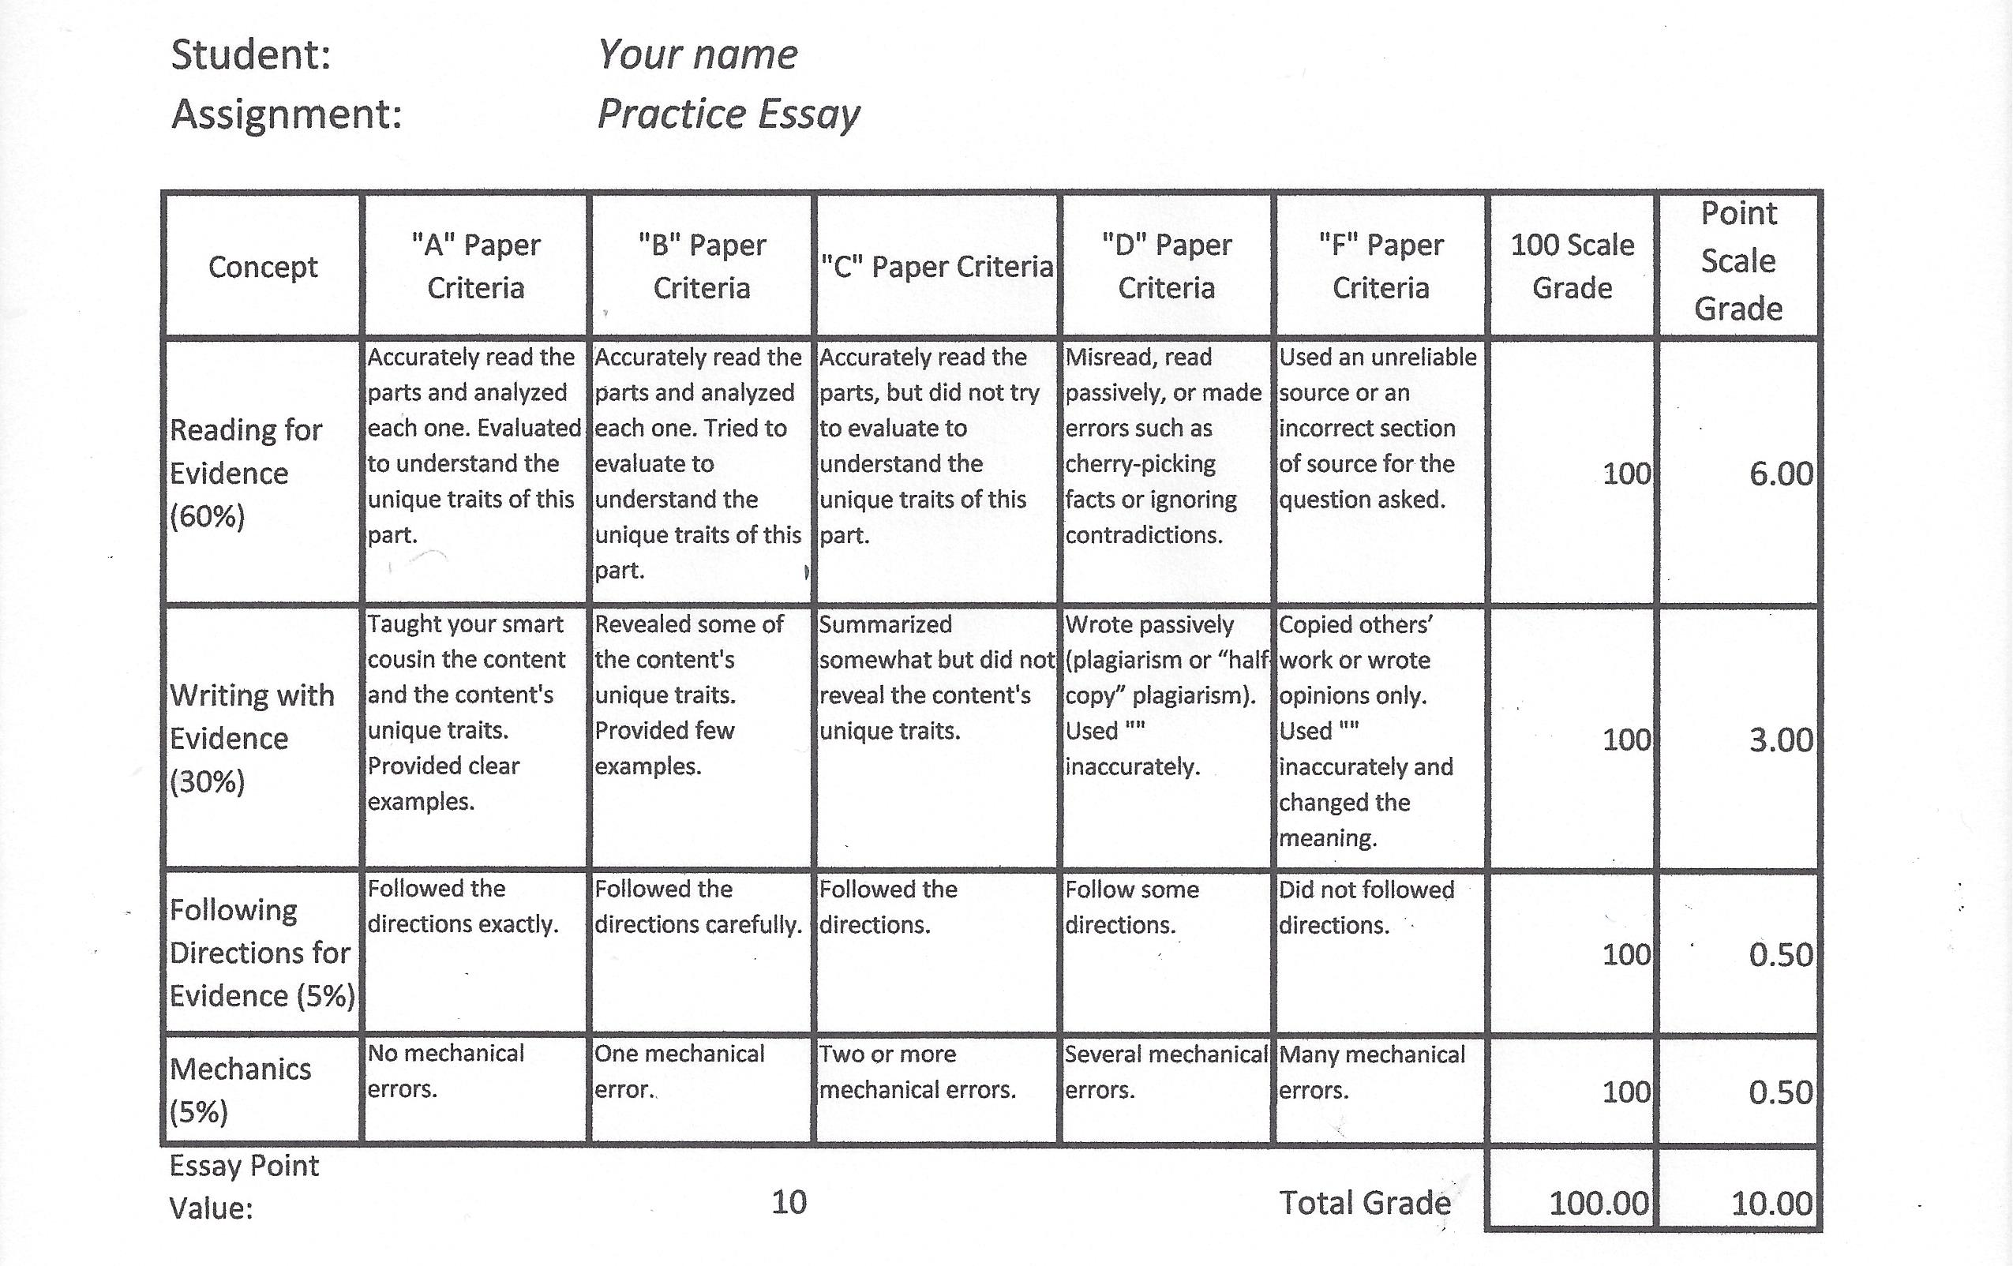

Second, Let’s Look at Evidence Rubric If the Student Did Not Do Well on the Practice Essay

Click here to hear a voice explanation of How the Evidence Rubric reveals what the student and calculates the points.

In this case, imagine that the student:
- Had a question—to use an example from United States History I—on Africans who were brought to the colonies and the student wrote about English servants.
- Just grabbed some words exactly from the source and copied them and just swapped some other words in the author’s sentences (what The Bedford Handbook calls “half-copy” plagiarism).
- Followed the instruction on the maximum length and that was it.
- Did have only one grammatical error.

Now, notice what happens to the 100 Scale Grade and that Point Scale. I also will try to color highlight, as I do below, to help you recognize what letter of grade I believe is appropriate. Yellow indicates a warning sign and green something is positive.
If you do not see the rubric with showing a student who did not do well, click here.
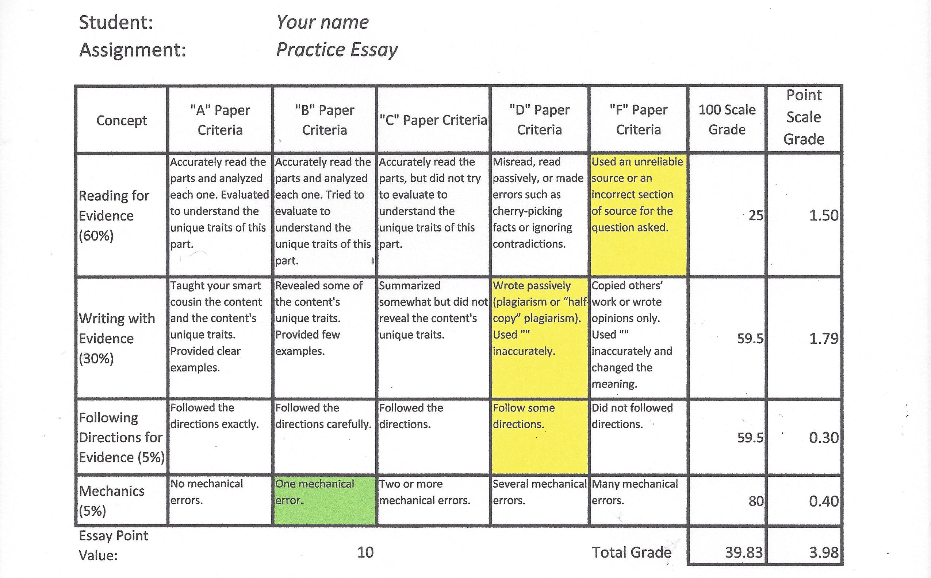

Click here to hear a voice explanation of what you do in Step 2 (and get the extra credit)

What Do You Do in Step 2 (and Get the Extra Credit)?
When you read for and wrote the Practice Essay you did Step1 in this process. You are now going to do Step 2.

In Step 2, you are not rewriting, not modifying anything, and not creating a new version of this assignment. You are going to work to see yourself as others (a boss or a prof) might see you.

So what are you to do?
In this order, do this:
- Go copy what you submitted as your Practice Essay into a file (such as a .doc file or an .rtf file). You will later copy it into your reply to my email with the rubric for you.
If you don’t know how, click on Quizzes & Exams, click on your submitted Practice Essay, and follow the prompts to choose to see what you submitted. Then copy and paste the question and your answer. Copy and Paste functions or those on
- Put your book and what you wrote side by side so you can compare them easily. I have found touching the words on each one very helpful in making myself observe carefully.
- If I marked in the row for Reading for Evidence that you had one or more of the errors listed under the “D” Paper Criteria, compare carefully the page(s) you were supposed to read with what you wrote:
- If the textbook does not specifically support what you say, then strike through each of the words in your paper that you cannot verify in the textbook. (Strike through looks like this.)
- If you think that those pages you were supposed to read do specifically support what you say and that you could tell me a specific place on a specific page where the textbook does back that up, then you may leave it alone but you must show me where the fact is.
- If I marked in the row for Reading for Evidence that you one or more of the errors listed under the “F” Paper Criteria, state beside that row the Chapter # and the exact heading(s) that you were to read for the topic that you were to answer.

- If I marked in the row for Writing with Evidence the errors listed under the “D” Paper Criteria that you wrote passively (plagiarism or “half-copy” plagiarism”), underline in your paper every word and every part of a word that you used from the book. (Underline looks like this.)
Example of using part of a word::
If the author wrote the word demonstrating and if you wrote demonstrated, then you underline demonstrated

- If I marked in the row for Writing with Evidence the errors listed under the “D” Paper Criteria that you modified a quotation or under the “F” Paper Criteria that you modified the quotation and changed its meaning, it means that you have placed some words of the author’s within quotations marks, but you have:
- EITHER modified the quotation without following the rules in The Bedford Handbook to reveal your changes to a reader
- AND/OR used the author’s words for another purpose than he or she intended

So what do you do? You go compare letter-by-letter the author’s words and yours:
- IF you modified the quotation without following the rules in The Bedford Handbook to reveal your changes to a reader, insert a [ ] immediately after the quotation and write it exactly.
- IF you used the author’s words for another purpose than he or she intended, strike through the quotation. (Strike through looks like this.)

Questions You May Have

If You Are Really Puzzled about Plagiarism or “Half-copy” Plagiarism Being Marked, Read This
Students are usually puzzled about the plagiarism or “half-plagiarism” marking because they lack some basic information. Here are the basics.

- The submission of a paper with words from an author without quotation marks can be the professor's evidence that you plagiarized. Some professors may not notice, but some may call it plagiarism. Do not assume that past responses by professors guarantees what future professors will want (and no boss ever will pay people—not well anyway—to copy words from one place to another).
- If you do this, some professors may label your work as “half-copy” plagiarism (term from The Bedford Handbook, page 692) if you:
- Either copy an author’s phrases without quotation marks (“”)
- Or use the author’s sentence structure and just swap a few words with what you think are synonyms
- Caution: If you think saying the name of the source means you can copy another’s words without quotations marks, look at this table.
If you use a fact in the author’s words, citation is not enough; you must also use quotation marks.
What are the rules for citation and use of quotation marks? The rules vary depending upon whether you are writing:
- A fact from the source in your own words
- A fact in the author’s words (you are quoting):

What Kind of Fact Are You Using | Do You Need Citation (Page # etc.)? | Do You Need Quotation Marks (“”)?
A fact in your own words | Yes—although I do not require that in the Blackboard’s tiny box for essays or in an essay an on-campus student writes in class. | No
A fact in the author’s words | Yes | Yes <Notice this.

Specifics about this course:
- I do not require citations when you use facts in an essay that you do in the Blackboard’s tiny box for essays, but there are conditions.
- On the other hand, I do require quotation marks if you use the author’s words. In this course, you may not plagiarize or “half-copy” plagiarize. You may however quote, but you have to use the rules for quoting. If you want more tips, check the preventions link below. If you have questions, please ask.

If You Are Confused about What Words in the Author’s Textbook Require Quotation Marks in Your Writing
If you are confused about when to use quotation marks, these examples may help you.
What the Author Wrote | What Words You Want to Write | Do You Need Quotation Marks (“”)? and Why
the Mississippi River | the Mississippi River | No – Proper nouns belong to all of us.
the green, roaring river | the river | No – Common nouns belong to all of us.
the green, roaring Mississippi River | the roaring Mississippi River | Yes <Notice this. – These are the author’s unique string of words so you identify them as not your creation with “”:  Trade was harder because of the “roaring Mississippi River.”
 | roaring | Yes <Notice this. – This is the author’s labeling of a condition and it is easier to be clear by using the author’s word with “”.  The author explained that the “roaring” river made trade more difficult.

What is the Goal for Writing in This Course? – Think about it as teaching some section of history to your smart cousin.
With something that people talk about in many ways, sometimes it helps to state what is not the goal. With writing in this course, you:
- Are not summarizing or not paraphrasing the textbook.
- Do not need to repeat every fact or word in the textbook.
- Are not showing your personal writing style while stating your feelings or your opinions.

Instead, in this course, the goal of all writing assignments is for you to do activities that help you learn the history of our nation. One of the most powerful ways to learn something is to try to teach it.

You will succeed in these assignments if you do these things:
- If you read carefully and work to understand what happened and ask if you need help.
- If you figure out what essential facts that you would teach your cousin.
- If you figure how you could organize those facts as simply and as accurately as you can.
- If you write in a common sense way as though you are teaching your cousin history that he or she needs to understand.

How Does Your Instructor Grade Your Writing?
Because the goal of writing is to help you learn our nation’s history and the priority is for you to be accurate, I grade your writing by comparing what you wrote side by side with the facts in the textbook. With essays submitted, I use a method that lets me quickly identify all of the submissions where the students wrote on the same question. It is—as is obvious—a slow method, but it works.

- I download those submissions, print them, and place them side by side:
- On the left, the textbook opened to the probable section or sections students should have used.
- On the right, the submissions of students’ papers on that question.
- I use the Evidence Rubric for feedback (shown above) and grade each student’s submissions one by one.
- If there are multiple possible questions, I then repeat the steps above with the next question.

With the two essays for the Unit exams, I grade one of the questions using the method above. Sometimes I toss a coin or something like that to be sure I am not grading the same topic number each time. Unless I find problems such as factual errors in that first essay I grade, I grade the other one without the textbook side by side with your paper—a quicker method.

th the e

What Is the Evidence Checklist?
The Evidence checklist is the other side of the Rubric. Think of it as a two-sided coin. I use the Evidence Rubric to grade with. You can use the Evidence Checklist to help yourself be stronger. Both rely on common standards (accepted rules or models) for academics and for jobs that depend on evidence:
- The word evidence emphasizes that you must have proof for what you say—some fact from our approved source that anyone using that source can see for himself or herself.
- The word checklist means a list of steps or things necessary for success (such as a pilot’s checklist for takeoff).

Each checklist number:
- Begins with an informal statement of a common standard that applies to academics and to jobs
- Below that are our specific requirements, identified with the underlined phrase In this course.

I can also offer additional tips for how to prevent problems (including with Checklist # 3). Just ask and I will provide preventions for these items.
1. | For your source of facts, you use only sources your professor (or boss) accepts as reliable.  In this course, the only sources are the textbook chosen by the History Department and the sources provided at our Course Website. Do not use Internet websites, another textbook, or any other source—including your own memory.
2. | You must follow common standards to reveal to your reader who created the words and/or found the facts you are using in your writing. This is a requirement in courses and in some jobs.  In this course, you may:  - Either write facts in your own words  - Or you may use exact sentences or phrases from the textbook placed within quotation marks according to the specific rules for quotation marks (“”) to reveal ownership that are covered in The Bedford Handbook  In this course, you may not copy an author’s phrases without quotation marks. You also may not replace a few words in an author’s sentence. Both are what The Bedford Handbook calls “half-copy” plagiarism (page 692).
3. | You must follow common standards to reveal any changes you made to the author’s words. This may not be just a punctuation error. You may be misleading your reader about the evidence.  In this course, if you use another’s words, you must be sure either not to change them or—if you change them—to follow the specific rules in The Bedford Handbook to reveal those changes to the reader.
4. | You must use reliable sources to verify what you write. (To verify means you use a reliable source to confirm the accuracy of anything you write.)  In this course, if you cannot verify the fact, do not write it and do not assume that the source agrees with you. If you are certain something is true and you cannot find it clearly in our sources, ask me for help.  In this course, you also must select facts to reveal the facts accurately. Examples:  - If a question is about something specific (such as a time, type of person, or region), verify that the source is about that specific thing.  - If the source covers facts about two or more sides or positions or actions from two or more groups or individuals, do not include only one side as though the other did not occur.
5. | With most written work for professors (or bosses), if asked, you must be able to state exactly where (a specific page) in the source that each fact came from—whether you wrote the words or the author did. With many college assignments, you must provide citations and use a specific standard (such as MLA, APA, or the Chicago Manual of Style).  In this course with most written assignments, you do not need to provide citations (the specific page number from our textbook) unless I cannot recognize where the fact came from.  If I cannot recognize where the fact came from, then you must show me the location on the page. It cannot be a vague statement: if a reasonable person using a reliable dictionary and reading the entire passage would not agree that you have evidence for what you say, then neither will I.  If you ask to do the more challenging alternative assignment instead of the essays for Unit 2, then you must cite according to the instructions.

Copyright C. J. Bibus, Ed.D. 2003-2013

WCJC Department: | History – Dr. Bibus
Contact Information: | 281.239.1577 or bibusc@wcjc.edu
Last Updated: | 2013
WCJC Home: | http://www.wcjc.edu/

