Making Sure Your Device and Browser Will Work with Blackboard and Logging into Blackboard
Caution: If you want to use your own laptop or tablet, you must do step 1 about the “Computer Requirements.”
- Use the “Computer Requirements” link before you log in. If you are in WCJC’s Computer Lab, skip this step.
- Log into Blackboard. You’ll need your Banner ID (@######## twice).
- Do change your password.
Tips: If your browser is not listed in the lower right hand corner, then you need to try another one. In 2016 Fall, the recommendation is not Firefox, but Chrome.
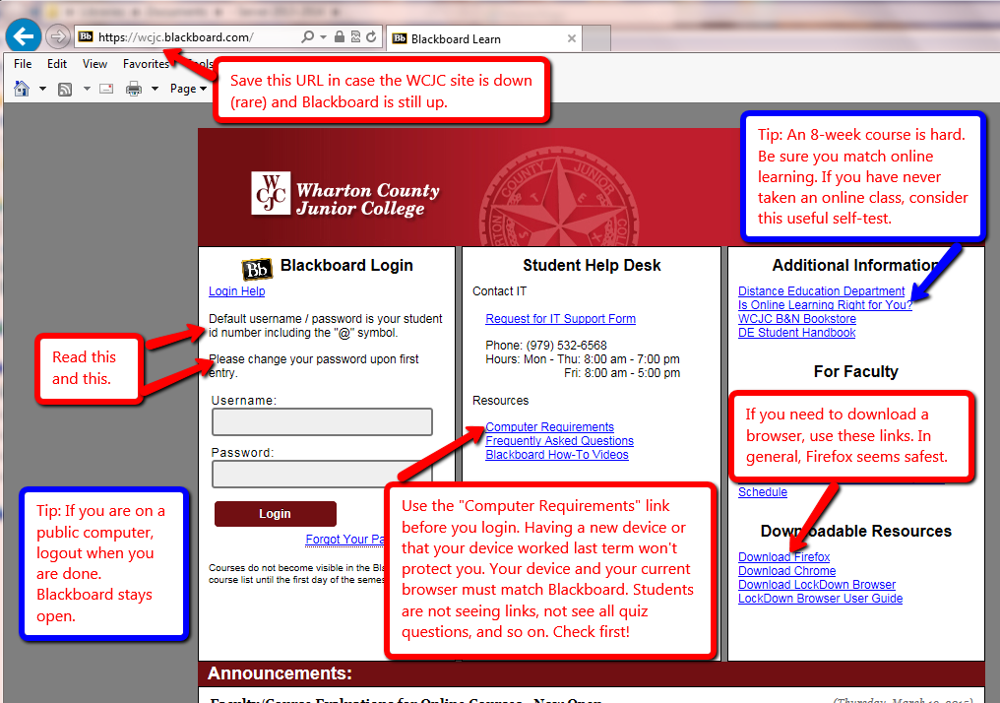

Taking the Blackboard Acknowledgement Quiz
When you come in the course, you will see the Blackboard Acknowledgement Quiz. Click on it.
It will then show you a folder called Getting Started and you will find:
- Turnitin Assignment to submit your Course Plan.
Do not forget that you also must give me a print of that plan to get credit.
- The Measuring Yourself link on evidence.
Use the tutorial being sure to do each of the 5 questions.
Also write on a piece of notebook paper which habit(s) you need to work on.
Also bring that paper to me on or before the computer lab.

WCJC Department: | History – Dr. Bibus
Contact Information: | 281.239.1577 or bibusc@wcjc.edu
Last Updated: | 2016
WCJC Home: | http://www.wcjc.edu/

