What’s Include in This Handout
Making Sure Your Device and Browser Will Work with Blackboard and Logging into Blackboard 1
What You May Need on this Screen and How to Enter Your Blackboard Course and Stay on the “Path” 2
What You See Next 2
What You Do and See – Once you have the password to the quiz. 2
What You Watch As a Demonstration and Then Do 2

Making Sure Your Device and Browser Will Work with Blackboard and Logging into Blackboard
Caution: If you want to use your own laptop or tablet, you must do step 1 about the “Computer Requirements.”
- In WCJC’s Computer Lab, skip this step: Use the “Computer Requirements” link before you log in.
- Log into Blackboard. You’ll need your Banner ID (@######## twice).
- Do change your password.
Tip: If your browser is not listed in the lower right hand corner, then you need to try another one.
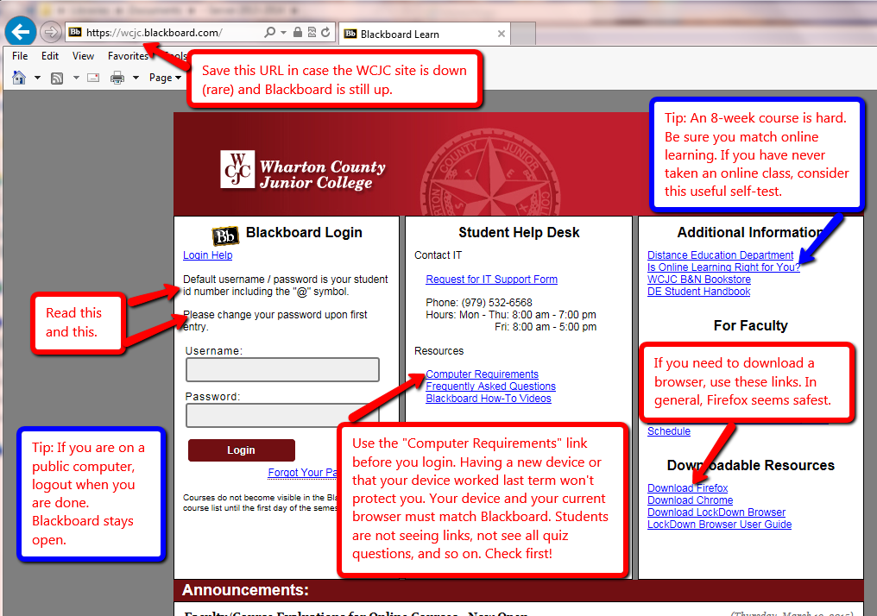

What You May Need on this Screen and How to Enter Your Blackboard Course and Stay on the “Path”
The green and yellow arrows identify 2 things you may need.
The blue box identifies the Course List, the only way to enter your course in Blackboard and stay on the “path.”
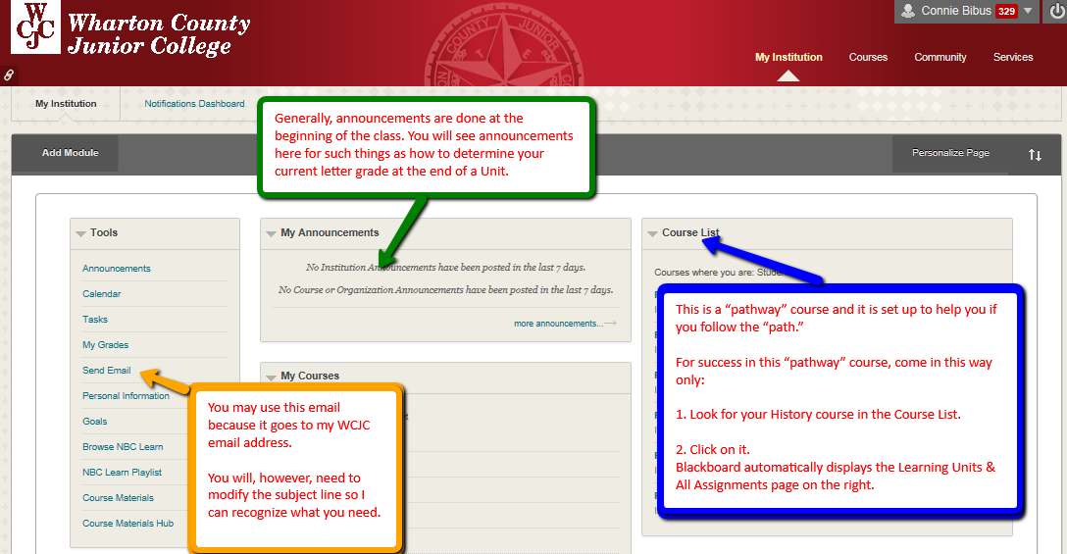

What You See Next
On the Learning Units & All Assignments, on the right side of the screen, you see labels for all of the parts of the course listed in your Course Schedule.

What You Do and See – Once you have the password to the quiz.
- Take the Blackboard Acknowledgement Quiz on the Learning Units & All Assignments page.
Blackboard displays the Getting Started Section and Unit 1.
- Your professor briefly tells you about two of the 3 things in Getting Started.
The 3rd thing (Good Habits for Evidence form) I will introduce in the next class meeting.
I will also cover how each Unit and each Chapter is organized.

What You Watch As a Demonstration and Then Do
- Your professor shows you the instructions for Registration of InQuizitive and where you go after you do that and leaves the instructions visible.
- Leaving the instructions visible, a student volunteer stays in Blackboard and follows those steps as a demonstration.
- Once registered, the student immediately clicks in Blackboard in this order:
- On Unit 1
- Chapter 1
- Chapter 1 InQuizitive
- To complete the process, the student answers questions in Chapter 1 InQuizitive.
Caution: If you are successful, the InQuizitive points will be visible in the Chapter 1 InQuizitive grade

WCJC Department: | History – Dr. Bibus
Contact Information: | 281.239.1577 or bibusc@wcjc.edu
Last Updated: | 2015
WCJC Home: | http://www.wcjc.edu/

