Logging into Blackboard – You’ll need your Banner ID (@######## twice). Do change your password.

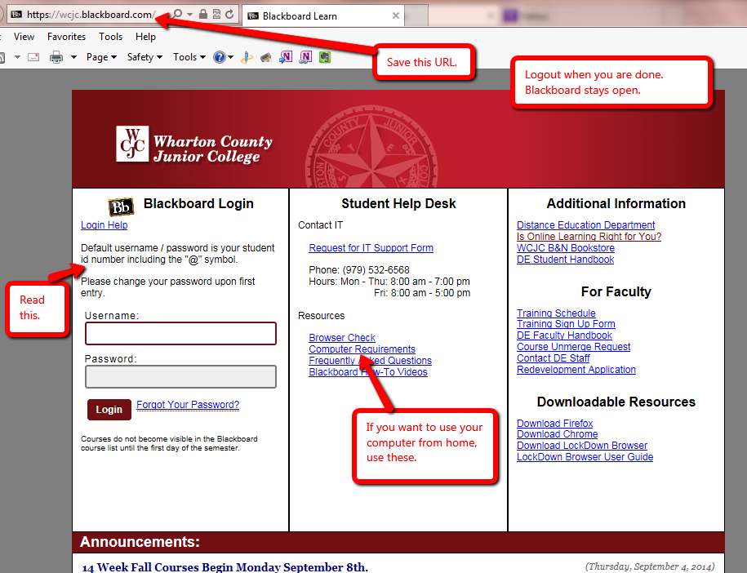

Course Menu on the left– Blackboard opens with the Learning Units + the rest.

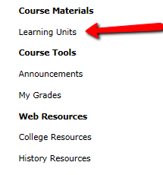

Using a quiz password – a Demo from your instructor with a Blackboard Acknowledgement Quiz
Be sure you write down the exact password for today.

Layout of a Unit
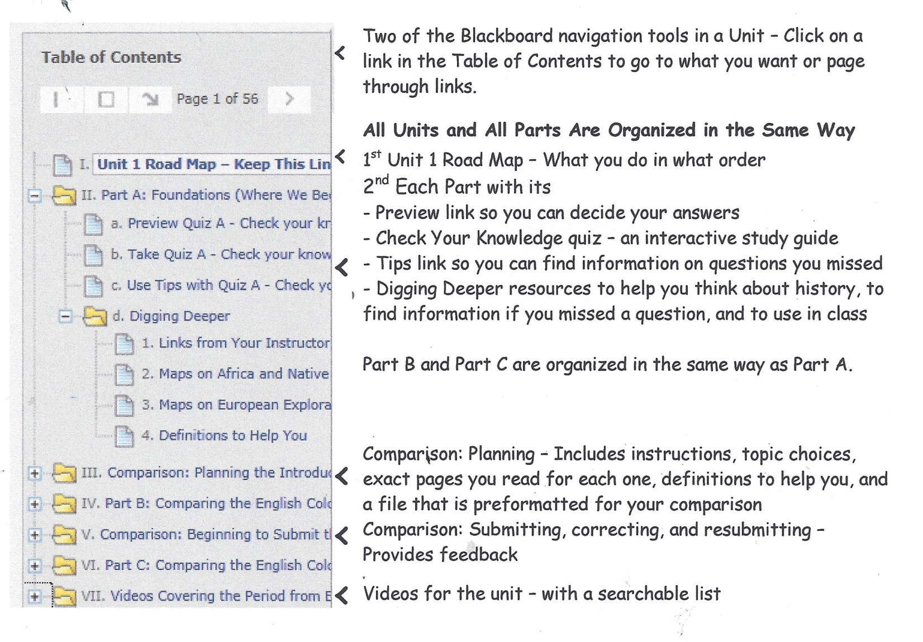

Using the Check Your Knowledge quizzes – the things that have puzzled students.

- Click on a Check Your Knowledge quiz .
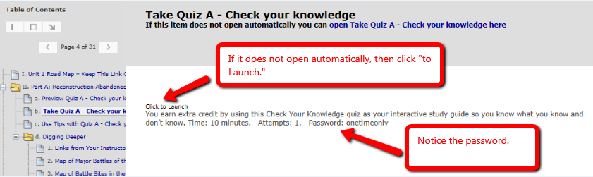

- Click Begin and enter the password. Notice no spaces between the words.

- Enter exactly what you planned when you listed your answers on that piece of paper

- When you first take the quiz, you press the OK button to see which ones you missed and got right.
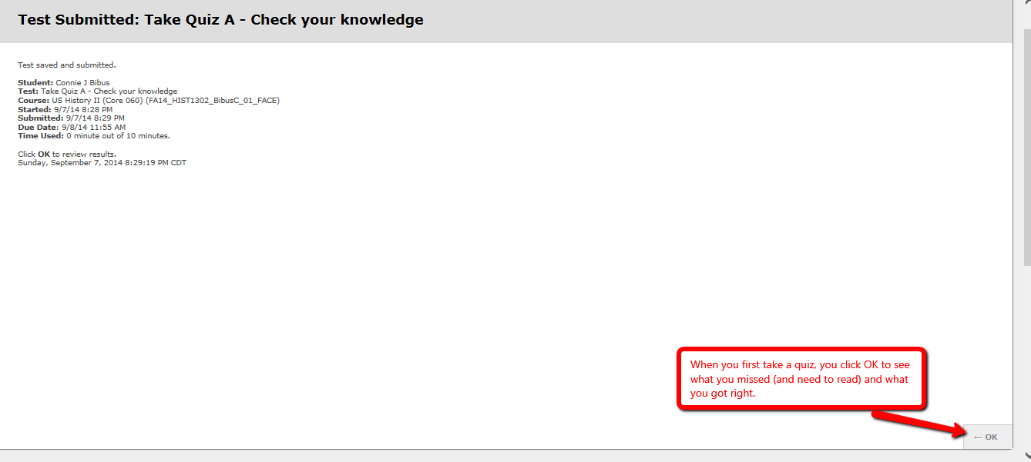

- If you decided you need to check on something and go back to see your completed quiz, you eventually see this screen.

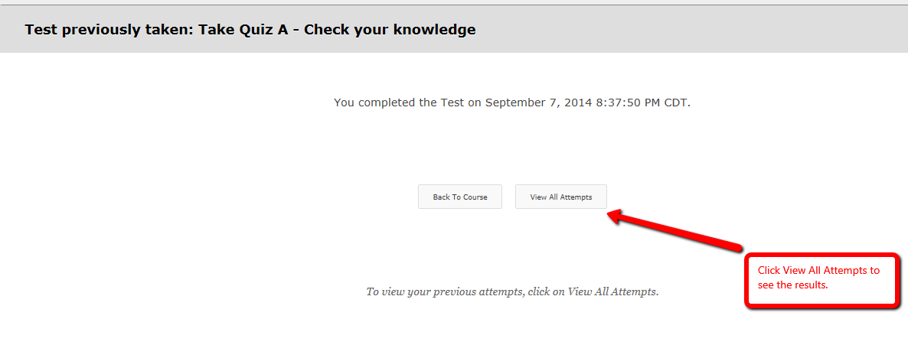
- Clicking on View All Attempts results in this screen. The red arrow shows what you click.
