Using a Quiz Created in Blackboard – the things that have puzzled students.
This information applies to any quiz created in Blackboard —including the Blackboard Acknowledgement Quiz.

Taking a Quiz for the first time
- Click on a quiz created in Blackboard.

- Click Begin and enter the password (if any). Notice no spaces between the words.

- When you first take a quiz, you press the OK button to see the results or just to return to the .

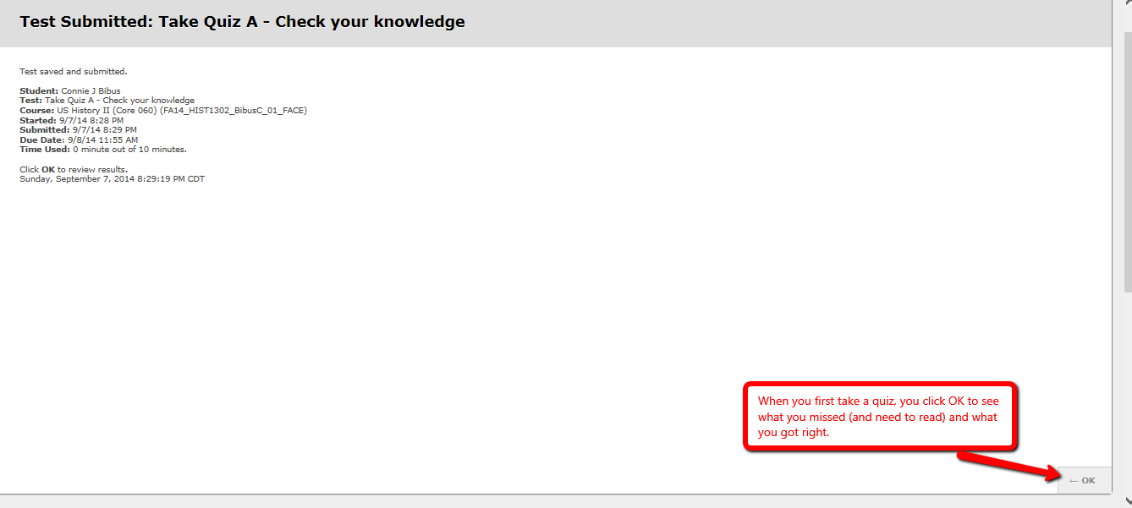

If you decide you want to see the results again
- If you decided you need to go back to see your completed quiz, you eventually see this screen.

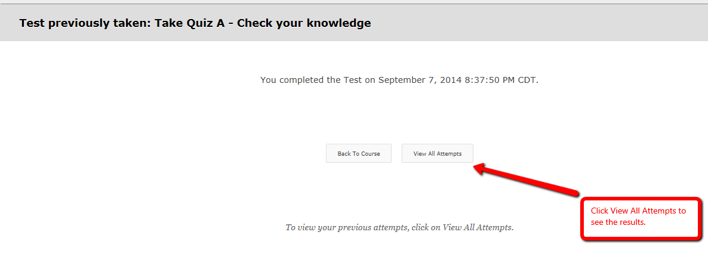

- Clicking on View All Attempts results in this screen. The red arrow shows what you click.
