How to Use This Review
Caution: Do not memorize words—these are not the exact words on the Final and not every question is on the Final. Test yourself and then grade yourself to see which ones you don’t know. Each quiz A-G has between 3 and 16 questions. Tip:
- Take a piece of notebook paper and write evenly spaced on the top line A through G and then number the left margin 1 to 16.
- Write your answers on the notebook paper.
- Then click on the Answers (in the link below this) and grade yourself.

Review Quiz A-1301

Match the item and the correct description.
A. Coercive Acts (or Intolerable Acts)
B. Stamp Act
C. Sugar Act
D. Tea Act

 | 1. | This British law reflected the British misunderstanding of the colonists and their concerns about the shift from British taxes to control trade and taxes for revenue. The law was a tax demanding a seal on all documents and resulted in a congress declaring no taxation without representation.
 | 2. | This British law was one of the attempts to get around the colonial rejection of taxes collected within the colonies by instead collecting taxes at the port for commonly used imports. It was also meant to save a financially vulnerable private British company and it reduced the price of that import to make it cheaper than the smuggled product. It greatly angered colonial merchants and colonists enough that one response was the destruction of the product.
 | 3. | This British law reveal the widening gap between the British and colonists. It attempted to force Massachusetts and Boston to back down following the destruction of the product by such measures as calling for the quartering of troops by the colonists, reducing the powers of self-government in Massachusetts, and calling for royal officers accused of crimes to be tried in Britain.

Match the location and the description.
A. New Orleans
B. Philadelphia
C. Saratoga
D. Yorktown

 |  | 4. | The American victory that brought about the French alliance occurred at this location.
 |  | 5. | In the American south, the battle and siege at this location involved the French fleet, combined the French army and American army, and resulted in the Patriots' successful end of the war for independence. Lord Cornwallis had to surrender there.
 |  | 6. | This victory in this city Jackson against the British occurred after the War of 1812 was over. The result of what is sometimes called our “Second War for Independence” was no real change from the way things were before the war. It did, however, result in the United States gaining:  - Its national anthem “The Star Spangled Banner”  - A hero, Andrew Jackson, who dominated the coming era and the presidency for 2 terms.
 | Review Quiz A-1301 Continued

Match location and the description.
A. England (later called Great Britain)
B. France
C. Portugal
D. Spain
E. the Netherlands

 | 7. | At the end of the 1400s, this western European country had the most powerful monarchy and seemed to be the most powerful nation. The papacy echoed this nation’s superiority with such actions as the Line of Demarcation (Treaty of Tordesillas) dividing the new world between it and another Catholic nation. Its famous explorer was the Genoan Christopher Columbus.
 | 8. | This western European country was the preeminent maritime power in the 1400s. Its exploration in the late 1400s concentrated on finding a route to the Orient by sailing east (around Africa). It also became dominant in the African slave trade.
 | 9. | Since the beginning, the focus in North America of this country was mainly fur trading and trapping. Among its allies were the Algonquians. At its defeat in the war ending in 1763, this nation lost all lands in North America.

Review Quiz B-1301

Match the person and the description.
A. John Quincy Adams  B. Preston Brooks  C. John Brown  D. Frederick Douglass  E. William Lloyd Garrison  F. George I  G. George II  H. George III | I. U.S. Grant  J. Alexander Hamilton  K. Henry VIII  L. Rutherford B. Hayes  M. Anne Hutchinson  N. Andrew Jackson  O. John Jay | P. Thomas Jefferson  Q. Andrew Johnson  R. Abraham Lincoln  S. James Madison  T. Tom Paine  U. William Penn  V. Dred Scott | W. Elizabeth Cady Stanton  X. Harriet Beecher Stowe  Y. Roger Williams

 | 1. | This Republican candidate in 1876 had fewer votes than the Democratic candidate, and there were disputes over electoral ballots in four states. In return for the Democrats accepting his victory in the Compromise of 1877, he and Republican Party ended Reconstruction.
 | 2. | The first Secretary of State for the United States, appointed during the Washington administration, was this individual who had been central in the American Revolution and who was central in the development of the Democratic-Republican Party during the Adams administration. He was also President for two terms. He is best known as the person who wrote the draft of the Declaration of Independence:
 | 3. | Sometimes called the “Father of the Constitution,” this individual was one of the authors of the Federalist Papers, a set of publications explaining the Constitution and the principles behind the organization of the new government. He also wrote the draft of the Bill of Rights, the first 10 amendments.
 | 4. | This person was the leading black abolitionist. He was born into slavery, ran away, and later bought his own freedom. He spent years lecturing in England against slavery, wrote a respected autobiography, and founded the newspaper The North Star:
 | 5. | The book Uncle Tom's Cabin was both an indicator and a cause of the growing division between North and South. It sold over 300,000 copies in 1852, its first year, and spread the message of abolitionism to an enormous new audience. Its author was:
 | 6. | What former Democrat from Tennessee who remained loyal to the Union was put on the Republican Party ticket in 1864 as a token. He became President and the initial controller of Reconstruction (or Restoration as he called it) in the seven months following the assassination of the prior President and the next session of Congress.
 | 7. | This person was the leading white abolitionist. He was the editor of The Liberator.
 | 8. | In 1856, This member of the House of Representatives nearly beat to death Senator Charles Sumner, an anti-slavery Senator, while he was seated in the Senate chamber. He broke his cane in the attack on Charles Sumner and Southerners sent him replacement canes.
 | 9. | The Supreme Court found in 1857 that this individual could not bring suit to prove he was a free person because he was not a citizen of the United States. The Court further found that slaves were property and the Missouri Compromise was unconstitutional, a decision that the South viewed as a vindication of slavery.

Review Quiz B-1301 Continued

 | 10. | This looser in the election of 1824 against John Quincy Adams and 2 other candidates, an election he and his followers considered a “corrupt bargain.” The election was so close that it was decided by the House of Representatives led by Henry Clay. Adams later made Clay his Secretary of State, a position previously considered a stepping stone to the presidency. This looser in 1824 was able to win the Presidency in 1828.  In his presidency, he is known for his use of the “spoils system” (replacing office holders with members of his party), the confrontation with South Carolina, for his part in the removal of the Cherokee Indians from Georgia to Indian Territory in what is called the “Trail of Tears,” and for his destruction of the national bank—the banking system established by Alexander Hamilton.
 | 11. | This individual was a Quaker who create a haven for his own faith and allowed diverse religions to settle in the colony.
 | 12 | The president who “announced” the end of Reconstruction in 1877, even though the tribulations of the post-war continued for decades afterward, was the Ohio Republican. Republicans removed the federal troops from the South.
 | 13. | This colonist in New England established Rhode Island for freedom of religion for all people.
 | 14. | This president had fewer of the popular votes in the much-disputed election of 1876 but the Democrats agreed to let him win in return for the Republicans ending the troops in the South. Reconstruction ended with this.

Review Quiz C-1301
Find the letter (A, B, C, D, or E on the map where the described event happened.
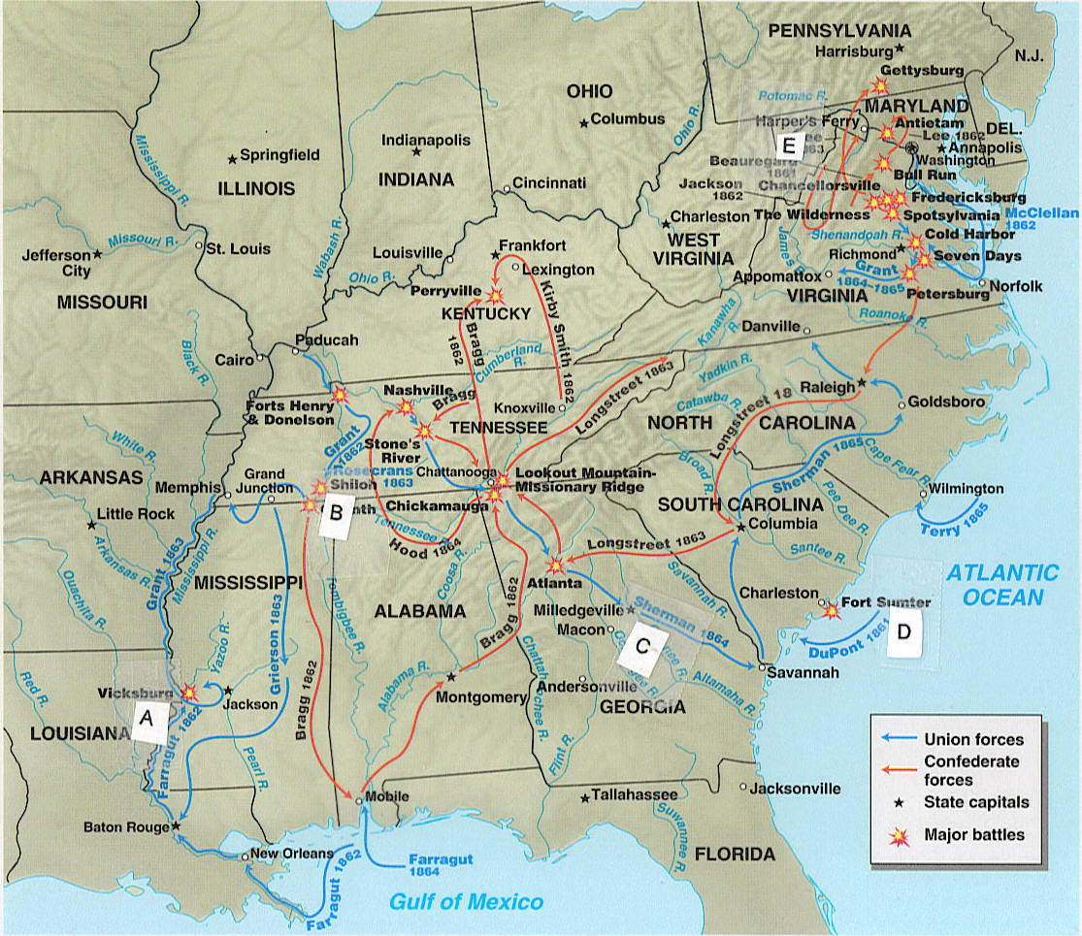
 | 1. | This engagement brought the war to the civilian population in the South and divided the South into small portions, with the victory also uniting the Republican Party behind Lincoln in 1864.
 | 2. | In 1863 two battles--one in the West and one in the East--occurred that moved the Union forward to complete victory over the Confederacy. In the West, following six weeks of siege and near starvation the city fell, completing the Union control of the Mississippi River. With this victory by U.S. Grant, the Mississippi River now divided the Confederacy and united the North with the Gulf of Mexico. (See Quiz D for the other battle. Remember the 2 battles as a pair.)
 | 3. | The Western campaign was crucial to victory for the Union because it would enable the North to reach into the interior of the South. In April 1862, the South seemed to be winning over the North at this battle, but the Union received 25,000 reinforcements overnight and pushed back the Southern forces with heavy losses on both sides.  :
 | 4. | John Brown, when in Kansas, and his followers murdered and mutilated five pro-slavery settlers in retaliation for pro-slavery forces’ “sack of Lawrence.” In 1859, he led a raid on the arsenal at this location to supply weapons to slaves for a revolt.
 | 5. | Following this engagement in April 1861, four more slave states left the Union. Lincoln informed the South he would send supplies (not troops or munitions), but the South bombed the federal installation in the harbor for two days until it surrendered:

Review Quiz C-1301 Continued
Match the country and the description.
A. Barbary States
B. France
C. Great Britain
D. Haiti
E. Mexico
F. Spain

 | 6. | The war with this nation resulted in the United States gaining new territory from it in the 1840s. The territory this nation surrendered was parallel to existing settlements in the United States or with the Republic of Texas.
 | 7. | The United States was able to buy the vast Louisiana Territory from this country because it was at war with the British and it needed money.
 | 8.. | The war of 1812 was fought with this country.

Review Quiz D-1301
Find the letter (A, B, C, D, or E on the map where the described event happened.
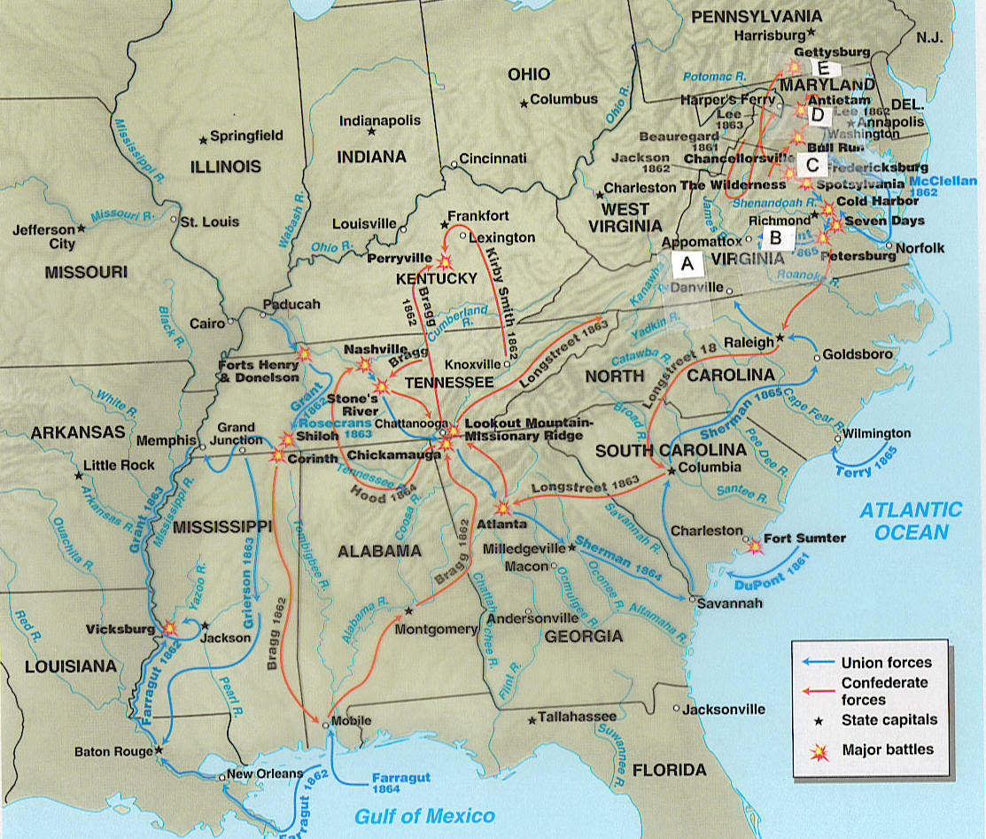
 | 1. | In 1863 two battles--one in the West and one in the East-- occurred that moved the Union forward to complete victory over the Confederacy. In the East, this battle, led by General Robert E. Lee, included a deadly and disastrous charge in which the Confederates were mowed down and few survived to engage the Union force, with total losses at 23,000 men (about one third of their force). The South had hoped to have a major victory in the North so that it could gain British and French support and would have a victory to balance a probable defeat in the West. (See Quiz C for the other battle. Remember the 2 battles as a pair.)
 | 2. | This 1862 battle was among the bloodiest engagements, it was indecisive militarily, and the North lost an opportunity to destroy much of the Confederacy. It was, however, technically a Union victory. President Lincoln, therefore, used the technical victory as a justification for issuing the Emancipation Proclamation.
 | 3. | The surrender of Robert E. Lee's worn-down forces occurred here. The surrender took place before Lincoln was assassinated.
 | 4. | This city in this state was the location of the capital of the Confederacy.
 | 5. | In July 1861, this battle, the first major battle of the war, was a Confederate victory close to Washington, DC. Spectators came to observe the expected Union victory, but instead they became part of a disorderly retreat.

Review Quiz D-1301 Continued

Match the item to its description.
A. Emancipation Proclamation
B. Freedman’s Bureau
C. 13th Amendment
D. 14th Amendment
E. 15th Amendment

 | 6. | This measure, ratified in 1865, meant that slavery was no longer legal in the US.
 | 7. | This method was the Radical Republicans' way to help the ex-slaves (now freedmen) and later was one of the methods to deal with the South's actions, such as passage of black codes. It provided food relief to poor blacks (and whites), established schools, provided legal help, and helped some blacks find work or land.
 | 8. | This document in 1862 meant Lincoln freed the slaves in the rebellious territories, not in the slave-holding border states nor in the other Northern states. (In other words, he freed no one.)  The document did have consequences because Lincoln:  - Regained control of the political competition in the North (abolitionists in Congress, in the military, and in the popular press)  - Did not give the border slave-holding states a reason to leave the Union  - Gained sympathy for the Union in England (particularly among the lower class and the middle class) and France.
 | 9. | This measure, ratified in 1868, was a response to the new state legislatures in the South passing black codes. The measure defined citizenship as being born in the US or naturalized in it, and forbade states from denying "due process" to citizens. It also required Congressional approval for amnesty for those who had taken an oath to support the Constitution and then violated it. It further forbade payment of debts related to the rebellion:
 | 10. | This measure stated that federal and state governments could not abridge the right of a citizen to vote on account of race, color, or previous condition of servitude. (In other words, voting could not be denied to male ex-slaves. Women could still not vote...)

Review Quiz E-1301

Match the term and the description.
A. Capital  B. Confederacy  C. Columbian Exchange  D. Declaration of Independence  E. Free Soil  F. Impressment  G. Great Awakening | H. Manifest destiny  I. Mercantilism  J. nonimportation or boycott  K. Popular sovereignty  L. Reconstruction  M. Republic  N. Suffrage

 |  | 1. | During the French and Indian War, the British had seized supposed British sailors from colonial ports or merchant ships for service on British ships. The British and the French followed this practice during their wars. This practice that was one of the issues leading to the War of 1812. This practice is called by what term?
 |  | 2. | The period following the Civil War until the Compromise of 1877 is called by what term?
 |  | 3. | This term used by Abraham Lincoln for the rapid return of the Southern states to the Union, including letting them vote as Senators and Representatives and citizens.
 |  | 4. | The movement leading to waves of religious revivals beginning in the 1730s and spreading throughout the English colonies was _____.
 |  | 5. | The new Constitution of the seceding South prohibited protective tariffs, guaranteed slavery, and protected slavery in any new territories, and protected the dominance of sovereign states over a central government. The form of government and the key word in its name for its new nation was this term.
 |  | 6. | The term ________________________ can be defined as the view that the United States was justified by God and history to expand its land. This movement became national policy with the election of President Polk in 1844 and his campaign for acquisition of both Oregon and Texas. In the campaign to take Oregon the slogan was “Fifty-four forty or fight.”
 |  | 7. | The political position that the people should, by their votes, be the ones to decide on the matter of slavery when a territory applied for statehood was called ___________________________. This position became a national issue because of expansion into the Kansas-Nebraska territories.
 |  | 8 | A period of time known for both:  - Negatives such as decimation of the native population  - Positives such as more diverse cultures, plants, and animals
 |  | 9 | Before the late 1700s, major European nations believed in controlling colonial economies so they:  - were markets for the mother-country’s goods  - provided raw materials to the mother country  - blocked other nations from trade
 |  | 10. | Refusal to buy (a legal action) as a means to force others to change. This worked well for the Patriots because the merchants who sold these goods also were members of the House of Commons.
 | Review Quiz E-1301 Continued

 | 11 | Explanation by newspaperman John Louis O’Sullivan about his view of the future of the US: “manifest destiny to overspread the continent allotted by Providence for the free development of our yearly multiplying millions.” If you look up the 2 words individually you will understand the power of the phrase to encourage war or at least land expansion.  (URL: https://www.americanyawp.com/reader/manifest-destiny/john-osullivan-declares-.americas-manifest-destiny-1845/)
 | 12 | Term defined by Merriam-Webster Online as “net worth: excess of assets over liabilities.”  - In the North in the early 1800s, they were able to turn profits from success in trading to manufacturing.  - In the South in the early 1800s, their “capital” was tied up in slaves and land. When land was fertile, the value of slaves and land were high, but when the land was worn out, slaves were just “liabilities.”  The problem was compounded by regions in the South growing one crop so when the crop was down in value, others in the region did not want to buy your land or slaves so you could get a fresh start.
 | 13 | The right to vote – By the 1830s white male universal suffrage was common in America. Notice who is excluded.
 | 14 | A political movement calling for “free soil, free speech, free labor, and free men” –no expansion of slavery into new lands.

Review Quiz F-1301
Find the letter (A, B, C, D, or E) on the map where the described event happened. With rivers, the letter is placed immediately below the blue box marking the river.
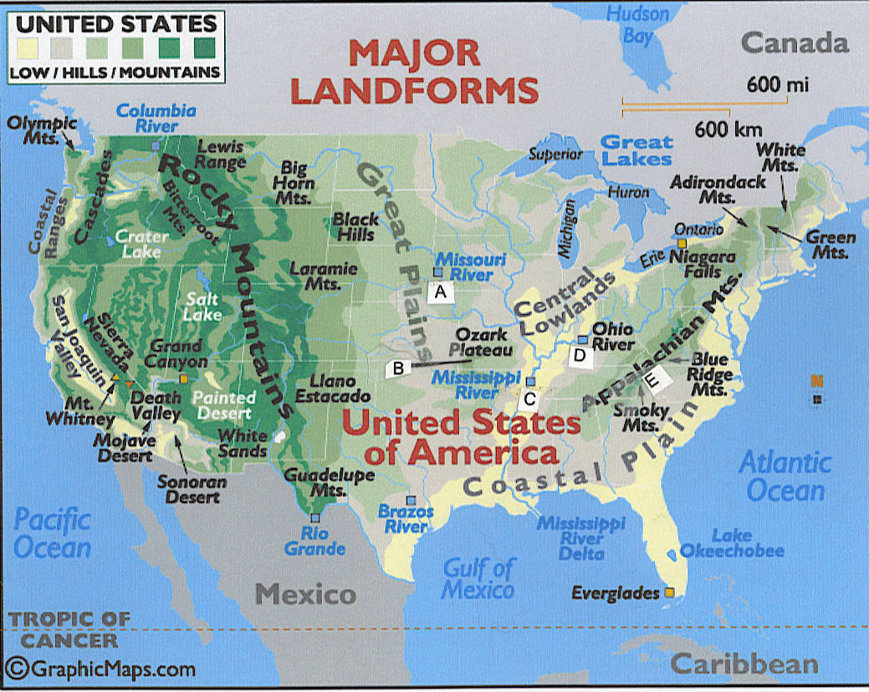

 | 1. | This area was the barrier following the end of the French and Indian War (the Seven Years War) with the Proclamation Line of 1763. In particular, the colonists wanted the Ohio River Valley because of its fertility and its access to the New Orleans through the river system.
 | 3. | This area was the barrier at the end of the American Revolution. It was the boundary set by the British at the peace treaty.
 | 3. | Among the decisions on slavery in the early 1800s was the _________ Compromise. With the exception of this state, this 1820 legislation prohibited slavery north of the 36 30’ parallel, the lower boundary of the state. (It also used admission of an equal number of slave and free states as the solution to the nation’s sectional divisions.)

Review Quiz G-1301

Mark the letter of the correct answer. Asterisk (*) = the correct answer
1. | What factor is believed to have dramatically reduced Indian populations after initial contact with Europeans?  a. War  b. Disease  c. Starvation  d. Enslavement
2. | From the 1600s past the American Revolution and the Constitution and beyond, these statements were accurate about Virginia and Maryland except:  a. Leaders such as Washington, Madison, and Jefferson did not own slaves.  b. Most people made their living from agriculture.  c. Most planters preferred not to use the labor of white indentured servants.  d. The dominant crop was tobacco.
3. | The Appalachian Mountains had been a geographic barrier to settlement of the Ohio Valley; the French and the Indians, the military barrier. With the defeat of the French, which of the following prohibited colonial settlement west of the Appalachian Mountains?  a. Proclamation of 1763  b. Relocation Act of 1764  c. Navigation Act of 1772  d. Townshend Acts of 1767
4. | The period when the new nation governed itself under the Articles of Confederation can BEST be described as:  a. A period of the establishment of many of the basic institutions set up in the Constitution, including Congress passing laws that set up the executive departments and the judiciary and that dealt with financial vulnerabilities of the new nation  b. A period when the nation became involved in the struggles between France and Britain, when the Congress passed laws restricting freedom of the press and speech, and when organization of political parties developed, including with grassroots organization of the Democratic-Republicans  c. A period when the central government could not tax or effectively make treaties
5. | This individual was one of the authors of the Federalist Papers. He was also the first Secretary of Treasury for the United States and set the financial policies of the United States. He advocated a national bank, assumption of state war debts, paying all debts the United States made under the Articles of Confederation, and a protective tariff. In his presidency, he was a wartime commander in chief (the first) in the War of 1812. This individual was:  a. James Madison  b. Thomas Jefferson  c. Alexander Hamilton  d. John Jay  e. Benjamin Franklin
6. | The Supreme Court’s ruling in the case of Marbury v. Madison established the legal principle of judicial review. It:  a. Stated that Congress had no authority to expand the power of the Supreme Court (Congress had in the 1791 legislation said the Supreme Court could issue the type of writ that Marbury needed.)  b. Stated that the Supreme Court had the power to nullify an act of Congress  c. Both of the above  d. Neither of the above

Review Quiz G-1301 Continued

 | 7. | President James Monroe is known for being President during all events except one:  a. During the so-called “Era of Good Feeling, “a period when the opposition part no longer existed  b. During the crisis called the Missouri Compromise, when settlers tried to establish a slave state in the previously unsettled Louisiana Territory  c. During the attempt to destroy the national bank established shortly after the Constitution was ratified  d. During the time former colonies of Spain had pushed the Spanish out and established new republics and America (and Great Britain) feared that imperial powers might try to take over these new republics and therefore the Monroe Doctrine stated that the American continents were no longer subjects for future colonization by European powers.
 | 8. | During Andrew Jackson’s term, these people had their own written language and Constitution; however, they were subjected to a deadly forced march to what is now Oklahoma. The “Trail of Tears,” as this forced march was called, resulted in the death of about ¼ of these people.  a. Cherokee Indians  b. Iroquois Indians  c. Mexicans in Texas  d. Seminole Indians
 | 9. | All of these phrases accurately apply to this section in the period from about 1830 to about 1860: large cities, impoverish Irish immigrants who came for any work that was available (including working in factories), depleted farmland with some farmers leaving the land to work in factories, many canals and railroads. Which section is it?  a. Northeast  b. Northwest  c. Southeast (upper South)  d. Southwest (lower South)
 | 10. | All of these phrases accurately apply to this section in the period from about 1830 to about 1860: predominantly rural, numerous slaves and a high proportion of slaves to whites (increasing feelings of insecurity among whites), new and fertile farmland used to grow King Cotton, and relying on rivers for transportation of goods. Which section is it?  a. Northeast  b. Northwest  c. Southeast (upper South)  d. Southwest (lower South)
 | 11 | This election brought to a head the sectional divisions over slavery. Abraham Lincoln was elected; the secession of the South followed the:  a. Election of 1828  b. Election of 1840  c. Election of 1860  d. Election of 1876
 | 12. | Which of the following does NOT describe President Abraham Lincoln?  a. He wanted to avoid a Civil War.  b. He would have allowed the South to maintain slavery if it would avoid the war.  c. He issued the Emancipation Proclamation.  d. He was the President of the Confederacy.

Review Quiz G-1301 Continued

13 | Which of the following is not descriptive of Reconstruction period in the South?  a. The Freedman’s Bureau and black northerners came South to help educate former slaves, and ambitious southern blacks presented themselves as natural leaders of the race.  b. White southerners sneered at white northern “carpetbaggers” who supported the Republican cause.  c. White southern Republicans were called “scalawags” and were ostracized by other white southerners.  d. African Americans were the clear majority in most southern legislatures elected under Reconstruction.  e. Black southerners formed their own churches instead of continuing to worship with whites.
14 | Why did Radical Republicans plan to take political control of the South after the Civil War, protect southern Unionists, and assist the freed slaves fail?  a. The refusal of most southern whites to recognize the legitimacy of Republican state governments and the eventual lack of support by the Northern public  b. The destructive impact of the Civil War on the southern economic system  c. The opposition of the U.S. Supreme Court to major elements of the Republican program  d. The stability and recovery of the national economy in the decade after the Civil War
15. | After 1810s, moving heavy products to markets relied on _____________; after the 1830s, _____________-  a. waterways such as the Erie Canal (and others), rails to make it possible to move loads overland  b. rails to make it possible to move loads overland, waterways such as the Erie Canal (and others)
16. | Whether canals or railroads, most building was in:  a. The North  b. The South
17. | After Congress made external (not state to state) slave trade illegal, slave owners did these things except:  a. Rewarded pregnancy  b. Punished slaves using less violence  c. Allowed slaves to work at a range of tasks, including some skilled work  d. Taught slaves to read and write  Ask if you do not know why?

Copyright C. J. Bibus, Ed.D. 2003-2020

WCJC Department: | History – Dr. Bibus
Contact Information: | 281.239.1577 or bibusc@wcjc.edu
Last Updated: | 2020
WCJC Home: | http://www.wcjc.edu/

