This is a low-tech solution but it has worked to help people refresh for the Final Exam and get straight some facts before they take the Final Exam. For some students, this will help more than online testing because they can see the whole passage of time easier.
If you have been doing Learning Quizzes, you will recognize some of the questions. Cautions:
- Do not memorize exact words because the exact words will not be on the Final Exam. The Final is my selection from the History Department database. Refresh yourself on the meaning, not the exact words.
- Notice the parts of an answer, not just the name associated with all the parts.
- Not all of the questions are on the Final. There are 50 questions on the Final and there are more than that here.

First: How to Use This File to Test Yourself
- If you have any paper with lines (notebook paper or a page from a spiral notebook), use that.
- Across the top, write the letters A, B, C, D, E, F, G, H, I evenly spaced enough that you can see each column. For me, I’d draw a vertical line between them.
- Down the side, write the numbers 1, 2, 3, 4, 5, 6, 7, 8, 9, 10, 11, 12, 13, 14 evenly spaced enough that you have room for a few notes. For me, I’d put a blank line between each one.
Many of the quizzes A through I have 10 questions, but not all.

Second: How to Use the Other File to Figure Out What You Need to Study (What You Know and You Do Not Know)
- When you are done with quizzes A through J, click on the link below and compare your piece of lined paper the answers.
- Mark the ones you do not know.
- Do not memorize an answer. You are unlikely to see similar text so just figure it out. Go back to the Lessons if you need more information.

Quiz A-1302
Match the person and the description. Write the correct letter on the answer sheet you made.

A. George H. Bush  B. George W. Bush  C. Jimmy Carter  D. William Clinton | E. Calvin Coolidge  F. Ulysses S. Grant  G. Warren G. Harding  H. Herbert Hoover | I. Lyndon B. Johnson  J. Ronald Reagan  K. Franklin D. Roosevelt  L. Theodore Roosevelt | M. Harry Truman  O. Woodrow Wilson

F | 1. | Although this President did not profit from it, he was associated with scandals at all levels of government and in private business. Scandals included prominent industries of the era (Crédit Mobilier---an overpaid railroad construction company with stocks to bribe Congress), Congress (bribes and their Salary Grab), and the executive branch (including the care of Indians and a taxation scheme with the Whiskey Ring).
G | 2. | This Republican offered to return the nation to “normalcy.” Although he did not profit personally, his administration is most associated with the scandals that occurred during his administration, such as the Teapot Dome scandal involving public lands leased to private companies in return for payments to the Secretary of the Interior.
K | 3. | In his speech accepting the Democratic nomination for President, this man promised Americans a “new deal” in their struggle with the Great Depression.  Using an executive order (9066), he ordered the relocation and internment of Japanese on the west coast, including those born here. (Note: this was not done to Germans or Italians.)
M | 4. | Using the atomic bomb at Hiroshima and Nagasaki, removing MacArthur from command in Korea, containment as the method to deal with the Communists, and a surprise victory over Dewey in 1948 are best associated with this person.  Using executive orders, he ended racial segregation in the military (9981) and in federal jobs (9980).
I | 5. | Taking office after John Fitzgerald Kennedy’s assassination, promoting the Great Society, Medicare and Medicaid being established, Civil Rights Act of 1964, Voting Rights Act of 1965, Gulf of Tonkin Resolution, and his decision not to run for President in 1968 are best associated with this person.
A | 6. | The following were factors in this president’s defeat in the election of 1992: Saddam Hussein reemerged as a potent force in Iraq; in spite of the promise of “no new taxes” in spring 1990, by summer the president considered “tax revenue increases”; and Americans feared that giving the president four more years would mean a continuation of problems with the economy.
D | 7. | Campaigning in 1992 as a “New Democrat,” a strong civil rights advocate, and a supporter of education, he faced the Somalia disaster and the challenge of Bosnia, a predominantly Muslim area in now divided and partly Christian Yugoslavia. Facilitated talks between PLO’s Yasser Arafat and Israel’s Rabin. Dealt with Newt Gingrich and the “Contract with America”; united on welfare changes; reduced the national debt for the first time in decades and even created budget surpluses. Favored NAFTA (North American Free Trade Agreement). Was damaged by the Monica Lewinsky scandal and faced impeachment; however, polls indicated that the public did not believe he should be removed from office.
B | 8. | Ran against Al Gore for the Democrats and Ralph Nader for the Green Party, with the disputed Florida votes being decided in a Supreme Court decision. In domestic policy: large tax cuts, rising deficits, rolling back environmental regulations. In foreign policy: events of 9/11, and a second Gulf War. During his administration, the executive branch expanded with the creation of the Department of Homeland Security.
O | 9. | Racist who established segregation in federal employment. Supporter of Plessy v. Ferguson and the League of Nations. Advocate of U.S. involvement in World War I.
J | 10. | The greatest increase in the national debt occurred during this popular President’s 8 years in office.

Quiz B-1302
Find the letter (a, b, c, d, e, A, B, C, D, or E) on the map where the described event happened. Then write that letter on the answer sheet you made, being sure to use capital or lowercase letters.

f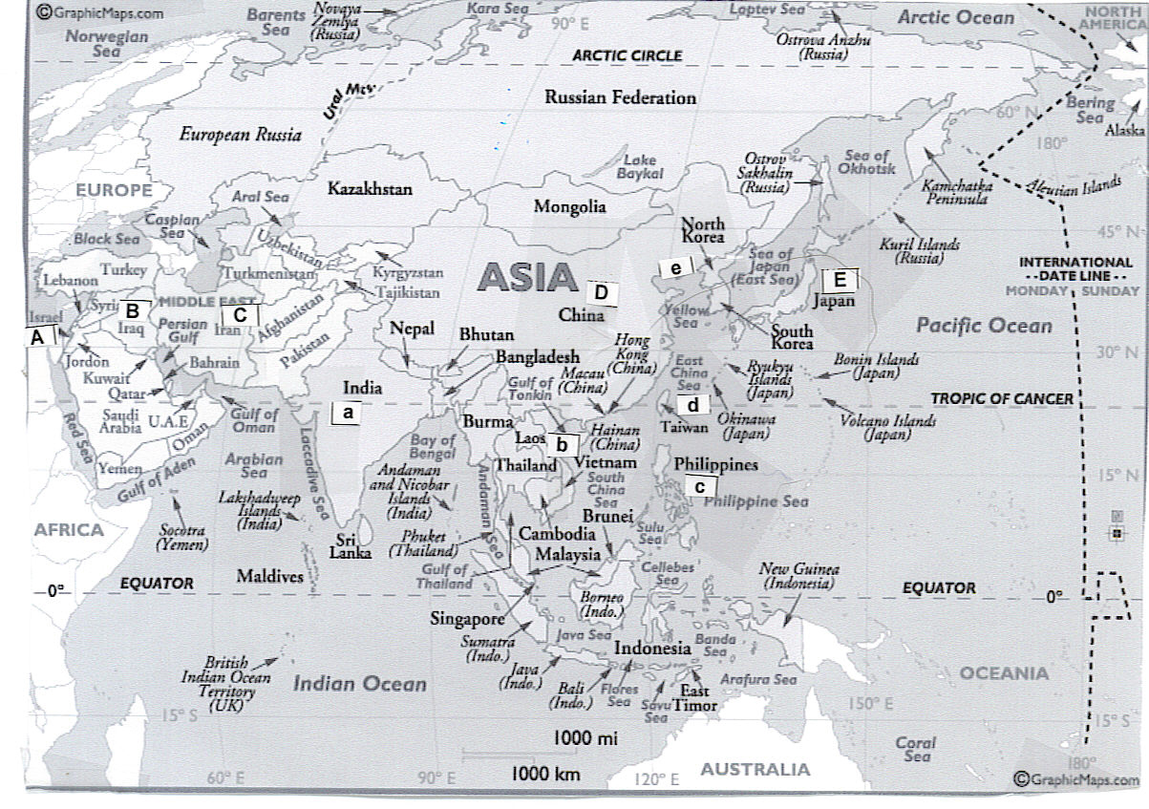
c | 1. | As the result of the Spanish American War, the United States gained this territory, one that became an increasing problem for foreign policy because of the native population’s armed resistance to US control.
E | 2. | This nation was an Axis power in World War II. After its defeat, it was occupied by the United States.
e | 3. | The war in this divided country began with the North attacking the South, was followed by Truman convincing the United Nations to pass a resolution to repel the North’s attack, proceeded to a stalemate that lasted for years and that kept the North and South divided at the 38th parallel, and ended (in Eisenhower’s administration) with nothing in the North and South really changed.
b | 4. | Beginning with a civil war in this country that was still controlled by the French in the 1950s, the war grew in the 1960s and 1970s. The conclusion of the war with this country was over 350,000 American casualties, almost 600 prisoners of war with some held as long as seven years, Americans divided in how they chose to respond to returning US veterans, and the fall—only two years after US withdrawal⎯of the part of this country that the US had supported financially and militarily since the 1950s.
D | 5. | In the area of foreign policy in 1972, Nixon reopened diplomatic relations with this country in a dramatic personal visit.
A | 6. | In October 1973, this country was attacked by Egypt and Syria in the Yom Kippur War. The US backed this country with an airlift of essential supplies, resulting in Organization of Petroleum Exporting Countries (OPEC) cutting off oil to the US, Western Europe, and Japan. The oil embargo ended a year later, but prices tripled and continued to rise, thus altering US prosperity for the future.
Match the item and the description. Write the correct letter on the answer sheet you made.
A. Fundamentalism  B. Pragmatism  C. Progressivism | D. Social Darwinism  E. Social Gospel

D | 7. | The philosophy known as __________ is associated with Herbert Spencer and held that "survival of the fittest," a term Spencer coined, applied to people.
E | 8. | Among those rejecting Herbert Spencer’s philosophy was this movement that provided assistance to slum residents.
B | 9. | Beginning in the early part of the 1900s, this movement tried to solve the problems in American politics and society created by industrialization.

Quiz C-1302
Find the letter (a, b, c, d, or e) on the map where the described event happened. Then write that letter on the answer sheet you made

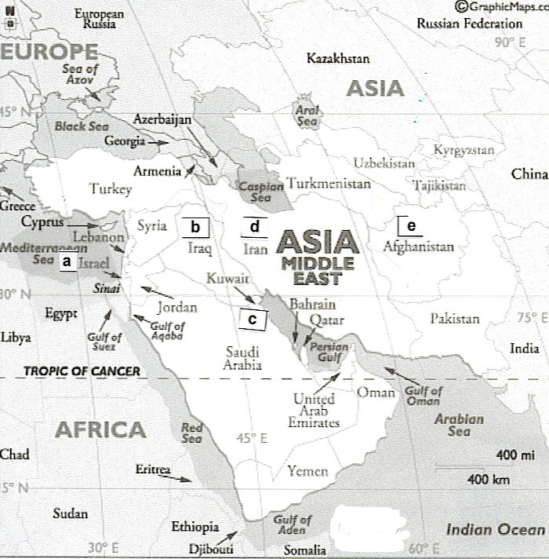
d | 1. | Among the 1950s covert actions by the CIA under the Eisenhower administration were events in this country. The US intervened when the new government nationalized British-controlled oil fields and overthrew the royal leader. The CIA intervened and returned the royal leader to power, with the leader subsequently splitting oil production (40% to US oil companies, 40% to British companies, and 20% to Dutch companies).
a | 2. | In 1979, with President Jimmy Carter’s assistance, Egypt under President Sadat and this country under Prime Minister Begin came to an agreement with the Camp David Accords for Egypt to recognize this country and this country to return the captured Sinai to Egypt.
e | 3. | One of the areas that moved toward Islamic fundamentalist governments was this area previously governed by the Soviet Union (a government in decline whose attempts to stop the Islamic revolt failed), but this area was repeatedly under the power of the Taliban.
c | 4. | After the Iran-Iraq war, the US allowed Iraq to purchase heavy machinery and to increase weapons of mass destruction. In 1990, the US ambassador stated the US had “no position” on Iraq’s dispute with this country, Iraq’s oil-rich neighbor. Iraq attacked this country, an attack that eventually led to the multinational war on Iraq in Operation Desert Storm. In this war, the multinational allies carefully chose to push Iraq out of this country but not to invade Iraq itself.

Match the person and the description. Write the correct letter on the answer sheet you made. (1 description can be used with 2 people)
A. William Jennings Bryan  B. Dwight D. Eisenhower  C. Langston Hughes  D. Zora Neal Hurston | E. Charles Lindbergh  F. Joseph McCarthy  G. Pancho Villa  H. Mark Twain

H | 5. | Among the most famous of authors of the Gilded Age is this person who wrote such books as The Adventures of Tom Sawyer and Adventures of Huckleberry Finn and who even named the age.
G | 6. | This individual from Mexico invaded Texas border towns and escaped from US troops during Wilson’s administration.
C/  D | 7. | This individual is representative of the Harlem Renaissance, a great flowering of African American culture occurring in the North following the Great Migration of blacks in the 1920s.
B | 8. | This individual was commander of the invasion of Western Europe and the leader of the unified operations at Normandy in World War II.  As President of the United States in the 1950s, he pushed for a massive public works project to create an interstate highway system—a matter of national defense in the age of possible nuclear war.

Quiz D-1302
Find the letter (a, b, c, d, e, A, B, C, D, or E) on the map where the described event happened. Then write that letter on the answer sheet you made, being sure to use capital or lowercase letters.
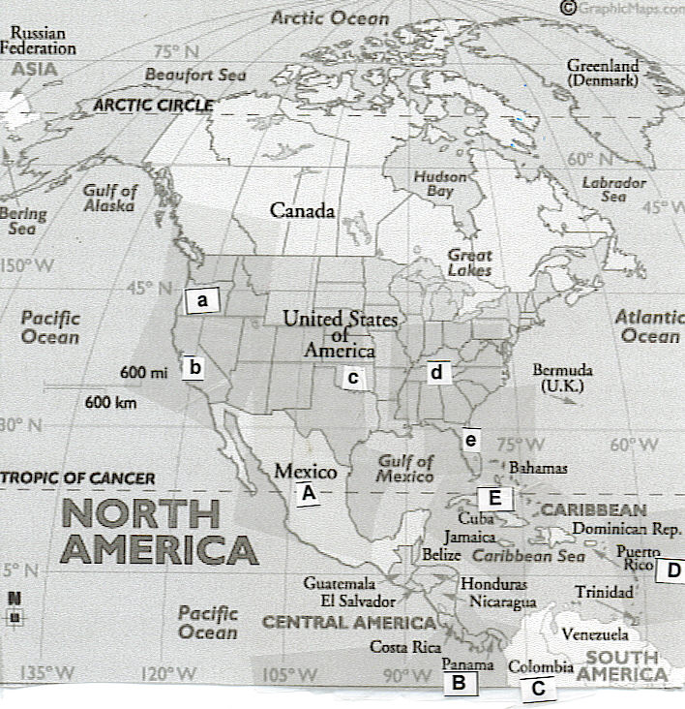
D | 1. | As a result of the Spanish American War, the United States gained this territory.
A | 2. | In 1993, the United States signed the North American Free Trade Agreement with two countries. One was?
E | 3. | In 1962 in this country, the Kennedy administration countered Khrushchev in the most dangerous event of the Cold War, one that could have resulted in nuclear war. The Soviet atomic warheads and missiles were in this country, but the Kennedy administration successfully handled the two-week crisis by blockade of this country, international candor, and careful maneuvering of Khrushchev.
Match the law and the description. Write the correct letter on the answer sheet you made.
A. Agricultural Adjustment Act  B. Dawes Act of 1887 | C. Social Security Act  D. Sherman Anti-Trust Act

B | 4. | The law attempted to divide reservations into single farms, planned to use farm ownership to "civilize" the Native Americans, and made more land available to whites.
A | 5 | This law was intended to reduce over-production on the nation’s farms—both grains, foods, and livestock
D | 6 | This law was intended to undo mergers of corporations who wanted to create a monopoly, drive out competing companies, and then be able to raise prices to consumers.

Quiz E-1302
Match the person and the description. Write the correct letter on the answer sheet you made.

A. Madeline Albright  B. William Jennings Bryan  C. Allen Dulles  D. John Foster Dulles | E. Geraldine Ferraro  F. Betty Friedan  G. Newt Gingrich  H. Ruth Bader Ginsburg | I. Henry Kissinger  J. Henry Cabot Lodge  K. Joseph McCarthy  L. George E. Marshall | M. Thurgood Marshall  N. Sandra Day O’Connor  O. Colin Powell  P. Clarence Thomas

B | 1. | This individual was the Presidential candidate for both Democratic and Populist Parties, and he gave the “Cross of Gold” speech. He served as Secretary of State, but resigned over Wilson’s policies toward Germany and Great Britain. In the 1920s, he was the prosecutor in the Scopes Trial in Tennessee and his statements helped to discredit fundamentalism in urban areas.
J | 2. | This Republican Senator was not invited to participate in the treaty negotiations ending World War I. He successfully led the fight against the United States signing the Treaty of Versailles and joining the League of Nations.
L | 3. | Truman’s Secretary of State was _______. He proposed the European Recovery Plan, a plan for the infusion of massive amounts of American capital into war-torn Europe as a means to a deal with the aftermath of World War II. Because Russia walked out of the initial conference and would not participate, aid was not provided to it (or its satellites) by his plan.
A | 4. | The Secretary of State for William Clinton, and the first woman to serve in this role, was this person.
B | 5 | Democratic candidate for President in 1896 who gave the “Cross of Gold” speech, Secretary of State for Woodrow Wilson who resigned because of his view of Wilson’s actions, and fundamentalist prosecutor at the Scopes Monkey Trial.
O | 6 | The first African American to be chairman of the Joint Chiefs of Staff, to serve on the National Security Council, and to be Secretary of State.

Quiz F-1302
Find the letter (a, b, c, d, e, A, B, C, D, or E) on the map where the described event happened. Then write that letter on the answer sheet you made, being sure to use capital or lowercase letters. 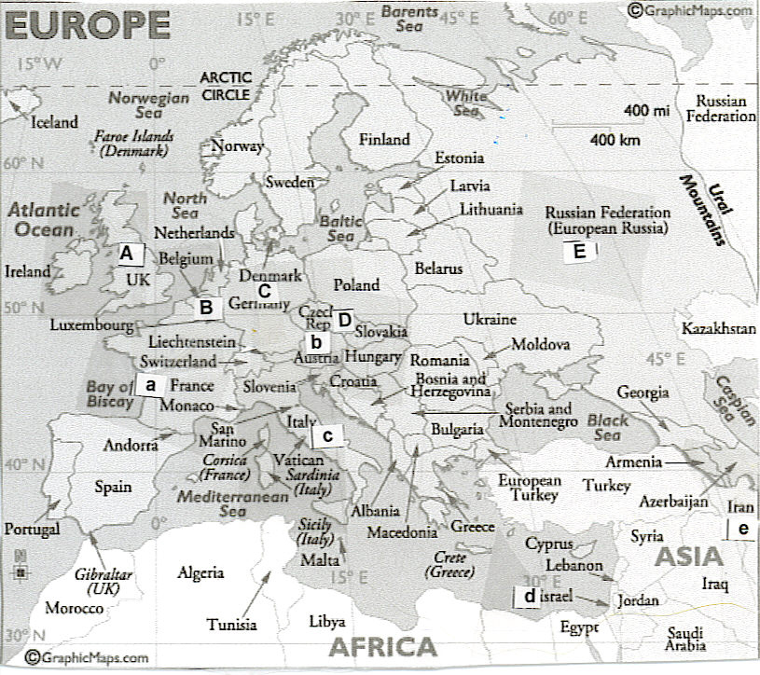
A | 1. | In addition to Russia and France, this nation was an Allied Power in World War I.
c | 2. | In the 1920s and 1930s, this nation was fascist and led by Benito Mussolini (Duce) It joined in an alliance with another fascist nation in 1935 and attacked Ethiopia in 1935 and Albania in 1939.
D | 3. | At a meeting in Munich, Germany, in 1938, both Great Britain, led by Neville Chamberlain, and France accepted Hitler’s demands for this area, in spite of France’s treaty alliance with this nation. Hitler’s justification was that it had a high German population. Carrying an umbrella (later became a symbol of appeasement), Chamberlain proclaimed that this would bring "peace in our time." The area was the Sudetenland in this country.
C | 4. | This nation (and its capital) was partitioned at the end of World War II, with the American, British, and French sections eventually being unified into one country and the Soviet section eventually being another country.
d | 5. | This nation was initially part of one of the territories mandated to Great Britain following World War I. Religious immigrants came into this region in increasing numbers as the Nazis increased their persecution. Britain’s inability to find a solution acceptable to the two religious groups dominant in the region resulted in its taking the issue to the United Nations, with the UN deciding to split the mandated territory to form two nations. This new nation was recognized immediately by President Truman.
e | 6. | The Islamic cleric Ayatollah Khomeini overthrew the Eisenhower-restored Shah of this country whose secret police and military used “widespread torture.” Among Khomeini’s first acts was to stop selling oil to the US, the second gasoline crisis in six years. He made this country into a fundamentalist, Islamic state.
E | 7. | In the late 1980s during the presidencies of George H. Bush of the United States and Mikhail Gorbachev of the Soviet Union, this country officially ceased to exist and broke into its component parts, with those parts showing strong nationalism and sometimes religious and ethnic issues.

Quiz G-1302
Match the person and the description. Write the correct letter on the answer sheet you made.
A. Madeline Albright  B. Betty Friedan  C. Ruth Bader Ginsburg | D. Martin Luther King  E. Thurgood Marshall  F. Sandra Day O’Connor | G. Francis Willard  H. Clarence Thomas

B | 1. | In 1963, this individual wrote The Feminine Mystique, covering what she called “the problem that has no name.” In 1967, she was elected President of the just-organized National Organization for Women which worked primarily for the passage of the equal rights amendment and equality in the workplace.
G | 2. | Representative of the reform in the Gilded Age and of the strength of the Prohibition movement was this President of the Women’s Christian Temperance Union.
E | 3. | In his second term, Lyndon Johnson appointed and the Senate confirmed the nomination of the first African American to serve on the Supreme Court, an individual who had been an NAACP attorney in the historic cases before the Supreme Court beginning in the 1950s.
F | 4. | Reflective of the changing political power of women were appointments of women to the Supreme court. The first was Ronald Reagan’s 1981 appointment of this person.

Match the item and the description. Write the correct letter on the answer sheet you made.
A. Alexander Graham Bell  B. Thomas Edison | C. Joseph Glidden  D. J. P. Morgan | E. John D. Rockefeller  F. George Westinghouse

E | 5. | As Andrew Carnegie is to the steel industry, this industrial capitalist is to the oil industry.
B | 6. | Among those in the age of inventors that marked the Gilded Age, this individual was associated with Menlo Park laboratory for inventing, electrical lighting, and invention of the phonograph.

Match the item and the description. Write the correct letter on the answer sheet you made.
A. Civilian Conservation Corps (CCC)  B. Federal Deposit Insurance  Corporation (FDIC) | C. Federal Reserve Board  D. GI Bill of Rights  E. Securities and Exchange Commission (SEC) | F. Social Security Act  G. Soldiers Bonus Act

C | 7. | To determine the amount of money in circulation, to respond to cyclical business changes, and to expand or contract the nation's credit, Congress created this organization during Woodrow Wilson’s term.
B | 8. | To insure bank deposits and to prevent the manipulation of people’s assets that had helped lead to the Depression, Congress passed the Glass-Steagall Act that prevented banks from selling stock and that created this program.
A | 9. | This New Deal program paid $5 per month to young men and $25 per month to their families. The young men lived in camps and did conservation projects such as planting trees, digging ditches, and fighting fires.
E | 10. | To prevent manipulation of the stock and bond market and the disastrous drain of America’s resources into speculation and to create transparency so people could know about companies before they bought stock, Roosevelt argued for, and Congress created, this agency.
G | 11. | To compensate World War I veterans for their service, Congress passed a bill granting certificates that matured in 1945. By 1932, the vets marched on Washington asking for early payment of those bonuses but they were driven out of their encampment with tear gas.
D | 12. | To avoid unemployment for returning vets as had happened at the end of World War I and to help returning veterans who had served the nation in war, Congress passed this law providing assistance with such things as education (including going to college) and aid for home mortgages

Quiz H-1302

Mark the letter of the correct answer on the answer sheet you made. (*to the left of a letter = correct)
1. | Which of the following provided the "final straw" that led the United States to enter into the Spanish American War over Cuba?  a. The Spanish herded Cubans into "reconcentration" camps.  b. The de Lôme letter criticizing William McKinley was published.  c. The "yellow press" in America published incendiary news stories about Spanish actions in Cuba.  *d. The USS Maine exploded in Havana Harbor.  What’s the meaning of USS?  “In 1907 President Theodore Roosevelt issued an Executive order that established the present usage:  In order that there shall be uniformity in the matter of designating naval vessels, it is hereby directed that the official designation of vessels of war, and other vessels of the Navy of the United States, shall be the name of such vessel, preceded by the words, United States Ship, or the letters U.S.S., and by no other words or letters.  ─ Executive Order 549, 8 January 1907.” (URL: https://www.history.navy.mil/content/history/nhhc/browse-by-topic/heritage/customs-and-traditions/ship-naming.html)
2. | Submarine warfare and trench warfare were characteristic of World War I. Using the new technology of the submarine, the 1915 German navy reduced Allied shipping.  *a. True  b. False
3. | Which of the following is not true of American participation in World War I?  *a. Expansion of U.S. control of Europe.  b. Protection of shipping of American goods to Europe.  c. Political concerns about voters’ anger over imperial Germany’s use of submarine warfare.  d. Threat by the Germans with the Zimmerman Note of U.S. territory in North America.
4. | The “Good Neighbor” policy:  a. Is most associated with Franklin D. Roosevelt  b. Improved US relations with Latin America  c. Resulted in our renouncing the Platt Amendment in return for our keeping Guantánamo Bay in Cuba  d. Faced its greatest test in Mexico, where the Roosevelt administration convinced Mexico to compensate American companies after Mexico nationalized industries there  *e. All of the above
5. | The period immediately following World War II established institutions that remain dominant today. In addition to creation of the National Security Council (NSC), which of the following was created under the National Security Act of 1947?  *a. Central Intelligence Agency (CIA)  b. Federal Bureau of Investigation (FBI)  c. North Atlantic Treaty Organization (NATO)
6. | Who made the statement "I have here in my hand a list of 205 Communists that were made known to the secretary of state”? (He later claimed the page was actually his list of his laundry.) Whose methods were revealed to the American people by having his hearings televised and his actions were exposed on Murrow’s See It Now television program? Who was the subject of indirect speeches by the President of the United States? And who, after years dominating Congress, was finally condemned by the Senate?  a. Dwight D. Eisenhower  b. Douglas MacArthur  *c. Joseph McCarthy
7. | Although covert action and funding occurred earlier, public involvement of the United States in the conflict in Vietnam begins in this decade:  a. 1940s  b. 1950s  *c. 1960s  d. 1970s  e. 1980s
8. | The public grief in response to the assassination John Fitzgerald Kennedy combined with Johnson’s legendary ability to get things done in Washington resulted in substantial changes. As part of the Great Society programs, Johnson:  a. Declared a “war on poverty” in a nation with 20% of the people below the poverty line in 1960 (reduced to 12% by 1970)  b. Emphasized community action, encouraging⎯with mixed success⎯neighborhood groups to play an active role in federally funded projects, including Head Start  c. Succeeded in pushing Congress to pass health programs⎯Medicare for the elderly and Medicaid for the indigent of any age  d. Succeeded in pushing Congress to pass the Kennedy’s previously proposed Civil Rights Act and also the Voting Rights Act  *e. All of the above
9. | The Watergate scandal included these actions:  a. Began with a break-in of the Democratic National Headquarters  b. Resulted in impeachment articles drawn up and passed by the House Judiciary Committee (The House itself did not vote on them because Nixon resigned before that could happen.)  b. Led to the resignation, a first in United States history, of Richard Nixon whose successor Gerald Ford later granted him a full pardon for anything illegal he might have done while in office  c. Resulted in the release of tapes of Oval Office conversations that caused the American people to question Nixon's fitness to lead the country because the conversations revealed Nixon played an active role in attempts to cover up White House involvement in Watergate, including use of “hush money” from readily available Republican funds.  *d. all of the above
10. | In the years following Nixon’s impeachment, Congress did these things to avoid repetition of the problems revealed by Nixon’s actions:  a. Congress passed the War Powers Act requiring the president to notify Congress within 48 hours of deployment of American combat troops and to withdraw those troops within 60 days if Congress did not endorse the President’s action  b. Congress passed the Freedom of Information Act allowing Americans to request information on government actions  c. The Senate held hearings that showed abuse of power by the FBI and actions ranging from illegal drug experiments and failed assassinations by the CIA  *d. all of the above
11. | Although Reagan’s domestic agenda can be described as anti-big government, his commitments included:  a. not to cut social programs such as Social Security.  b. to increase defense spending.  c. not to tamper with Head Start or school lunch programs.  *d. all of the above

Quiz I-1302

Mark the letter of the correct answer on the answer sheet you made. (*to the left of a letter = correct)

1. | Which of the following statements was/were true of the Fifteenth Amendment?  *a. It stated that federal and state governments could not abridge the right of a citizen to vote on account of race, color, or previous condition of servitude.  b. Susan B. Anthony supported the amendment because it included the right for women to vote in the future.  c. Abolitionists such as William Lloyd Garrison and Frederick Douglass condemned the amendment.
2. | Most "new immigrants" to the United States in the late 1800s  *a. were from Southern and Eastern Europe.  b. entered the United States at Boston Harbor.  c. were quickly assimilated into the dominant society.  d. were from Northern and Western Europe.
3. | In 1890, the Census Bureau announced that  *a. America no longer had a real frontier.  b. most Americans lived in urban areas.  c. California had surpassed New York in population.  d. both a and b
4. | In this landmark 1896 case, the Supreme Court declared segregation to be legal.  a. Brown v. Board of Education of Topeka  b. Griswold v. Connecticut  *c. Plessy v. Ferguson  d. Schechter v. U.S.
5. | The census of 1920 reported that for the first time  a. America really had no frontier left.  b. there were more immigrants than native-born Americans in the United States.  *c. more people lived in urban areas than in rural areas.  d. both a and b
6. | The Immigration Act of 1924 set up national-origin quotas based on the nationalities in the United States in 1890, predominantly from northern and western Europe.  *a. True  b. False
7. | People who lost jobs in the 1920s were usually helped by  a. unemployment insurance.  b. old age pensions.  c. federal welfare programs.  d. all of the above  *e. none of the above
8. | The decade-long Great Depression was caused by all of these things except:  a. Decades of low prices for farm products, with farmers producing more than they could sell.  b. Over-production of cars and houses by industries producing more than they could sell and resulting in loss of jobs  c. Loss of jobs resulting in less spending by consumers  *d. Too tight controls on the stock market
9. | In this decision in 1954, the Supreme Court declared separate educational facilities to be inherently unequal:  *a. Brown v. Board of Education of Topeka  b. Griswold v. Connecticut  c. Plessy v. Ferguson  d. Schechter v. U.S.
10. | The 1950s were prosperous for all of these reasons except:  a. Baby Boom (Babies require goods and services; they do not need jobs to support themselves.)  b. Consumerism (Pent up demands from the Great Depression and World War II were stimulated by advertising.)  c. Few competitors in world markets (The US provided 2/3rds of goods in world markets. The US was the only major nation in the war that did not get bombed.)  d. GI Bill (Returning vets went to college so they did not immediately look for a job. They also had help with mortgage costs for a new home.)  *e. Women workers (Women were valued employees who put to use the skills they had developed in key industries during World War II.)
11. | Television’s influence marked American life. The increasing intersection of television and political campaigning began in this year with the Presidential debate. The Democrat, John Fitzgerald Kennedy was a Catholic who met the issue of his Catholicism head on, by vowing to preserve separation of church and state. The Republican was Richard Nixon, who had been Eisenhower’s Vice President. The year was:  a. 1944  b. 1956  *c. 1960  d. 1968  e. 1972
12. | Which events were not televised?  a. Black riots that began in the Watts area of Los Angeles (CA)  b. Vietnam War  c. Watergate Hearings  d. White mob violence in Little Rock’s Central High School before Eisenhower nationalized the Arkansas Guard, sent 1000 army paratroopers, and ordered them to protect students entering the school.  *e. World War II
13. | In 1965, the Immigration and Nationalization Act ended national-origin quotas. It increased the number of immigrants per year and stressed “family unification.”  *a. True  b. False
14. | Which of the following was not true of immigration in the 1990s?  *a. Most immigrants were from Northern Europe.  b. Increased numbers of Hispanics and Asians resulted in the so-called “browning of America.”  c. Hispanic birthrates are higher than other groups.  For more on this issue than is in your current textbook, click here for quotations from the last two census reports. (URL: http://www.cjbibus.com/1990s_and_beyond_Supporting_info_Ethnicity.htm )

WCJC Department: | History – Dr. Bibus
Contact Information: | 281.239.1577 or bibusc@wcjc.edu
Last Updated: | 2018
WCJC Home: | http://www.wcjc.edu/

