Quiz A-1302

Match the person and the description. Write the correct letter to the left of the description.

A. George H. Bush
B. George W. Bush
C. Jimmy Carter
D. William Clinton
E. Calvin Coolidge
F. Ulysses S. Grant
G. Warren G. Harding
H. Herbert Hoover
I. Lyndon B. Johnson
J. Ronald Reagan
K. Franklin D. Roosevelt
L. Theodore Roosevelt
M. Harry Truman
O. Woodrow Wilson

F | 1. | Although this President did not profit from it, he was associated with scandals at all levels of government and in private business. Scandals included prominent industries of the era (Credit Mobilier---an overpaid railroad construction company with stocks to bribe Congress), Congress (bribes and their Salary Grab), and the executive branch (including the care of Indians and a taxation scheme with the Whiskey Ring).
L | 2. | This President is associated with the Square Deal and later the New Nationalism, with his assisting labor as well as industry in the Anthracite Coal strike, and with his policy of aiding or stopping trusts dependent on his view of their acting in the public interest.
G | 3. | This Republican offered to return the nation to “normalcy.” Although he did not profit personally, his administration is most associated with the scandals that occurred during his administration, such as the Teapot Dome scandal involving public lands leased to private companies in return for payments to the Secretary of the Interior.
H | 4. | This man was President at the time of the Bonus March and Milo Reno’s Farmers’ Holiday Association, when unemployment was nearly 25%, and when the government shifted from advocating voluntary actions by business to trying government intervention, such as the Reconstruction Finance Corporation and the Emergency Relief and Reconstruction Act, to stop the Great Depression.
K | 5. | In his speech accepting the Democratic nomination for President, this man promised Americans a “new deal” in their struggle with the Great Depression. Using an executive order (9066), he ordered the relocation and internment of Japanese on the west coast, including those born here. (Note: this was not done to Germans or Italians.)
M | 6. | Using the atomic bomb at Hiroshima and Nagasaki, removing MacArthur from command in Korea, containment as the method to deal with the Communists, and a surprise victory over Dewey in 1948 are best associated with this person.  Using executive orders, he ended racial segregation in the military (9981) and in federal jobs (9980).
I | 7. | Taking office after John Fitzgerald Kennedy’s assassination, promoting the Great Society, Medicare and Medicaid being established, Civil Rights Act of 1964, Voting Rights Act of 1965, Gulf of Tonkin Resolution, and his decision not to run for President in 1968 are best associated with this person.
A | 8. | The following were factors in this president’s defeat in the election of 1992: Saddam Hussein reemerged as a potent force in Iraq, making some question whether the president had ended the war too soon; in spite of the promise of “no new taxes” in spring 1990, by summer the president considered “tax revenue increases”; and Americans feared that giving the president four more years would mean a continuation of problems with the economy.
D | 9. | Campaigning in 1992 as a “New Democrat,” a strong civil rights advocate, and a supporter of education, he debated not just the Republican candidate but Ross Perot as well in 1992 and ran against Perot again in 1996. Placed the 1st Lady in charge of determining a plan for health care, but failed in the attempt to reform it partly because of opposition from industry groups. Faced the Somalia disaster and the challenge of Bosnia, a predominantly Muslim area in now divided and partly Christian Yugoslavia. Facilitated talks between PLO’s Yassir Arafat and Israel’s Rabin. Dealt with Newt Gingrich and the “Contract with America”; united on welfare changes; reduced the national debt for the first time in decades and even created budget surpluses. Favored NAFTA (North American Free Trade Agreement). Was damaged by the Monica Lewinsky scandal and faced impeachment; however, polls indicated that the public did not believe he should be removed from office. These facts are best associated with this person.
B | 10. | Ran against Al Gore for the Democrats and Ralph Nader for the Green Party, with the disputed Florida votes being decided in a Supreme Court decision. In domestic policy: large tax cuts, rising deficits, rolling back environmental regulations. In foreign policy: events of 9/11, the creation of the Department of Homeland Security, and another Gulf War. These facts are all best associated with this person.
O |  | Racist who established segregation in federal employment. Supporter of Plessy v. Ferguson and the League of Nations. Advocate of U.S. involvement in World War I.
J |  | The greatest increase in the national debt occurred during this President’s 8 years in office.

Quiz B-1302

Find the letter (a, b, c, d, e, A, B, C, D, or E) on the map where the described event happened. Then write that letter to the left of the description, being sure to use capital or lowercase letters. MAP WRONG Mikhail Gorbachev

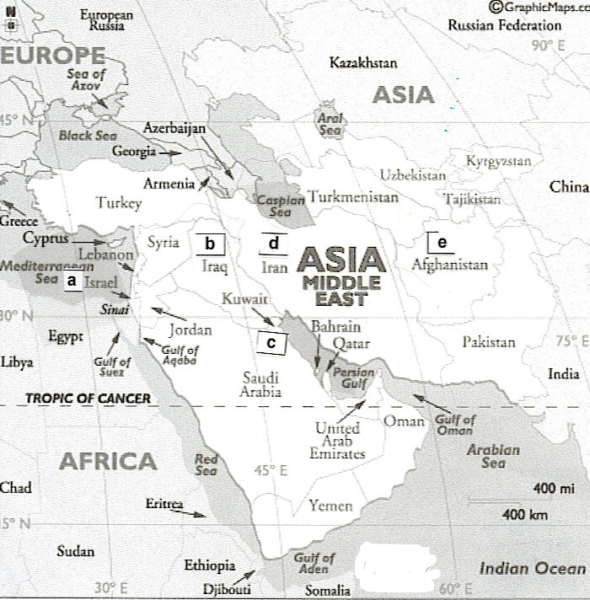
c | 1. | As the result of the Spanish American War, the United States gained this territory, one that became an increasing problem for foreign policy because of the native population’s armed resistance to US control.
E | 2. | This nation was an Axis power in World War II. After its defeat, it was occupied by the United States.
e | 3. | The war in this divided country began with the North attacking the South, was followed by Truman convincing the United Nations to pass a resolution to repel the North’s attack, proceeded to a stalemate that lasted for years and that kept the North and South divided at the 38th parallel, and ended (in Eisenhower’s administration) with nothing in the North and South really changed.
b | 4. | The conclusion of the war with this country was over 350,000 American casualties, almost 600 prisoners of war with some held as long as seven years, Americans divided in how they chose to respond to returning US veterans, and the fall—only two years after US withdrawal⎯of the part of this country that the US had supported financially and militarily since the 1950s.
D | 5. | In the area of foreign policy in 1972, Nixon reopened diplomatic relations with this country in a dramatic personal visit.
A | 6. | In October 1973, this country was attacked by Egypt and Syria in the Yom Kippur War. The US backed this country with an airlift of essential supplies, resulting in Organization of Petroleum Exporting Countries (OPEC) cutting off oil to the US, Western Europe, and Japan. The oil embargo ended a year later, but prices tripled and continued to rise, thus altering US prosperity for the future.
B | 7. | This country attacked Kuwait in the 1990s.

This nation was facing a civil war between the Nationalists and the Communists. They temporarily delayed the Civil War while they fought the Japanese invaders. After the Japanese defeat, the Communists pushed the Nationalists to the island of Formosa (AKA Taiwan). What area did the Communists control?

Match the item and the description. Write the correct letter to the left of the description.
A. fundamentalism
B. pragmatism
C. Social Darwinism
D. Social Gospel

C | 8. | The philosophy known as __________ is associated with Herbert Spencer and held that "survival of the fittest," a term Spencer coined, applied to people.
D | 9. | Among those rejecting Herbert Spencer’s philosophy was this movement that provided assistance to slum residents.
B | 10. | The philosophy of ______________ developed by William James focused on practical solutions to problems.

Quiz C-1302
Find the letter (a, b, c, d, or e) on the map where the described event happened. Then write that letter to the left of the description

d | 1. | Among the 1950s covert actions by the CIA under the Eisenhower administration were events in this country. The US intervened when the new government nationalized British-controlled oil fields and overthrew the royal leader. The CIA intervened and returned the royal leader to power, with the leader subsequently splitting oil production (40% to US oil companies, 40% to British companies, and 20% to Dutch companies).
a | 2. | In 1979, with President Jimmy Carter’s assistance, Egypt under President Sadat and this country under Prime Minister Begin came to an agreement at the Camp David Accords for Egypt to recognize this country and this country to return the captured Sinai to Egypt.
e | 3. | One of the areas that moved toward Islamic fundamentalist governments was this area previously governed by the Soviet Union (a government in decline whose attempts to stop the Islamic revolt failed), but this area was eventually ruled by the Taliban.
c | 4. | After the Iran-Iraq war, the US allowed Iraq to purchase heavy machinery and to increase weapons of mass destruction. In 1990, the US ambassador stated the US had “no position” on Iraq’s dispute with this country, Iraq’s oil-rich neighbor. Iraq attacked this country, an attack that eventually led to the multinational war on Iraq in Operation Desert Storm.

Match the person and the description. Write the correct letter to the left of the description.
A. William Jennings Bryan  B. Dwight D. Eisenhower  C. F. Scott Fitzgerald  D. Langston Hughes  E. Charles Lindbergh | F. Douglas MacArthur  G. Joseph McCarthy  H. John J. Pershing  I. Mark Twain

I | 5. | Among the most famous of authors of the Gilded Age is this person who wrote such books as The Adventures of Tom Sawyer and Adventures of Huckleberry Finn and who even named the age.
H | 6. | In 1993, the United States signed the North American Free Trade Agreement with two countries. One was?  This individual pursued the Mexican rebel Pancho Villa and later commanded the American Expeditionary Force in World War I.
D | 7. | This individual is representative of the Harlem Renaissance, a great flowering of African American culture occurring in the North following the Great Migration of blacks in the 1920s.
C | 8. | Author of The Great Gatsby, this individual’s work is representative of the disillusioned youth of the 1920s.
F | 9. | This individual was the leader at the removal of the Bonus Army from Washington during Hoover’s administration; commander in the Philippines and of the American forces in the Pacific during FDR’s administration; leader of Occupied Japan and the commander of UN forces in Korea during Harry Truman’s administration. His outspoken views on strategy with Korea and China, a strategy that differed from the Truman and the Joint Chiefs of Staff, resulted in his being removed from command by Harry Truman.
B | 10. | This individual was commander of the invasion of Western Europe and the leader of the unified operations at Normandy.

Quiz D-1302
Find the letter (a, b, c, d, e, A, B, C, D, or E) on the map where the described event happened. Then write that letter to the left of the description, being sure to use capital or lowercase letters.
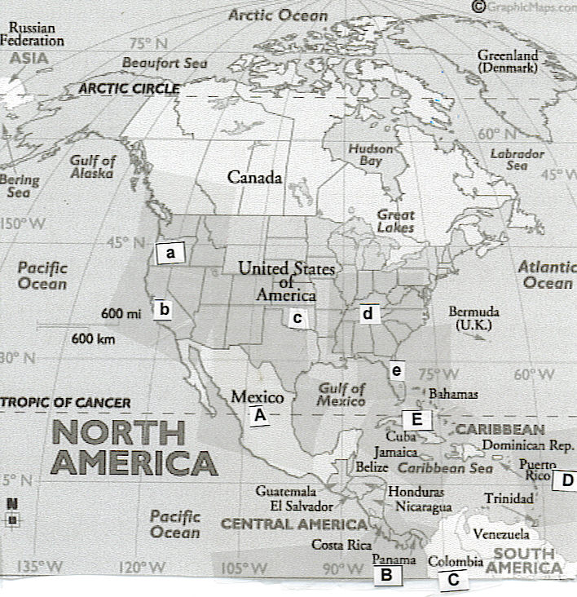
D | 1. | As a result of the Spanish American War, the United States gained this territory.
C | 2. | What country lost Panama when Panama was recognized by the United States?
B | 3. | What country declared itself independent and thereby became the way for American vessels to save months of transportation time?
A | 4. | Pancho Villa of ________ successfully raided United States towns in 1916.
b | 5. | One of the consequences of the Dust Bowl was that farmers in the Dust Bowl states (such as the Okies) became part of the growing numbers of migratory workers thrown off the land and seeking work in such areas as this state’s vegetable and fruit fields.
c | 6. | Adding to the burden of farmers, the Dust Bowl of the 1930s devastated farm lands, with winds so powerful that dust was found on ships at sea. The Dust Bowl occurred in such states as?
d | 7. | Congress created the Tennessee Valley Authority (TVA) to aid America’s poorest region. It provided flood control, electric power, and jobs, but was also criticized because of such problems as displacement of people. TVA was located in such states as?
E | 8. | In 1962 in this country, the Kennedy administration countered Khrushchev in the most dangerous event of the Cold War, one that could have resulted in nuclear war. The Soviet atomic warheads and missiles were in this country, but the Kennedy administration successfully handled the two-week crisis by blockade of this country, international candor, and careful maneuvering of Khrushchev.
Match the person and the description. Write the correct letter to the left of the description.
A. Agricultural Adjustment Act
B. Dawes Act of 1887
C. Grant’s “peace policy”
D. Resettlement Administration Act

C | 9. | This policy toward Native Americans relied most heavily on herding them onto reservations.
B | 10. | The policy attempted to divide reservations into single farms, planned to use farm ownership to "civilize" the Native Americans, and made more land available to whites.

Quiz E-1302
Match the person and the description. Write the correct letter to the left of the description.

A. Madeline Albright
B. William Jennings Bryan
C. Allen Dulles
D. John Foster Dulles
E. Geraldine Ferraro
F. Betty Friedan
G. Newt Gingrich
H. Ruth Bader Ginsburg
I. Henry Kissinger
J. Henry Cabot Lodge
K. Joseph McCarthy
L. George E. Marshall
M. Thurgood Marshall
N. Sandra Day O’Connor
O. Colin Powell
P. Clarence Thomas

B | 1. | This individual was the Presidential candidate for both Democratic and Populist Parties, and he gave the “Cross of Gold” speech. He served as Secretary of State, but resigned over Wilson’s policies toward Germany and Great Britain. In the 1920s, he was the prosecutor in the Scopes Trial in Tennessee and his statements helped to discredit fundamentalism in urban areas.
J | 2. | This Republican Senator was not invited to participate in the treaty negotiations ending World War I. He successfully led the fight against the United States joining the League of Nations.
L | 3. | Truman’s Secretary of State was _______. He proposed the European Recovery Plan, a plan for the infusion of massive amounts of American capital into war-torn Europe as a means to a deal with the aftermath of World War II. Because Russia walked out of the initial conference and would not participate, aid was not provided to it (or its satellites) by his plan.
K | 4. | This Wisconsin Senator’s name became representative of an era of searches for alleged communists in government and of increasing power for those who made accusations, regardless of their accuracy. (This Senator will not be stopped for four years.)
D | 5. | Eisenhower’s Secretary of State labeled the buildup of atomic warheads and the implied threat of using them as brinksmanship and held that (in the domino theory) the fall of one country would lead to the fall of others, with Vietnam being considered the key domino in 1954.
I | 6. | The Secretary of State for most of Nixon’s two terms and for the term completed by Gerald Ford was this individual. He was most associated with secret talks with North Vietnam and with China.
E | 7. | Jimmy Carter’s former Vice President Walter Mondale was the 1984 Democratic nominee against popular Ronald Reagan. Having little chance of beating him, Mondale made the symbolic choice of this woman, a New York Representative, as his running mate.
G | 8. | This individual was associated with the “Contract with America” (tested in focus groups) and the 1994 Republican victory in Congress.
A | 9. | The Secretary of State for William Clinton, and the first woman to serve in this role, was this person.
O | 10. | George Walker Bush’s Secretary of State, and the first African American to serve in that role, was also a former chairman of the Joint Chiefs of Staff.  .

Quiz F-1302
Find the letter (a, b, c, d, e, A, B, C, D, or E) on the map where the described event happened. Then write that letter to the left of the description, being sure to use capital or lowercase letters. If you have trouble seeing this map, click here.
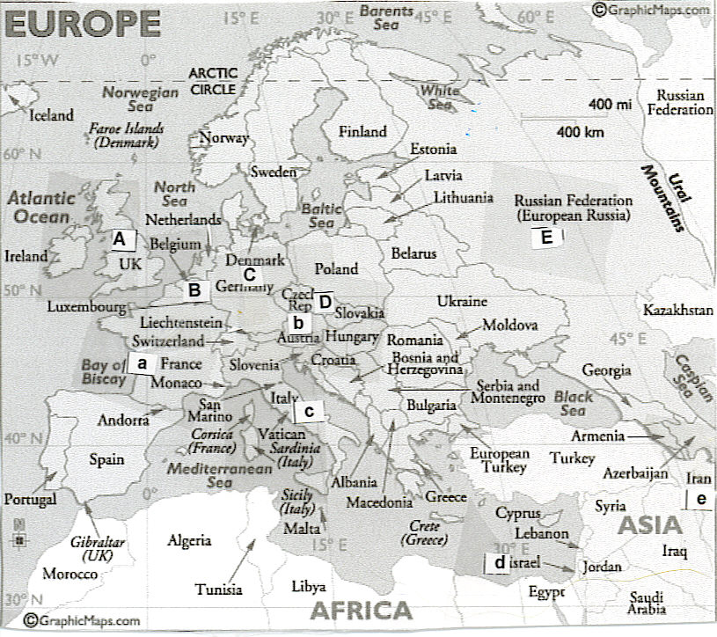
b | 1. | In addition to Germany and the Ottoman Empire, the Central Powers included an empire centered in this area.
A | 2. | In addition to Russia and France, this nation was an Allied Power in World War I.
c | 3. | In the 1920s and 1930s, this nation was fascist and led by Benito Mussolini (Duce) It joined in an alliance with another fascist nation in 1935 and attacked Ethiopia in 1935 and Albania in 1939.
D | 4. | At a meeting in Munich, Germany, in 1938, both Great Britain, led by Neville Chamberlain, and France accepted Hitler’s demands for this area, in spite of France’s treaty alliance with this nation. Hitler’s justification was that it had a high German population. Carrying an umbrella (later became a symbol of appeasement), Chamberlain proclaimed that this would bring "peace in our time." The area was the Sudetenland in this country.
a | 5. | The Battle of Normandy occurred in this nation. It was the 2nd front that Stalin had asked for repeatedly.
B | 6. | The Battle of the Bulge in this nation was the last counteroffensive by the Germans in World War II, with both Americans and Germans losing thousands of troops.
C | 7. | This nation (and its capital) was partitioned at the end of World War II, with the American, British, and French sections eventually being unified into one country and the Soviet section eventually being another country.
d | 8. | This nation was initially part of one of the territories mandated to Great Britain following World War I. Religious immigrants came into this region in increasing numbers as the Nazis increased their persecution. Britain’s inability to find a solution acceptable to the two religious groups dominant in the region resulted in its taking the issue to the United Nations, with the UN deciding to split the mandated territory to form two nations. This new nation was recognized immediately by President Truman.
e | 9. | The Islamic cleric Ayatollah Khomeini overthrew the Eisenhower-restored Shah of this country whose secret police and military used “widespread torture.” Among Khomeini’s first acts was to stop selling oil to the US, the second gasoline crisis in six years. He made this country into a fundamentalist, Islamic state.
E | 10. | In the late 1980s during the presidency of George H. Bush, this country officially ceased to exist and broke into its component parts, with those parts showing strong nationalism and sometimes religious and ethnic issues.

Quiz G-1302
Match the person and the description. Write the correct letter to the left of the description.
A. Madeline Albright  B. Betty Friedan  C. Ruth Bader Ginsburg  D. Martin Luther King  E. Thurgood Marshall  F. Sandra Day O’Connor  G. Francis Willard  H. Clarence Thomas | Thomas

B | 1. | In 1963, this individual wrote The Feminine Mystique, covering what she called “the problem that has no name.” In 1967, she was elected President of the just-organized National Organization for Women, a political organization working primarily for the passage of the equal rights amendment and equality in the workplace.
G | 2. | Representative of the reform in the Gilded Age and of the strength of the Prohibition movement was this President of the Women’s Christian Temperance Union.
E | 3. | In his second term, Lyndon Johnson appointed and the Senate confirmed the nomination of the first African American to serve on the Supreme Court, an individual who had been an NAACP attorney in the historic cases before the Supreme Court beginning in the 1950s.
F | 4. | Reflective of the changing political power of women were appointments of women to the Supreme court. The first was Ronald Reagan’s 1981 appointment of this person.

Match the item and the description. Write the correct letter to the left of the description.
A. Alexander Graham Bell
B. Thomas Edison
C. Joseph Glidden
D. J. P. Morgan
E. John D. Rockefeller
F. George Westinghouse

Write the correct letter to the left of the item.
E | 5. | As Buchanan Duke is to the tobacco industry in the South and as Andrew Carnegie is to the steel industry, this industrial capitalist, using horizontal integration in his industry, made his fortune in the oil industry.
B | 6. | Among those in the age of inventors that marked the Gilded Age, this individual was associated with Menlo Park laboratory for inventing, electrical lighting, and invention of the phonograph.

Match the item and the description. Write the correct letter to the left of the description.
A. Civilian Conservation Corps (CCC)
B. Federal Deposit Insurance Corporation (FDIC)
C. Federal Reserve Board
D. Securities and Exchange Commission (SEC)
E. Social Security Act

C | 7. | To determine the amount of money in circulation, to respond to cyclical business changes, and to expand or contract the nation's credit, Congress created this organization during Woodrow Wilson’s term.
B | 8. | To insure bank deposits and to prevent the manipulation of people’s assets that had helped lead to the Depression, Congress passed the Glass-Steagall Act that prevented banks from selling stock and that created this program.
A | 9. | This New Deal program paid $5 per month to young men and $25 per month to their families. The young men lived in camps and did regional environmental products such as planting trees, digging ditches, and fighting fires.
D | 10. | To prevent manipulation of the stock and bond market and the disastrous drain of America’s resources into speculation and to create transparency so people could know about companies before they bought stock, Roosevelt argued for, and Congress created, this agency.

Quiz H-1302

Mark the letter of the correct answer.
1. | Which of the following provided the "final straw" that led the United States to enter into the Spanish American War over Cuba?  a. The Spanish herded Cubans into "reconcentration" camps.  b. The de Lôme letter was published.  c. The "yellow press" in America published incendiary letters about Spanish actions in Cuba.  *d. The Maine, an American naval vessel, exploded in Havana Harbor.
2. | Submarine warfare and trench warfare were characteristic of World War I. Using the new technology of the submarine, the 1915 German sinking of the __________ cost 128 American lives and enraged the American public.  a. Arabic *b. Lusitania c. Maine d. Sussex
new | Which of the following is not true of American participation in World War I?  *a. Expansion of U.S. territory in Europe.  b. Protection of shipping of American goods to Europe.  c. Political concerns about voters’ anger over imperial Germany’s use of submarine warfare.  d. Threat by the Germans with the Zimmerman Note of U.S. territory in North America.
3. | Which of the following is not true of American participation in World War I?  *a. The United States used a volunteer system for raising troops in World War I, given the large number of people opposed to the war.  b. When intelligence tests showed no difference between black and white troops, the army reconfigured the tests to reflect prevailing prejudices.  c. Americans used convoys to escort shipments of food and troops to France.  d. The U.S. government turned to war bonds to help finance the war.
4. | The “Good Neighbor” policy:  a. Is most associated with Franklin D. Roosevelt  b. Improved US relations with Latin America  c. Resulted in our renouncing the Platt Amendment in return for our keeping Guantánamo Bay in Cuba  d. Faced its greatest test in Mexico, where the Roosevelt administration convinced Mexico to compensate American companies after Mexico nationalized industries there  *e. All of the above
5. | The period immediately following World War II established institutions that remain dominant today. Which of the following was created under the National Security Act of 1947?  a. Central Intelligence Agency (CIA) b. Federal Bureau of Investigation (FBI) c. National Security Council (NSC)  d. North Atlantic Treaty Organization (NATO) *e. both a and c
6. | Although covert action and funding occurred earlier, public involvement of the United States in the conflict in Vietnam begins in this decade:  a. 1940s b. 1950s *c. 1960s d. 1970s e. 1980s
7. | The Watergate scandal included these actions:  a. Began with a break-in of the Democratic National Headquarters  b. Led to the resignation, a first in United States history, of Richard Nixon whose successor Gerald Ford later granted him a full pardon for anything illegal he might have done while in office  c. Resulted in the release of tapes of Oval Office conversations that caused the American people to question Nixon's fitness to lead the country because the conversations revealed Nixon played an active role in attempts to cover up White House involvement in Watergate, including use of “hush money” from readily available Republican funds.  *d. all of the above
8. | In the years following Nixon’s impeachment, Congress did these things to avoid repetition of the problems revealed by Nixon’s actions:  a. Congress passed the War Powers Act requiring the president to notify Congress within 48 hours of deployment of American combat troops and to withdraw those troops within 60 days if Congress did not endorse the President’s action  b. Congress passed the Freedom of Information Act allowing Americans to request information on government actions  c. The Senate held hearings that showed abuse of power by the FBI and actions ranging from illegal drug experiments and failed assassinations by the CIA  *d. all of the above
9. | Background as the governor of Georgia; as President, focusing on human rights, withdrawing support for repressive regimes in Chile and Nicaragua, ending US control over the Panama Canal, negotiating the Camp David Accords between Israel and Egypt, and presiding over the Iran Hostage Crisis. Under his administration, the US experienced the combination of unemployment and inflation. These facts are best associated with:  *a. Jimmy Carter b. Ronald Reagan c. George H. Bush d. William Clinton e. George W. Bush
10. | Which of these statements was true of the Iran-Contra Affair during Reagan’s administration?  a. The executive branch’s National Security Council (NSC) believed hostages taken in Lebanon would be freed only if the US sold arms to the Islamic government of Iran, which had been financing terrorism against America during most of the 1980s.  b. Profit from the sale of these arms to Iran was secretly used to support the right-wing Contras against the Sandinistas in Nicaragua although Congress specifically forbade aid by the executive branch to them.  c. The high-level participants in the Iran-Contra arrangements, including Oliver North, faced no serious legal penalties because Congress gave them immunities to get them to testify about the operations.  *d. all of the above.

Quiz I-1302

1. | Which of the following statements was/were true of the Fifteenth Amendment?  *a. It stated that federal and state governments could not abridge the right of a citizen to vote on account of race, color, or previous condition of servitude.  b. It assured African Americans the right to hold office and ended voting restrictions.  c. Susan B. Anthony supported the amendment even though it did not provide for women's right to vote.  d. Abolitionists such as William Lloyd Garrison and Frederick Douglass condemned the amendment.  e. both a and b
2. | All of the following are amendments to the Constitution that occur in the post-Civil War era except:  *a. 13th amendment freeing slaves in the rebellious territories  b. 13th amendment ending slavery  c. 14th amendment forbidding the states from denying “due process” to citizens and declaring citizenship to be anyone born in the United States or naturalized  d. 15th amendment granting the right to vote to former slaves (who were male)  e. both a and c
3. | In the case of Munn v. Illinois, the Supreme Court ruled that __________ were legal.  a. monopolies  *b. regulatory commissions  c. pools  d. rebates  e. trusts
4. | In this landmark 1896 case, the Supreme Court declared segregation to be legal.  a. Brown v. Board of Education of Topeka b. Griswold v. Connecticut *c. Plessy v. Ferguson  d. Schechter v. U.S. e. U.S. v. Butler
5. | In this decision in 1954, the Supreme Court declared separate educational facilities to be inherently unequal:  *a. Brown v. Board of Education of Topeka b. Griswold v. Connecticut c. Plessy v. Ferguson  d. Schechter v. U.S. e. U.S. v. Butler
6. | Who made the statement "I have here in my hand a list of 205 Communists that were made known to the secretary of state”? Whose methods were revealed to the American people by having his hearings televised and his actions were exposed on Murrow’s See It Now television program? Who was the subject of indirect speeches by the President of the United States? And who, after years dominating Congress, was finally condemned by the Senate?  a. Dwight D. Eisenhower b. Douglas MacArthur *c. Joseph McCarthy d. Franklin D. Roosevelt e. Harry Truman
7. | Television’s influence marked American life. The increasing intersection of television and political campaigning began in this year with the Presidential debate. The Democrat, John Fitzgerald Kennedy was a Catholic who met the issue of his Catholicism head on, by vowing to preserve separation of church and state. The Republican was Richard Nixon, who had been Eisenhower’s Vice President. The year was:  a. 1944 b. 1956 *c. 1960 d. 1968 e. 1972
8. | Which of the following was a social or technological development of the 1980s?  a. Cable television and alternatives to the major networks became widespread, with people such as Ted Turner representing the trend  b. Many Americans came to see the nation’s public school system as needing an overhaul, but they differed as to the methods to be used.  c. The number of single-parent families declined for the first time since the 1960s.  *d. both a and b
9. | Which of the following did not signify the deep divisions affecting the United States in the 1990s?  a. The O.J. Simpson verdict, to which whites and blacks exhibited polarized reactions  b. The battle over gay rights  *c. The Supreme Court’s reversal of its earlier decision in Roe v. Wade  d. Moves to restrict affirmative action, including the 1996 Supreme Court case of Hopwood v. Texas, a case invalidating the selection method used by the University of Texas Law School
10. | Which events were not televised?  a. Black riots that began in the Watts area of Los Angeles (CA)  b. Vietnam War  c. Watergate Hearings  d. White mob violence in Little Rock’s Central High School before Eisenhower nationalized the Arkansas Guard, sent 1000 army paratroopers, and ordered them to protect students entering the school.  *e. World War II

Quiz J-1302

1. | Most "new immigrants" to the United States in the late 1800s  *a. were from Southern and Eastern Europe.  b. entered the United States at Boston Harbor.  c. were quickly assimilated into the dominant society.  d. were from Northern and Western Europe.
2. | In 1890, the Census Bureau announced that  *a. America no longer had a real frontier.  b. most Americans lived in urban areas.  c. California had surpassed New York in population.  d. both a and b
3. | Areas investigated by muckrakers for newspapers and magazines (such as McClure’s) included all EXCEPT:  *a. Food products regulated by the Department of Agriculture (Dr. Harvey Wiley)  b. Meatpacking (Upton Sinclair)  c. City government (Lincoln Steffens)  d. Standard Oil (Ida Tarbell)
4. | The census of 1920 reported that for the first time  a. America really had no frontier left.  b. there were more immigrants than native-born Americans in the United States.  *c. more people lived in urban areas than in rural areas.  d. both a and b
5. | People who lost jobs in the 1920s were usually helped by  a. unemployment insurance. b. old age pensions. c. federal welfare programs.  d. all of the above *e. none of the above
6. | One reason for the shift in the New Deal before the 1936 election was its critics from the left who had large followings in American. These critics included:  a. Frances Townsend with his proposed pension of $200 monthly for everyone over sixty  b. Senator Huey Long of Louisiana with his “Share Our Wealth” program calling for a redistribution of wealth from the rich to the poor to “make every man a king”  c. Father Charles Coughlin, the “Radio Priest, ” with his mix of anti-Semitism, religion, attacks on bankers, and calls for “free silver”  *d. all of the above
7. | All of the following led to the growth of suburbs after the war except:  a. The G.I. Bill's low mortgage rates that allowed veterans to buy houses  b. William Levitt's building of masses of houses using techniques borrowed from the Ford assembly line  *c. The high numbers of African Americans who found cheap housing in the suburbs  d. The attractions of suburbia's good schools and open spaces  e. The need for affordable houses brought on, in part, by the baby boom
8. | The public grief in response to the assassination John Fitzgerald Kennedy combined with Johnson’s legendary ability to get things done in Washington resulted in substantial changes. As part of the Great Society programs, Johnson:  a. Declared a “war on poverty” in a nation with 20% of the people below the poverty line in 1960 (reduced to 12% by 1970)  b. Emphasized community action, encouraging⎯with mixed success⎯neighborhood groups to play an active role in federally funded projects, including Head Start  c. Succeeded in pushing Congress to pass health programs⎯Medicare for the elderly and Medicaid for the indigent of any age  d. Succeeded in pushing Congress to pass the Kennedy’s previously proposed Civil Rights Act and also the Voting Rights Act  *e. All of the above
9. | Although Reagan’s domestic agenda can be described as anti-big government, his commitments included:  a. not to cut social programs such as Social Security.  b. to increase defense spending.  c. not to tamper with Head Start or school lunch programs.  *d. all of the above
10. | Which of the following was not true of immigration in the early 1990s?  *a. Most immigrants were from Northern Europe.  b. Increased numbers of Hispanics and Asians resulted in the so-called “browning of America.”  c. Legal immigrants averaged 600,000 per year; illegal, from 300,000 to 500,000.  d. The state of California passed Proposition 187, which barred illegal immigrants from receiving state education and health benefits.  e. Studies showed that legal and illegal immigrants contribute more than they use in government services.

Copyright C. J. Bibus, Ed.D. 2003-2018

WCJC Department: | History – Dr. Bibus
Contact Information: | 281.239.1577 or bibusc@wcjc.edu
Last Updated: | 2018
WCJC Home: | http://www.wcjc.edu/

