Lessons in Blackboard’s Unit 3—a Different Approach Than the Earlier Units and a Different Method to Provide a Study Guide
Unit 3 is different than Unit 1 and 2 and therefore there is a different approach. Across the period of time covered by Unit 3, we live with rapid, repeated changes:
- With the same issues in our nation
- In the same regions of the world
Regions on the Snapshots (plus North America) Using the Merriam-Webster Online Dictionary
Latin America | “all of the Americas south of the United States”
Europe | “continent of the eastern and northern hemispheres that has the Atlantic Ocean to its west, the Arctic Ocean to its north, Asia to its east, and Africa and the Mediterranean and Black seas to its south”
Middle East | “the countries of southwest Asia and north Africa —usually considered to include the countries extending from Libya on the west to Afghanistan on the east”
Far East | “Asian countries bordering on the Pacific” and “sometimes” also the countries of “India, Sri Lanka, Bangladesh, Tibet, & Myanmar”
North America | “continent of the western hemisphere northwest of South America bounded by the Atlantic, Arctic, and Pacific oceans and including Canada, the United States, Mexico, and the countries of Central America area”
Tip: The Essentials Quiz for Unit 3 covers the names of the key regions, such as the Far East, so you know which period we are talking about.

Across the period of time covered by Unit 3, three Lessons cover the years (15 years, 28 years, and 28 years). Each Lesson is divided by the presidencies because after World War II the executive branch has gained ever more power than in Unit 2. Further two issues within the presidencies continue to reveal our world:
- Age cohorts ranging from the baby boom, to Gen-X, to the millennials, to Gen-Z
- The national debt as it grew, declined briefly with bipartisan effort in President Clinton’s term, and then climbed again to a higher peak
Click here if you want the names of the age cohorts and their traits and the national debt over time
Link Address: http://www.cjbibus.com/1302_Concepts_about_Generations_Debt_Change_Over_Time.pdf

In Unit 3, all Lessons begin with a 1-page Snapshot that:
- Covers in rows the same places or issues for each of the 3 time periods (In other words, if you put the 1-page Snapshots side by side on a kitchen table and looked at the row for the Far East, you could see what the US was doing there for about 70 years.
Example: Notice below that the Middle East is covered throughout the 70 years.
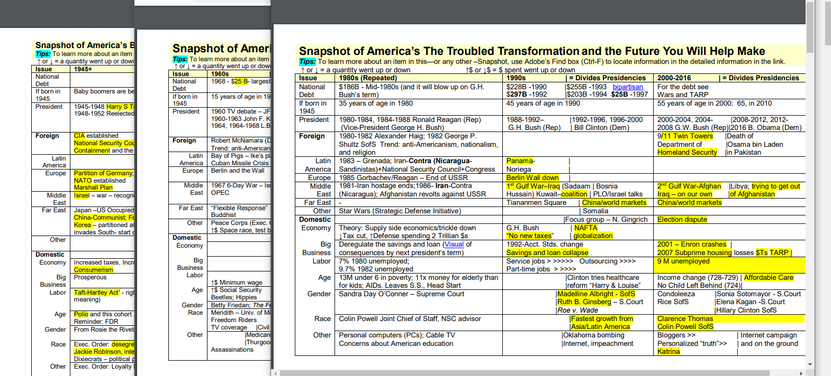
- Covers in columns the presidencies, with the last presidency in the 1st snapshot being repeated in the next Snapshot to make it easier to think about change without having to look back at an earlier snapshot.
Example: Notice above that the 1st column on the third snapshot is labeled as (Repeated) because it is the 3rd column on the 1960s to 1980s.
- Is followed by a detailed chronology (events in time order) of the period so you can look up details if you want.
Example: If you saw CIA in one of the Snapshots, you could press Ctrl-F to display a small area for entry of words and then type CIA.
You could then click to see where CIA was covered in the chronology

In Unit 3, the 1-page Snapshots serve as a study guide when used with this webpage and with types of questions. Click here for the types of questions. the types of questions.
Link Address: http://www.cjbibus.com/1302_Unit_3_Study_Guide_Visual_to_be_Used_with_the_3_1-page_Snapshots.pdf

