A Quick Tour of What Possible Buyers Would See If They Came on This Property?
This also highlights how much maintenance a buyer would fear having to do to keep the flooding out.
From the Street 2
Drainage Pipes Exiting to the Street 2
Maintenance - On the left pipe, carefully clean out the cracked pipe. Also, use a hoe to keep the space between curb and the grass clear for about 6’ where there is a crack in the curb. Why? Because the prior owners did not make the necessary hole in the curb so the slope will let the water go to the street. 2
Pea Gravel Used on the Right Side of the Front Yard Since Water Flow Killed the Grass and It was a Sea of Mud 2
Maintenance – Following a heavy storm, use a hoe to restore the path for the water so it does not spread out as it did in 2015 and is shown on the right... 2
In the Backyard on the Right Side of the House 3
Through the Gate – the 1st of 6 Catch Basins in the Back Yard 3
Maintenance – All catch basins have to be cleaned before storms. 3
Drainage Pipe Beside the Separate Building and Leading to the Sump Pump (with Details about the Pump) 3
Maintenance – both leaves and small size gravel must be kept out of the catch basin for the sump pump 3
In the Backyard on the Right Side of the House (Continued) 4
Visible Damage in the Separate Building 4
Visible Damage from Prior Flooding on the Back of the Separate Building 4
Drainage at Right Corner of the Yard to Direct Water to the Catch Basin by the Separate Building 4
Maintenance– Sweep away grass and leaves to keep water moving beside the fence and toward the catch basin shown. Clean the catch basin. 4
In the Backyard at the Fence Next to the Neighbors Whose Properties Flood the Klauke House 5
Maintenance – Not merely regular yard maintenance, but pulling away leaves that cluster behind the wall to be sure the soaker pipe and the green grates are clear of leaves. 5
Maintenance—The greatest amount of leaves is the section by the neighbor with the water garden. 5
At the Center of the Yard - Patio and the Door to the Porch Room –Key Vulnerabilities of the Property 5
Waterline Showing Prior Flooding on the Wall on the Patio and by the Backdoor to the Porch Room 5
At the Center of the Yard - Patio and the Door to the Porch Room (Continued) 6
Given Costs, Ugly Attempts to Keep Water from the Corner of the Porch Room 6
Drainage to the Sump Pump from the Length and Width of the Patio 6
All of this is using leftover materials or messed up materials. Example: the old pipe used on the left did not have enough holes. We used black-plastic from a prior drainage project to line trenches around the patio. 6
Maintenance - Used leftover black plastic to create a trench around on 2/3s of the patio because the plastic pipe previously there could not cope with the volume of water. It works OK at least for now, but requires maintenance to remove leaves and—each week--grass clippings. The Black grates (the pictures show 1 of 3) have to be cleaned. 6
At the Center of the Yard - Patio and the Door to the Porch Room (Continued) 7
Gutter Downspouts to Take Water from the Roof to the Drainage to the Sump Pump 7
In the Backyard on the Left Side of the House 8
Maintenance –Because of costs, used leftover black plastic, leftover 2x16 cinder blocks and leftover metal edging to help the water flow toward the fence. Not only have to remove grass clippings as with the other black plastic trenches--if the rain is hard--have to sweep the water toward the fence. The end of the slope must be cleaned out regularly so it will flow 8
All Pipes and Drains 8
General Maintenance – In all drains and pipes, regularly use Mosquito Dunks to keep down the mosquitoes. 8
Without the Sump Pump, Flooding Happens and Why a Generator Is Essential 9
Maintenance: The generator has to be observed in its weekly test. 9
Other Problems Than Flooding--and Would Anyone Buy It at the Price FBCAD Says? 10

From the Street

Drainage Pipes Exiting to the Street
On the left, one built by the prior owner; on the right, one built in 2012

Maintenance - On the left pipe, carefully clean out the cracked pipe. Also, use a hoe to keep the space between curb and the grass clear for about 6’ where there is a crack in the curb. Why? Because the prior owners did not make the necessary hole in the curb so the slope will let the water go to the street.
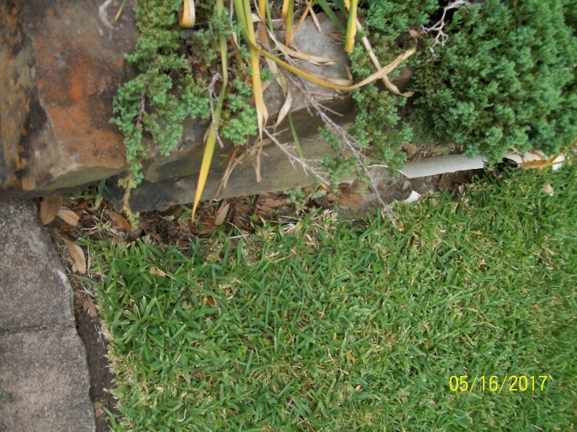 | 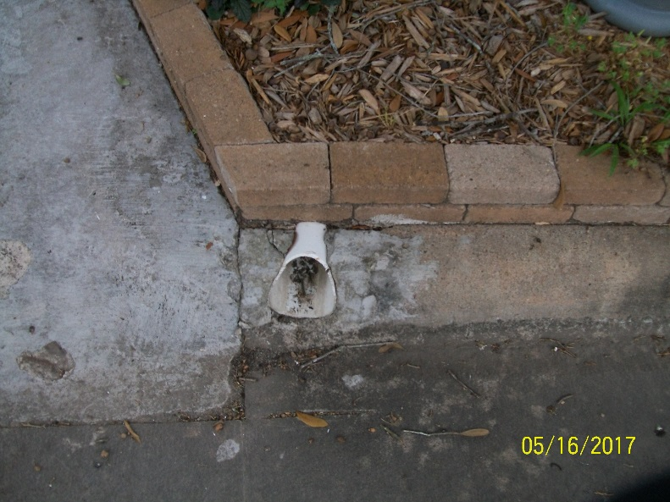

Pea Gravel Used on the Right Side of the Front Yard Since Water Flow Killed the Grass and It was a Sea of Mud
In spite of the drainage pipe along the fence, some of the water comes down and drags gravel into my neighbor’s yard.

Maintenance – Following a heavy storm, use a hoe to restore the path for the water so it does not spread out as it did in 2015 and is shown on the right...
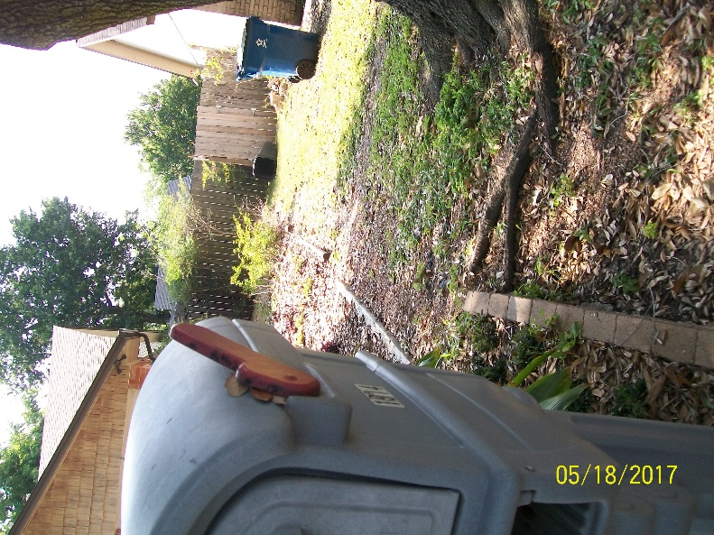 | Example of how bad it has been  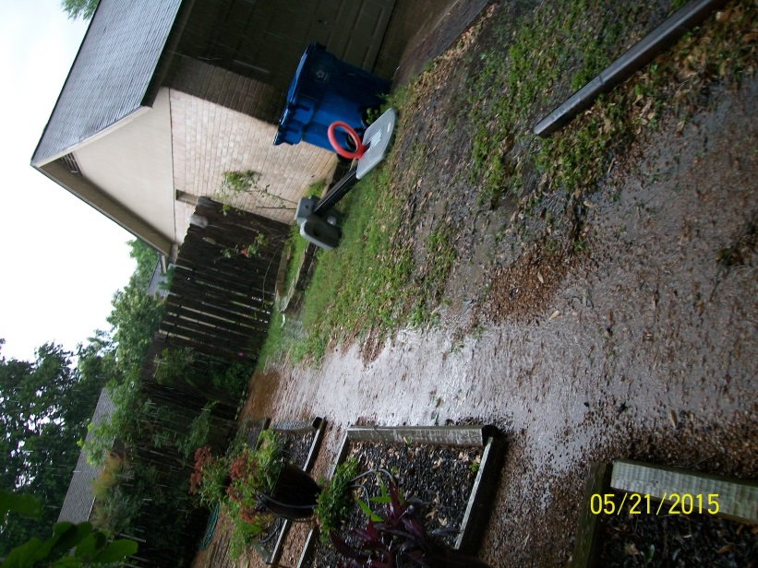

In the Backyard on the Right Side of the House

Through the Gate – the 1st of 6 Catch Basins in the Back Yard
The first view of a catch basin. This one leads to a pipe that goes to the main pipe running beside the fence and to the street. The blue hoses are attached to soaker hoses to try to prevent the foundation problems.
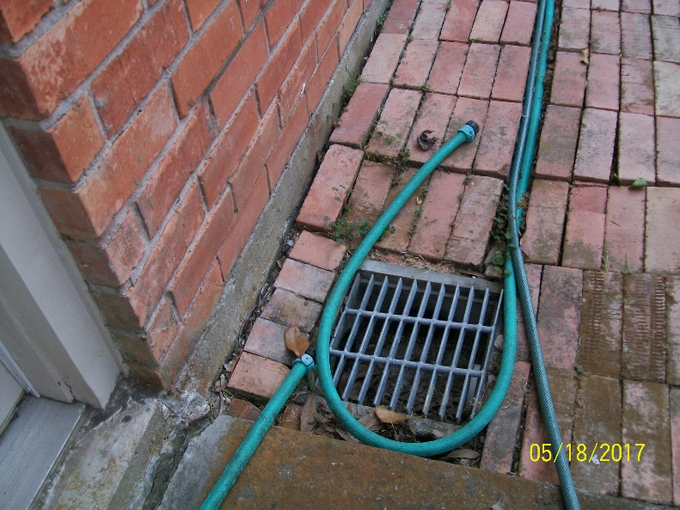

Maintenance – All catch basins have to be cleaned before storms.

Drainage Pipe Beside the Separate Building and Leading to the Sump Pump (with Details about the Pump)
The soaker pipe is under the gravel. The end of the pipe near the intersection of the neighbor’s fence and our fence is a 4 foot Y to try to catch more water. After problems in 2015, this had to be rebuilt with heavier gravel in summer 2016.
The other end is the sump pump shown on the right. It has to be covered with an additional grate. It sends water to a pipe that connects to the street. It sends water from this pipe and from all of the patio area, including the two downspouts carrying water from the roof. It is crucial to get the water away from the house. We have a backup sump with all connectors ready in case this goes out.

Maintenance – both leaves and small size gravel must be kept out of the catch basin for the sump pump
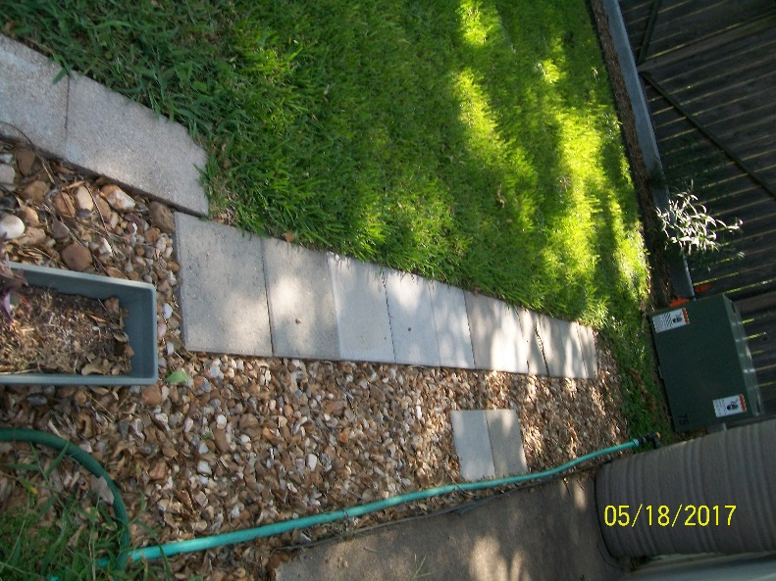 | 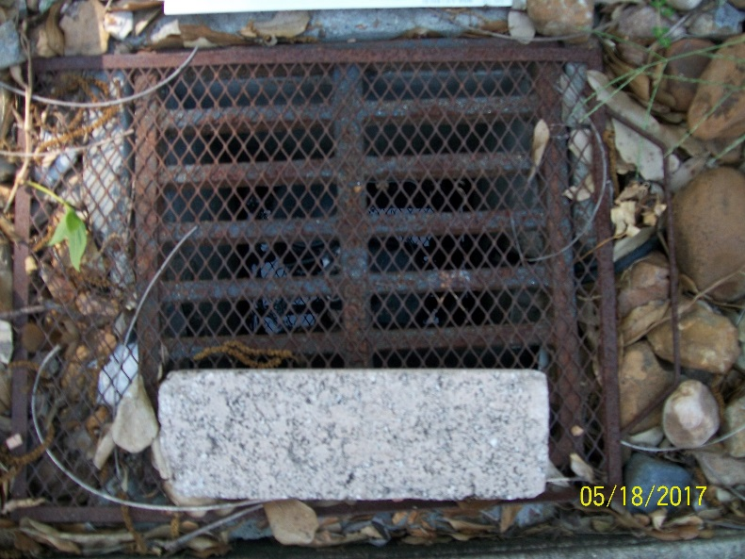

In the Backyard on the Right Side of the House (Continued)

Visible Damage in the Separate Building
The flooding was identified in the initial 2010 inspection report and covered in the 2015 and 2016 appraisal protests. Cinder blocks to hold up the shelving since the wood is rotting. Flooding is better, but not enough to replace the wood.
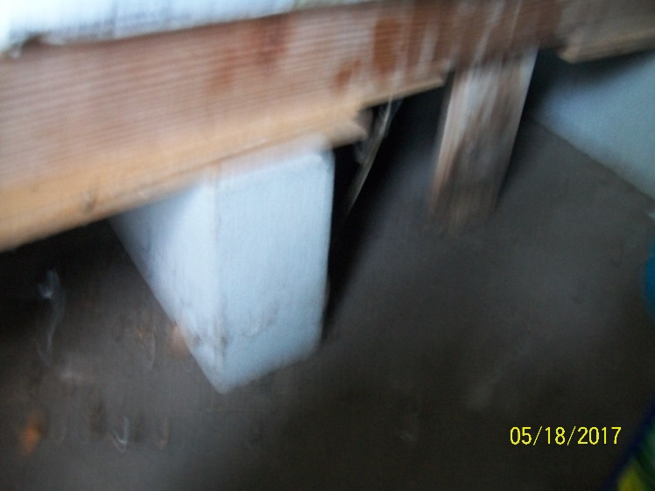 | Note: there are 3 parts of this building. This part has flooded regularly probably because it is near the intersection of the Klauke fence and the fence drainage for the neighbor  The center room—the air-conditioned room advertised as the prior owner’s home office—had flooded also. That was included in the Brookside Inspection Service report.  The inspector told us to build a frame of 2X4s to keep the boxes we planned to store out of the water.  The third storage area as only flooded once, but it has flooded.

Visible Damage from Prior Flooding on the Back of the Separate Building
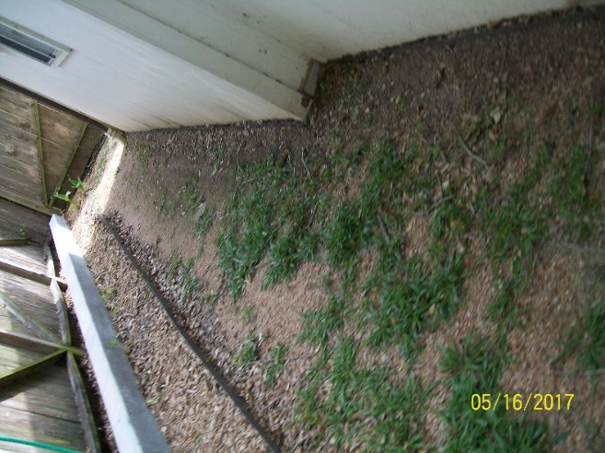

Drainage at Right Corner of the Yard to Direct Water to the Catch Basin by the Separate Building
The family who lives to the right has been flooded by the water from this neighbor’s yard, but not as much as our house.

Maintenance– Sweep away grass and leaves to keep water moving beside the fence and toward the catch basin shown. Clean the catch basin.
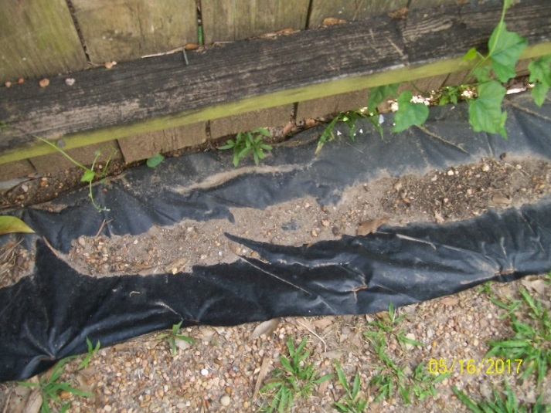 | 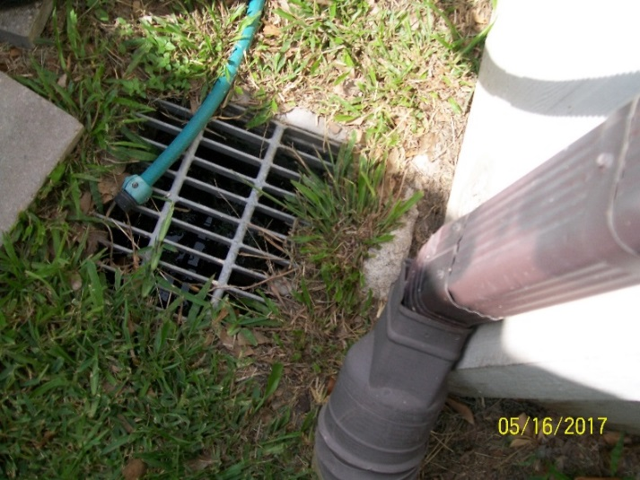

In the Backyard at the Fence Next to the Neighbors Whose Properties Flood the Klauke House
Pictures showing how these properties flood the Klauke house are in both the May 2015 and June 2016 protests.
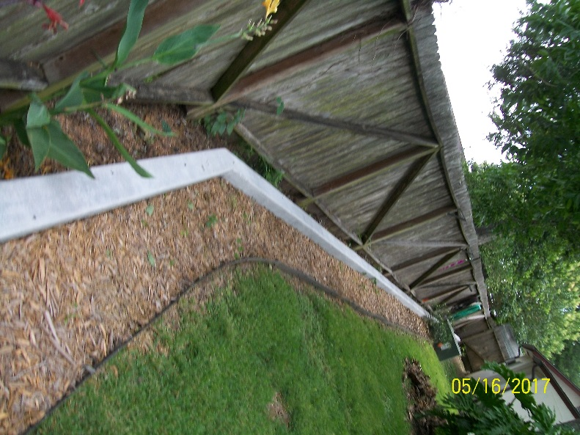 | 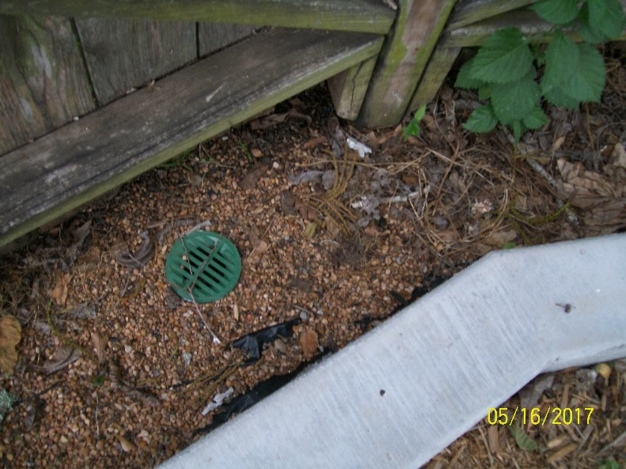
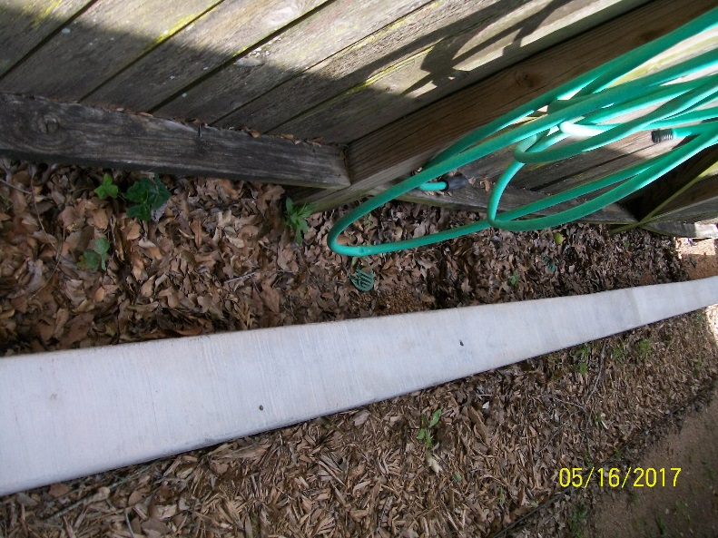 | Maintenance – Not merely regular yard maintenance, but pulling away leaves that cluster behind the wall to be sure the soaker pipe and the green grates are clear of leaves.  <  Maintenance—The greatest amount of leaves is the section by the neighbor with the water garden.

At the Center of the Yard - Patio and the Door to the Porch Room –Key Vulnerabilities of the Property

Waterline Showing Prior Flooding on the Wall on the Patio and by the Backdoor to the Porch Room
As the pictures in the June 2016 protest shows, water flows toward the back door and this wall. I have places old sheets and towels down to keep back the water. There is more to do here to stop this mess, but after the decision by the appraiser in June 2016, the issue was the greatest threats and not pretty.
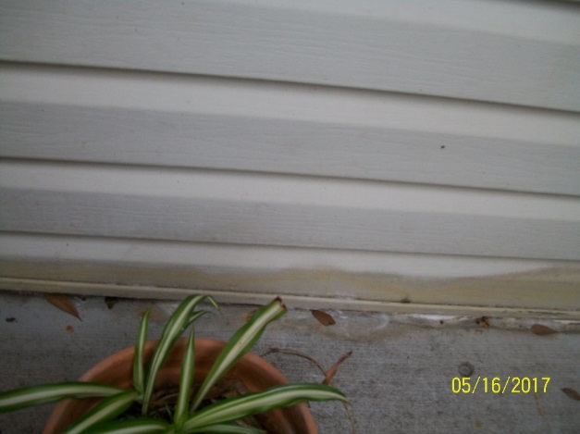 | 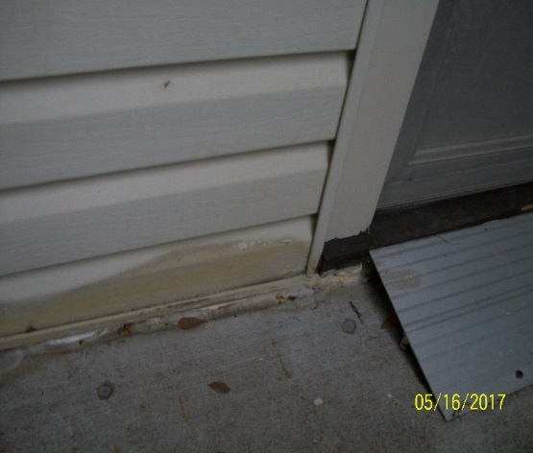

At the Center of the Yard - Patio and the Door to the Porch Room (Continued)

Given Costs, Ugly Attempts to Keep Water from the Corner of the Porch Room
The water has come so heavily and so long (before we bought the house) that there are worn-down sections where—in desperation—we used these products because they were cheap.
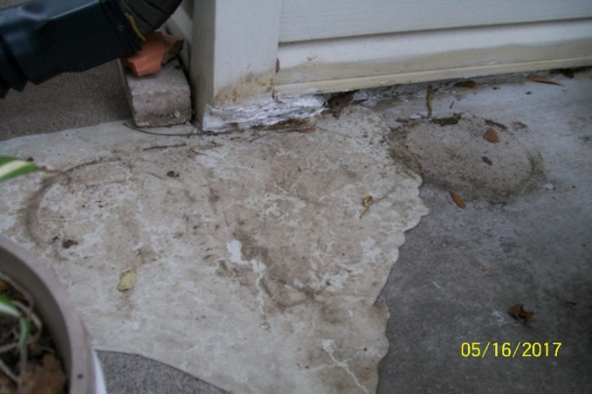 | <White filler chalk to keep the water from entering the corner.  < Self-leveling chalk where regular flow of water has worn down an area used to keep water away from the corner. The water now pools following the edges of this blob of chalk—but it is not in the house.

Drainage to the Sump Pump from the Length and Width of the Patio

All of this is using leftover materials or messed up materials. Example: the old pipe used on the left did not have enough holes. We used black-plastic from a prior drainage project to line trenches around the patio.
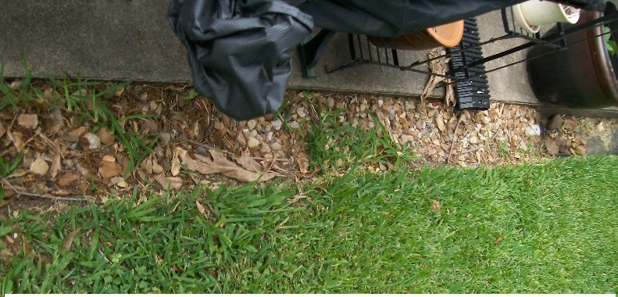 | 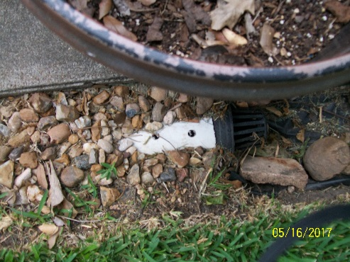
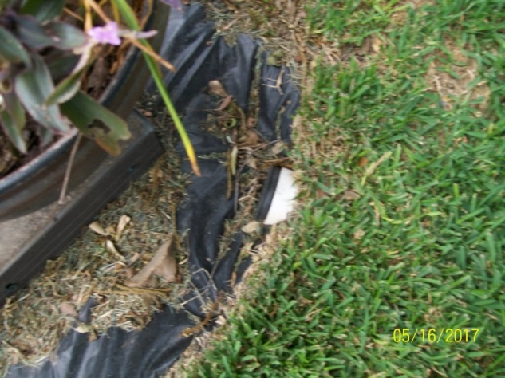 | 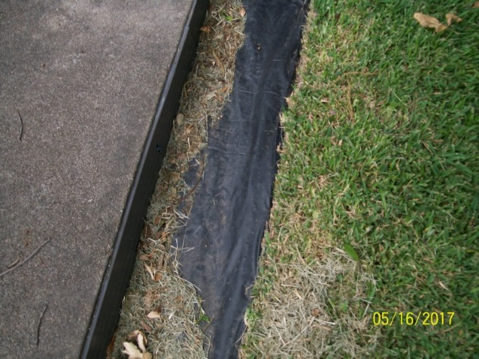

Maintenance - Used leftover black plastic to create a trench around on 2/3s of the patio because the plastic pipe previously there could not cope with the volume of water. It works OK at least for now, but requires maintenance to remove leaves and—each week--grass clippings. The Black grates (the pictures show 1 of 3) have to be cleaned.

At the Center of the Yard - Patio and the Door to the Porch Room (Continued)

Gutter Downspouts to Take Water from the Roof to the Drainage to the Sump Pump
The water flow had hurt the fireplace and part of the bricks had to be replaced now to avoid further damage.
Maintenance – The downspout on the right had to be kept in place with bricks to flow to the black-plastic covered trench because it seems to move when there is a lot of water.
Downspout to the right of the wall with the back door | Downspout to the right of the brick fireplace
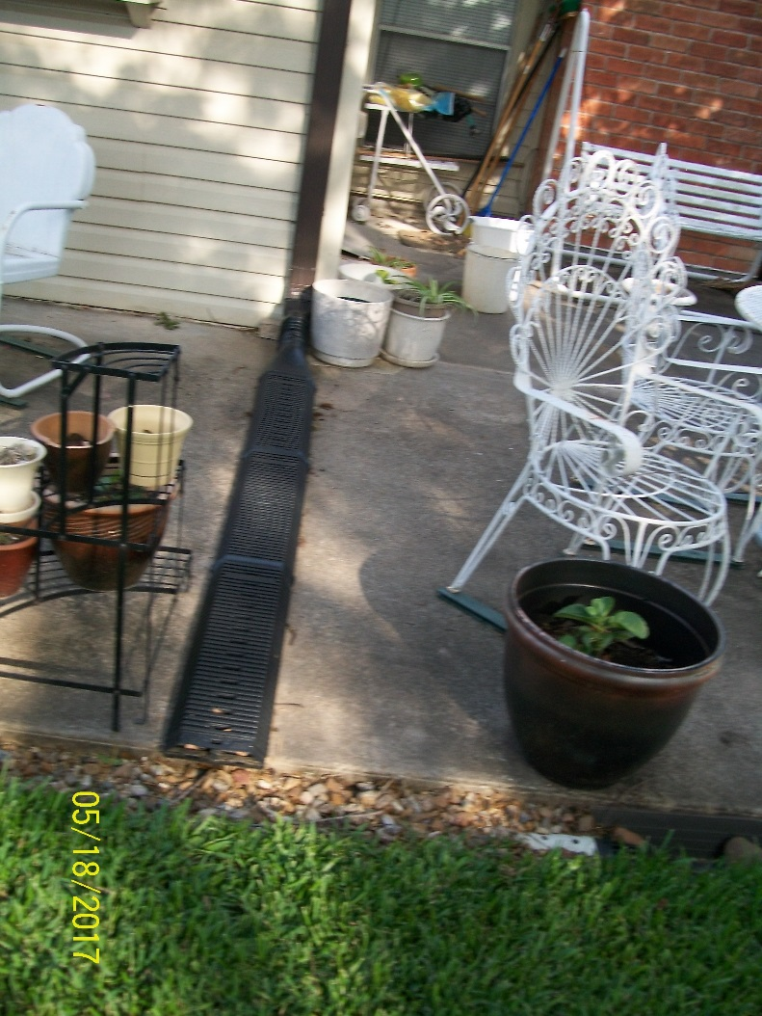 | 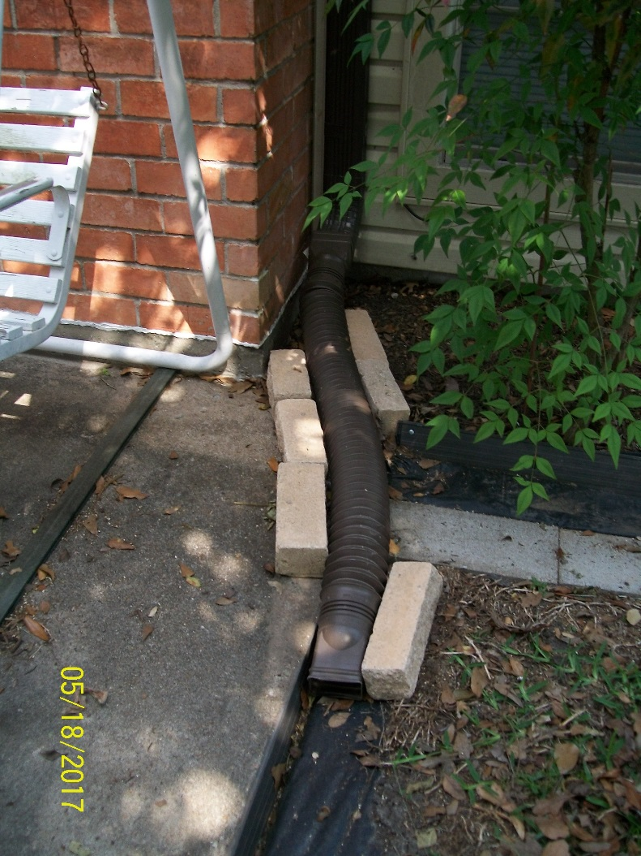

In the Backyard on the Left Side of the House
This is difficult because the land is on a very slight slope since the house is lower than the land and must flow to the lower area of the fence line. Water only flows to the target you want if it is lower than the source.
This trench is 28” from the wall of the living room and a bedroom. As the picture from the 2016 protest shows, the water has been close: I dug shallow trenches with a hoe to try to get the water to flow away from the house.
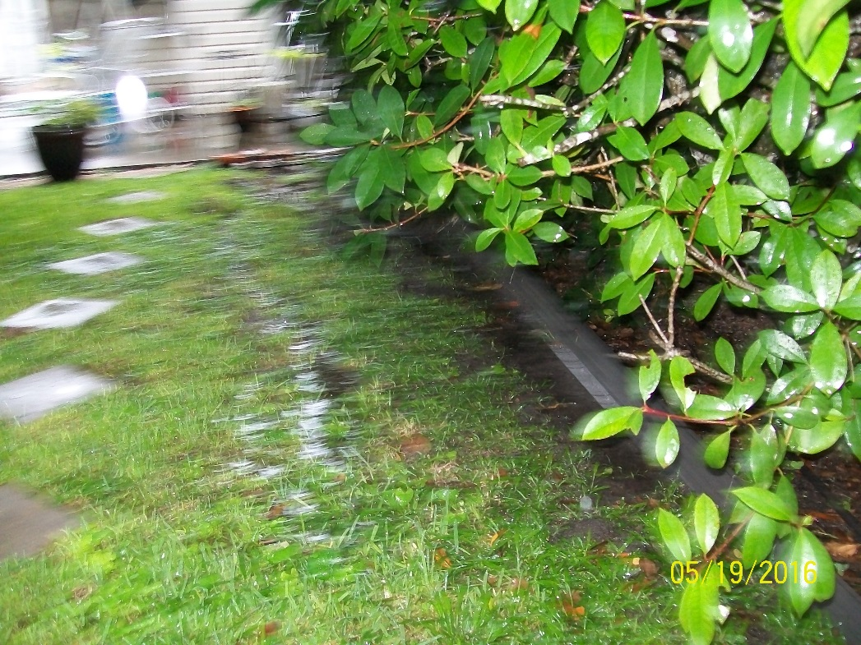

Maintenance –Because of costs, used leftover black plastic, leftover 2x16 cinder blocks and leftover metal edging to help the water flow toward the fence. Not only have to remove grass clippings as with the other black plastic trenches--if the rain is hard--have to sweep the water toward the fence. The end of the slope must be cleaned out regularly so it will flow
Beginning of the slope at downspout on the prior page. | Ending of the slope near the fence line.
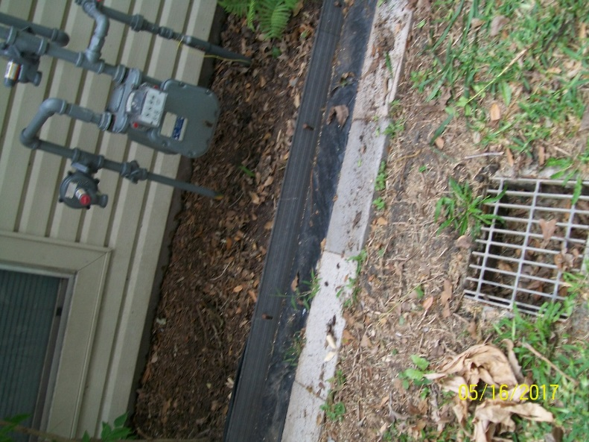 | 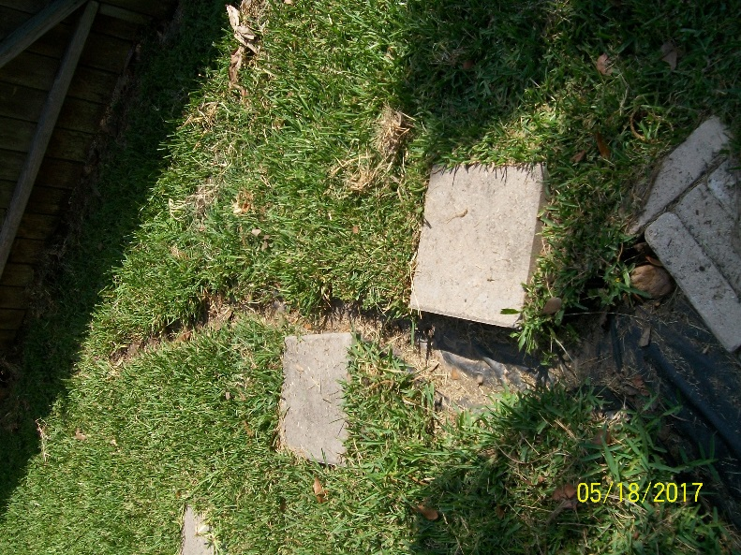

All Pipes and Drains

General Maintenance – In all drains and pipes, regularly use Mosquito Dunks to keep down the mosquitoes.

Without the Sump Pump, Flooding Happens and Why a Generator Is Essential
1/20/2017, the sump pump was overwhelmed and shut down. This shows what starts to happen without the pump.
Black trenches are full but not moving. | Water overflows pipes and trenches and onto the patio.
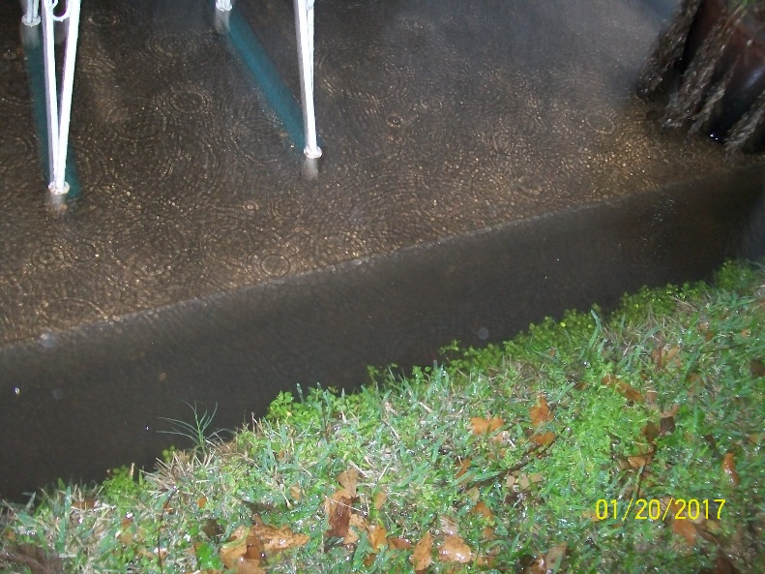 | 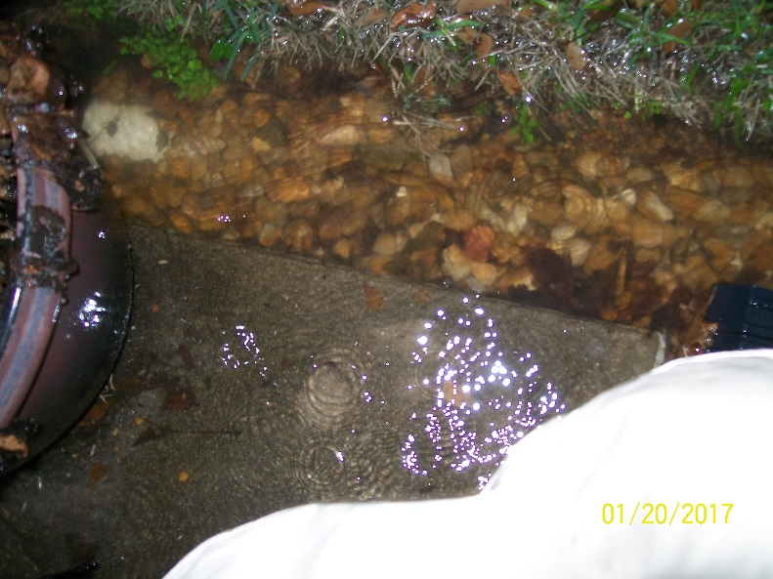

Leaves show where the water flowed on the patio.
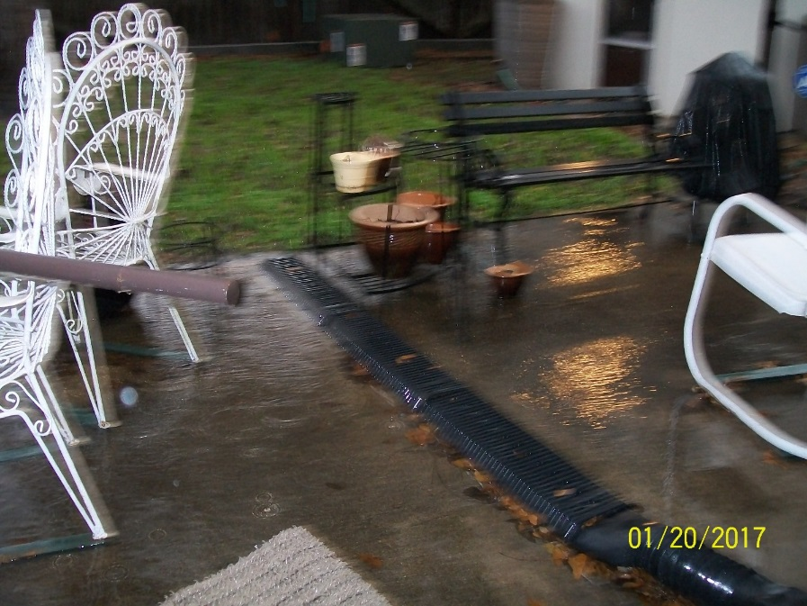 | 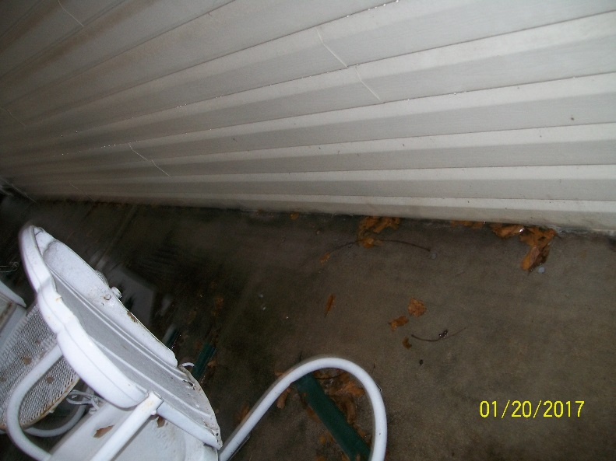

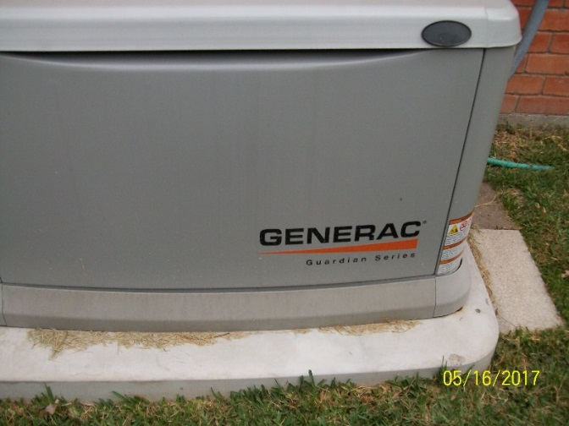 | If there is no electricity, there is no sump pump and water will rise until it is in the house.  Maintenance: The generator has to be observed in its weekly test.  Note: the only way I could purchase this was on credit. It has to be essential for me to have taken that risk.

Other Problems Than Flooding--and Would Anyone Buy It at the Price FBCAD Says?
This house has other problems such as lead pipes that are corroding. The first one leaked and had to be replaced this May.
The list of needed major repairs was in the estimates at the June 2016 protest.
This is not a house a person would buy if they knew the realities—and a person certainly would not buy for the value stated by FBCAD.

