A Quick Tour of What Possible Buyers Would See If They Came on This Property?
The moment they look, possible buyers can see that this house is dealing with ongoing flooding. They can see ugly solutions for flooding built from left-over materials that require constant maintenance. Why? If a cheap (but ugly) fix was available, we did it because all money had to go to essential purchases to prevent the flooding. As background, the tour also includes some time-stamped pictures provided to the 2015 and 2016 Appraisers.
.
From the Street – What the Possible Buyer Sees First 3
Drainage Pipes Exiting to the Street 3
Maintenance Requirements 3
Pea Gravel Used on the Right Side of the Front Yard Why? Water Flow Killed the Grass and It was a Sea of Mud 3
Maintenance Requirement and a in the 2015 Appraisal Protest Documents 3
Through the Gate – Catch Basins, Pipes, and a Sump Pump 4
Through the Gate – the 1st of 6 Catch Basins in the Back Yard 4
Maintenance Requirement for All 6 Catch Basins and Accessible Pipes 4
Drainage Pipes and Trenches and the Necessity of the Sump Pump 4
Maintenance Requirement and Essential Purchase of a Backup Sump Pump 4
The Biggest Thing in the Backyard—The Wall Between the House and Neighbors’ Properties That Flood 5
Background Shown by Time-Stamped Pictures Provided to 2015 and 2016 FBCAD Appraiser 5
Essential Purchase for Something the Homeowners Could Not Build 5
Maintenance Requirement 6
In the Backyard on the RIGHT Side of the House – What Damaged the 7
The Problem to Fix the Flooding of What FBCAD Calls the “Residential Storage” 7
The Cheap Fix 7
Visible Damage in the “Residential Storage” 7
Reality 8
Visible Damage from Prior Flooding on the Back of the “Residential Storage” 8
Drainage at Right Corner of the Yard to Direct Water to the Catch Basin by What FBCAD Calls the “Residential Storage” 8
Maintenance Requirement 8
At the Center of the Yard – Water on the Patio and Coming Into the Den 9
Waterline Showing Prior Flooding on the Wall on the Patio and by the Backdoor to the den 9
Given Costs, Ugly Attempts to Keep Water from the Corner of the Den 9
Reality 9
Drainage to the Sump Pump from the Length and Width of the Patio 10
Reality 10
Maintenance Requirements 10
At the Center of the Yard - Patio and the Door to the Den (Continued) 11
Gutter Downspouts to Take Water from the Roof to the Drainage to the Sump Pump 11
Reality and Maintenance Requirement of the Downspout Extenders 11
In the Backyard on the LEFT Side of the House 12
Reality 12
Maintenance Requirements 12
Without the Sump Pump, Flooding Happens and Why a Generator Is Essential 13
Maintenance Requirement: The generator has to be observed in its weekly test. 13
Other Problems Than Flooding--and Would Anyone Buy It at the Price FBCAD Says? 14
Meaning of the Labels Maintenance and Reality 14

From the Street – What the Possible Buyer Sees First

Drainage Pipes Exiting to the Street
On the left, one built by the prior owner. On the right, one built in 2012

Maintenance Requirements
On the left pipe, carefully clean out the cracked pipe; use a hoe to keep the space between curb and the grass clear for about 5’ where there is a crack in the curb that lets the water reach the street.
Each year, these pipes to the street have to be blown out with water hose at the catch basins in the backyard.
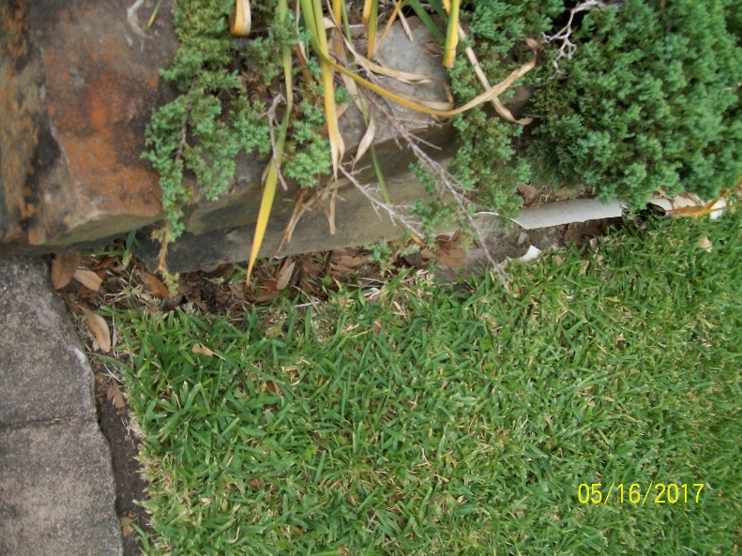 | 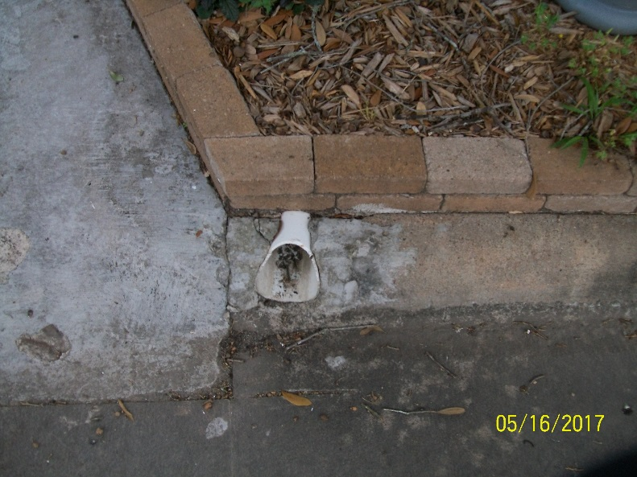

Pea Gravel Used on the Right Side of the Front Yard Why? Water Flow Killed the Grass and It was a Sea of Mud
In spite of the drainage pipe below ground to the street, some water still comes above ground and drags gravel into the neighbor’s yard.

Maintenance Requirement and a in the 2015 Appraisal Protest Documents
Following a heavy storm, use a hoe to restore the path in the pea gravel for the water and restore my neighbor’s yard.
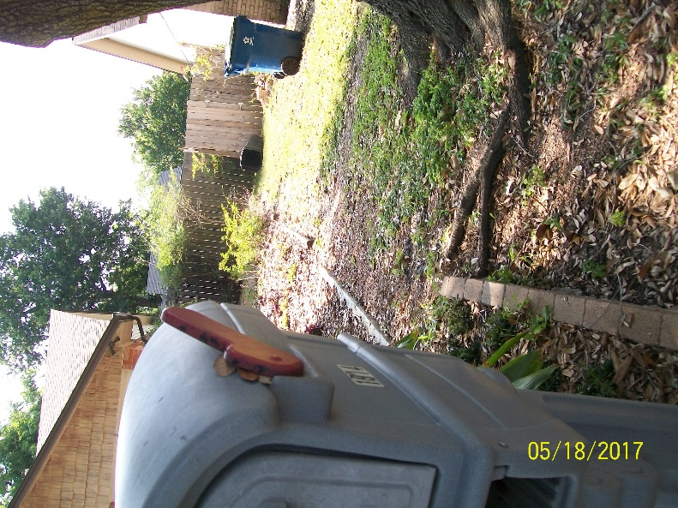 | Example from 2015 of flow above ground.  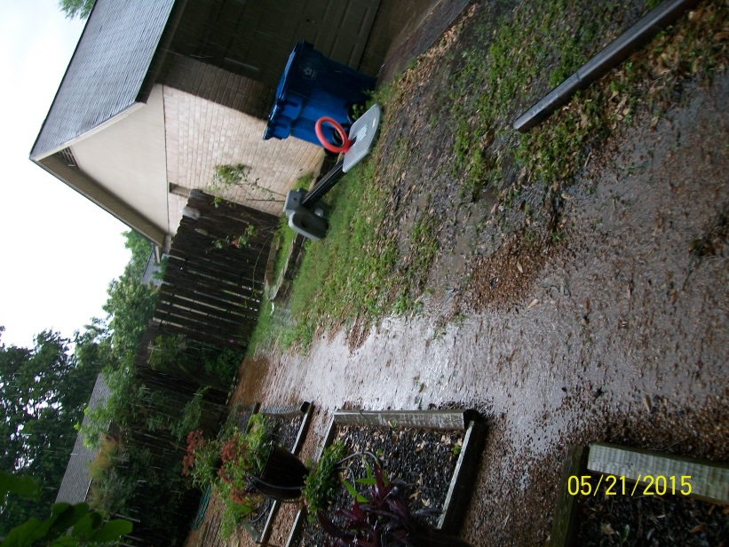

Through the Gate – Catch Basins, Pipes, and a Sump Pump

Through the Gate – the 1st of 6 Catch Basins in the Back Yard
Their first view is a catch basin. This one leads to a pipe that goes to the main pipe running beside the fence and to the street. The blue hoses are attached to soaker hoses to try to prevent the foundation problems in dry weather.

Maintenance Requirement for All 6 Catch Basins and Accessible Pipes
- All catch basins have to be cleaned before storms.
- In all catch basins and pipes, regularly use Mosquito Dunks to keep down the mosquitoes.
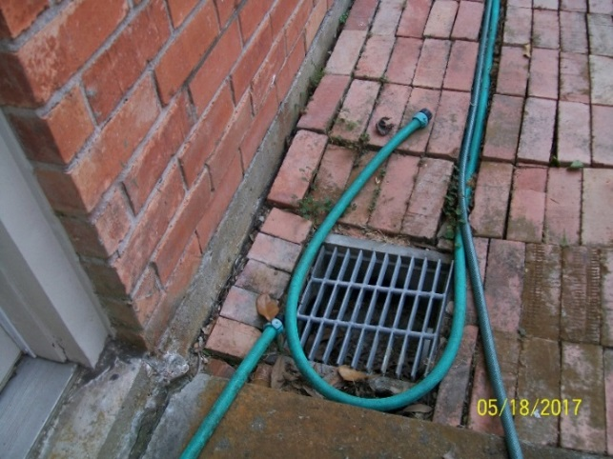

Drainage Pipes and Trenches and the Necessity of the Sump Pump
Slope will not take care of the amount of water coming in the yard. There has to be a sump pump—a pump for forcing water away a structure that will be damaged by water.
Drainage pipes and trenches carry water to the sump pump and the pump sends water to a pipe that connects to the street. Without this sump pump (as the Appraisal protest for 2015 and 2016 show with time-stamped pictures), water would:
- From the water coming from the left side of the yard, cover the patio and enter the room beside it
- From the water coming from the right side of the yard, enter the building that FBCAD calls “Residential Storage” and also add to the water on the patio

Maintenance Requirement and Essential Purchase of a Backup Sump Pump
Leaves and small size gravel must be kept out of the catch basin for the sump pump to work, thus the additional grate and regular checking to be sure it is clear.
If this pump goes out, we flood; therefore, we have a backup sump with all connectors ready.
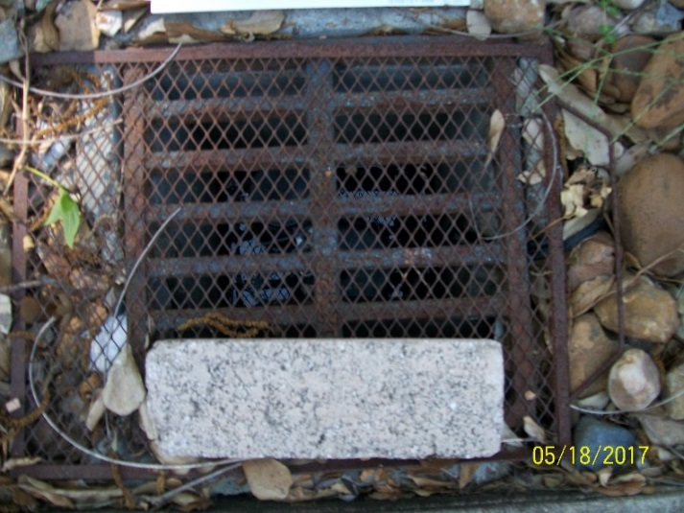

The Biggest Thing in the Backyard—The Wall Between the House and Neighbors’ Properties That Flood

Background Shown by Time-Stamped Pictures Provided to 2015 and 2016 FBCAD Appraiser
In both of these pictures, the water is flowing into what FBCAD in its online documents calls “Residential Storage.” It has been badly damaged by the flooding and is covered next.
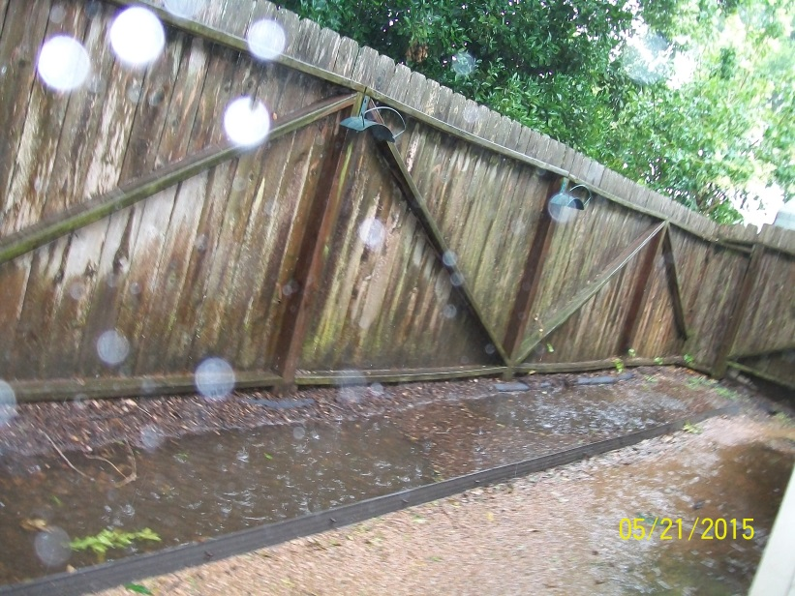 | 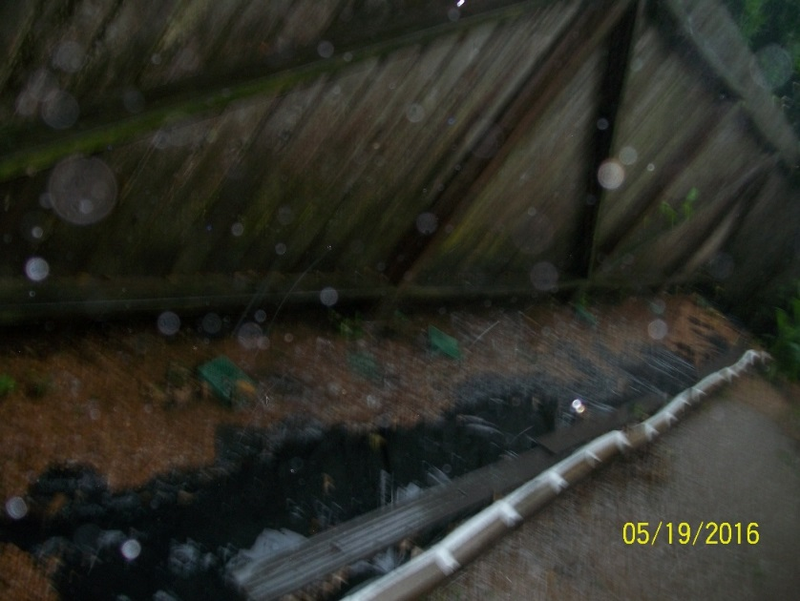

Essential Purchase for Something the Homeowners Could Not Build
The retaining wall was not in the proposed repairs and estimates in the 2016 documents to FBCAD’s appraiser—documents he would not look at. The prior estimates I had heard for a retaining wall were over $4000. A worker I interviewed to dig some drainage trenches made a bid of $1765. It has helped greatly; however, ugly and a future homebuyer may not want a property that has a big wall.

Maintenance Requirement
Not merely regular yard maintenance, but pulling away leaves that cluster behind the wall to be sure the soaker pipe and the green grates are clear of leaves. The greatest amount of leaves—as well as the greatest amount of water--is in the section by the neighbor with the water garden.
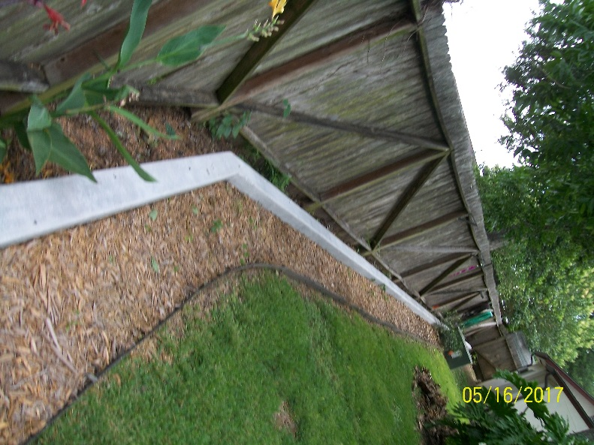 | 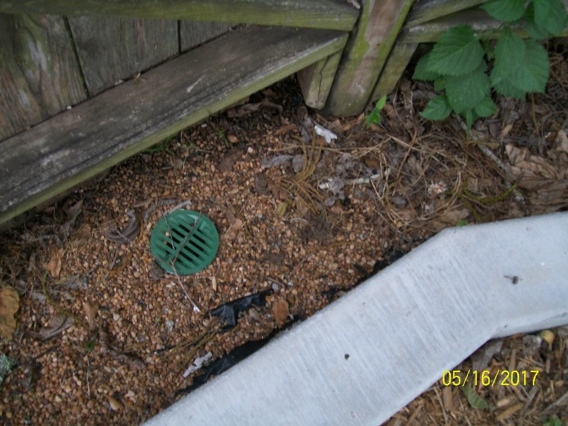

In the Backyard in What FBCAD Calls Online “Residential Storage”

Visible Damage in the “Residential Storage”
The flooding was identified in the initial 2010 inspection report and covered in the 2015 and 2016 appraisal protests. Cinder blocks hold up the shelving since the wood is rotting. The flooding is better, but not enough to replace the wood.
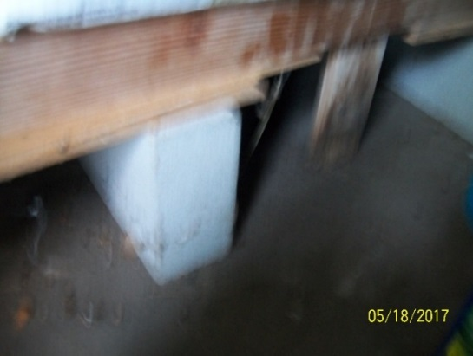 | Status of the 3 parts of this building:  - This part has flooded regularly probably because it is near the intersection of the Klauke fence and the fence drainage for the neighbor. That was included in the Brookside Inspection Service report.  - The center room was also included in that report. The inspector told us to build a frame of 2X4s to keep the boxes we planned to store out of the water.  - The third storage area as only flooded once, but it has flooded.

Visible Damage from Prior Flooding on the Back of the “Residential Storage”
The exterior of the storage area was also included in the Brookside Inspection Service. The owners used the Hardy board incorrectly and placed it flush against the ground. The damage on the left is the result of many years of trying to stop this flooding. In the last few days, the crack on the right became visible with another in its beginning stages. I will chalk it securely. As with the comment above, the flooding is better, but not enough to try to fix this yet.
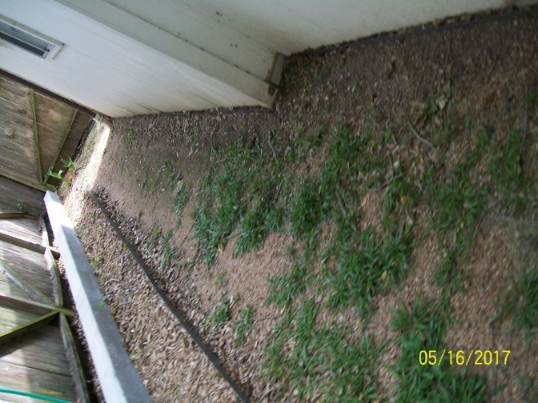 | 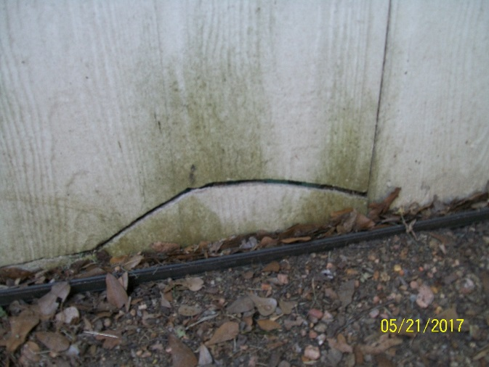

Drainage at Right Corner of the Yard to Direct Water to the Catch Basin at the Corner of the Building

Maintenance Requirement
In addition to cleaning the catch basin, sweep away grass and leaves to keep water moving beside the fence and toward the catch basin shown. If the water starts to pool, sweep it away from the building toward the basin.
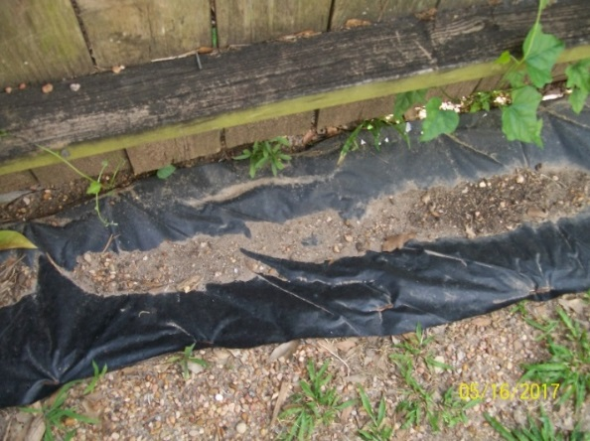 | 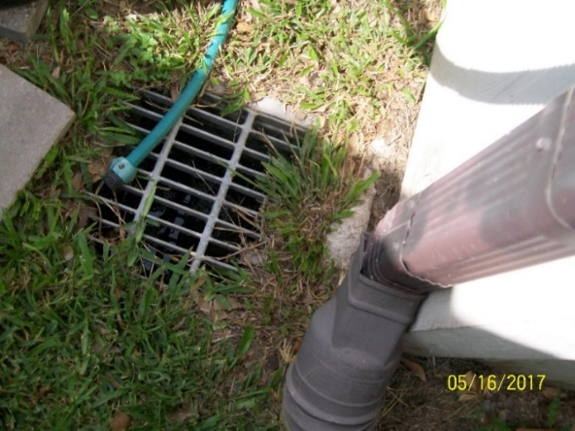

At the Center of the Yard – Water on the Patio and Coming Into the Den

Background Shown by Time-Stamped Pictures Provided to 2015 and 2016 FBCAD Appraiser
In both of these pictures, the water is flowing into what FBCAD in its online documents calls “Residential Storage.” It has been badly damaged by the flooding and is covered next.

Waterline Showing Prior Flooding on the Wall on the Patio and by the Backdoor to the den
As the pictures in the June 2016 protest shows, water flows toward the back door and this wall. I have placed old sheets and towels down to keep back the water.
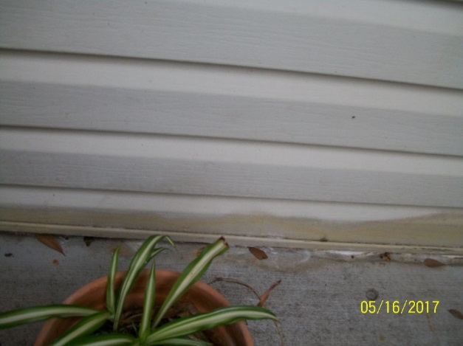 | 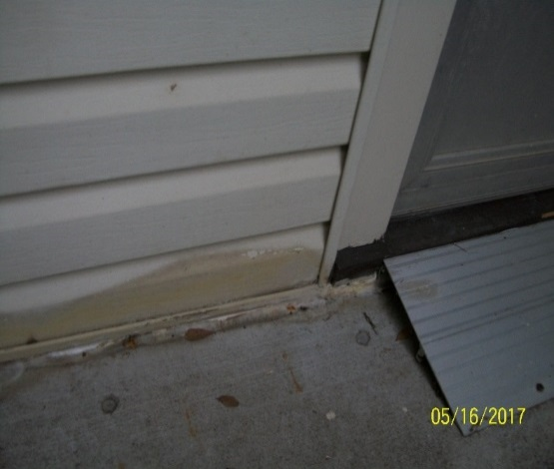

Given Costs, Ugly Attempts to Keep Water from the Corner of the Den
The water has come so heavily and so long (before we bought the house) that there are many worn-down sections where water pools that still need to be done. This one was a worst spot because water was pooling at the corner.
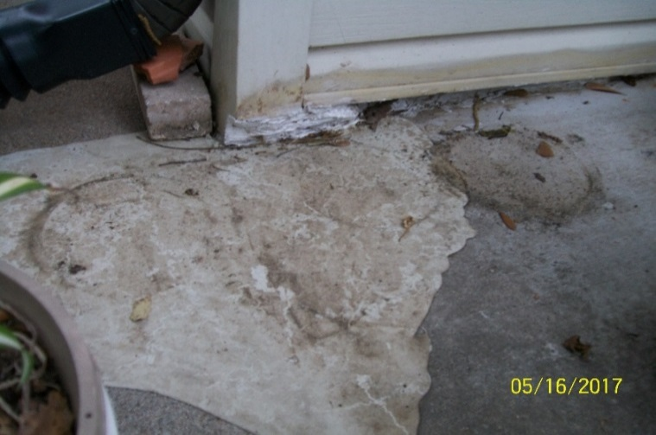 | Reality  In desperation with the immediate need to fill this area, we used these products because they were cheap.  <White filler chalk to keep the water from entering the corner.  < Self-leveling chalk where regular flow of water had worn down an area used to keep water away from the corner. The water now pools following the edges of this blob of chalk—ugly, but it is not in the house.

Drainage to the Sump Pump from the Length and Width of the Patio

Reality
All of the drainage is using leftover materials or messed up materials. Example: The old pipe used on the left did not have enough holes so we drilled more holes. For 2/3rds of the drainage around the patio, we used black-plastic from a prior drainage project to line trenches around the patio.
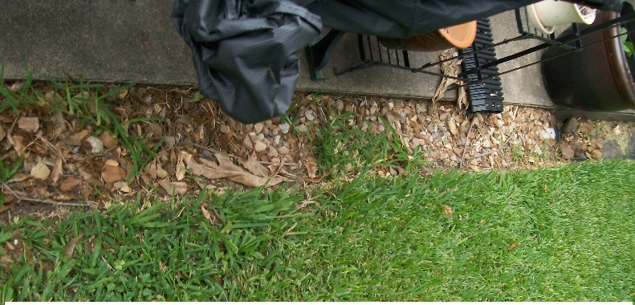 | 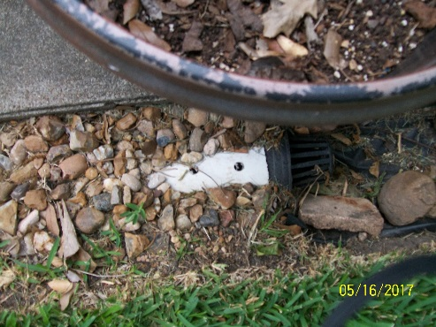
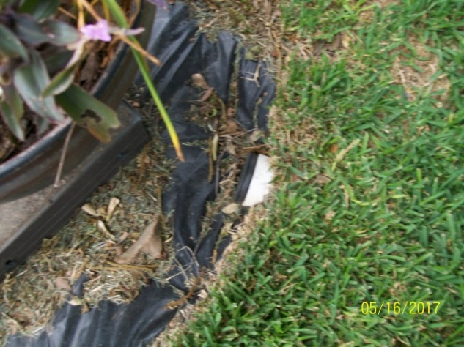 | 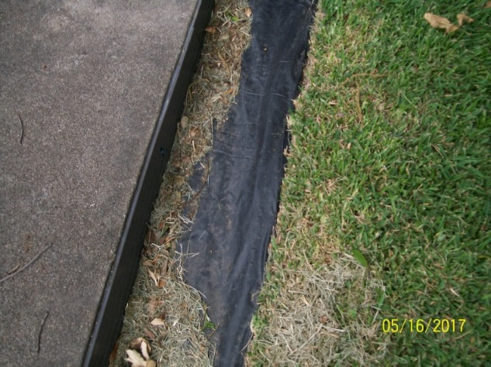

Maintenance Requirements
The black plastic works OK at least for now, but requires maintenance to remove leaves and—each week--grass clippings. The black grates (the pictures show 1 of 3) have to be cleaned.

At the Center of the Yard - Patio and the Door to the Den (Continued)

Gutter Downspouts to Take Water from the Roof to the Drainage to the Sump Pump

Reality and Maintenance Requirement of the Downspout Extenders
The downspout extender on the right does reach the black plastic covered trench, but it seems to move when there is a lot of rain. We used beige blocks a neighbor had thrown away to keep the extender in place. Mowers tend to move the bricks so their position has to be checked every mowing day.
Downspout to the right of the wall with the back door | Downspout to the right of the brick fireplace
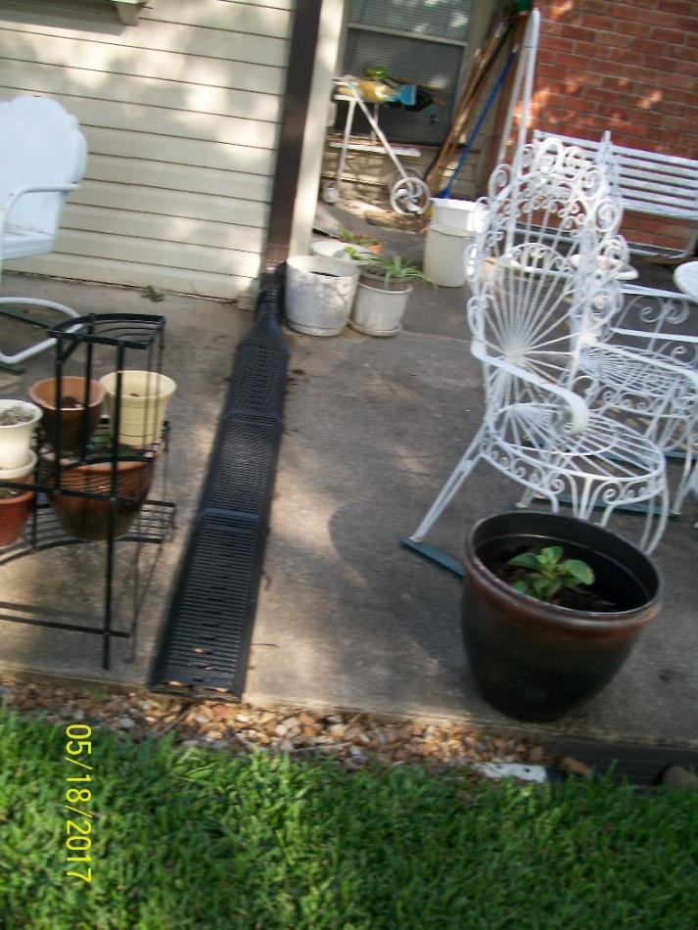 | 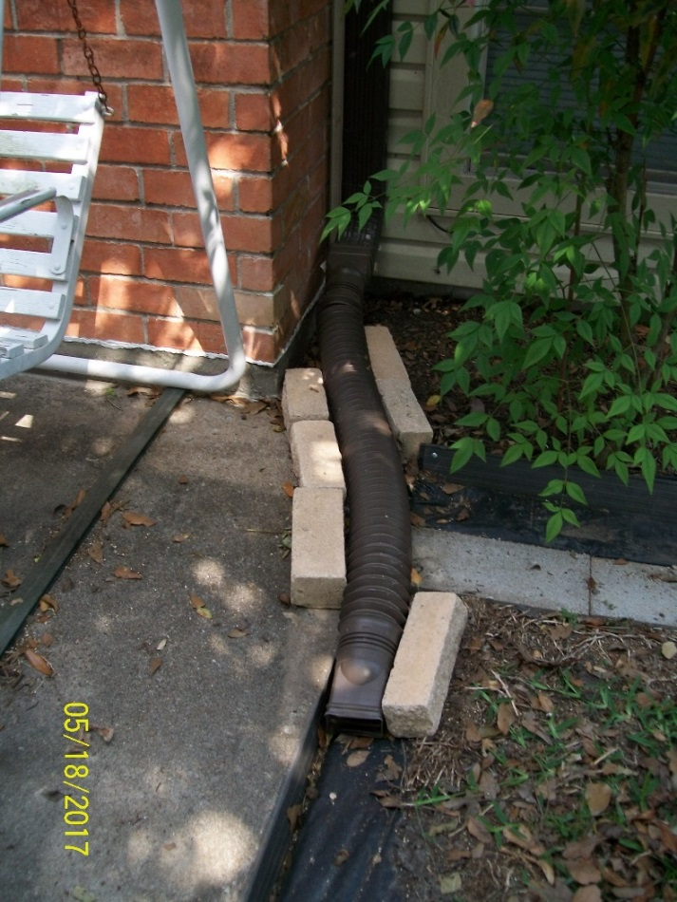

In the Backyard on the LEFT Side of the House
This is difficult because the land is on a very slight slope since the house is lower than the land and must flow to the lower area of the fence line. Water only flows to the target you want if it is lower than the source.
This trench is 28” from the wall of the living room and a bedroom. As the picture from the 2016 protest shows, the water has been close: I dug shallow trenches with a hoe to try to get the water to flow away from the house.
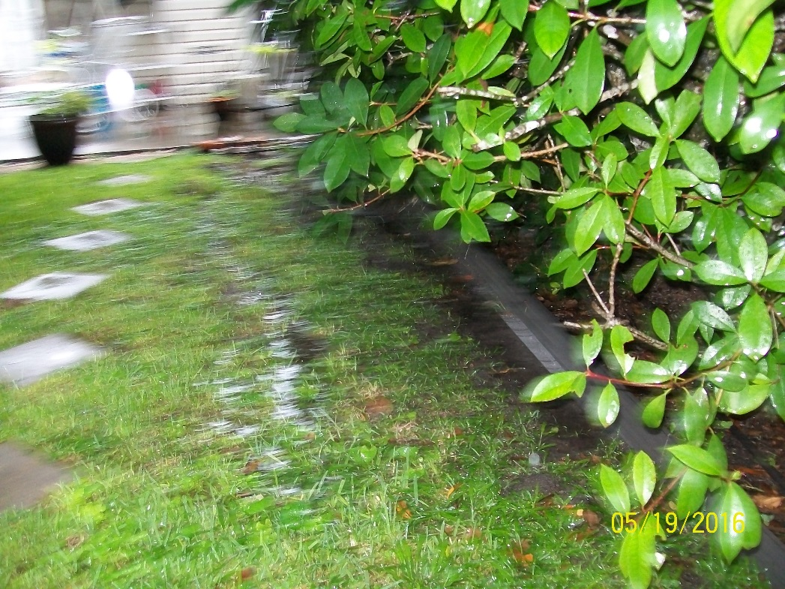

Reality
Because of costs, used leftover black plastic, leftover 2x16 cinder blocks and leftover metal edging to help the water flow toward the fence. Used beige blocks that a neighbor had thrown away to block the end of the slope (in the picture on the right) and create a turn where the water could flow along a longer slope to the fence line.

Maintenance Requirements
Not only have to remove grass clippings as with the other black plastic trenches, but also--if the rain is hard--have to sweep the water toward the fence. The end of the slope must be cleaned out regularly so it will flow.
Beginning of the slope at downspout on the prior page. | Ending of the slope near the fence line.
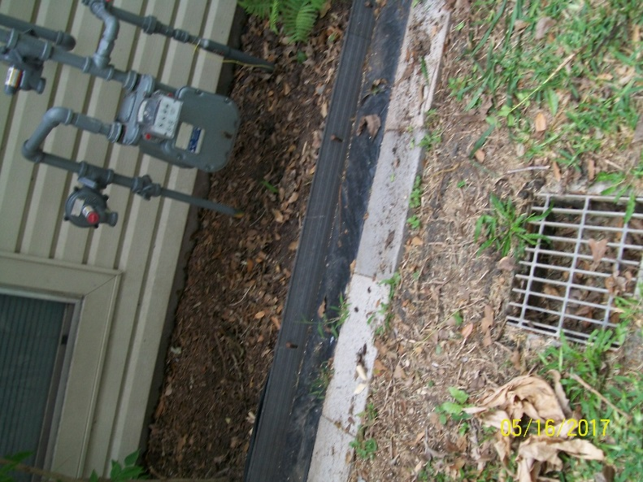 | 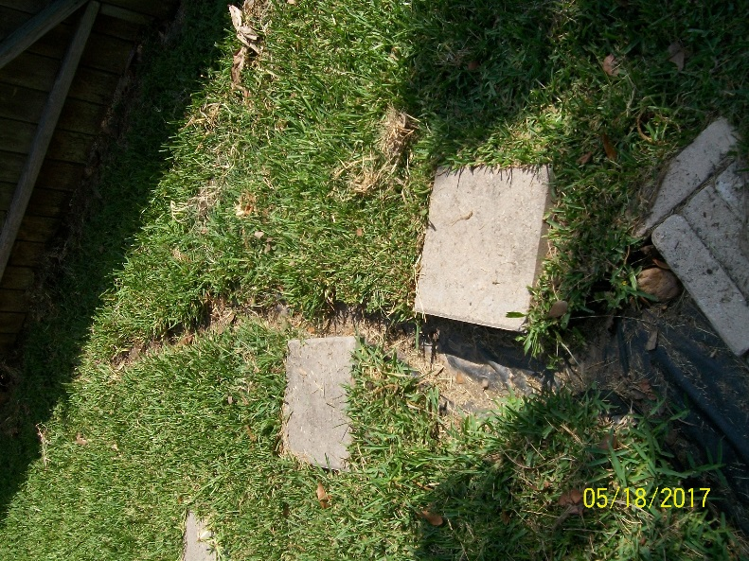

Without the Sump Pump, Flooding Happens and Why a Generator Is Essential
1/20/2017, the sump pump was overwhelmed and shut down. This shows what starts to happen without the pump.
Black trenches are full but not moving. | Water overflows pipes and trenches and onto the patio.
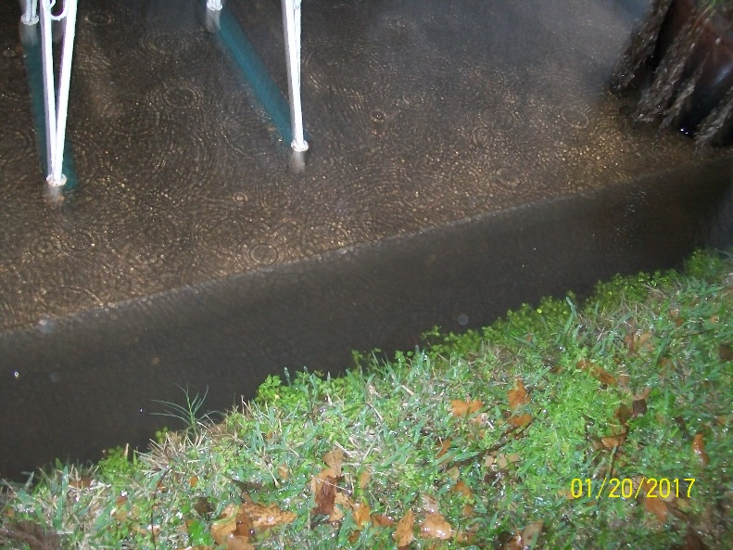 | 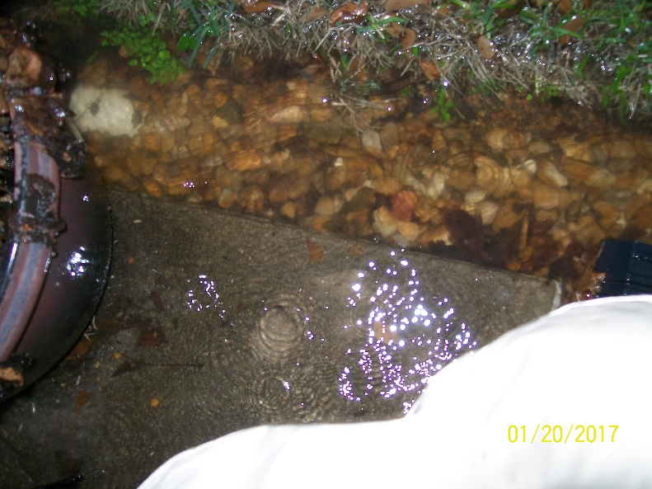

Leaves show where the water flowed on the patio.
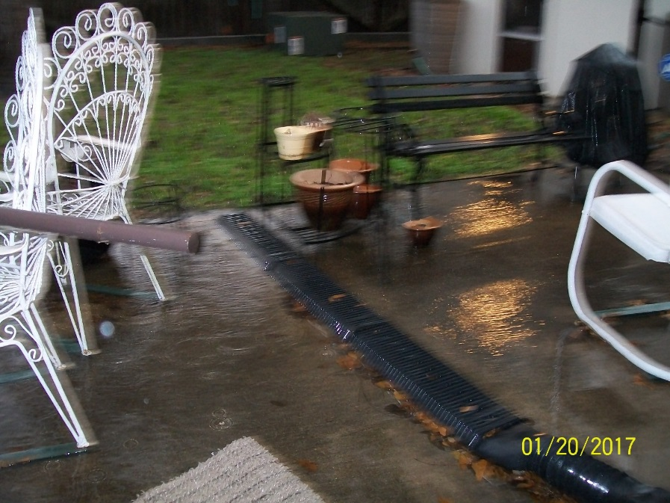 | 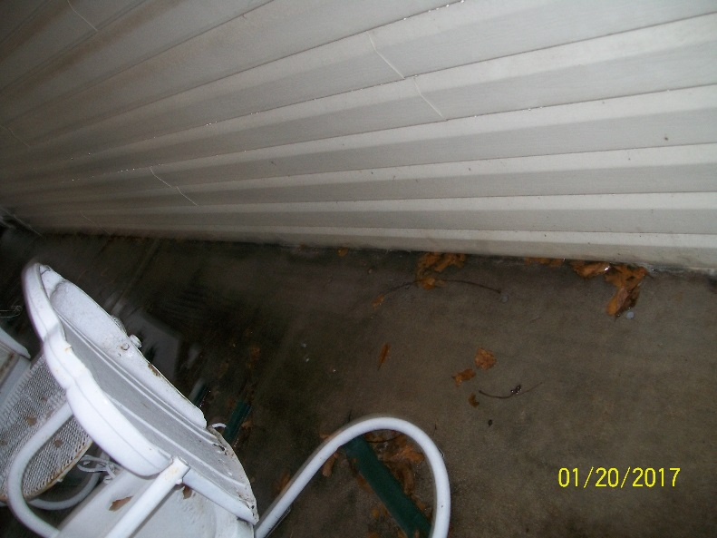

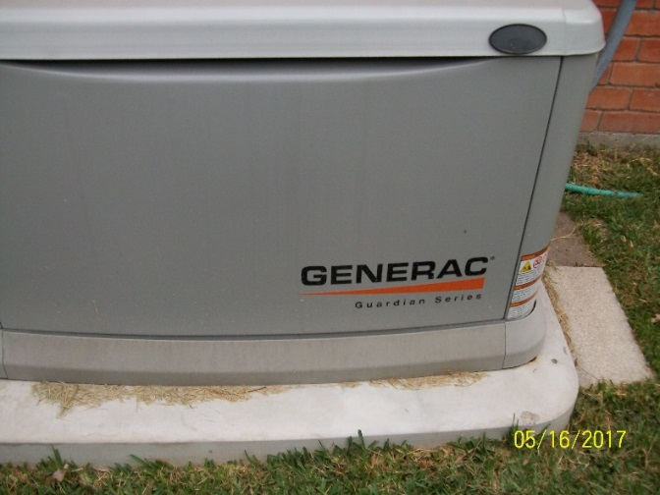 | If there is no electricity, there is no sump pump and water will rise until it is in the house.  Maintenance Requirement: The generator has to be observed in its weekly test.  Note: the only way I could purchase this was on credit. It has to be essential for me to have taken that risk.

Other Problems Than Flooding--and Would Anyone Buy It at the Price FBCAD Says?
This house has other problems such as lead pipes that are corroding. The first one leaked and had to be replaced this May.
The list of needed major repairs was in the estimates at the June 2016 protest.
This is not a house a person would buy if they knew the realities—and a person certainly would not buy for the value stated by FBCAD.

Meaning of the Labels Maintenance and Reality
The label Maintenance covers actions the homeowner must do to keep the drainage system working.
The label Reality is an explanation of decisions during Summer 2016 after the FBCAD appraiser in June 2016 would not look at the time-stamped pictures of damage to the property coming from repeated flooding and my estimates of the cost to stop that flooding. My understanding from the FBCAD appraiser in May 2015 was that I had to bring estimates of cost of repairs to the hearing and further that if I paid for a repair before that hearing that the dollars could not count to lower the value of the house.
The reality was that the flooding had be stopped. That meant an additional reality: using the cheapest methods to stop water from coming into the house at the worst spots and ignoring how they looked. Examples include using leftover materials from prior projects for as many things as possible
These methods do not increase value; further, repeated flooding had already decreased it.

