A Quick Tour of Why Possible Buyers Will Know This Is Damaged Property
The moment possible buyers look, they can see that this house is dealing with ongoing flooding. They can see that the attempts to prevent that flooding or further damage may lower value because money had to go essential purchases to prevent the flooding and, anywhere possible, the decision was for a cheap, even ugly and constant-maintenance, solution. We built from left-over materials and messed up materials. Why? The goal was to be able to safely stay in the house. As background, the tour also includes some time-stamped pictures provided to the 2015 and 2016 Appraisers.
From the Street – What the Possible Buyer Sees First 2
Drainage Pipes Exiting to the Street 2
Constant Maintenance Requirements 2
Pea Gravel Used on the Right Side of the Front Yard Why? Water Flow Killed the Grass and It was a Sea of Mud 2
Constant Maintenance Requirement and Background on Water Flow in the 2015 Appraisal Protest Documents 2
Through the Gate – Their 1st view is a catch basin leading to drainage pipes 3
1st of 6 Catch Basins in the Back Yard 3
Constant Maintenance Requirement for All 6 Catch Basins and All Accessible Pipes 3
Drainage Pipes and Trenches and the Necessity of the Sump Pump 3
Constant Maintenance Requirement and Essential Purchase of a Backup Sump Pump 3
The Wall—the Biggest Thing in the Yard—Between the House and Neighbors’ Properties That Flood 4
Background Shown by Time-Stamped Pictures Provided to 2015 and 2016 FBCAD Appraisers 4
Essential Purchase of the Retaining Wall--Something the Homeowners Could Not Build 4
Constant Maintenance Requirement and A Prevention of Further Damage That May Lower Value 4
In the Backyard Visible Damage In and Out of the Storage Building 5
Visible Damage in the Storage Building and a Prevention of Further Damage That May Lower Value 5
Visible Damage on the Back of the Storage Building and a Prevention of Further Damage That May Lower Value 5
Prevention of Flooding That May Lower Value—Plastic to Direct Water to the Catch Basin at the Corner 5
Constant Maintenance Requirement 5
At the Center of the Yard – Visible Signs of Water on the Patio (Water also has come in the Den.) 6
Background Shown by Time-Stamped Pictures of this Corner Provided to 2016 FBCAD Appraiser 6
Recognition Additional Cause of Flooding Is That the House Is LOWER Than the Back of the Yard 6
Waterline Showing Prior Flooding on the Wall on the Patio and by the Backdoor to the den 6
Prevention of Flooding That May Lower Value—Attempts to Keep Water from the Corner of the Den 6
At the Center of the Yard – Drainage to Move Water from 3 Areas to the Sump Pump 7
Constant Maintenance Requirements and a Preventions of Flooding That May Lower Value in All 3 Areas 7
1. To the Sump Pump of Water from the Neighbors’ Flooding by Drainage by the Storage Building 7
2. To the Sump Pump of Ground-Level Water Carried by Drainage beside the Patio 7
3. To the Sump Pump of Roof Water Carried by 2 Downspouts and Extenders to Drainage beside the Patio 8
Constant Maintenance Requirements and Essential Purchases 8
Background Shown by Time-Stamped Pictures (2 of Many) Provided to 2015 and 2016 FBCAD Appraisers 8
In the Backyard on the LEFT Side of the House – Water Rising Beside Living Room and Bedroom 9
Constant Maintenance Requirements and Preventions of Flooding That May Lower Value 9
Without the Sump Pump, Flooding Happens and Why a Generator Is Essential 10
Constant Maintenance Requirement, Preventions of Flooding That May Lower Value, and Essential Purchase 10
And There Are More Problems Than These—Would Any Buyer Want This Property at the Price FBCAD Says? 11
Status of the 2016 Estimates to the Appraiser, Including Repairs and Preventions Not Done after His Decision 11
Summary 11

From the Street – What the Possible Buyer Sees First

Drainage Pipes Exiting to the Street
On the left, one built by the prior owner. On the right, one built in 2012

Constant Maintenance Requirements
On the left pipe, carefully clean out the cracked pipe; use a hoe to keep the space between curb and the grass clear for about 5’ where there is a crack in the curb that lets the water reach the street.
Each year, these pipes to the street have to be blown out with water hose at the catch basins in the backyard.
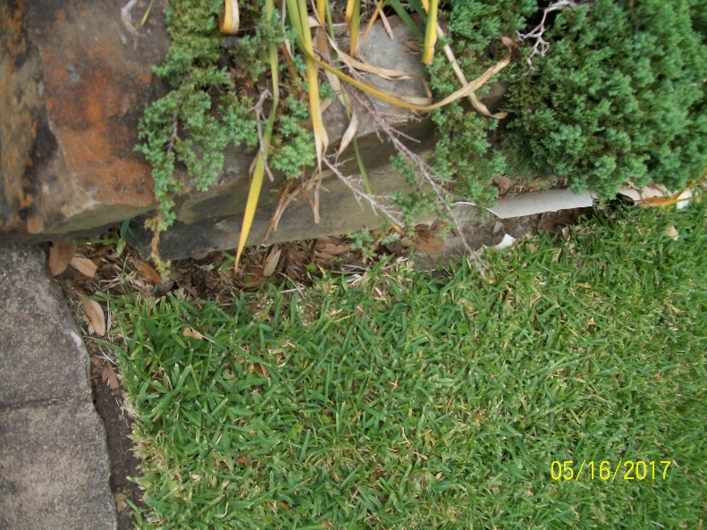 | 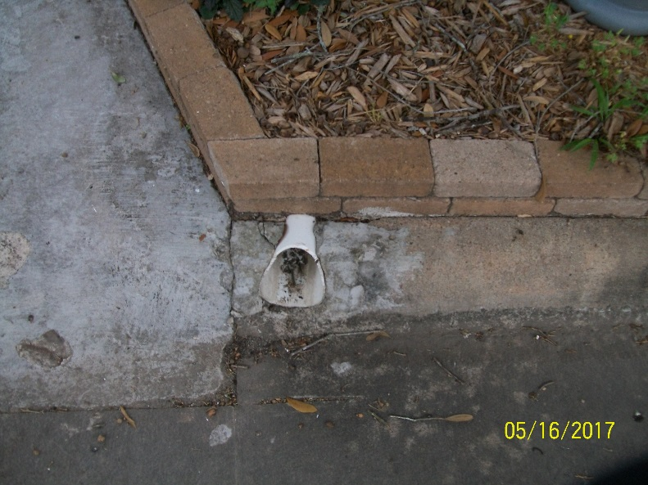

Pea Gravel Used on the Right Side of the Front Yard Why? Water Flow Killed the Grass and It was a Sea of Mud
In spite of the drainage pipe below ground to the street, some water still comes above ground and drags gravel into the neighbor’s yard.

Constant Maintenance Requirement and Background on Water Flow in the 2015 Appraisal Protest Documents
Pre-storm, attach a hose to the water barrel attached to the downspout and take the end to the street.
Post storm, use a hoe to restore the path in the pea gravel for the water and restore my neighbor’s yard.
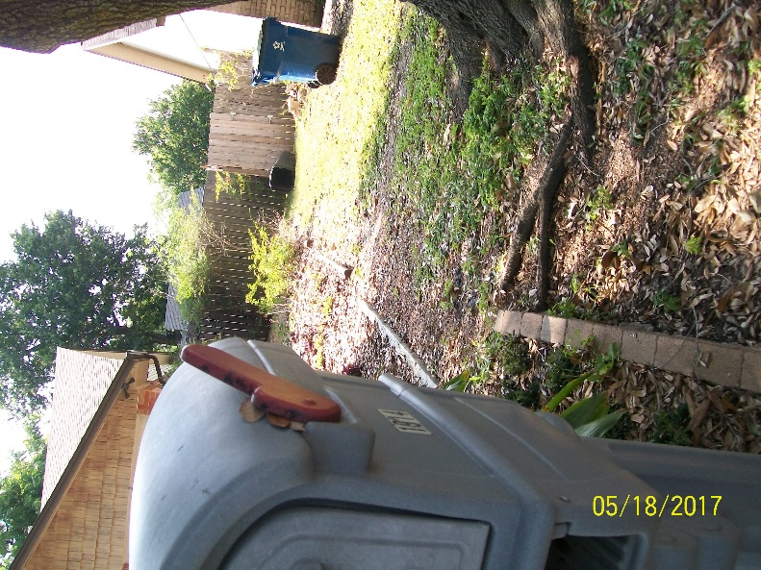 | Background example from 2015 of flow above ground. 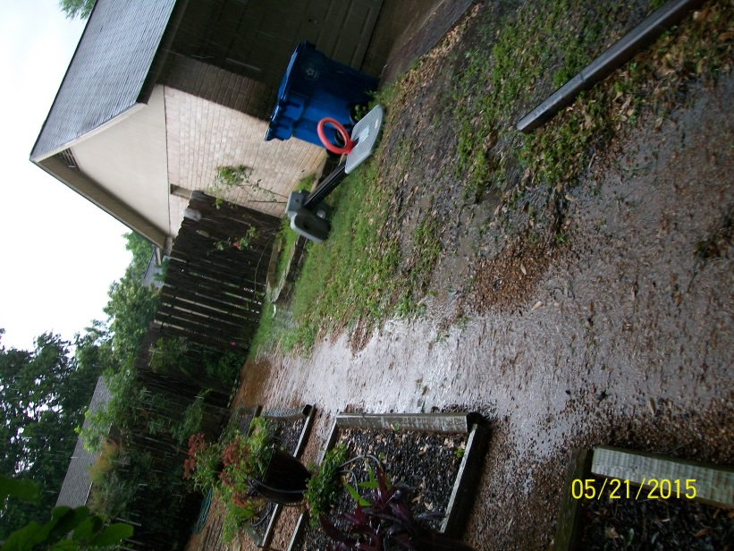

Through the Gate – Their 1st view is a catch basin leading to drainage pipes

1st of 6 Catch Basins in the Back Yard
This one leads to a pipe that goes to the main pipe running beside the fence and to the street. The blue hoses are attached to soaker hoses to try to prevent the foundation problems in dry weather.

Constant Maintenance Requirement for All 6 Catch Basins and All Accessible Pipes
- All catch basins must be cleaned before storms.
- In all catch basins and pipes, must regularly use Mosquito Dunks to keep down the mosquitoes.
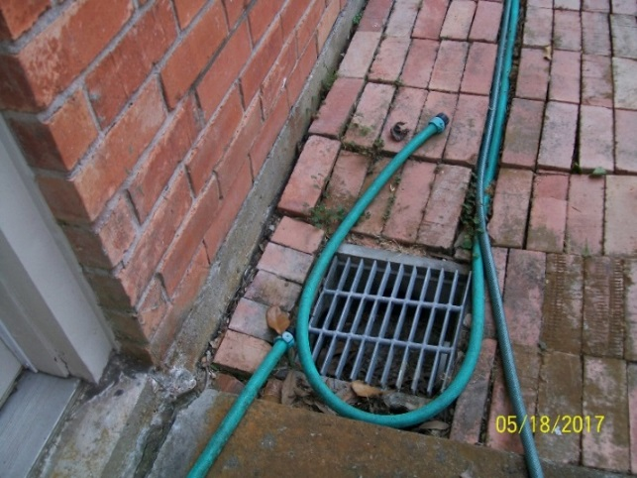

Drainage Pipes and Trenches and the Necessity of the Sump Pump
Slope will not take care of the amount of water coming in the yard. There has to be a sump pump—a pump for forcing water away a structure that will be damaged by water. In this yard, drainage pipes and trenches carry water to the sump pump and the pump sends water to a pipe that connects to the street. Without this sump pump (as the Appraisal protest for 2015 and 2016 show with time-stamped pictures), water would flow:
- From the water coming from the left side of the yard and cover the patio and enter the room beside it
- From the water coming from the right side of the yard and enter the storage building and also add to the water on the patio

Constant Maintenance Requirement and Essential Purchase of a Backup Sump Pump
Leaves and small size gravel must be kept out of the catch basin for the sump pump to work, thus the additional grate and regular checking to be sure it is clear.
If this pump goes out, we flood; therefore, we have a backup sump with all connectors ready as well as a generator.
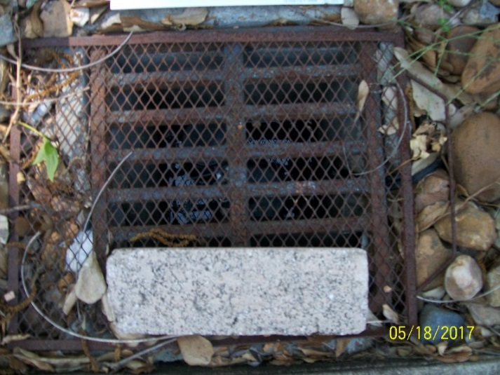

The Wall—the Biggest Thing in the Yard—Between the House and Neighbors’ Properties That Flood

Background Shown by Time-Stamped Pictures Provided to 2015 and 2016 FBCAD Appraisers
In both of these pictures, the water is flowing into the storage building. That 26 X 14 building has been badly damaged by the flooding and the water shown flows into parts of it.
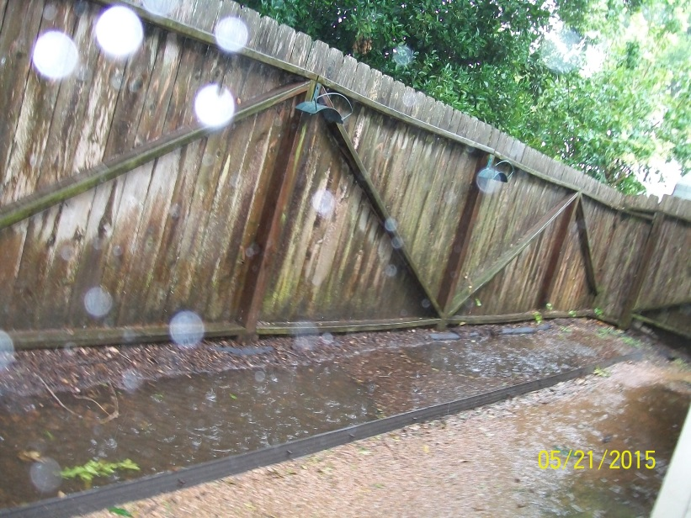 | 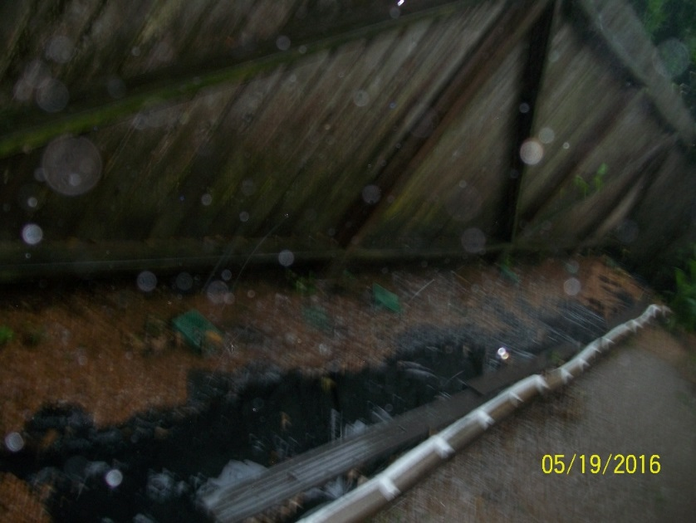

Essential Purchase of the Retaining Wall--Something the Homeowners Could Not Build
The retaining wall was not in the proposed repairs and estimates in the 2016 documents to FBCAD’s appraiser—documents he would not look at. The prior estimates I had heard for a retaining wall were over $4000. A worker I interviewed to dig some drainage trenches made a bid of $1765.

Constant Maintenance Requirement and a Prevention of Flooding That May Lower Value
Not merely regular yard maintenance, but pulling away leaves that cluster behind the wall to be sure the soaker pipe (perforated pipe encased on the bottom by plastic) and the green grates are clear of leaves. The greatest amount of leaves—as well as the greatest amount of water--is in the section by the neighbor with the water garden.
The wall has helped; however, a possible homebuyer may not want a property that has a big wall—especially at the price that FBCAD proposes.
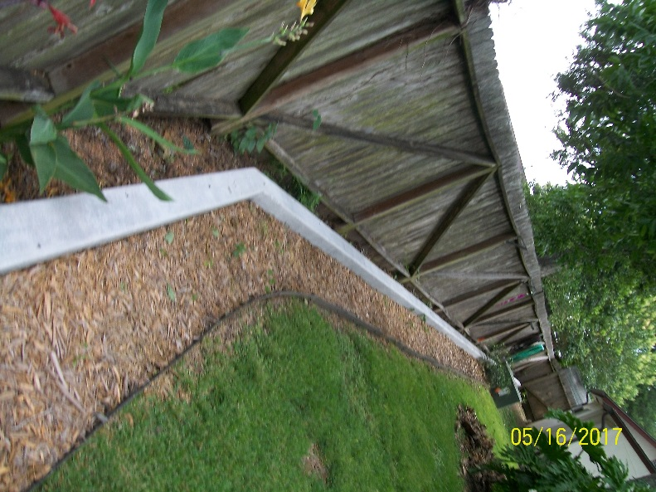 | 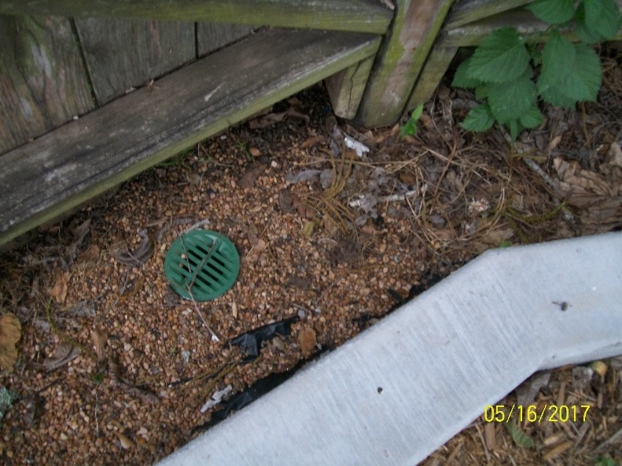

In the Backyard Visible Damage In and Out of the Storage Building

Visible Damage in the Storage Building and a Prevention of Further Damage That May Lower Value
Since wood is rotting, cinder blocks hold up shelving. The flooding is less, but not enough to try to replace wood.
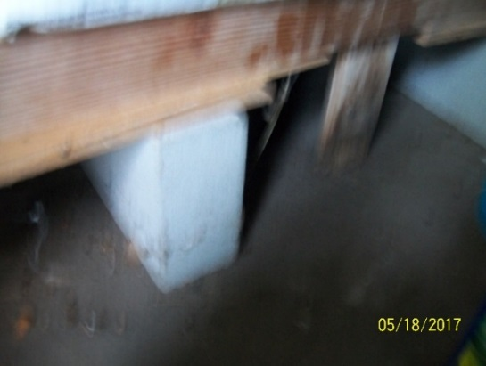 | Prior to purchase, Brookside Inspection Service report (available) examined the property and identified flooding in the 1st 2 parts of this building. The owner confirmed that the house itself had not flooded (provided in the last document in 2015 Appraisal Protest Documents).  Status of the 3 parts of this building:  - This part has flooded regularly. It is at the intersection of the Klauke fence and the fence of the neighbor on the right.  - The center room is moldy. The inspector suggested to build a frame of 2X4s to keep the boxes we planned to store out of the water.  - The third storage area has only flooded once, but it has flooded.

Visible Damage on the Back of the Storage Building and a Prevention of Further Damage That May Lower Value
The exterior of the storage area was also included in the Brookside Inspection Service. The owners incorrectly used Hardy board and placed it flush against the ground. On the left, visible damage during years of trying to stop this flooding. On the right, greater damage developing. All I can do is chalk it securely. The flooding is less, but not enough to try fix this.
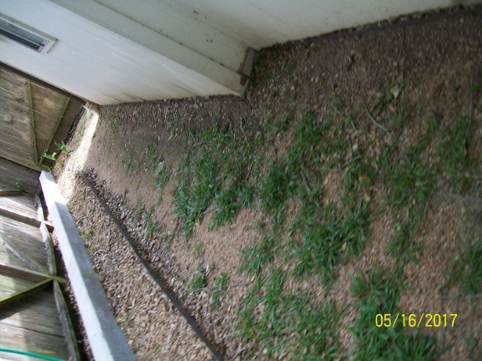 | 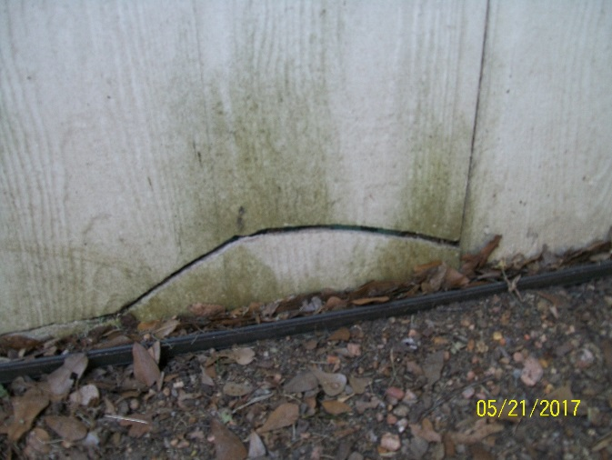

Prevention of Flooding That May Lower Value—Plastic to Direct Water to the Catch Basin at the Corner

Constant Maintenance Requirement
In addition to cleaning the catch basin, sweep away grass and leaves to keep water moving beside the fence and toward the catch basin shown. If the water starts to pool behind the building, use a push broom to sweep it toward this slope and the catch basin on the corner of the building.
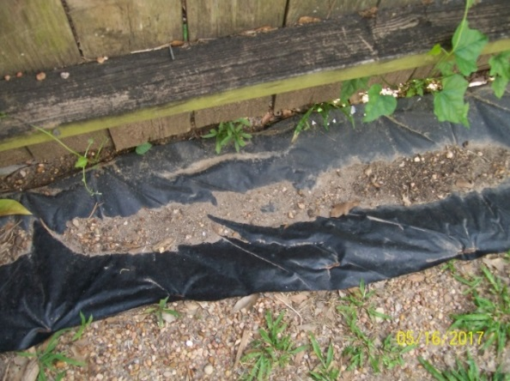 | 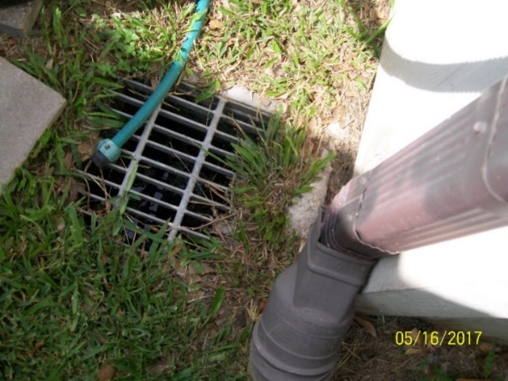

At the Center of the Yard – Visible Signs of Water on the Patio (Water also has come in the Den.)

Background Shown by Time-Stamped Pictures of this Corner Provided to 2016 FBCAD Appraiser
In the May flooding, old sheets and towels used to cover plants in winter were a desperate attempt to block water.
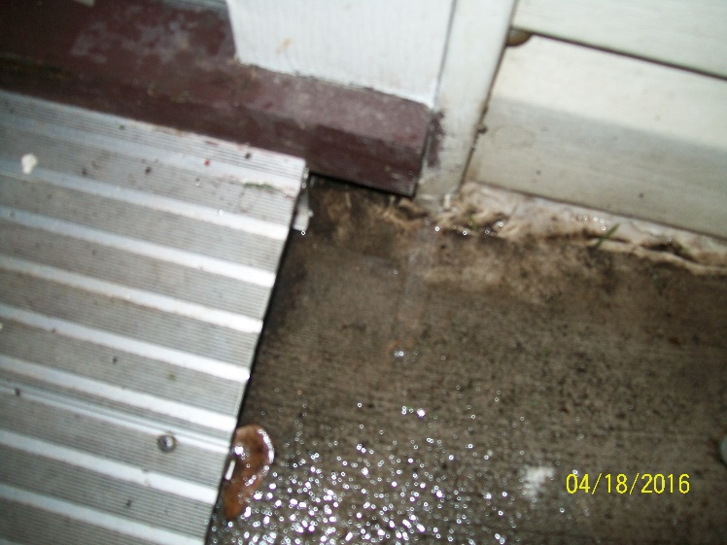 | 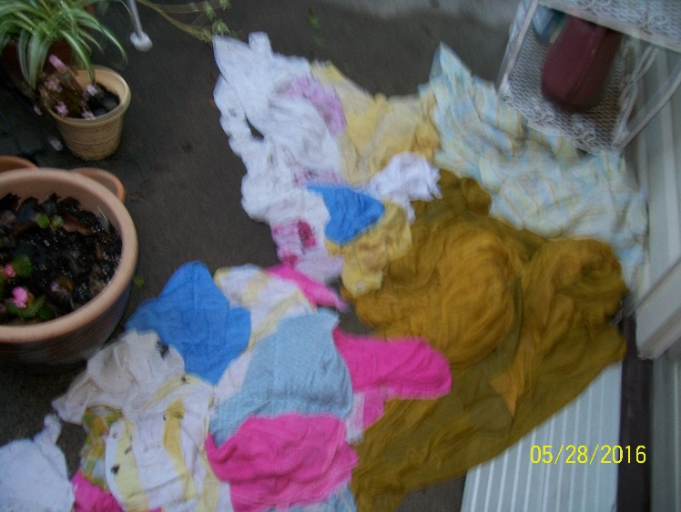

Recognition Additional Cause of Flooding Is That the House Is LOWER Than the Back of the Yard
My years of time-stamped videos combined with talking with one vendor showed that solving the flooding from my neighbors would not end all of the flooding. Why? The patio and house are lower than the back of the yard.

Waterline Showing Prior Flooding on the Wall on the Patio and by the Backdoor to the den
As the pictures provided in the June 2016 protest shows, water flows toward the back door and this wall. I have placed old sheets and towels down to keep back the water.
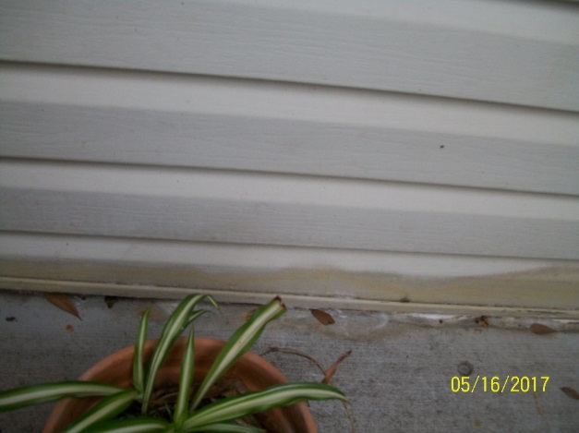 | 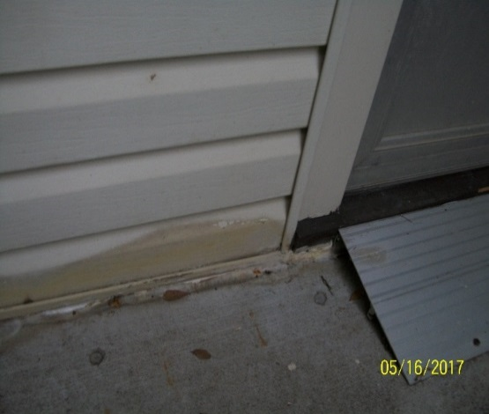

A Prevention of Further Damage That May Lower Value—Attempts to Keep Water from the Corner of the Den
The water has come so heavily and so long (before we bought the house) that there are many worn-down sections where water pools that still need to be done. This one was a worst spot because water was pooling at the corner.
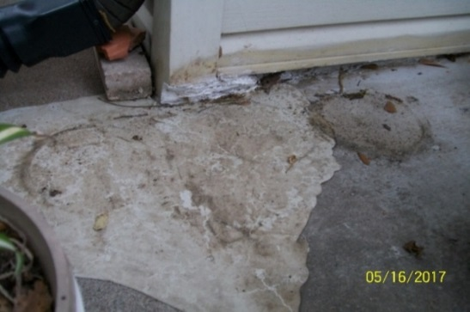 | In desperation with the immediate need to fill this area, we used these products because they were cheap.  <White filler chalk to keep the water from entering the corner.  < Self-leveling chalk where regular flow of water had worn down an area used to keep water away from the corner. The water now pools following the edges of this blob of chalk—ugly, but it is not in the house.  <We also did do the self-leveling tubes of Emedco sealant, but the remaining preventions for this area in the 2016 appraisal protest could not be done during Summer 2016 because of money.

At the Center of the Yard – Drainage to Move Water from 3 Areas to the Sump Pump

Constant Maintenance Requirements and Preventions of Flooding That May Lower Value in All 3 Areas
The black plastic works OK at least for now, but requires by-hand maintenance to remove leaves and—each week--grass clippings. All of the drainage was built using leftover materials or messed up materials and a close look may lower value:
- Area 1 - Leftover stepping stones from a prior attempt to deal with the flooding are placed below ground level and sloped to the drainage pipe. The only new purchase was a larger size gravel because the pea gravel used by a prior vendor got stuck in perforated areas of the pipe and made it less able to collect water.
- Area 2 - The left picture shows an old pipe that did not have enough holes so we drilled more holes. An old black grate connects the pipe to trenches lined with black-plastic from a prior drainage project.
- Area 3 - To keep the extender in place, we used beige blocks a neighbor had thrown away.

To the Sump Pump of Water from the Neighbors’ Flooding by Drainage by the Storage Building
The test on the left with the black plastic showed that—in spite of the pipe next to the storage building—there was still water coming down the neighbor’s fence line and toward the patio.
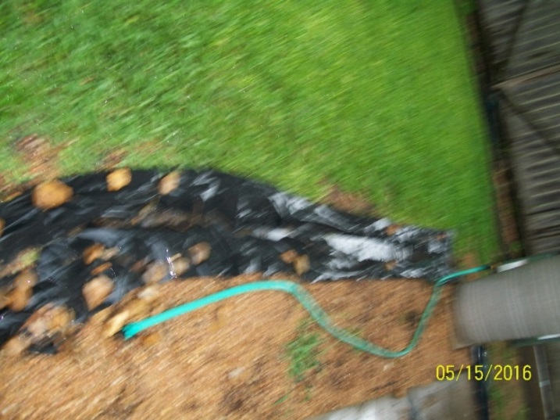 | 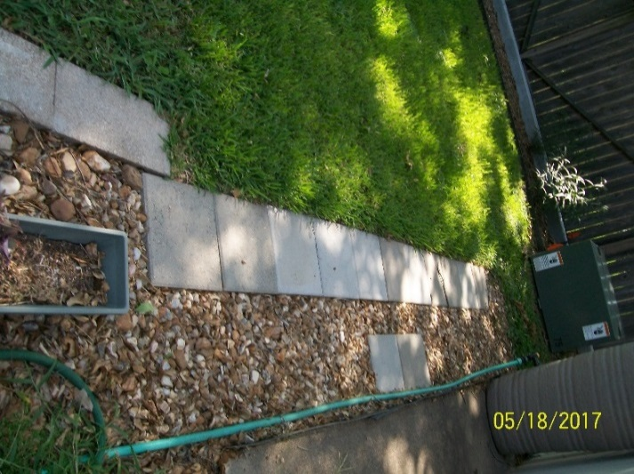

To the Sump Pump of Ground-Level Water Carried by Drainage beside the Patio
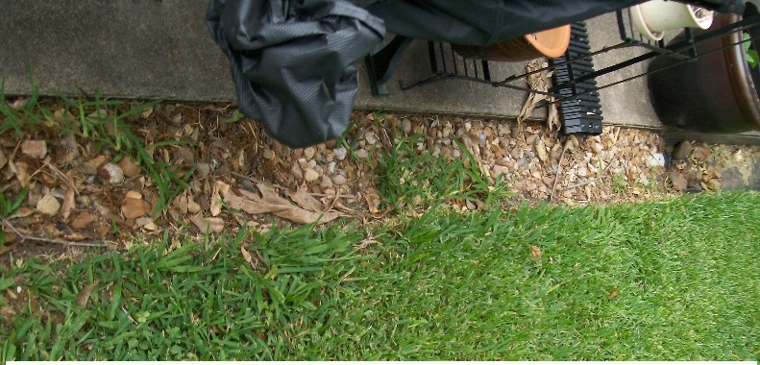 | 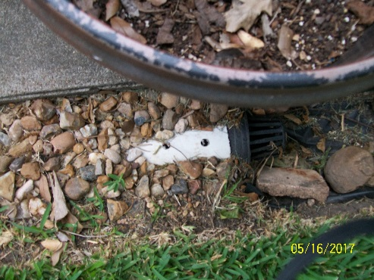
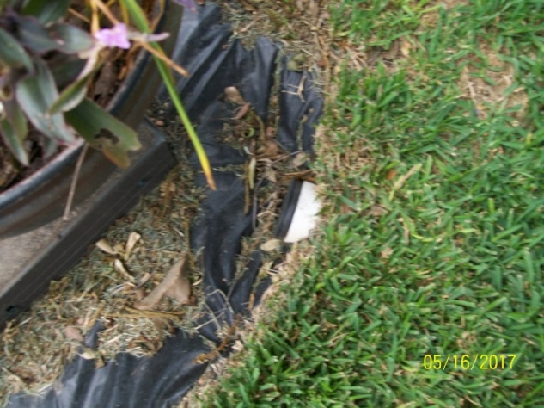 | 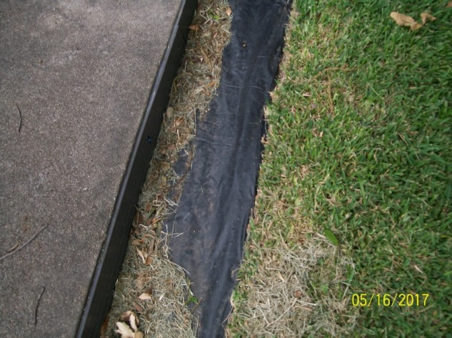

To the Sump Pump of Roof Water Carried by 2 Downspouts and Extenders to Drainage beside the Patio

Constant Maintenance Requirements and Essential Purchases
Essential Purchases: Repair of bricks and mortar from water damage. Replacement of bending 4” gutters with 5” gutters, installation of flashing to protect the brick fireplace, installation of 2 downspouts, and purchase of extender so water from the roof goes to the drainage beside the patio and then to the sump pump.
Maintenance: The extender on the right does reach the black plastic covered trench, but it seems to move when there is a lot of rain. Mowers tend to move the bricks so their position has to be checked every mowing day.
Downspout to the left of the wall with the back door | Downspout to the right of the brick fireplace
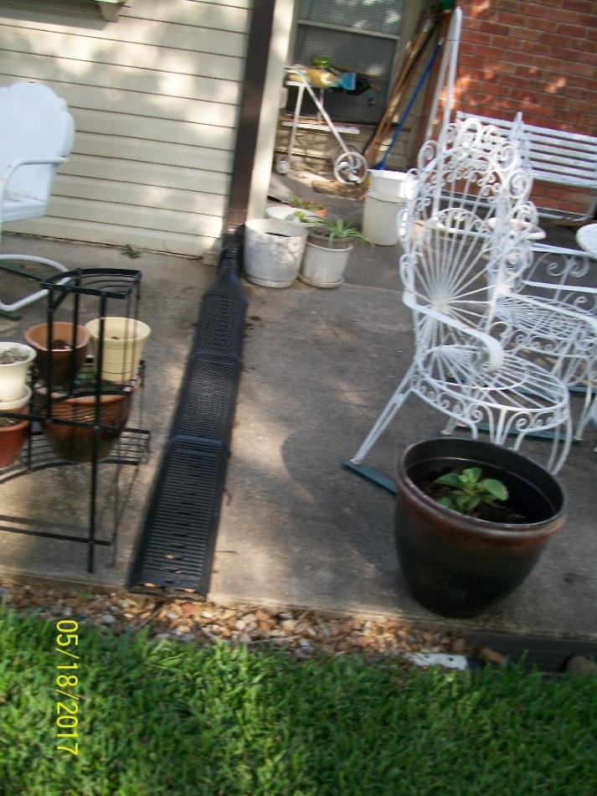 | 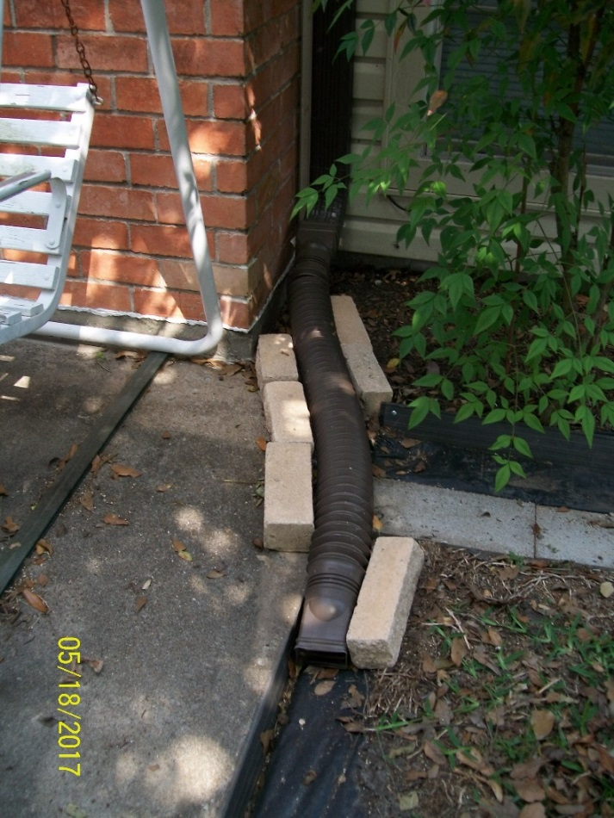

Background Shown by Time-Stamped Pictures (2 of Many) Provided to 2015 and 2016 FBCAD Appraisers
Ground-water on patio and to the backdoor (not shown) | Rate of water off the roof beside the fireplace.
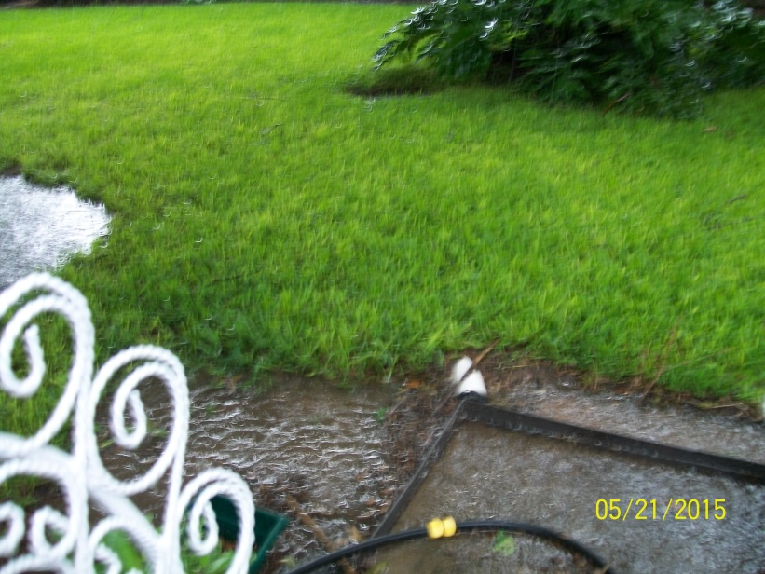 | 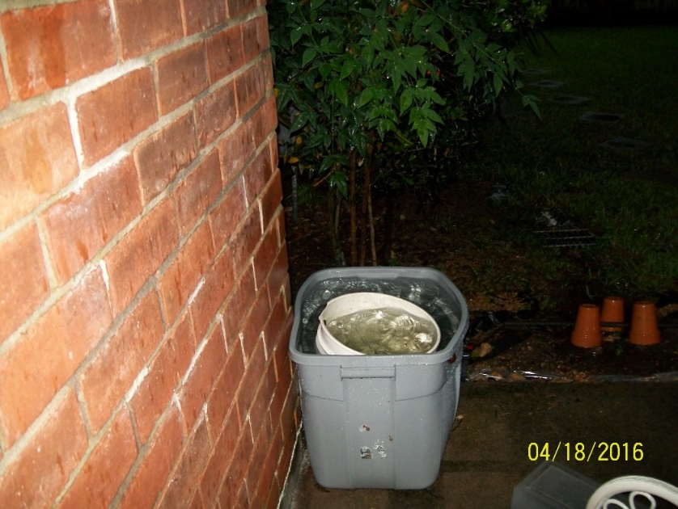

In the Backyard on the LEFT Side of the House – Water Rising Beside Living Room and Bedroom
This is difficult because the land is on a very slight slope since the house is lower than the land and the only lower area is the fence line. This water was not just to the metal edging but in the shrubs by the wall of the living room and a bedroom. As the picture from the 2016 protest shows, the water has been close: I dug shallow trenches with a hoe about two feet from the metal edging to try to get the water to flow away from the house.
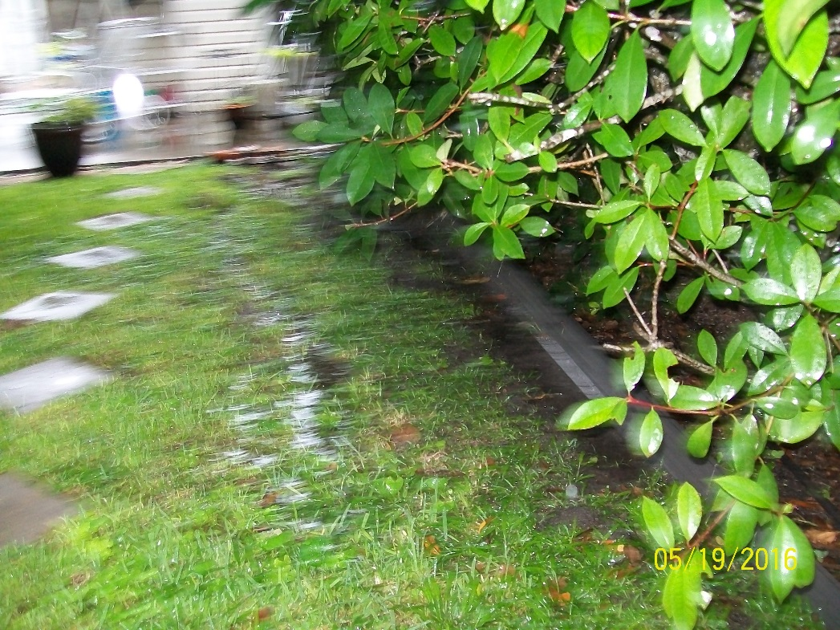

Constant Maintenance Requirements and Preventions of Flooding That May Lower Value
Not only have to remove grass clippings as with the other black plastic trenches, but also--if the rain is hard--have to sweep the water toward the fence. The end of the slope must be cleaned out regularly so it will flow.
Because of costs, used leftover black plastic, leftover 2x16 cinder blocks and leftover metal edging to help the water flow toward the fence. Used beige blocks that a neighbor had thrown away to block the end of the slope (in the picture on the right) and create a turn where the water could flow along a longer slope to the fence line. This is the method that will probably fail and have to be done as written in the estimate provide to the 2016 Appraiser.
Beginning of the slope at downspout on the prior page. | Ending of the slope near the fence line.
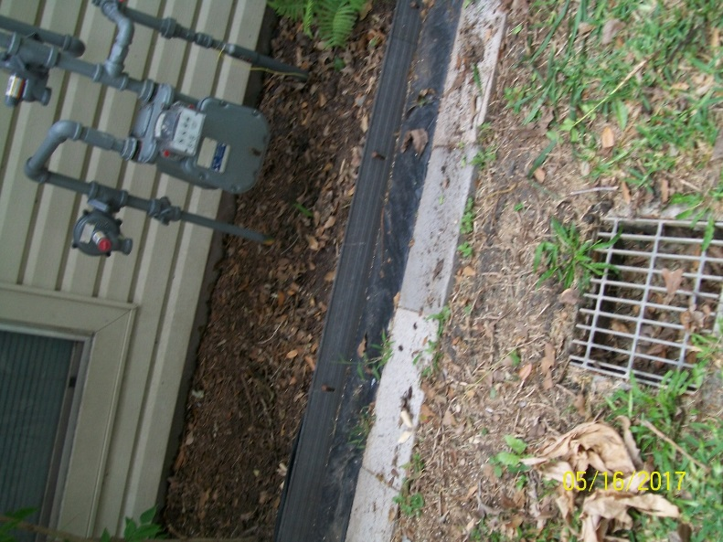 | 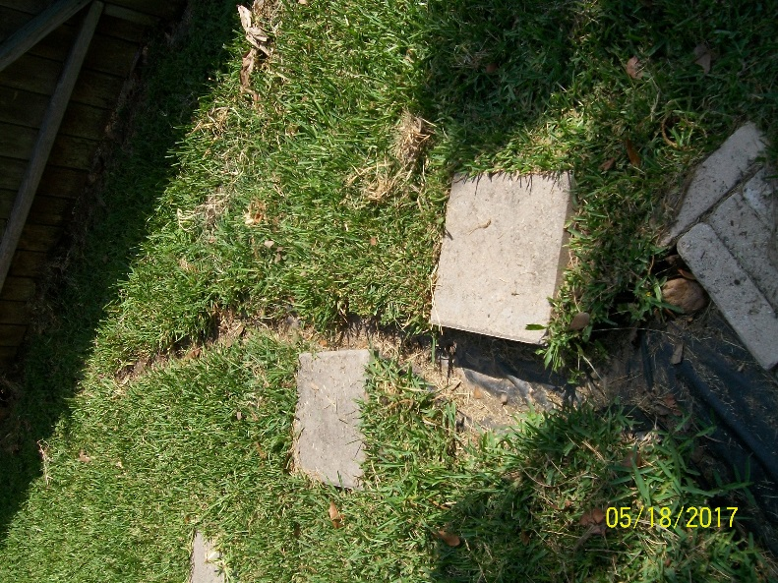

Without the Sump Pump, Flooding Happens and Why a Generator Is Essential
1/20/2017, the sump pump was overwhelmed and shut down. This shows what starts to happen without the pump.
Black trenches are full but not moving. | Water overflows pipes and trenches and onto the patio.
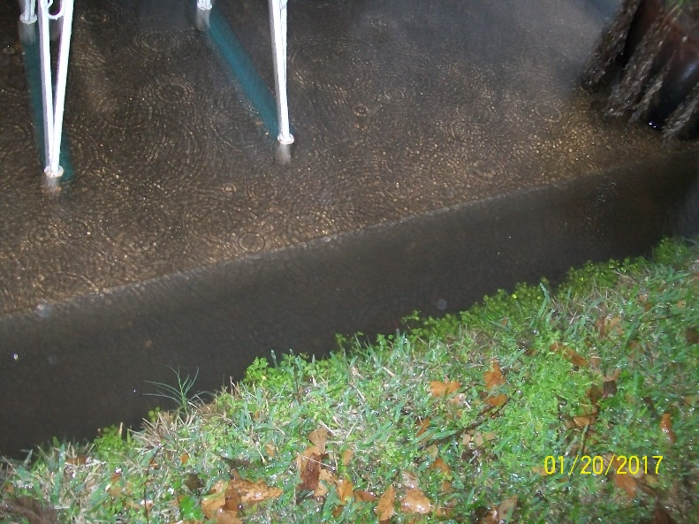 | 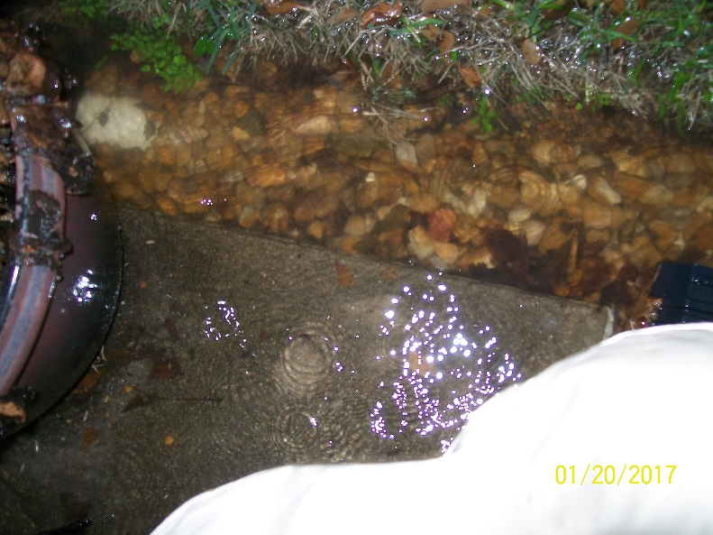

Leaves show where the water flowed on the patio.
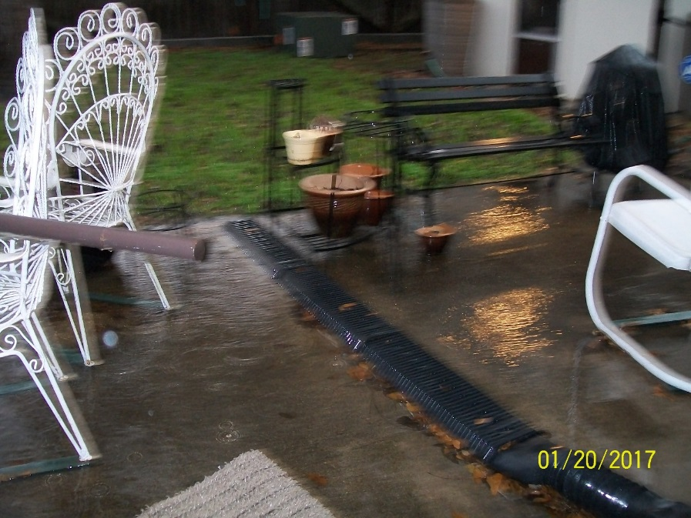 | 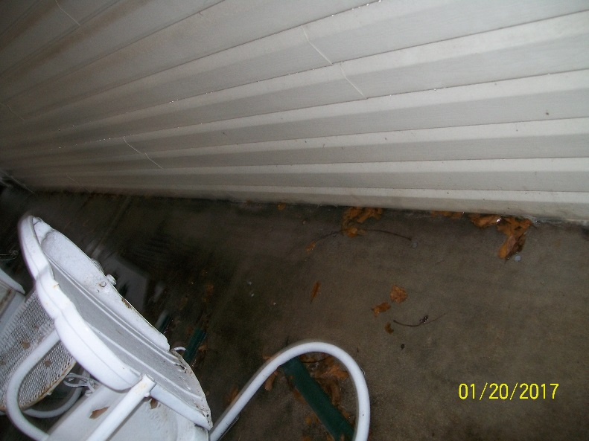

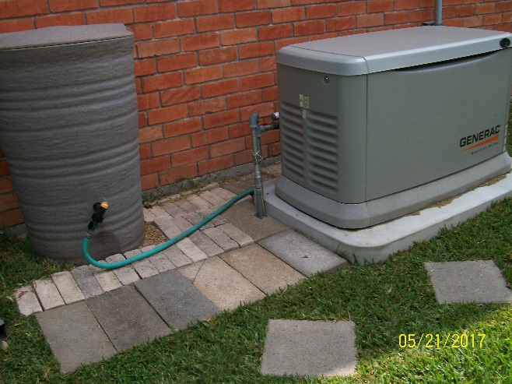 | Constant Maintenance Requirement, Preventions of Flooding That May Lower Value, and Essential Purchase  Maintenance: The generator has to be observed in its weekly test.  Preventions of Flooding That May Lower Value: No grass will live in the area to the left of the generator. To avoid spending money, we filled in the area in with stones my neighbors threw away and leftover 8X16s from other projects.  Essential Purchases: If there is no electricity, there is no sump pump and water will rise until it is in the house. We have lost power in this house in regular storms. In a hurricane, in this house, the generator is not a choice.

And There Are More Problems Than These—Would Any Buyer Want This Property at the Price FBCAD Says?

Status of the 2016 Estimates to the Appraiser, Including Repairs and Preventions Not Done after His Decision
To O’Conner & Associates:
If useful, I can copy in the estimates from the 2016 Appraisal Protest and I can label each:
- as done and the cost
- as not done

Summary
This is not a house a person would buy if they knew the realities. Now—unlike 2010 when we bought the house—those realities are visible just by walking on the property.
A person certainly would not buy for the value stated by FBCAD.

