Your Name—Form Used to Show Points Off an Exam &--If Needed—How to Be More Successful Next Time

1st Prepare Your Test Area (Caution: With the Final, your prof highlights in orange in the 2 right columns means points lost.)
The required actions are the same as in your syllabus, but in this table they have tips and are in the order you do them in Respondus.
STEP | Student’s Required Actions to Prepare the Test Area and Yourself for Each STEP with Respondus | Minus 30% | 0 for Exam
STEP 2 | You place the external webcam so it shows the test area completely. | X
STEP 2 | Caution: You must remain in the webcam view during the whole exam to the last question. |  | X
STEP 2 | You turn on the microphone so it records and you make sure it continues to record. | X
STEP 4 | You turn on sufficient lighting and places lights so no backlighting. | X
STEP 4 | You sit with your computer on a hard surface (desk, table, TV tray, etc.) (Caution: Not with the computer on your lap and not sitting or lying on a bed or a couch.) .Have nothing on the hard surface except your computer and Photo ID. | X
STEP 4 | You remove all unauthorized materials near your test area. Examples:  - No phone  - No papers  - No clutter of any type.  To quote the video, all “out of reach.”  Tip: To avoid picking up their bedrooms, some students take exams on a kitchen table or on a patio table. That is fine with your prof. |  | X
STEP 4 | You do not  - Talk with others during the exam  - Play music or other audio recordings  Tip: That also means no headphones. |  | X
STEP 5 & 6 | You must have a valid PHOTO ID. If you have a Texas Driver’s License, that qualifies.  Cautions:  - If you have a long Texas ID, you must follow directions in the link below.  - If you do not have a Texas Driver’s License, email in Blackboard Course Messages a scan of the ID you propose to use so your prof can decide if it will qualify. Do this at the beginning of the term, and your prof will reply back ASAP.  Click here for Preparing for STEP 5 & 6: Picture and Photo ID (Link Address: http://www.cjbibus.com/Two_Quick_Solutions_for_More_Difficult_IDs.pdf) | X
STEP 7 | You show a complete environment video with 10% each for showing clearly these 3 parts: `  - All parts of the hard surface where you will take your exam  - Your lap and the floor below the hard surface  - All 4-walls (a 360-degree) view of your room. | X

2nd Do the 9 STEPS Respondus Shows You So You Can Begin an Exam
STEP | Short Reminders of What WCJC’s Demonstrator Did and You Must To. Caution: Look at WCJC’s 3rd Video.
STEP 1 | TERMS OF USE – Just click.
STEP 2 | Recognizing Where You Should Be in WCJC’s 3rd Video Starting Your Test  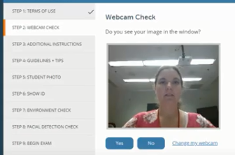
STEP 2 | WEBCAM CHECK – You do what WCJC’s Demonstrator did on the screen:  Caution:  - If you have an internal webcam, you must change your webcam to external.  - Then speak aloud (alphabet or count to 10) to check the microphone.  - Then check your webcam to be sure your image is in the right place.
STEP2 | Recognizing Where You Should Be in WCJC’s 3rd Video Starting Your Test  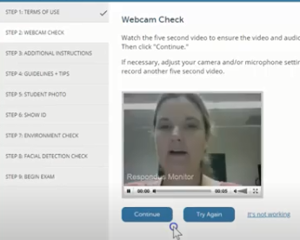< Notice the Try Again button if you were not correct.  Tip and Caution:  - In many locations, Respondus lets you click on Try Again to correct your work. Use it.  - Your prof can tell if you checked your own work and corrected it. Do not ignore your responsibility.
STEP 3 | Recognizing Where You Should Be in WCJC’s 3rd Video Starting Your Test <In this and most classes, this screen lists solutions for possible problems.  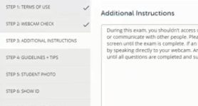
STEP 3 | ADDITIONAL INSTRUCTIONS – Read this and notice what you may need to explain in the video when you take a test.
STEP 4 | Recognizing Where You Should Be in WCJC’s 3rd Video Starting Your Test <Caution: Meaning matters!  - Guidelines = ropes that help you avoid falling off mountains.  - Tips = “expert information.”  Use both!  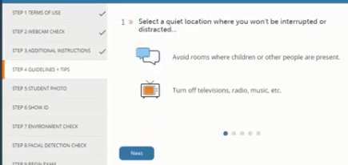
STEP 4 | GUIDELINES + TIPS –If you read a TIP that you have not done, do it now and then resume. Caution: The syllabus says an external webcam is required for this course.
STEP 5 | Recognizing Where You Should Be in WCJC’s 3rd Video Starting Your Test <NOTICE! Make your face fill the frame (the rectangle).  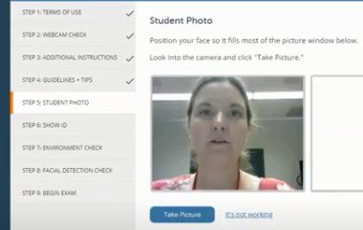  FYI: Michele, once I know what is going to happen, I can get rid of the extra spacing.
STEP 5  FROM>  TO > | STUDENT PHOTO – Click here for Preparing for STEP 5 & 6: Picture and Photo ID (Link Address: http://www.cjbibus.com/Two_Quick_Solutions_for_More_Difficult_IDs.pdf  Michele, in prior conversations (and it has been a while), I hope that I understood correctly that this could be a fast fix to put Kim’s WCJC ID on the right instead of a 2nd picture of her. It could help this very useful video be clearer.  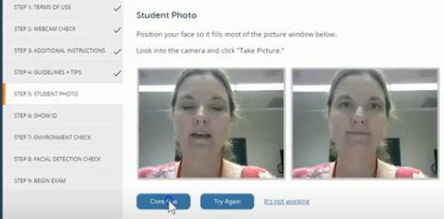  All of these incomplete or incorrect versions could disappear FROM here.  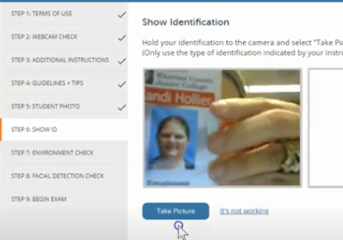  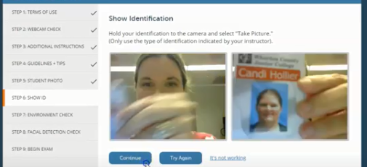  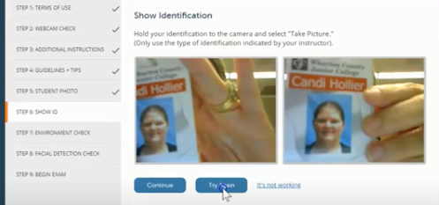  All of these could disappear TO here
STEP 6 | Recognizing Where You Should Be in WCJC’s 3rd Video Starting Your Test  If this could be fixed fast, put the corrected snippet with Kim’s PHOTO on left and Kim’s ID on the right here.
STEP 6 | SHOW ID – You show the Photo ID that you determined you could use above.  Caution about STEP 5 and STEP 6: Respondus shows your PHOTO and your ID and the prof is required to determine:  - If the photo of the person taking the test is the person in the picture on the PHOTO ID  - If the name on the PHOTO ID matches the name you used in registering for the class.
STEP 7 | Recognizing Where You Should Be in WCJC’s 3rd Video Starting Your Test  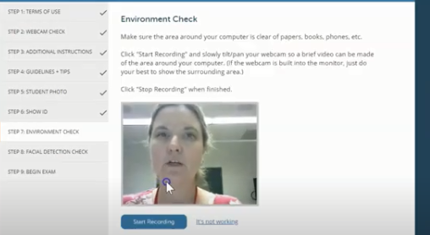
STEP 7-1st | ENVIRONMENTAL CHECK – Do all that the Demonstrator does.  - Remove the external webcam  - Use it to point slowly, moving the webcam from one side of the workspace to the other to each of these locations:  1st, have nothing on the workspace except your computer and your Photo ID. 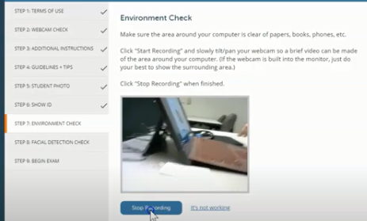  Lift up the mouse pad and the keyboard or laptop so the prof can see under them.  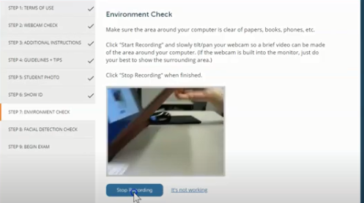  Not shown here, but in WCJC’s 3rd video, show:  - Your computer  - The space on both its left and right sides and behind the computer.
STEP 7-2nd | 2nd, show lap and feet and under workspace below the hard surface on both left and right sides.  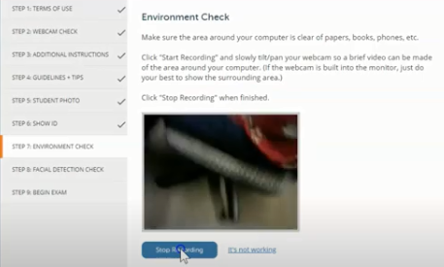
STEP 7-3rd | 3rd, show an all 4-walls (360-degree) view of your room. Michele, when I saw your statement on the lower right hand corner of Blackboard about the 360 degree, I realized I needed to make that fact more prominent in this section.  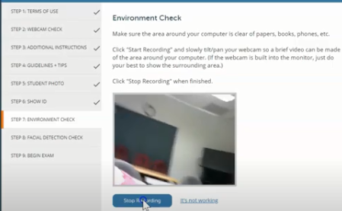  For this class, if the workspace is a large table, then show the far side of the workspace and the chair seats.  Tip to slow down: Show things from left to right and said aloud what you are showing. No blurs.
STEP 8 | Recognizing Where You Should Be in WCJC’s 3rd Video Starting Your Test <Once you complete your 4-walls –360 degree—view of your environmental, then do this:  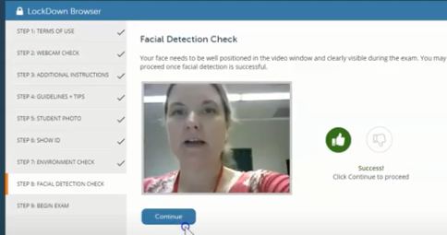
STEP 8 | FACIAL DETECTION CHECK – Restore your external webcam to its correct position. When doing the exam, you can scratch your nose, and twist your neck, but keep in the frame (the Respondus rectangle).  Tip: Blackboard records this number for the prof.
STEP 9 | BEGIN EXAM – You follow the steps in the video to start the Sample Respondus Exam—or any other exam you must use with Respondus Monitor.

