Caution: For Your Sake, Do Not Come Into the Course This Way
As the illustration shows, do not click where the arrow points. | Do NOT use this  ↓
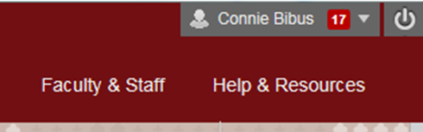
Why? The Director of Distance Education at WCJC encourages students never to use what is called Blackboard’s Global Navigation.
What I have seen is that students who use it fail horribly. Examples:
- Blackboard did not record that these students were in the course so—as far as their instructor knew—they were not in the course.
- Some students thought they were failing because they clicked on something they thought was My Grades—but it was not.
- Many students thought they could just click on an assignment or test or discussion and just submit anything. They failed because they:
- Did not see the List of Due Dates – a key to success in courses.
- Did not plan their work, such as not seeing the instructions.
- Did not allow enough time to do the work, such as starting their 100-point writing at 9:30 PM on the day it was due at 11:59 PM.
- Did not see the resources already provided for the work. Examples:
  - Required links to WCJC’s links to show students how to download Respondus Monitor and to take a test with it
  - Required primaries for writing
  - Required list of Terms for the Study Guide for a Unit Exam.

