Course Orientation (in Pictures) & the List of Tasks You Do for Points in Getting Started
If there are other things that you need details or pictures about, just email me or post in General Course Questions & Repeated Announcements & Tips
How to Login and Succeed with this Course
How to Login and Succeed with this Course 2
Caution: For Your Sake, Do Not Come Into the Course This Way 2
During Getting Started, Blackboard Shows You “Read Me First” 3
Key to Success with Learning Modules (All Content &Graded Work) 4
At Getting Started, What Do You Need on the Course Menu? 5
What’s on Learning Modules? (Everything you need in one spot.) 8
What’s in a Unit? (All Units have the same things in the same order.) 9
How Do You Know What to Do Where and When? 11
What’s All This Stuff about Self-Tests and Full-Tests: How Do They Look? 13
14
What’s All This Stuff about Self-Tests and Full-Tests: How Do They Work to Help You? 15
Tasks You Do During Getting Started 17

How to Login and Succeed with this Course  - Go to https://wcjc.blackboard.com  - You see a Login Here section on the left.  Before you login, notice the upper right section of the screen with the link Help & Resources. You must use that link to make sure your computer and browser work with this Blackboard.  FYI: I care about you all, but I am not a techy. WCJC’s IT can help (at Help & Resources). My 1 tech tip is—if your browser is not working or displaying what I say is there—try a different browser for a day.  - Follow the directions in the Login Here section for what you type in those 2 fields.  - Login on the Blackboard log in screen.  - On the left side of the new screen see the words My Courses.  - Look for our course and click on it.  Tip: the naming conventions for Blackboard courses have changed so you may have trouble guessing our course.  - For US History I, look for the letters WWW 18 in the name  - For US History II, look for the letters WWW 28 in the name  - What you see when you click on the course varies with whether you log in.  - During Getting Started, Blackboard automatically displays Read Me First on the right side of your screen. After you have read it, click on Learning Modules (All Content & Graded Work) and then Getting Started.  - After Getting Started has ended, Blackboard displays the Home Page and a list of Announcements.  Caution: You must click on Learning Modules and then Getting Started and do the tasks there. Email in the Course if you need help. The syllabus covers how you can get points even though it is late.  - When you are ready to start history work, click on Learning Modules on the Course Menu and then Unit 1. |  | Caution: For Your Sake, Do Not Come Into the Course This Way  The Director of Distance Education at WCJC encourages students never to use what is called Blackboard’s Global Navigation.  The students that I have seen fail horribly used this tool in the upper right area next to the log out button.  Do NOT use this  ↓  A few examples of disasters from this way to come in the course:  - Students thought they were failing because they clicked on something they thought was My Grades.  - Other students seem to think that they can click and go. They skip the instructions so they frequently fail and sometimes do work they did not need to do.  - Blackboard does not record that you are in the class so—as far as your instructor knows—you are not in the course.
2 |  | 3

1st Steps in Getting Started  In this class, “Read Me First” tells you what you do in Getting Started and where to do it. so having it visible as you work can make your life easier. You can always return to it if you  Blackboard automatically opens Read Me as the picture below shows:  - On the left, what Blackboard calls the Course Menu  - On the right, a bit of the right of the screen where Blackboard automatically displays the “Read Me First” file and fills the screen.  - Before you do the next step, click on that link so you can see the file in a New Tab or New Window so you can see “Read Me” when you need to.  - Now click on Learning Modules (All Content & Graded Work).  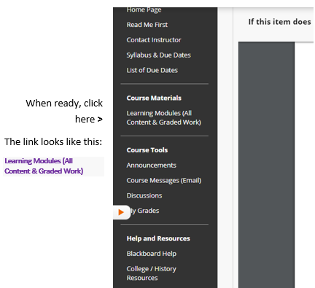 |  | - Now click on Getting Started.  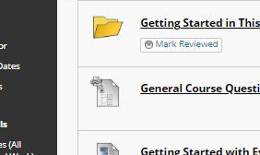  - At the top you see this. Skip it for now.  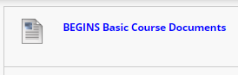  - Scroll down to this: do picture over with key to an da different course  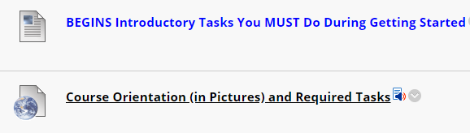  - Do each item from the top to the bottom in order.  - Start with Course Orientation and look at/think about the pictures. They are what I would show you online in the course if we were sitting together.  - The end of the Course Orientation link lists every task you need to do for the 50 points—and to do well in this class.
4 |  | 3

Key to Success with Learning Modules (All Content &Graded Work)
The word module means that something contains all—all content and work for a grade—that you need to complete a part of a course. Pass all modules and you pass the course. You do not have to hunt around—you just have to go in through the right door.

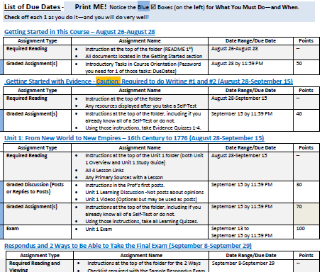
2 |  | 3

At Getting Started, What Do You Need on the Course Menu?

< When you come in the course, what you see 1st after Getting Started

<When you come in the course, what you see 1st during Getting Started
< Office hours, contact information – Ask! I am glad to help you.
< Use as a reference that is searchable using Ctrl-F (Ctrl with the F key)
<The only way to know when to prepare and what’s due and when
<Two methods to locate Course Materials (work you do in the course):
- Learning Modules (Blackboard’s word)–Safer method—Provides everything you need: from study guides, instructions, lessons, to primaries—including all of the Blackboard tools you use from assignments to quizzes to discussions to exams
- Shortcut to All Graded Work–Provides only Blackboard tools to submit work
<Blackboard tools that we use in this course
<Blackboard’s tool for public communication or public submission of writing by students.
< Blackboard’s tool for personal communication, such as feedback on your writing.
< Blackboard’s tool for public news.
< Blackboard’s tool for your personal view of your grades in the Gradebook.
Tip: Make sure that the upper right at My Grades shows Order by: Course order
<Additional information
- Videos from Blackboard to help you with Blackboard’s tools
- College links, such as to Disability Services.
- History links, such as an introduction to the discipline of history, a searchable and sorted US Constitution, Merriam-Webster Online Dictionary, and to a map website

Learning Modules (All
Content & Graded Work)

What’s on Learning Modules? (Everything you need in one spot.)
The Learning Modules page not only gives you access to whatever is listed in the List of Due Dates, but gives you reminders of what we will be available on the date in the List of Due Dates.
For example, this screen was made before the course opened. At 8:00 AM, that first item will be gone and you will see the actual Getting Started module. The word everything on the right side of the page means instructions, all content, all tools, and a discussion so you can ask (and answer) questions to get help and to get points.
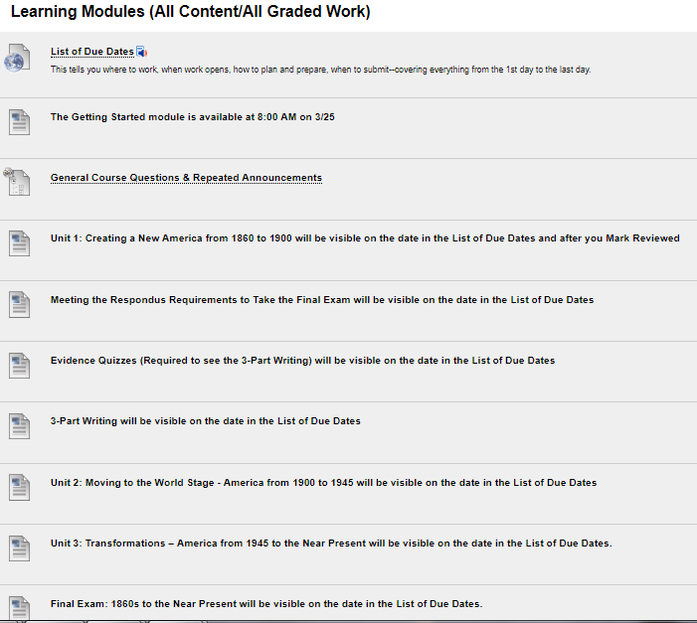
< Another location for the List of Due Dates
< Everything for Getting Started
< Another location for the General Discussion
< Everything for Unit 1
< Everything to meet the Respondus requirement
< Everything to learn about Evidence rules requirement
< Everything for the 3-Part Writing from content to the Discussion tool
< Everything for Unit 2

< Everything for Unit 3

<Everything for the Final Exam

What’s in a Unit? (All Units have the same things in the same order.)
All Units are organized in exactly the same way.
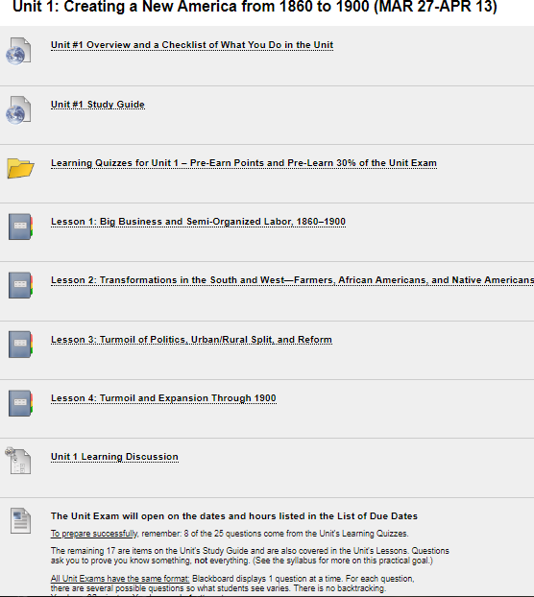 | < A reminder of what happens in the Unit
 | < The Study Guide for the Unit (and guide to 17 of 25 exam questions)
 | < Learning Quizzes for the Unit (and source of 8 of 25 exam questions)
 | < Usually 3 to 4 Lessons in each Unit to help you see the patterns of history not just for a good grade but as a life-time understanding
 | < Learning Discussion for the Unit
 | < Reminder of where the exam will be and tips

How Do You Know What to Do Where and When?
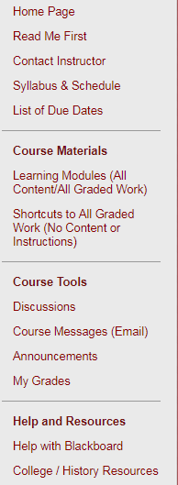
< Use the List of Due Dates for when and where to work

What’s All This Stuff about Self-Tests and Full-Tests: How Do They Look?
This shows an example from United States History I, but it is also applicable to United States History II>

Notice Blackboard Before You Take the Self-Test on Essential Terms
Units begin with a quiz on common concepts in history that freshman students commonly do not know.
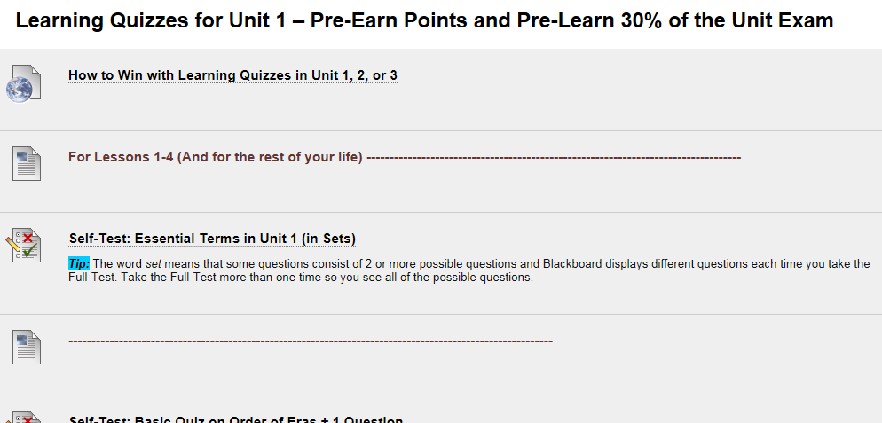

Notice Blackboard After You Take the Self-Test on Essential Terms
Notice the Self-Test is still there—and you cannot retake it, but you can still look at and you should. Why? You need to know what you know and what you have to learn.
Notice there is additional material to help you teach yourself and below that the Full-Test you can retake as many times as you want—with the highest score counting.

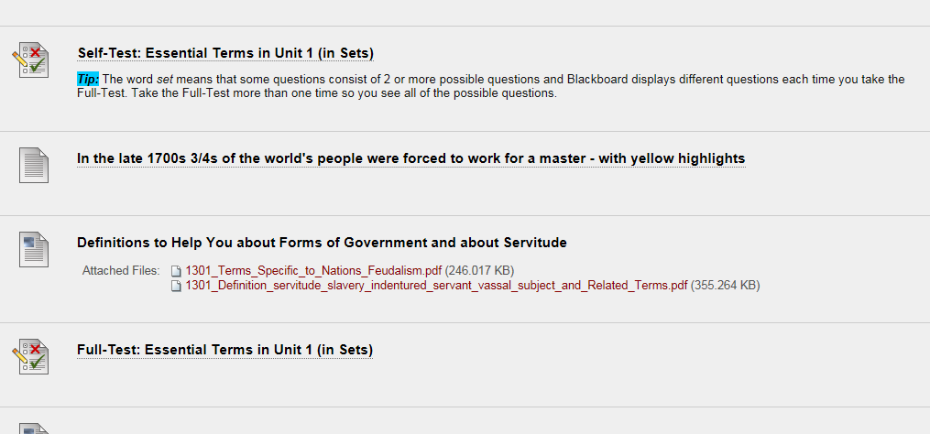

2

How Do Self-Tests and Full-Tests Work to Help You?
A common sense, brilliant thinker about learning says that what make the difference for learners is their knowing what they know and do not know. This course tries to make it possible for you to learn what you do not know without cost to you in your grade. One of the Good Deals in this class is we use Self-Tests and Full-Tests. Self-Testing lets people—without losing points— know what they know and do not know before they do graded work. Self-Testing helps people with two kinds of content:
- Content such as vocabulary words, concepts, and map locations—things best learned by drill (repeated, corrected practice)
- Content such as instructions for work that may seem similar to prior experience but may not be—things best realized by questions where a person must choose what he or she thinks the question means and then sees whether he or she caught on correctly
Here’s what the syllabus says about how they work to help you.

Method of Using Quizzes to Help Students with Varied Backgrounds:
Whether Learning Quizzes on concepts or map locations (200 points) or the Evidence Quizzes for history (40 points), quizzes always consist of:
- A self-test so you find out what you know and you do not know. The name is self-test because you are testing yourself so you know what you need to do.) The goal is positive so no points are lost. Self-Tests are extra credit and have questions that are only worth .01. (A .01 is so small that it is equivalent to a penny compared to a dollar.)
Tip: On the other hand, it is in your interest to answer Self-Tests accurately so measure your own brain accurately for 2 reasons.
  - You want to know what you know and do not know to save time and to correct or complete what you do not know. Caution: With Evidence Quizzes, this is particularly important because, if you miss many questions, you must follow instructions carefully because writing about history is different from your prior experiences.
  - If you already know the content in the Self-Test and prove that by being correct on over 80 percent of the questions on that Self-Test, you earn the points for its Full-Test without taking it.
Your instructor enters those points at the end of each Unit after the Learning Quizzes close.
- Once you submit the self-test, Blackboard automatically displays additional content (if needed) and a Full-Test so that you can earn full points while teaching yourself the vocabulary and map locations that you do not know. You may repeat as many times as you wish, and your highest score counts.

How Do Self-Tests and Full-Tests Work to Help You?  A common sense, brilliant thinker about learning says that what make the difference for learners is their knowing what they know and do not know. This course tries to make it possible for you to learn what you do not know without cost to you in your grade. One of the Good Deals in this class is we use Self-Tests and Full-Tests. Self-Testing lets people—without losing points— know what they know and do not know before they do graded work. Self-Testing helps people with two kinds of content:  - Content such as vocabulary words, concepts, and map locations—things best learned by drill (repeated, corrected practice)  - Content such as instructions for work that may seem similar to prior experience but may not be—things best realized by questions where a person must choose what he or she thinks the question means and then sees whether he or she caught on correctly |  | A Visual to Help You: How a Self-Test and its Full-Test Works  When you take a Self-Test, what happens is different dependent on:  - Whether you are right on 80% or more of the questions – shown on the left side  - Whether you are right on 79% or fewer of the questions – shown on the right side  Read each row side by side so you can compare what happens.
 |  | You take a Self-Test
 |  | ↙ | ↘
 |  | You are right 80% or more of the questions. Notice what you missed. | You are right 79% or fewer of the questions.  Jot down what you missed—not the whole question but brief words. Tip: You can always go back to look at the Self-Test again.
 |  | ↓ | ↓
 |  | Blackboard sometimes displays resources, such as dictionary definitions.  If you made more than a 0, Blackboard always displays the Full-Test. | Blackboard sometimes displays resources, such as dictionary definitions. If it does, use Ctrl-F (Find) to search the resources for what you missed. (Ask if you need help.)  If Blackboard does not display the Full-Test, you made a 0 on the Self-Test. (Tip: You can confirm that at My Grades.) Email your instructor in Course Messages the exact name of the Self-Test. I will reply back that I deleted the 0 so you can take the Self-Test again
 |  | ↓ | ↓
 |  | If you want to, you may take the Full-Test. | You take its Full-Test until you make the highest points.
 |  | When the Unit tests close,  your instructor enters Full points for you. | Your highest score counts.
 |  | ↓ | ↓
 |  | You have the Full points  because you already knew it. | You have the Full points  because you taught yourself.

Probably del
1st you take the Self-Test.
- With this Self-Test, I tell you 1 answer so you will be certain a least 1 question right. Notice it. Why?
- Worried That You Might Miss 1? Questions are only worth .01 (like a penny out of a $) and they are extra credit anyway.
Tip: If you did miss questions, be sure you look at Syllabus + Examples. If you do not understand why you missed a question, email me in Blackboard Course Messages or post a question in the General Course Questions & Repeated Announcements & Tips right below Getting Started.
2nd Blackboard displays 2 things for you to use:
- Link to the Syllabus + Examples –What do you do with it? Look at the tips at the top for finding what you want. Do make sure that you find what you missed on the Self-Test.
Tip: This is the same as the Syllabus & Due Dates except it does not have anything specific to a class (the front pages) or date (the last 2 pages). Syllabus + Examples has links to the examples I would show you if we were talking together. FYI: profs cannot put links in the syllabus so this is the best thing I could do for you.
Full-Test: The Course Is Different but It is a Very Good Deal. What do you do with it? Take the Full-Test until you get every question correct. You can repeat as many times as needed—and the highest score (20) counts.

Tasks You Do During Getting Started

Why Is Getting Started Only 3 Days? (Caution: 3 Days on a 16 week Calendar Is 6 Days on an 8-week Calendar)

What’s the Reality?
- In an 8-week course and every week in that 8 weeks, we have to complete 2 weeks’ work in 1 week. Faculty are not allowed—and we should not be—to reduce the assignments in an 8-week course. You will get full college credit for this class because you did the same amount of work as a student in a 16 week course.
- If we are not starting history work at the end of the first 3 days of class (actually 6 days of class), we cannot have enough of time for the regular required work by the end of the last day of class.

What’s the Attempt to Give All Students Their Best Chance?
- I cannot drop assignments for you as a class or for individuals in the class
- But I can try to offer flexibility to everyone in the class. Examples of Flexibility: Opening an exam over 3 days. Having writing assignments open for at least one weekend. Having the Unit’s Learning Quizzes and Learning Discussion open until the end of the Unit’s Exam. And such as the policy below for what happens if you come in after Getting Started is over.

Section from the Syllabus on Getting Started Activities and Trying to Give All Students Their Best Chance in Getting Started
The Getting Started activities are listed on the last page of the Course Orientation link. If you come in past the due date, you must still do these activities, but I will record—temporarily—a 1.11 for each grade with a Comment about the grade if it had been on time. At the end of the term, you email your instructor that you have not been late with any other assignments. I then change the 1.11 grades to match what I have entered in the Comment for that grade.

What Are the Tasks You Need to Do for the 50 Points and to Figure Out How This Course Is a Very Good Deal?
# | Assignments You Must Do in Getting Started (With those worth 0 points are reminders you to protect you.) | Points
1 | Take the quiz named Key to Success. The password is in the link for the List of Due Dates (in Getting Started and on the Course Menu). When you are looking for the password, look in the top section of the List of Due Dates—and in the copy provided at the top of Getting Started. | 5
2 | Tip: If you have questions about how Self-Tests and Full-Tests work, look at the prior 2 pages.  - Take the quiz named Self-Test: This Course Is Different but It Is a Very Good Deal.  - Each question is .01 points and you can only take a Self-Test 1 time so you must enter a password. The password is selftest. <Notice no capitals, no punctuation, no spaces.  - Tip: Blackboard can only display the next things if you have at least 1 question right. If you read the questions carefully in this test, you can tell easily one of the answer.s  - Notice which ones you missed.  - Blackboard automatically displays:  - The syllabus for this course with links to examples. – You look as much or little as you want except you should figure out any questions you missed. Tip: Scan down looking at any links that look like they may help you.  - The Full-Test (Each question 5 points).  - Take the Full-Test. If you do not get all 20 on the first try, take it again until you do. The highest grade counts. | 20
3 | Take the quiz named Syllabus Acknowledgement Quiz. (Caution: You must do it to stay in the course.) | 1
4 | Respond to the Required Before the Class Opens Email according to the directions. This is in your wcjc.edu email.  This is the only task you do that you do not do in Getting Started.  Caution: You do need to show that you can receive and, if needed, reply to emails in your wcjc account. In Blackboard if I write an announcement that the whole class might need (such as change), I also can automatically email it to your wcjc email. | 10
5 | Respond to the Required After the Class Opens Email according to the directions. Use the link Course Messages (Email) that is in Getting Started.  Cautions: You do need to show that you know how to reply to emails in Blackboard. Why? Your feedback on written work comes through Blackboard email and you do not get the points and are not able to see the next writing until you reply to that email per the directions. | 10
6 | Post your Introduction in the Discussion that your instructor placed for you in Getting Started.  Tip: In Course Orientation this is meant to be the last thing you do. You can earn 50 points and this is only 4 points. | 4
7 | Copy this link from the 1st page of the official syllabus into an email message (or any other tool that you have that you can get to from anywhere): Online at Blackboard Login Page Link Address: wcjc.blackboard.com. Why? WCJC has had times when we could not get to Blackboard through the WCJC connection. We have always been able to get to Blackboard from that Link Address. It has always been open. | 0
8 | Make sure you prepare your computer using the tips in Before Class email sent during week before this Course begins. That email also tells you about your needing to get the required textbook and the required external webcam. | 0
 | Total for this Section of the Course | 50

Art

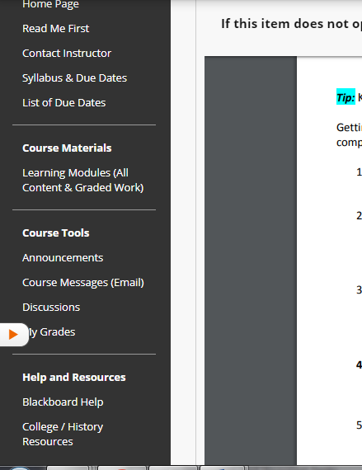
When ready, click here >
The link looks like this:

Learning Modules (All
Content & Graded Work)

Shell not used?????

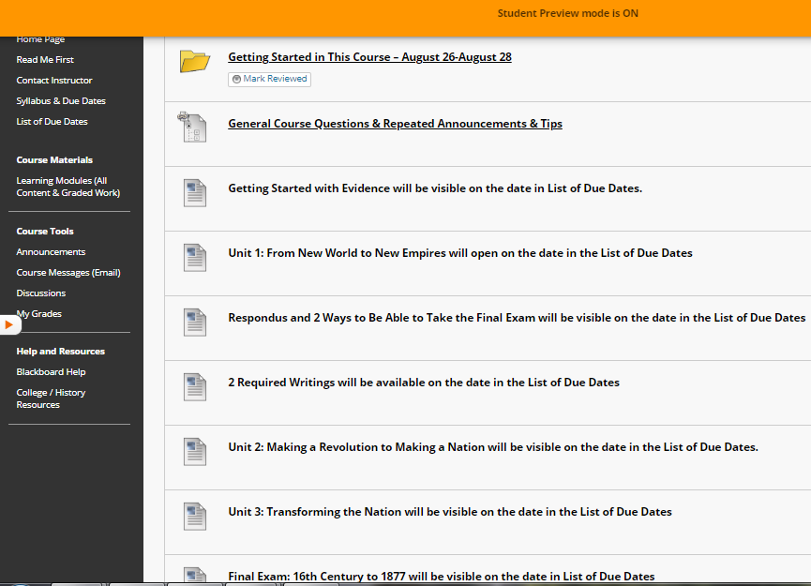
< All but 1 thing that you need for Getting Started is in this module. The exception is your access to your WCJC email.

Shell

2 |  | 3

