Course Orientation (in Pictures) & the List of Tasks You Do for Points in Getting Started
If there are other things that you need details or pictures about, just email me or post in General Course Questions & Repeated Announcements & Tips.
All but the tasks list are set up to look like a book with a left and right page side by side. It was the only way I could show things that I would tell you and draw for you if we were talking together. It is not pretty, but do read the left and right sides of the “book” together. The Tasks You Do During Getting Started are just on landscape pages.
What is in Course Orientation?
Title of the Page | Page # in the “Book”
How to Login and Succeed with this Course | 2
Caution: For Your Sake, Do Not Come Into the Course This Way | 3
1st Steps in Getting Started | 4-5
Key to Success with Learning Modules (All Content &Graded Work) | 6
What You See on Learning Modules (All Content & Graded Work) | 7
How to Find What You Need for Your Grade (and Brain) in Any Unit | 8-9
Things You Might Want to Do That Are on the Course Menu | 10
Details and Tips about My Grades | 11
How Do Self-Tests and Full-Tests Work to Help You? | 12
A Visual to Help You: How a Self-Test and its Full-Test Works | 13
Tasks You Do During Getting Started | 14

Quick and Temporary Note: Some of the illustrations are still of the 1301 course. Am still fighting a bug.

How to Login and Succeed with this Course  - Go to https://wcjc.blackboard.com  - You see a Login Here section on the left.  Before you login, notice the upper right section of the screen with the link Help & Resources. You must use that link to make sure your computer and browser work with this Blackboard.  FYI: I care about you all, but I am not a techy. WCJC’s IT can help (at Help & Resources). My 1 tech tip is—if your browser is not working or displaying what I say is there—try a different browser for a day.  - Follow the directions in the Login Here section for what you type in those 2 fields.  - Login on the Blackboard log in screen.  - On the left side of the new screen see the words My Courses.  - Look for our course and click on it.  Tip: the naming conventions for Blackboard courses are  - For US History I, look for the letters WWW 18 in the name  - For US History II, look for the letters WWW 28 in the name  - What you see when you click on the course varies with whether you log in.  - During Getting Started (usually the 1st three days), Blackboard displays Read Me First on the right side of your screen. After you have read it, click on Learning Modules (All Content & Graded Work) and then Getting Started. (Read Me First is also available in Getting Started.)  - After Getting Started has ended, Blackboard displays the Home Page and a list of Announcements.  Caution: You must click on Learning Modules and then Getting Started and do the tasks (50 points) listed at the end of this PDF. Email in the Course if you need help. A Before Class email and the syllabus cover how you can get points even though it is late.  - On the date when the first Unit opens, click on Learning Modules on the Course Menu and then Unit 1. |  | Caution: For Your Sake, Do Not Come Into the Course This Way  The Director of Distance Education at WCJC encourages students never to use what is called Blackboard’s Global Navigation.  The students that I have seen fail horribly used this tool in the upper right area next to the log out button.  Do NOT use this  ↓  A few examples of disasters from this way to come in the course:  - Students thought they were failing because they clicked on something they thought was My Grades—but it was not.  - Other students seem to think that they can click and go. They skip the instructions so they frequently fail and sometimes do work they did not need to do.  - Blackboard does not record that you are in the class so—as far as your instructor knows—you are not in the course.
2 |  | 3

1st Steps in Getting Started  In this class, “Read Me First” tells you what you do in Getting Started and where to do it. Blackboard automatically opens Read Me as the picture below shows:  - On the left, what Blackboard calls the Course Menu  - On the right, a bit of the right of the screen where Blackboard automatically displays the “Read Me First” file and fills the screen.  - Now click on Learning Modules (All Content & Graded Work).  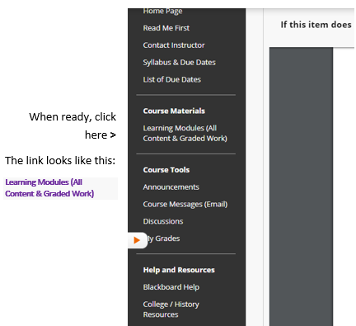 |  | - Now click on Getting Started.  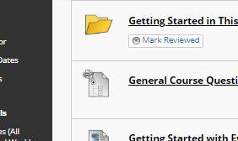  - At the top you see this. Skip it for now.  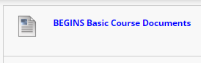  - Scroll down to this: 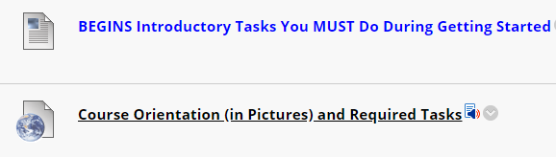  - Do each item from the top to the bottom in order.  - Start with Course Orientation and look at/think about the pictures. They are what I would show you online in the course if we were sitting and talking together.  - The end of the Course Orientation lists every task you need to do for the 50 points—and to do well in this class.
4 |  | 5

Key to Success with Learning Modules (All Content &Graded Work)  The word module means that something contains all—all content and work for a grade—that you need to complete a part of a course. Pass all modules and you pass the course.  You do not have to hunt around—you just have to come in the right door:  - The right door is Learning Modules (All Content & Graded Work)  - The Key to Success is the List of Due Dates  Notice that Getting Started in This Course is at the top:  - Of the List of Due Dates on this page  - Of Learning Modules (All Content & Graded Work) on the next page  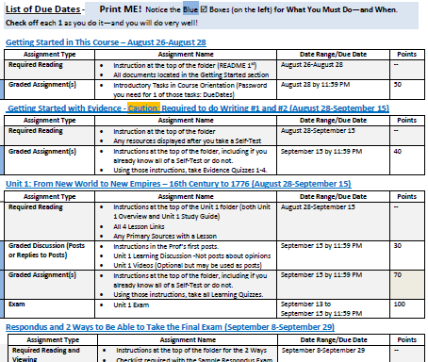  If you look at the 2nd page of the List of Due Dates, you will see the remaining modules down to the one for the Final Exam. |  | What You See on Learning Modules (All Content & Graded Work)  This page shows the screen in the first days of class. The open items are:  - Getting Started in This Course  - General Course Questions discussion  The rest of the items are placeholders. At 12:00 AM on the day in the List of Due Dates, Unit 1 will open. The others open on the List of Due Dates.  Each module begins with information to tell you what to do.  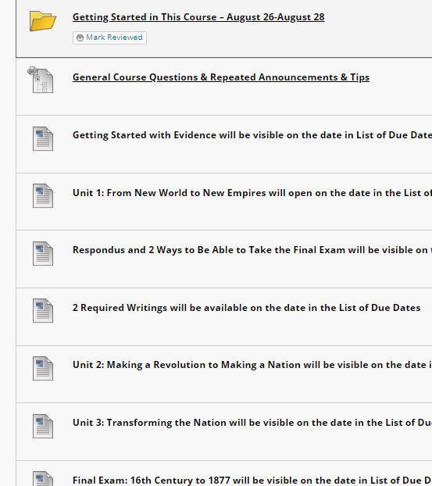
6 |  | 7

How to Find What You Need for Your Grade (and Brain) in Any Unit  All Units are organized in exactly the same way. All Units contain all content and all tools (Discussions and Exams) used with that content.  You want to use the Units to learn history—and the items together will help you do that. You also have the practical need to pass in a reasonable amount so the left column tells you how each part can help you pass the course.  A reminder of what you have to do and the points>  Guide to 17 of 25 exam questions>  Source of 8 of 25 exam questions>  Videos for Learning Discussion posts >  A part of content>  Learning Quizzes and Pre-Earning Points If Complete before the Exam  There are 200 points for Learning Quizzes in the 1000-point course, with the quantity varying with the Unit. Think of it this way:  - With an Exam, you can study hard (or so you try to do) but still make a low grade  - With Learning Quizzes in this class, you can:  - Either know the content before you came to class and prove it with a Self-Test (covered on 12-13) and get all the points  - Or use its Full-Test (covered on 12-13) repeatedly to help yourself drill and get all the points |  | The Remaining Parts of Unit 1 and all Units  This screen does not show Lessons 2 and 3.  A part of content>  A primary source>  Unit’s Discussion>  A placeholder for the Unit Exam>
8 |  | 9

Things You Might Want to Do That Are Available on the Course Menu  Scan down the left side looking for what you want to do.  Find out how to contact your instructor >  Know course work and course and WCJC policies >  Know when to prepare and what’s due and when >  In one place, all content, tools, and instructions >  Information from your instructor to the class >  Information between your instructor and you >  Tip: Use the discussion within the Learning Module >  Information from your instructor to you on grades >  Blackboard’s videos on how to use Blackboard >  College links, such as to Disability Services >  History Resources from your instructor >  History Resources  History resources include:  - Introduction to the discipline of history  - A searchable and sorted us constitution  - Merriam-Webster Online Dictionary-the only outside resource use for the Ask/Answer/Share moderated discussions  - Map website |  | Details and Tips about My Grades  This is Blackboard’s tool for your personal view of your grades in the Gradebook. It has the same data as the instructor’s gradebook, but it is not organized in the same way.  Tip about the Setting to Use to Display My Grades  Make sure that the upper right at My Grades shows:  Order by: Course order  If you have My Grades in Course order, you will be able to tell if you have missed some assignment. For example, you can tell if you never did the Full-Test.  Tip about Reading a Comment by a Grade or a 1.11 Grade  You instructor may place a comment by your grade. At My Grades, you can click on it to read what you need to do.  In this course, your instructor uses an odd series of numbers to indicate that you need to do something in order to solve a problem with a grade. If you see a number 1.11, do:  - Read the Comment  - Act quickly  - And ask if you need details (I posted the Comment and the 1.11 because I was trying to give you a chance and to avoid a lower grade.)
10 |  | 11

How Do Self-Tests and Full-Tests Work to Help You?  A common sense, brilliant thinker about learning says that what make the difference for learners is their knowing what they know and do not know. This course tries to make it possible for you to learn what you do not know without cost to you in your grade. One of the Good Deals in this class is we use Self-Tests and Full-Tests. Self-Testing lets people—without losing points— know what they know and do not know before they do graded work. Self-Testing helps people with two kinds of content:  - Content such as vocabulary words, concepts, and map locations—things best learned by drill (repeated, corrected practice)  - Content such as instructions for work that may seem similar to prior experience but may not be—things best realized by questions where a person must choose what he or she thinks the question means and then sees whether he or she caught on correctly  As the syllabus says, whether you are working with Learning Quizzes (200 points) or Evidence Quizzes (40 points), these quizzes work this way:  - A Self-Test lets you find out what you know and you do not know. To succeed, you need to measure yourself accurately—but with this grading system you do not lose points with Self-Tests. Self-Test questions are only extra credit and only worth .01 each. (Think of .01 as a penny to a $.)  - Once you submit the Self-Test and have at least 1 question correct, Blackboard automatically displays:  - Additional information If needed for you to succeed  - Full-Test with the same questions in the Self-Test, but with each question worth 1 or more points. With this grading system, you can earn full points while teaching yourself what you did not know. How? a) You may repeat as many times as you wish. b) Your highest score counts. If you persist, you can earn all of the possible points. That means you can pre-earn 24% of your grade if you complete them before the due dates.  12 |  | A Visual to Help You: How a Self-Test and its Full-Test Works  Password: selftest <Notice no spaces, no punctuation, no capitals  When you take a Self-Test, what happens is different dependent on:  - Whether you are right on 80% or more of the questions (left side)  - Whether you are right on 79% or fewer of the questions (right side)  Read each row side by side so you can compare what happens.
 |  | You take any Self-Test
 |  | ↙ | ↘
 |  | You are right 80% or more of the questions. Notice what you missed. | You are right 79% or fewer of the questions.  Jot down what you missed—not the whole question but brief words. Tip: You can always go back to look at the Self-Test again.
 |  | ↓ | ↓
 |  | Blackboard sometimes displays resources, such as dictionary definitions.  If you made more than a 0, Blackboard always displays the Full-Test. | Blackboard sometimes displays resources, such as dictionary definitions. If it does, use Ctrl-F (Find) to search the resources for what you missed. (Ask if you need help.)  If Blackboard does not display the Full-Test, you made a 0 on the Self-Test. (Tip: You can confirm that at My Grades.) Email your instructor in Course Messages the exact name of the Self-Test. I will reply back that I deleted the 0 so you can take the Self-Test again
 |  | ↓ | ↓
 |  | If you want to, you may take the Full-Test. | You take its Full-Test until you make the highest points.
 |  | When the Unit tests close,  your instructor enters Full points for you. | Your highest score counts.
 |  | ↓ | ↓
 |  | You have the Full points  because you already knew it. | You have the Full points  because you taught yourself.  13

Tasks You Do During Getting Started

If You Want to Know Why Getting Started Is Only 3 Days? (Caution: 3 Days on a 16 week Calendar Is 6 Days on an 8-week Calendar)

What’s the Reality?
- In an 8-week course and every week in that 8 weeks, we must complete 2 weeks’ work in 1 week. Faculty are not allowed—and we should not be—to reduce the assignments in an 8-week course. You will get full college credit for this class because you did the same amount of work as a student in a 16 week course.
- If we are not starting history work at the end of the first 3 days of class (actually 6 days of class), we cannot have enough of time for the regular required work by the end of the last day of class.

What’s the Attempt to Give All Students Their Best Chance?
- I cannot drop assignments for you as a class or for individuals in the class
- But I can try to offer flexibility to everyone in the class. Examples of Flexibility: Opening an exam over 3 days. Having writing assignments open for at least one weekend. Having the Unit’s Learning Quizzes and Learning Discussion open until the end of the Unit’s Exam. And such as the policy below for what happens if you come in after Getting Started is over.

Section from the Syllabus on Getting Started Activities and Trying to Give All Students Their Best Chance in Getting Started
The Getting Started activities are listed on the last page of the Course Orientation link. If you come in past the due date, you must still do these activities, but I will record—temporarily—a 1.11 for each grade with a Comment about the grade if it had been on time. At the end of the term, you email your instructor that you have not been late with any other assignments. I then change the 1.11 grades to match what I have entered in the Comment for that grade.

What Are the Tasks You Need to Do for the 50 Points and to Figure Out How This Course Is a Very Good Deal?
# | Assignments You Must Do in Getting Started (With those worth 0 points are reminders you to protect you.) | Points
1 | Take the quiz named This Course Is Different but It Is a Very Good Deal. The password is in the link for the List of Due Dates (in Getting Started and on the Course Menu). When you are looking for the password, look in the top section of the List of Due Dates—and in the copy provided at the top of Getting Started. The password is in yellow. | 5
2 | Tip: Before you do this, look at How Do Self-Tests and Full-Tests Work to Help You? and at A Visual to Help You: How a Self-Test and its Full-Test Works (  - Take the quiz named Self-Test: Dangerous Assumptions. The description with the quiz tells how this works and the password. It also tells you what Blackboard automatically displays:  - Blackboard automatically displays:  - The same questions that you saw followed by answers.  - The Full-Test (Each question 2 points).  - Take the Full-Test. If you do not get all 20 on the first try, take it again until you do. The highest grade counts. | 20
3 | Take the quiz named Syllabus Acknowledgement Quiz. (Caution: You must do it to stay in the course.) | 1
4 | Respond to the Required Before the Class Opens Email according to the directions. This is in your wcjc.edu email.  This is the only task you do that you do not do in the Getting Started folder. Here is the situation:  - Before the Blackboard course opened, it was fine to email me and for me to email you.  - After the Blackboard course opens:  - Anything you or I write that is to do with your grade or class policies needs to be in Course Messages (Blackboard’s email).  - I may from time to time write an announcement that the whole class might need immediately (such as change). In that case, I may email it to the entire class.  Caution: You do need to show that you can receive and, if needed, reply to emails in your WCJC account, but when the course opens, we need to do communications in Course Messages (Blackboard’s email). | 10
5 | Respond to the Required After the Class Opens Email according to the directions. Use the link Course Messages (Email) that is in Getting Started.  Cautions: You do need to show that you know how to reply to emails in Blackboard. Why? Your feedback on written work comes through Blackboard email and you do not get the points and are not able to see the next writing until you reply to that email per the directions. | 10
6 | Post your Introduction in the Discussion that your instructor placed for you in Getting Started.  Tip: In Course Orientation this is meant to be the last thing you do. You can earn 50 points and this is only 4 points. | 4
7 | Copy this link from the 1st page of the official syllabus into an email message (or any other tool that you have that you can get to from anywhere): Online at Blackboard Login Page Link Address: wcjc.blackboard.com. Why? WCJC has had times when we could not get to Blackboard through the WCJC connection. We have always been able to get to Blackboard from that Link Address. It has always been open. | 0
8 | Make sure you prepare your computer using the tips in General Course Questions & Repeated Announcements & Tips. That post also tells you about your needing to get the required textbook and the required external webcam. | 0
 | Total for this Section of the Course | 50

