Course Orientation – Key Pages & the List of Tasks You Do for Points in Getting Started
Tip: It helps if you realize that you need to measure your assumptions about distance learning/distance education classes. If you do not know why, do look at the test and what’s between the Self-Test and the Full-Test.

Title of the Page | Page # in the “Book”
How to Login and Succeed with this Course – same as the attachment sent before the class | 2
How Do Self-Tests and Full-Tests Work to Help You? | 12
A Visual to Help You: How a Self-Test and its Full-Test Works | 13
Tasks You Do During Getting Started | 14

When the Course 1st Opens, How to Login So You See What You Need  Use the information from your Before Class email before you start here. If you are used to coming in as shown at the bottom of this page, please do not  Instead, follow these steps:  - Go to https://wcjc.blackboard.com  - You see a Login Here section on the left. Notice the instructions:  - On the left, for what you enter in USERNAME and PASSWORD fields  - On the right, for this statement: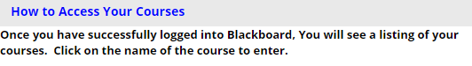  - Follow the directions in the Login Here section for what you type in the USERNAME and PASSWORD fields. Tip: For help, see How to Log In.  - Once you Login in, on the left of the new screen see the words My Courses.  - Look for our course and click on it. (This shows the instructor’s view for now.)  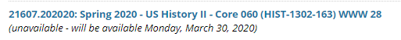  ------------------------------------------------------------------------------------------------------------  Caution: Do Not Come Into the Course This Way  The Director of Distance Education at WCJC encourages students never to use what is called Blackboard’s Global Navigation. The students who failed used this tool in the upper right area next to the log out button.  Do NOT use this  ↓ |  | . This course uses a List of Due Dates (clickable from the Course Menu on its left) that tells when everything shown below opens and when it is due and what you do for what number of points. The course is set up:  - For you do everything in one place—the Learning Modules (All Content & Graded Work). Everything means that you have in the folder:  - Not just content and instructions  - But also every assignment you do with that content  - For Blackboard to show work to you automatically as that work opens. Automatically means  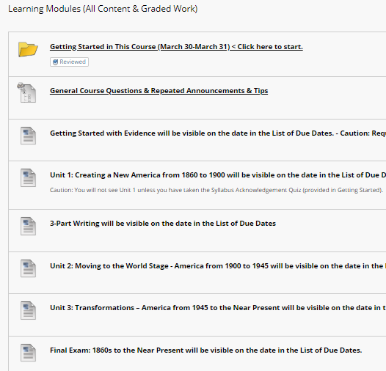
2 |  | 3

How Do Self-Tests and Full-Tests Work to Help You?  A common sense, brilliant thinker about learning says that what make the difference for learners is their knowing what they know and do not know. This course tries to make it possible for you to learn what you do not know without cost to you in your grade. One of the Good Deals in this class is we use Self-Tests and Full-Tests. Self-Testing lets people—without losing points— know what they know and do not know before they do graded work. Self-Testing helps people with two kinds of content:  - Content such as vocabulary words, concepts, and map locations—things best learned by drill (repeated, corrected practice)  - Content such as instructions for work that may seem similar to prior experience but may not be—things best realized by questions where a person must choose what he or she thinks the question means and then sees whether he or she caught on correctly  As the syllabus says, whether you are working with Learning Quizzes (200 points) or Evidence Quizzes (40 points), these quizzes work this way:  - A Self-Test lets you find out what you know and you do not know. To succeed, you need to measure yourself accurately—but with this grading system you do not lose points with Self-Tests. Self-Test questions are only extra credit and only worth .01 each. (Think of .01 as a penny to a $.)  - Once you submit the Self-Test and have at least 1 question correct, Blackboard automatically displays:  - Additional information If needed for you to succeed  - Full-Test with the same questions in the Self-Test, but with each question worth 1 or more points. With this grading system, you can earn full points while teaching yourself what you did not know. How? a) You may repeat as many times as you wish. b) Your highest score counts. If you persist, you can earn all of the possible points. That means you can pre-earn 24% of your grade if you complete them before the due dates.  12 |  | A Visual to Help You: How a Self-Test and its Full-Test Works  Password: selftest <Notice no spaces, no punctuation, no capitals  When you take a Self-Test, what happens is different dependent on:  - Whether you are right on 80% or more of the questions (left side)  - Whether you are right on 79% or fewer of the questions (right side)  Read each row side by side so you can compare what happens.
 |  | You take any Self-Test
 |  | ↙ | ↘
 |  | You are right 80% or more of the questions. Notice what you missed. | You are right 79% or fewer of the questions.  Jot down what you missed—not the whole question but brief words. Tip: You can always go back to look at the Self-Test again.
 |  | ↓ | ↓
 |  | Blackboard sometimes displays resources, such as dictionary definitions.  If you made more than a 0, Blackboard always displays the Full-Test. | Blackboard sometimes displays resources, such as dictionary definitions. If it does, use Ctrl-F (Find) to search the resources for what you missed. (Ask if you need help.)  If Blackboard does not display the Full-Test, you made a 0 on the Self-Test. (Tip: You can confirm that at My Grades.) Email your instructor in Course Messages the exact name of the Self-Test. I will reply back that I deleted the 0 so you can take the Self-Test again
 |  | ↓ | ↓
 |  | If you want to, you may take the Full-Test. | You take its Full-Test until you make the highest points.
 |  | When the Unit tests close,  your instructor enters Full points for you. | Your highest score counts.
 |  | ↓ | ↓
 |  | You have the Full points  because you already knew it. | You have the Full points  because you taught yourself.  13

What Are the Tasks You Need to Do for the 50 Points and to Figure Out How This Course Is a Very Good Deal?
# | Assignments You Must Do in Getting Started (With those worth 0 points are reminders you to protect you.) | Points
1 | Tip: Before you do this, look at How Do Self-Tests and Full-Tests Work to Help You? and at A Visual to Help You: How a Self-Test and its Full-Test Works (  - Take the quiz named Self-Test: Dangerous Assumptions. The description with the quiz tells how this works and the password. It also tells you what Blackboard automatically displays:  - Blackboard automatically displays:  - The same questions that you saw followed by answers.  - If needed, a link or other resource to help you see easily. For example, with these questions, if you missed something, you want to know what the reasoning is for that answer being incorrect. If you do not understand why something is incorrect, then talk to your prof.  - The Full-Test (Each question 2 points).  - Take the Full-Test. If you do not get all 20 on the first try, take it again until you do. The highest grade counts. | 20
2 | Notice the caution. Do be sure you find out why you missed it. Caution: You must make a 20 on this Full-Test to earn the extra 5 points and more than the points you want to know that your prof is probably is going to act differently than you would. | 5
3 | Take the quiz named Syllabus Acknowledgement Quiz. (Caution: You must do it to stay in the course. To ensure that that happens, you will not see Unit 1 folder unless you take this quiz. Do this during Getting Started so you do not forget.) | 1
4 | Respond to the Required Before the Class Opens Email according to the directions. This was sent to your wcjc.edu email before 3/30, when:  - The course opened  - And WCJC also changed its policy about the official email.  Here is the situation:  - Before the Blackboard course opened, faculty had long been told to contact students before the class opened, but things change  - After the Blackboard course opens and more importantly on 3/30, WCJC’s policy has changed and all communication between you and me must be in Blackboard Course Messages.  So here is the update on what you do:  - If you already replied to that email, thanks. It will count. On the other hand, let’s all avoid WCJC’s email unless WCJC’s policy changes.  - If you have not yet replied, go to the thread that I put in General Course Questions & Repeated Announcements & Tips (Also available in Discussions). Reply to it. It will count. | 10
5 | Respond to the Graded Email (for points and to prevent problems) according to the directions. Use the link Course Messages (Email) that is in Getting Started.  Cautions: You do need to show that you know how to reply to emails in Blackboard. Why? Your feedback on written work comes through Blackboard email and you do not get the points and are not able to see the next writing until you reply to that email per the directions. | 10
6 | Post your Introduction in the Discussion that your instructor placed for you in Getting Started.  Tip: In Course Orientation this is meant to be the last thing you do, not the only thing you do. You can earn 50 points and this is only 4 points. | 4
7 | Copy this link from the 1st page of the official syllabus into an email message (or any other tool that you have that you can get to from anywhere): Online at Blackboard Login Page Link Address: wcjc.blackboard.com. Why? WCJC has had times when we could not get to Blackboard through the WCJC connection. We have always been able to get to Blackboard from that Link Address. It has always been open. | 0
8 | Make sure you prepare your computer using the tips in General Course Questions & Repeated Announcements & Tips. That post also tells you about your needing to get the required textbook and the required external webcam. | 0
 | Total for this Section of the Course | 50

