Hi
The 2 screen examples are to help students avoid 2 problems.

Some students assumed that if they used Blackboard before, that the technical requirements to use it were the same or that new equipment the students had would work with Blackboard. For example, some students using unsupported browsers could not see links and quizzes. This link is meant to try to prevent that problem.

Making Sure Your Device and Browser Will Work with Blackboard
Use the “Computer Requirements” link before you login. It’s in the center of the login screen.
Tip: If your browser is not listed in the lower right hand corner, then you need to try another one.
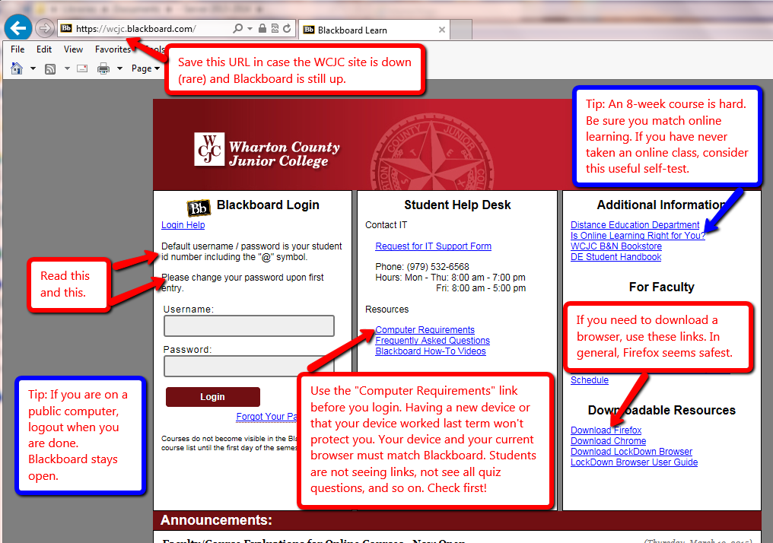

This is a “pathway” course and it is set up to help you if you follow the “path.” A “pathway” course is one of two broad types of distance learning courses that the Distance Learning Department encourages faculty to use. It is called a “pathway” course because it tries to provide a safe “path” for taking a distance learning course.

Thus far the students I have seen fail were entering through some shortcut method. Example, they clicked on a written exam and started trying to write. They didn’t realize that they could have seen all possible questions and prepared ahead if they had stayed on the “path.”

How to Enter Your Blackboard Course and Stay on the “Path”
Once in Blackboard, enter your course by clicking on it under the Course List—and no other way. For example, based on student comments, students who enter through some of the shortcut methods do not even see the instructions for exams or assignments. 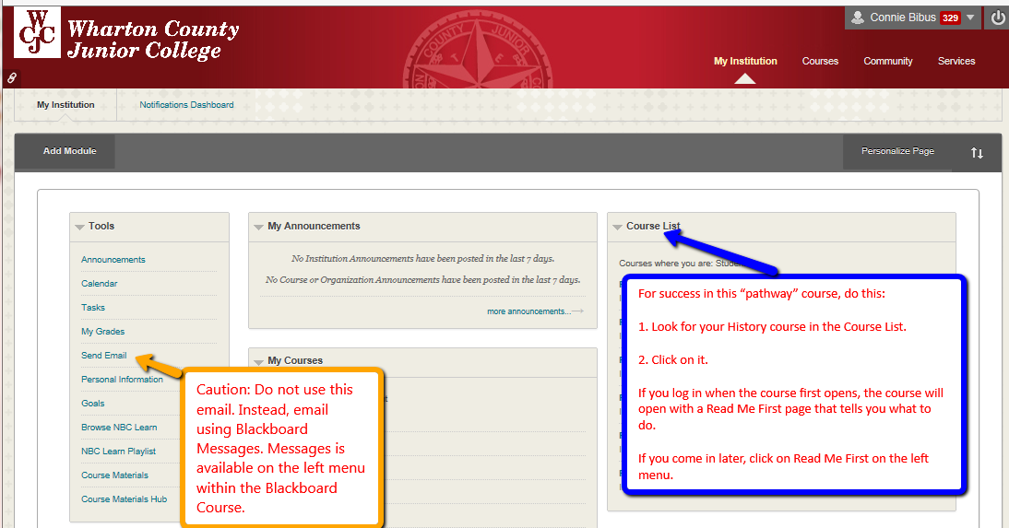

How to Go Directly to Getting Started
If you enter the course when it opens (and you should), Blackboard automatically displays the required items for Getting Starting—including the required “introductory tasks” you must do before the date in the Course Schedule. It also covers additional steps you must do immediately within the course.
Tip: If you enter the course late and Blackboard displays the Home Page, click on “Read Me First” on the left menu.

