What This Covers:
How “Pathway” Courses Save Time and Result in Higher Grades 1
How to Enter Your Blackboard Course and Stay on the “Path” 1
How to Go Directly to Getting Started 1

How “Pathway” Courses Save Time and Result in Higher Grades
A “pathway” course is one of two broad types of distance learning courses that the Distance Learning Department encourages faculty to use. A “pathway” course is not organized by the Blackboard tools you use, but by what you are trying to do. Everything you need to succeed with an assignment is in one place.

Example of How Using a “Pathway” Course Can Save Time and Result in a Higher Grade Because of Few Errors: If you are doing a writing assignment with required primaries, you will find in one place the instructions and the rubric used to grade the assignment, the primaries, any additional resources you might need, and the Blackboard tool you use to submit the written work.

Example of How Not Using the Path Can Waste Time and Result in a Lower Grade: Students who just click on the Unit 1 Objective, or Concept, or Written Exam through one of the shortcuts Blackboard provides usually fail. They do not realize that they could have seen all possible questions for each type of exam and prepared ahead if they had stayed on the “path” from the top of a Unit to the bottom.

How to Enter Your Blackboard Course and Stay on the “Path”
Once in Blackboard, enter your course by clicking on it under the Course List—and no other way
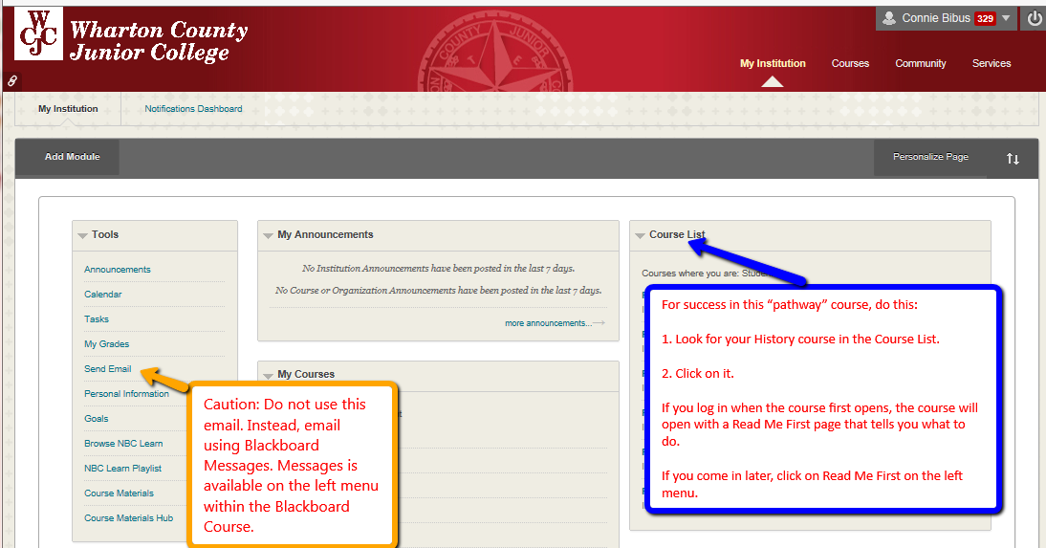

How to Go Directly to Getting Started
If you enter the course when it opens (and you should), Blackboard automatically displays the required items for Getting Starting—including the required “introductory tasks” you must do before the date in the Course Schedule. It also covers additional steps you must do immediately within the course.
Tip: If you enter the course late and Blackboard displays the Home Page, click on “Read Me First” on the left menu.

