Hi
This is not a sign of good skills with art, but of my concern about students, including about some students having technical problems. I do hope it helps. If you have questions, just ask.

Your history course is one of two broad types of distance learning courses that the Distance Learning Department encourages faculty to use. Some people call this type of course a “pathway” course because it tries to provide a safe “path” for taking a distance learning course.

Since this course may be different from what you have used before at WCJC or at other colleges, I’m providing these tips. This is not a substitute for your doing WCJC’s required Course Orientation, but a way:
- To avoid some technical problems that students in face-to-face and probably distance learning have been having
- To get you to that Orientation successfully and to help you avoid getting off the “path”

Making Sure Your Device and Browser Will Work with Blackboard and Logging into Blackboard
- Use the “Computer Requirements” link before you login.
- Log into Blackboard. You’ll need your Banner ID (@######## twice). Do change your password.
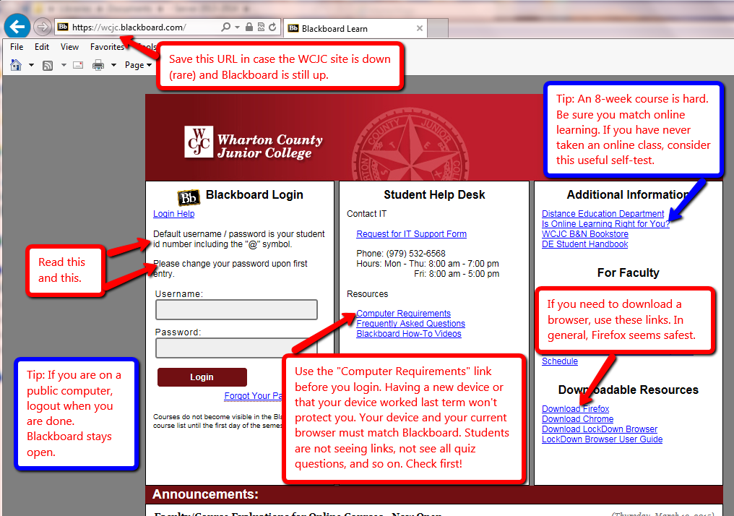

Once in Blackboard, enter your course in the way shown—and no other way.

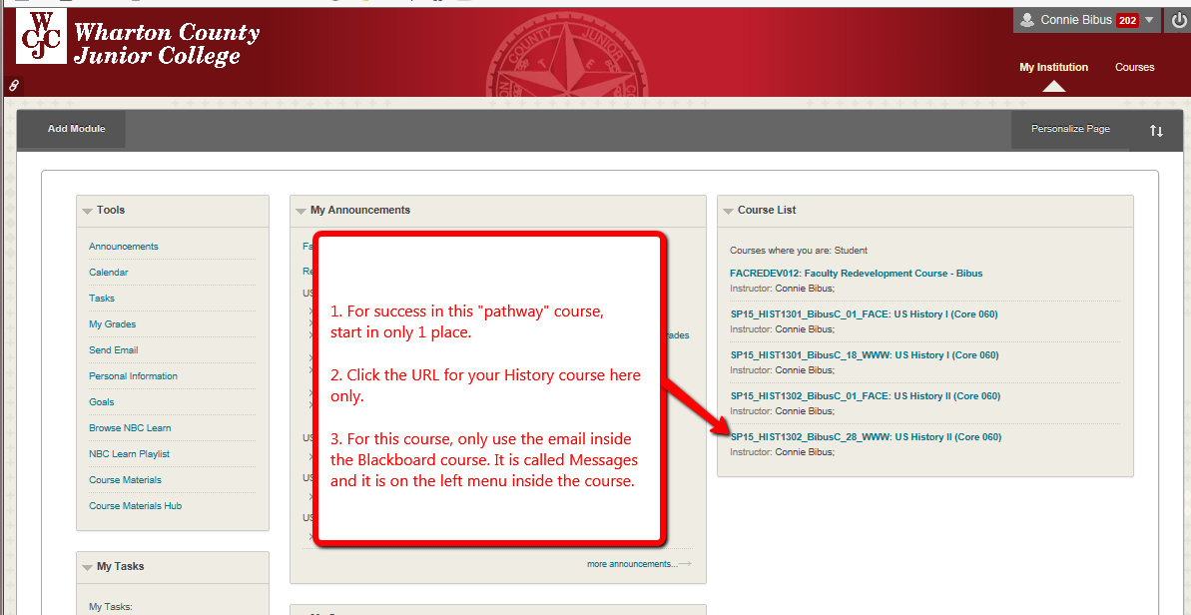

When you enter the course, Blackboard automatically displays the required items for Getting Starting—including the required “introductory tasks” you must do before the date in the Course Schedule.
