Hi
Just because a student used Blackboard before does not mean that the technical requirements are the same. In Spring term, some students using unsupported browsers could not see links and quizzes. This link is meant to try to prevent that problem.

Your history course is one of two broad types of distance learning courses that the Distance Learning Department encourages faculty to use. Some people call this type of course a “pathway” course because it tries to provide a safe “path” for taking a distance learning course.

Since this course may be different from what you have used before, I’m providing these tips. This is not a substitute for your doing WCJC’s required Course Orientation, but a way:
- To avoid some technical problems that students in face-to-face and probably distance learning have been having
- To get you to that Orientation successfully and to help you avoid getting off the “path”

Making Sure Your Device and Browser Will Work with Blackboard and Logging into Blackboard
- Use the “Computer Requirements” link before you login.
- Log into Blackboard. You’ll need your Banner ID (@######## twice). Do change your password.
If your browser is not listed in the lower right hand corner, then you probably need to download another one.
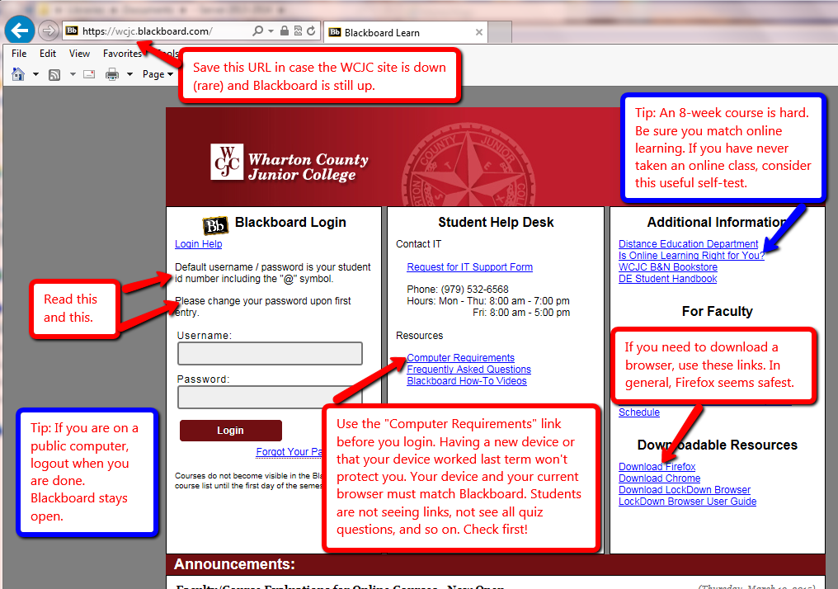

Once in Blackboard, enter your course in the way shown—and no other way.

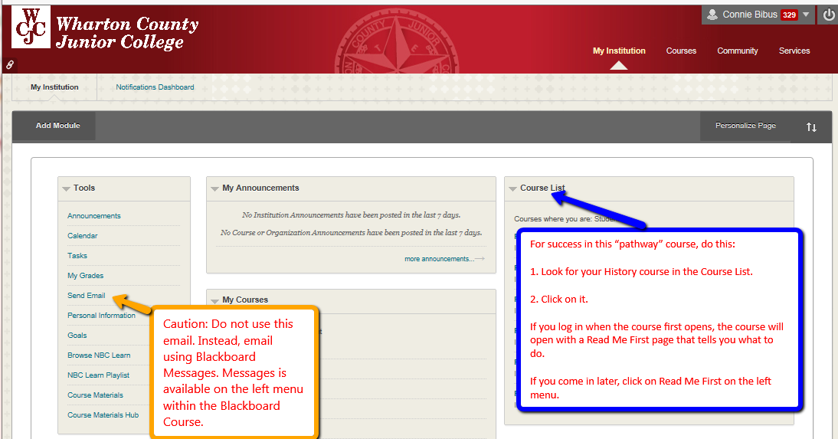

When you enter the course, Blackboard automatically displays the required items for Getting Starting—including the required “introductory tasks” you must do before the date in the Course Schedule.

