For success in this “pathway” course, do this:

1. Look for your History course in the Course List.

2. Click on it.

If you log in when the course first opens, the course will open with a Read Me First page that tells you what to do.

If you come in later, click on Read Me First on the left menu.

Caution: Do not use this email. Instead, email using Blackboard Messages. Messages is available on the left menu within the Blackboard Course.

You can click to display the Syllabus & Schedule from 2 places. Its last page is the Course Schedule—a key to doing your work on time. Tip: Print the 1-page Course Schedule. Check it off as you work and you will do well.
These are the two Blackboard tools you need during Getting Started.

The words and organization used are from the WCJC Distance Learning Department. They have given their permission for faculty to use them. (In other words, it is not plagiarism.)

Read Me First automatically opens on the right. It is a pdf so you can save it to your computer and leave it open until you complete each required task

In addition to Read Me First and the Syllabus & Schedule, these links cover the required introductory tasks.
The left menu is explained in Course Orientation.

Tip: Print the 1-page Course Schedule at the end of the Syllabus. Check it off as you work and you will do well.
These are the two Blackboard tools you need during Getting Started.

Hi
Just because a student used Blackboard before does not mean that the technical requirements are the same. In Spring term, some students using unsupported browsers could not see links and quizzes. This link is meant to try to prevent that problem.

Your history course is one of two broad types of distance learning courses that the Distance Learning Department encourages faculty to use. Some people call this type of course a “pathway” course because it tries to provide a safe “path” for taking a distance learning course.

Since this course may be different from what you have used before, I’m providing these tips. This is not a substitute for your doing WCJC’s required Course Orientation, but a way:
- To avoid some technical problems that students in face-to-face and probably distance learning have been having
- To get you to that Orientation successfully and to help you avoid getting off the “path”

Making Sure Your Device and Browser Will Work with Blackboard and Logging into Blackboard
- Use the “Computer Requirements” link before you login.
- Log into Blackboard. You’ll need your Banner ID (@######## twice). Do change your password.
If your browser is not listed in the lower right hand corner, then you probably need to try another one.
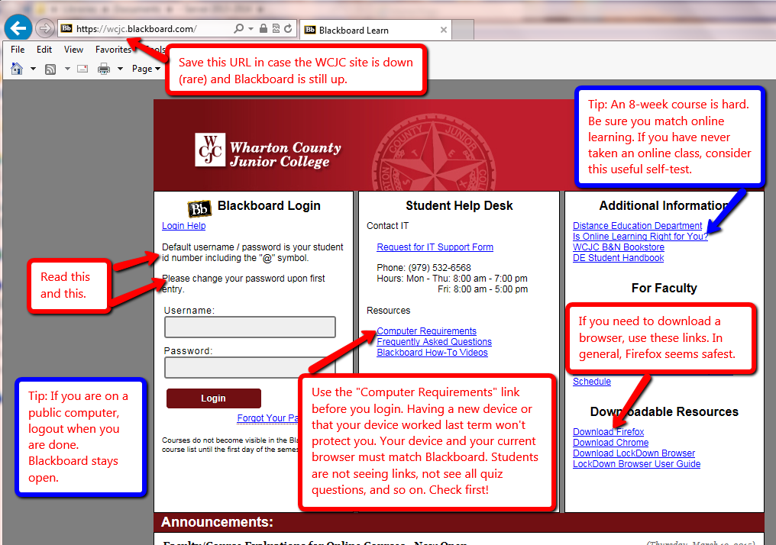

Once in Blackboard, enter your course in the way shown—and no other way.

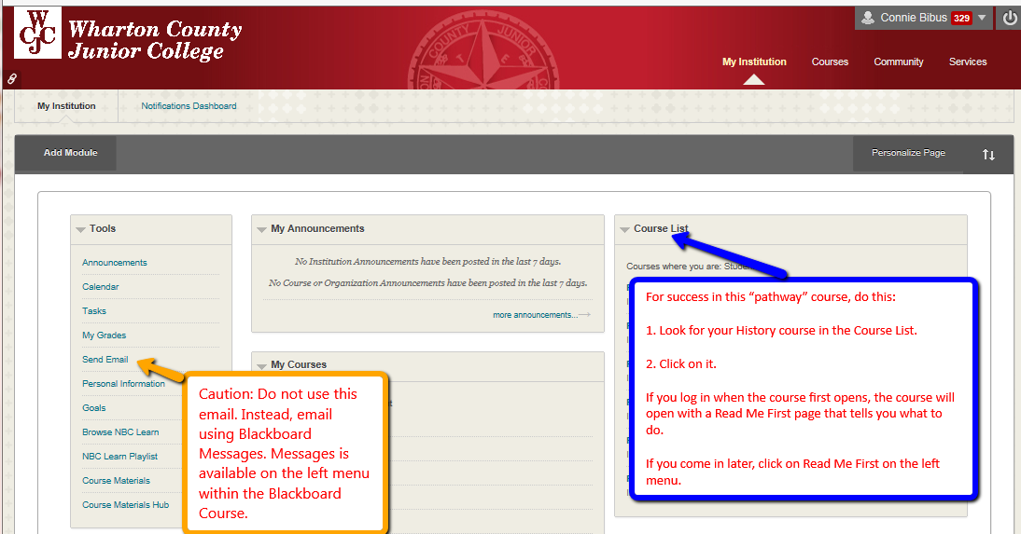

When you enter the course, Blackboard automatically displays the required items for Getting Starting—including the required “introductory tasks” you must do before the date in the Course Schedule.
