DL stuff on next page /OC below

Text for illustrations
This is a “pathway” course and it is set up to help you if you follow the “path.”

For success in this “pathway” course, come in this way only:

1. Look for your History course in the Course List.

2. Click on it.
Blackboard automatically displays the Learning Units & All Assignments page on the right.

Caution: You may use this email because it goes to my WCJC email address. You will, however, need to modify the subject line so I can recognize what you want.

Generally, announcements are done at the beginning of the class. You will see announcements for such things as how to determine your current letter grade at the end of a Unit.

DL stuff
Subject line: Read the attachment whether you are an experienced user of Blackboard or not and reply back to this email (Hint: I find small ways to reward people for acting in ways that help them succeed.)

I am sending this PDF with screen examples because of what happened in the Spring term. Some students assumed that if they used Blackboard before, that the technical requirements to use it were the same or that new equipment the students had would work with Blackboard. For example, some students using unsupported browsers could not see links and quizzes.

This PDF is meant to try to prevent that problem. It also shows you how to enter Your Blackboard Course so you go directly to Getting Started and the introductory tasks you must do in the first 2 days.

Text for illustrations
For success in this “pathway” course, do this:

1. Look for your History course in the Course List.

2. Click on it.

If you log in when the course first opens, the course will open with a Read Me First page that tells you what to do.

If you come in later, click on Read Me First on the left menu.

Caution: Do not use this email. Instead, email using Blackboard Messages. Messages is available on the left menu within the Blackboard Course.

You can click to display the Syllabus & Schedule from 2 places. Its last page is the Course Schedule—a key to doing your work on time. Tip: Print the 1-page Course Schedule. Check it off as you work and you will do well.
These are the two Blackboard tools you need during Getting Started.

The words and organization used are from the WCJC Distance Learning Department. They have given their permission for faculty to use them. (In other words, it is not plagiarism.)

Read Me First automatically opens on the right. It is a pdf so you can save it to your computer and leave it open until you complete each required task

In addition to Read Me First and the Syllabus & Schedule, these links cover the required introductory tasks.
The left menu is explained in Course Orientation.

Tip: Print the 1-page Course Schedule at the end of the Syllabus. Check it off as you work and you will do well.
These are the two Blackboard tools you need during Getting Started.

Hi
I am sending this PDF with screen examples because of what happened in the Spring term. Some students assumed that if they used Blackboard before, that the technical requirements to use it were the same or that new equipment the students had would work with Blackboard. For example, some students using unsupported browsers could not see links and quizzes. This link is meant to try to prevent that problem.

I am also providing this link because this is a “pathway” course and it is set up to help you if you follow the “path.” A “pathway” course is one of two broad types of distance learning courses that the Distance Learning Department encourages faculty to use. It is called a “pathway” course because it tries to provide a safe “path” for taking a distance learning course.

Since this course may or may not be different from what you have used before, I’m providing these tips. This is not a substitute for your doing WCJC’s required Course Orientation, but a way:
- To avoid technical problems that students have been having
- To get you to that Orientation successfully and to help you avoid getting off the “path”

Making Sure Your Device and Browser Will Work with Blackboard and Logging into Blackboard
- Use the “Computer Requirements” link before you login.
- Log into Blackboard. You’ll need your Banner ID (@######## twice).
- Do change your password.
Tip: If your browser is not listed in the lower right hand corner, then you need to try another one.
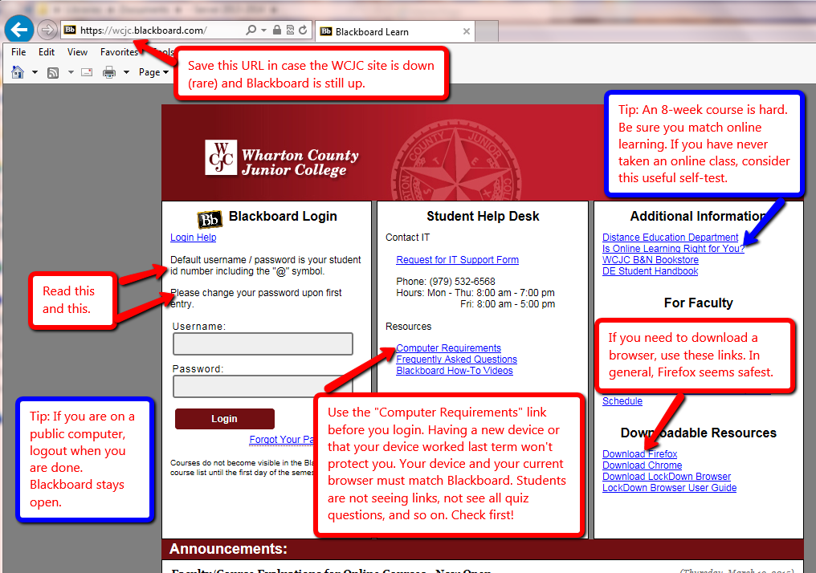

How to Enter Your Blackboard Course and Stay on the “Path”
Once in Blackboard, enter your course by clicking on it under the Course List—and no other way. 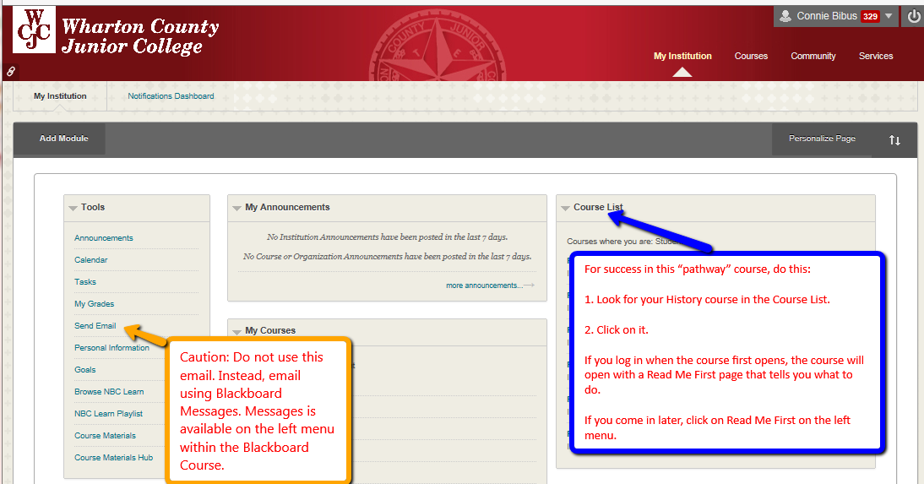

How to Go Directly to Getting Started
If you enter the course when it opens (and you should), Blackboard automatically displays the required items for Getting Starting—including the required “introductory tasks” you must do before the date in the Course Schedule.
Tip: If you enter the course late and Blackboard displays the Home Page, click on “Read Me First” on the left menuto display this screen.