Things to Do Before You Log in
- Use the “Computer Requirements” link before you login.
- If you are new to online learning Log into Blackboard. You’ll need your Banner ID (@######## twice).
- Do change your password.
Tip: If your browser is not listed in the lower right hand corner, then you need to try another one.
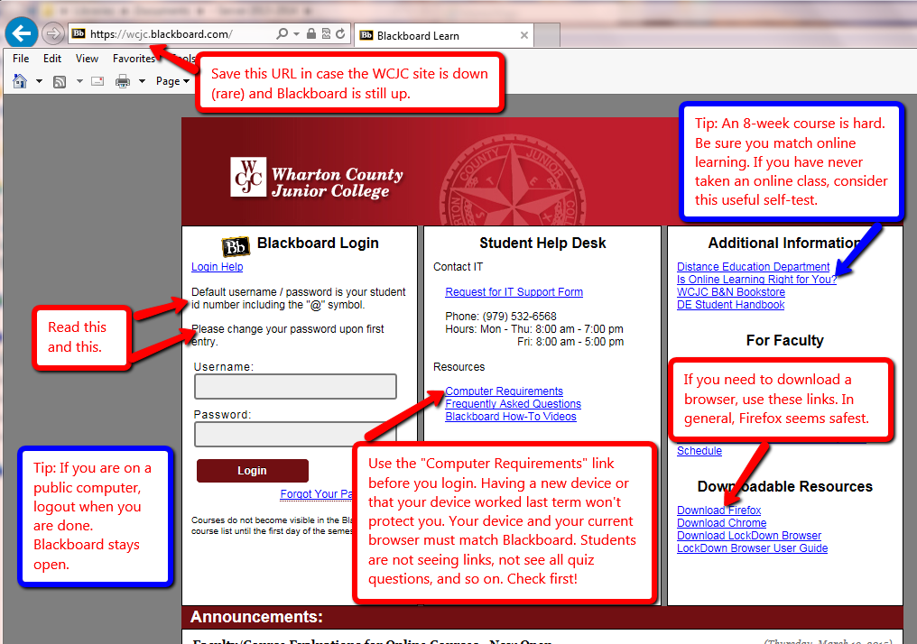

How to Enter Your Blackboard Course and Stay on the “Path”
Once in Blackboard, enter your course by clicking on it under the Course List—and no other way. For example, based on student comments, students who enter through some of the shortcut methods do not even see the instructions for exams or assignments.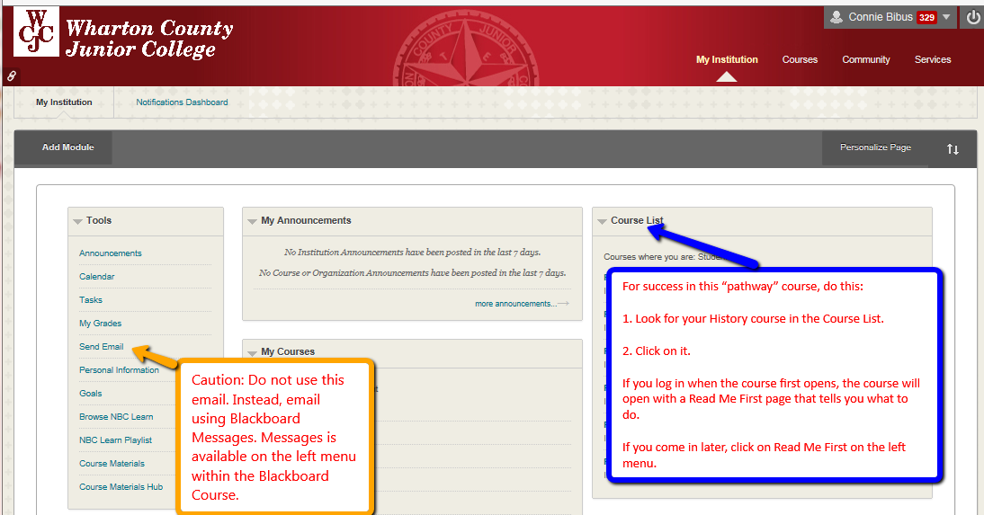

How to Go Directly to Getting Started
If you enter the course when it opens (and you should), Blackboard automatically displays the required items for Getting Starting—including the required “introductory tasks” you must do before the date in the Course Schedule. It also covers additional steps you must do immediately within the course.
Tip: If you enter the course late and Blackboard displays the Home Page, click on “Read Me First” on the left menu to display this screen.
