Hi
I am sending this PDF with screen examples because of what happened in the Spring term. Some students assumed that if they used Blackboard before, that the technical requirements to use it were the same or that new equipment the students had would work with Blackboard. For example, some students using unsupported browsers could not see links and quizzes. This link is meant to try to prevent that problem.

I am also providing this link because this is a “pathway” course and it is set up to help you if you follow the “path.” A “pathway” course is one of two broad types of distance learning courses that the Distance Learning Department encourages faculty to use. It is called a “pathway” course because it tries to provide a safe “path” for taking a distance learning course.

Since this course may or may not be different from what you have used before, I’m providing these tips. This is not a substitute for your doing WCJC’s required Course Orientation, but a way:
- To avoid technical problems that students have been having
- To get you to that Orientation successfully and to help you avoid getting off the “path”

Making Sure Your Device and Browser Will Work with Blackboard and Logging into Blackboard
- Use the “Computer Requirements” link before you login.
- Log into Blackboard. You’ll need your Banner ID (@######## twice).
- Do change your password.
Tip: If your browser is not listed in the lower right hand corner, then you need to try another one.
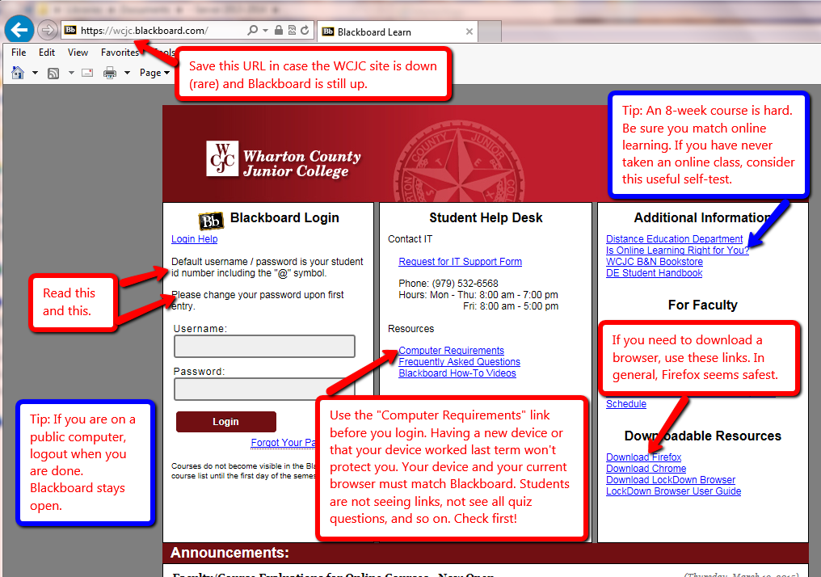

How to Enter Your Blackboard Course and Stay on the “Path”
Once in Blackboard, enter your course by clicking on it under the Course List—and no other way. 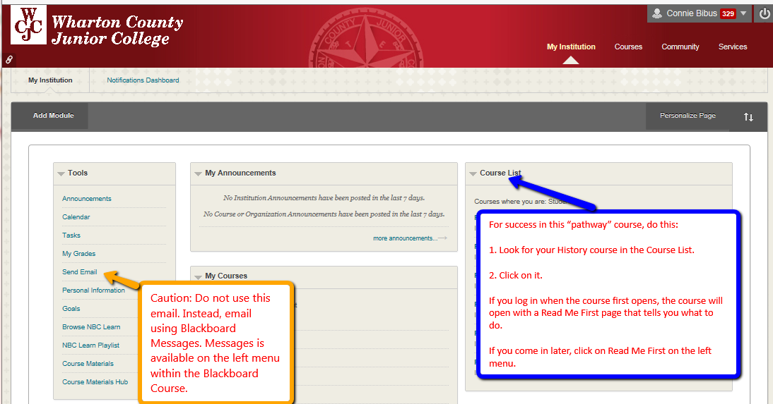

How to Go Directly to Getting Started
If you enter the course when it opens (and you should), Blackboard automatically displays the required items for Getting Starting—including the required “introductory tasks” you must do before the date in the Course Schedule.
Tip: If you enter the course late and Blackboard displays the Home Page, click on “Read Me First” on the left menu to display this screen.