America
a narrative history

The Essential Learning Edition

ONE VOLUME

Digital Products Registration and Purchase

1. Visit your book’s digital landing page: http://digital.wwnorton.com/amerele

2. Click on the big green button in the center of the page.

3. Select “No, I need to register, purchase, or sign up for trial access.”

4. Enter your name, school email [your name—such as Jo Young—as it is in Banner and the exact email address that WCJC assigned to you], and create a password.

5. As you complete registration, you’ll have three access options:

If you already have a registration code—Enter your registration code and click “Register my Code.”

If you want to purchase digital product access online—Select the “I want to purchase access” option.

If you want to try digital products before purchasing—Select the “I want to sign up for 21 days of free trial access” option.
For WCJC for this academic year: the free trial option is 180 days.

Stop! Once you register at the Norton website you must leave it and go within Blackboard. Do step 6 within Blackboard.

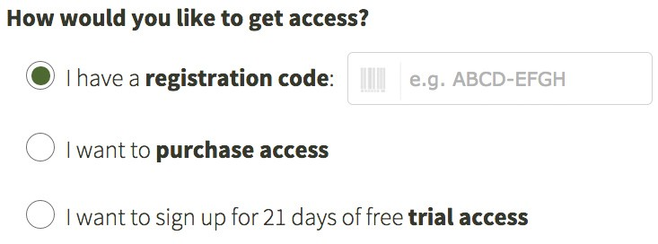6. Go back to Blackboard and complete registration by doing Chapter 1 InQuizitive there. Click these things in order:
Learning Units & All Assignments > Unit 1… > Chapter 1… > Chapter 1 InQuizitive (in the table of contents)
When you click on Chapter 1 InQuizitive, you see a box to sign in. Then try using InQuizitive. (Tip: It seems to take 33 or more points for InQuizitive to record points in Blackboard grades.
Do not worry about your grade. You can always make higher points. Using the link in Blackboard is how you get your grades stored in Blackboard. Your instructor is using LMS integration. To ensure your grades report to your instructor’s gradebook, after registration you will need to sign-in to InQuizitive at least once from the InQuizitive link(s) your instructor has added to your Learning Manage- ment System (Blackboard, Canvas, D2L, Moodle) course.

Need help?
If you need help, 1st contact your instructor by email or by calling her office number 281.239.1577.
Open a help desk ticket at support.wwnorton.com. Provide us: Your school
Your instructor’s name
Your section name

Modified for WCJC in the sections made yellow.
W. W. Norton & Company, Inc. • Independent and Employee-owned
wwnorton.com/history • Contact your local Norton representative at wwnorton.com/college/contact

