Evidence-Based Grading of History, Experts in Your Future, and Your Being Able to Become an Expert If and When You Need to Be
Experts and the 5 Good Habits for Evidence 1
Using Questions (With Answers Provided) and Examples to Introduce You to Evidence 1
Example 1: Citing a page as the source when Internet sites say the words but the page doesn’t 2
Example 2: Citing a specific detail when the page does not say that anywhere. 2
Example 3: Plagiarism or “half-copy” plagiarism because of the dangerous habit of typing with the source open. 4
Experts in Your Future – Without Answers 5
Evidence-Based Grading and Experts in Your Future – With Answers 6

Experts and the 5 Good Habits for Evidence
You will find an introduction to the Good Habits for Evidence in the link right below this one. It covers would anyone pay you for the actions that do not follow the Good Habits. . It also provides tips for each Good Habit.

Using Questions (With Answers Provided) and Examples to Introduce You to Evidence
- The History Department requires that all history courses require 30% of the course grade be for written assignments. With a 1000-point course like this one, that mean writing assignments consist of 300 points. The math shows (and there is an example in the Syllabus & Link to Examples on the Course Menu to help you realize this), you must try to do writing assignments if you want to make even a C.
- *True
- False

- Your instructor requires that you:
- Use only the required textbook. The syllabus and an emailed announcement tell you its title, author, and ISBN. (Note to me: cover the alternative)
- Use only the required primaries. They are all provided in the course.
- Cite from those required sources every fact that you write for any of the 3-Part F.I.O. Project whether the fact is in your own words or in the author’s words (a quotation).
- If you use the author’s words, not only use quotation marks correctly but also cite.
- Read and write carefully—and without exaggeration (embellishing) and without unsupported conclusions (cherry-picking as one part of this error).
- Carefully select facts for your answer to match the question.
- Proof carefully.
- *All of the above.

- Your instructor takes a long time to grade because she grades every written assignment that every student does side-by-side with the page of the textbook or the page from the primary that the student cited.
- *True
- False

- Question 2 (actually the 5 Good Habits for Evidence) and Question 3 together mean that not only can your prof easily recognize if you used a source other than the required ones, but also she can quickly prove that you did.
- *True
- False

Below are examples from prior students (and a prior textbook) on errors in facts and after Question 5 on plagiarism.

Example 1: Citing a page as the source when Internet sites say the words but the page doesn’t
Color added but the words are exactly what the student wrote.  One major event that lead to the American Revolution was the sugar act. The British government had a policy known as Mercantilism which is idea that trade generates wealth, this policy lead the British government to form new ideas on how to enhance their treasury. (Essentials,112) This was when the Sugar act came to be. This act imposed a tax of six pence per gallon of molasses. (Essential, 122) The British Government also came up with the Stamp act which imposed all American colonists to pay a tax on ever piece of printed paper they used. (Essentials, 125) These new policies angered the colonists to the point were they responded violently and added to the big conflict of the American Revolution. (Essentials, 125). | 112  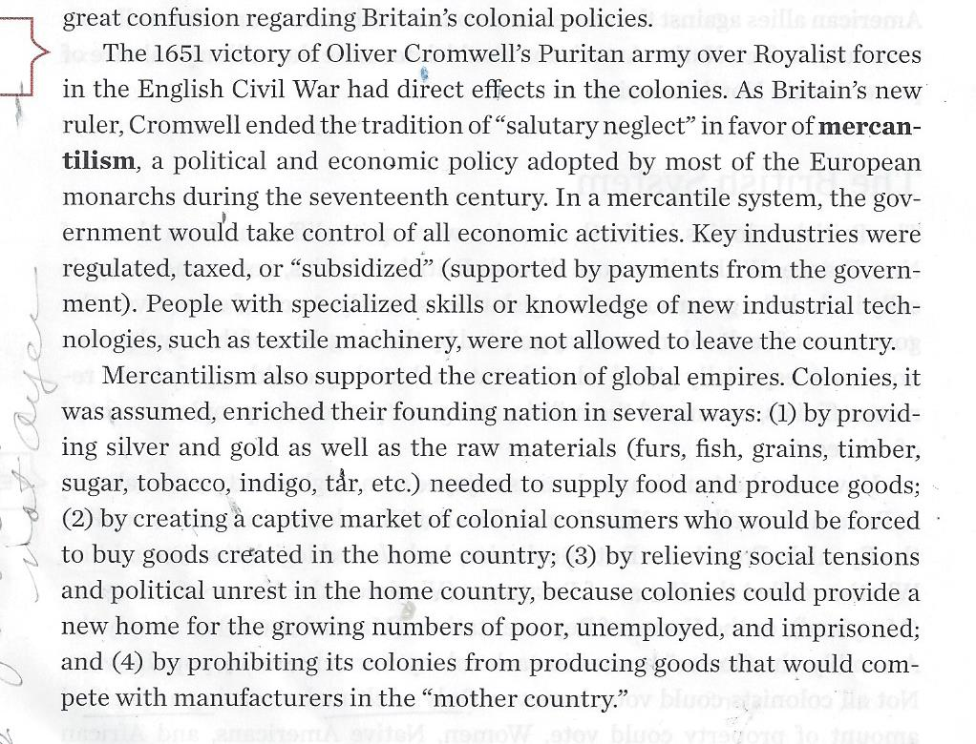

Example 2: Citing a specific detail when the page does not say that anywhere.
122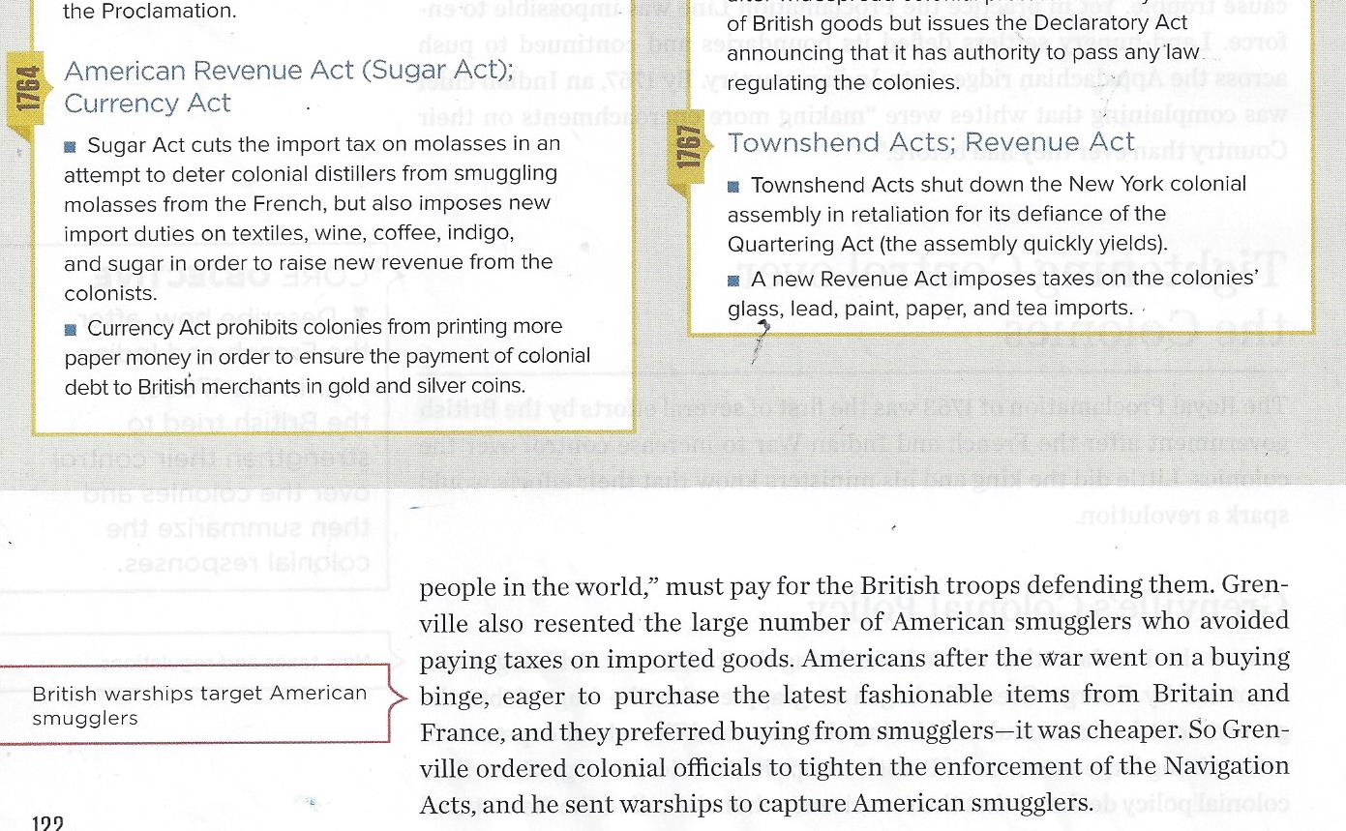

- Question 2 (actually the 5 Good Habits for Evidence) and Question 3 together mean that your prof or anyone can easily recognize and quickly prove if you copied the words from our required sources without quotation marks. According to standard rules for evidence, your doing that means you plagiarized or, at a minimum, did what the Bedford Handbook calls “half-copy” plagiarism.
- *True
- False

The plagiarism and “half-copy” plagiarism are on the next page.
The examples with errors also showed that everything changes if others have the same sources you have and you are required to provide a specific page number for the fact or a quoted statement.
With the conditions above, others can quickly know and prove:
- You misunderstood those facts.
- You plagiarized or “half-copy” plagiarized and you were presenting other people’s creation as your own.

It is not just possible to catch these things. It is hard not to see them.

FYI: I still write on papers in order to make me pay attention and be able to remember accurately if you ask for details, but I now provide feedback with the Discussion Rubric.
Background about this example: I would not have marked this brief an example, but this was a lovely student who was trying to replace her habit of just passively moving words around. She said her English teacher said it was right. I knew her English teacher so…

Example 3: Plagiarism or “half-copy” plagiarism because of the dangerous habit of typing with the source open.
Think of preventing these errors as an exercise program: Open/Close. You need to open to read and to close before you type.

The student slipped back into her habit of “half-copy” plagiarism with spinning, sewing, and weaving.

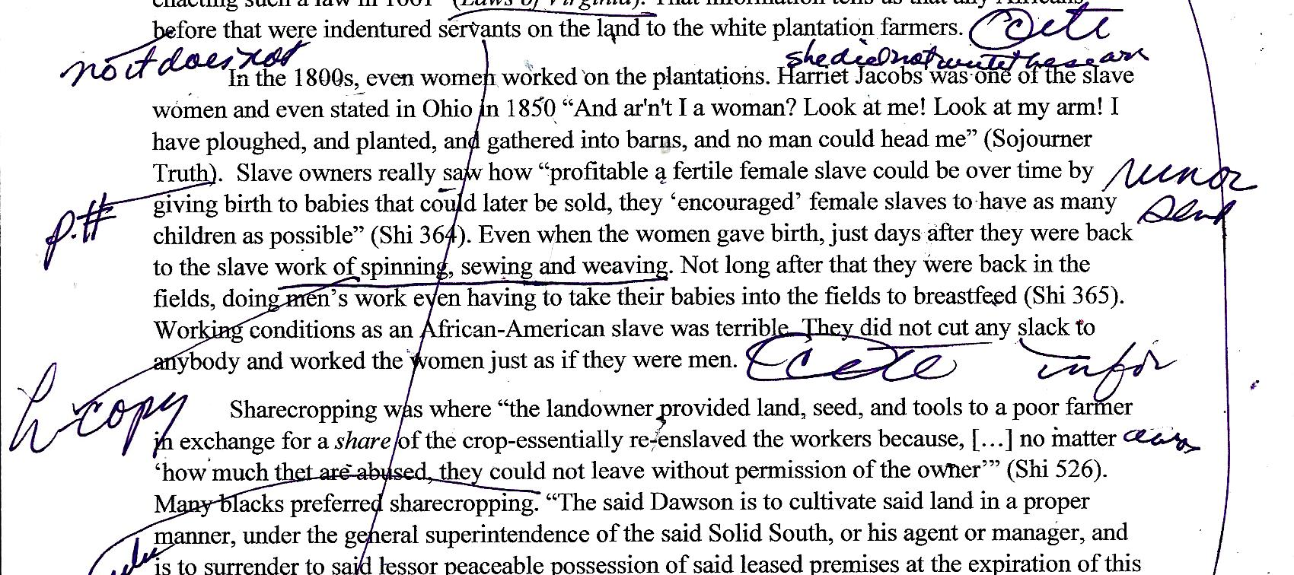
spinning, sewing, and weaving – and I showed the English teacher the source and we agreed the student could have avoided “half-copy” plagiarism if the student had not written the series of words exactly or if she had either:
- Used only 1 example such as weaving
- Used quotation marks accurately to show who created the words: “spinning, weavng, or sewing.”

Caution: The fundamental problem with plagiarism and “half-copy” plagiarism is:
- Not just classified as cheating
- But students who are accustomed to doing this slide into it again unless they teach themselves the habit of never typing with the book open.

Experts in Your Future – Without Answers
This is what I have seen in work and academic experiences. FYI: Bosses may not notice from your writing that you did a bad job of figuring things out, but they will know if what you argue for loses the company money or customers. Caution: If you personally are making a decision that can change your future, you also want to be able to be an expert if and when you need to be.
If the writer/speaker did not follow Good Habit # | Would a teacher expert in composition notice? | Would a boss who pays you who is expert in the business notice? | Would an upper-level professor who can write a letter of reference for you and who is expert in the discipline notice? | Would an instructor using your prof’s method notice? | Will you notice if you use my method with the 2nd Part F.I.O. Project?
1. Use reliable sources
2.Use a source that fits the question
3.Did not proof their work
4. and plagiarized or “half-copy” plagiarized
5. and changed the meaning of the author or made the author look incompetent with language

Evidence-Based Grading and Experts in Your Future – With Your Prof’s Answers
This is what I have seen in work and academic experiences. FYI: Bosses may not notice from your writing that you did a bad job of figuring things out, but they will know if what you argue for loses the company money or customers. Caution: If you personally are making a decision that can change your future, you also want to be able to be an expert if and when you need to be.
Orange = Shows habits that may be working for you now, but might hurt you in your future
Blue = Shows that building stronger habits is not high tech but common sense practices that will help you.
If the writer/speaker did not follow Good Habit # | Would a teacher expert in composition notice? | Would a boss who pays you who is expert in the business notice? | Would an upper-level professor who can write a letter of reference for you and who is expert in the discipline notice? | Would an instructor using your prof’s method notice? | Will you notice if you use my method with the 2nd Part F.I.O. Project?
1. Use reliable sources | No | Yes | Yes | Yes | Yes
2.Use a source that fits the question | No | Yes | Yes | Yes | Yes
3.Did not proof their work | No | Perhaps | Probably | Yes | Yes
4. and plagiarized or “half-copy” plagiarized | No | Probably not | Probably | Yes | Yes
5. and changed the meaning of the author or made the author look incompetent with language | No | Probably not | Probably on meaning and perhaps on language errors varying from the author | Yes | Yes

- When you do any written assignment, you need to do everything listed in Question 2.
- *True
- False

- When you do the 2nd Part F.I.O. Projects (work that earns large points in this course) and if you want those large points, you must look for everything listed in Question 2 and you must grade using the same method explained in Question 3.
- *True
- False

- Question 2 (actually the 5 Good Habits for Evidence) and Question 3 together—something your prof did by accident until she realized the power of it. Combined with my long experience in academia and industry where people had to understand new things, your prof realized that any teacher using this method can give the same type of feedback on your understanding of reality that you will experience from:
- A boss—one you hope will want to keep paying you.
- A professor in your career field—one you hope will write a reference for you.
- *Both of the above.

- Question 2 (actually the 5 Good Habits for Evidence) and Question 3 together plus the content already required by the History Department let you practice habits for figuring out something small that requires similar habits needed for larger tasks such as:
- Making a personal decision that could change your career, health, money—your life
- Getting to do a job that requires you to solve problems and not just repeat other peoples’ solutions
- Completing an academic assignment for an upper level professor in your career field
- Succeeding—if that is what you want--at your own business
- *All of the above.

- What is different in these history assignments from the real world is that:
- In industry you will probably not place citations within your written work, but you can better know exactly your proof for every fact that you say or write.
- In academics, different disciplines follow different standards for citation.
- *Both of the above

- Your instructor is willing to try to help every student because practicing these habits can make every student’s future easier. Just ask.
- *True
- False

