Evidence-Based Grading of History, Experts in Your Future, and Your Choosing to Become an Expert When You Need to Be
Experts and the 5 Good Habits for Evidence 1
Quick Questions to Introduce You. 1
Evidence-Based Grading and Experts in Your Future – Without Answers 5
Evidence-Based Grading and Experts in Your Future – With Answers 6

Experts and the 5 Good Habits for Evidence
http://www.cjbibus.com/Getting_Started_Good_Habits_for_Evidence_Would_anyone_pay_you_for_this_skill.pdf

Quick Questions and Examples to Introduce You to Evidence.
- The History Department requires that all history courses require 30% of the course grade be for written assignments. With a 1000-point course like this one, that mean writing assignments consist of 300 points. The math shows (and there is an example in the Syllabus & Link to Examples on the Course Menu to help you realize this), you must try to do writing assignments if you want to make even a C.
- *True
- False

- Your instructor requires that you:
- Use only the required textbook. The syllabus and an emailed announcement tell you its title, author, and ISBN. (Note to me: cover the alternative)
- Use only the required primaries. They are all provided in the course.
- Cite from those required sources every fact that you write for any of the 3-Part F.I.O. Project whether the fact is in your own words or in the author’s words (a quotation).
- If you use the author’s words, not only use quotation marks correctly but also cite.
- Read and write carefully—and without exaggeration (embellishing) and without unsupported conclusions (cherry-picking as one part of this error).
- Carefully select facts for your answer to match the question.
- Proof carefully.
- *All of the above.

- Your instructor takes a long time to grade because she grades every written assignment that every student does side-by-side with the page of the textbook or the page from the primary that the student cited.
- *True
- False

- Question 2 and question 3 together mean that not only can the instructor easily recognize if you used a source other than the required ones, but also she can quickly prove that you did.
- *True
- False

Below are examples from prior students. FYI: I had promised examples from recent students who gave me permission to use their papers, but I could not make things sufficiently protected.

Example 1: Citing a page as being the source when the page does not say that.
One major event that lead to the American Revolution was the sugar act. The British government had a policy known as Mercantilism which is idea that trade generates wealth, this policy lead the British government to form new ideas on how to enhance their treasury. (Essentials,112) This was when the Sugar act came to be. This act imposed a tax of six pence per gallon of molasses. (Essential, 122) The British Government also came up with the Stamp act which imposed all American colonists to pay a tax on ever piece of printed paper they used. (Essentials, 125) These new policies angered the colonists to the point were they responded violently and added to the big conflict of the American Revolution. (Essentials, 125). | 112  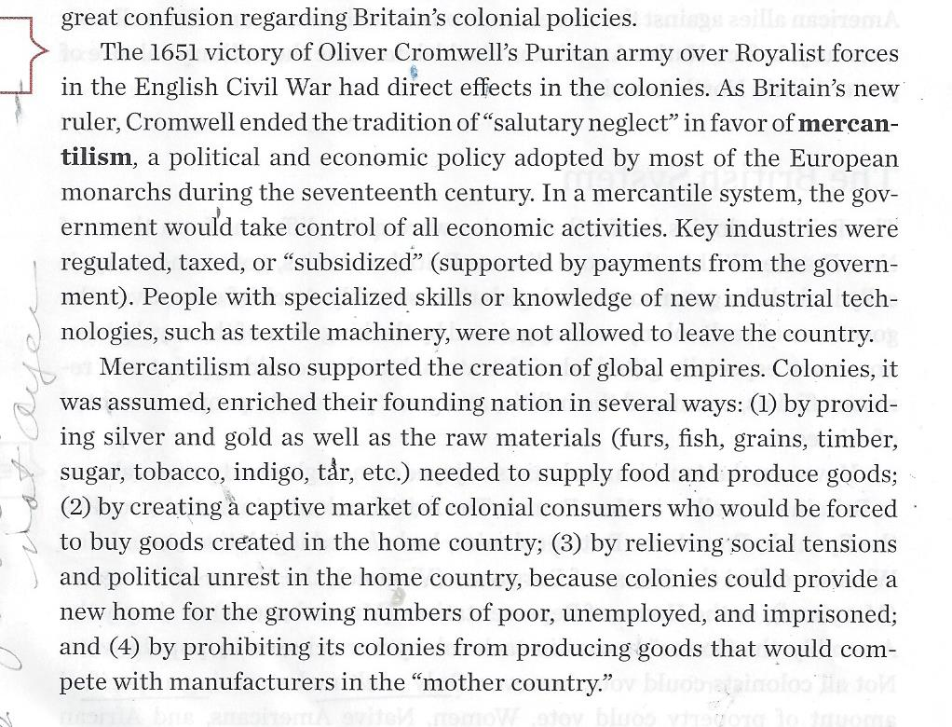

Example 2: Citing a specific detail as being the source when the page does not say that.
122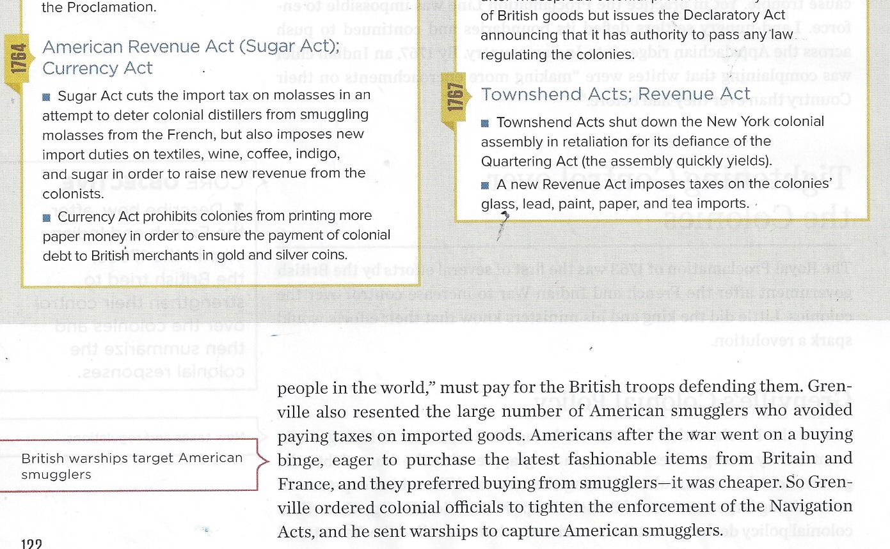

- Question 2 and Question 3 together mean that the instructor can easily recognize and quickly prove if you copied the words from our required sources without quotation marks. According to standard rules for evidence, your doing that means you plagiarized or, at a minimum, did what the Bedford Handbook calls “half-copy” plagiarism.
- *True
- False

Tip: I write on papers in order to make me pay attention and be able to remember if you ask for details, but students no longer look at that unless they ask to. Background: This was a lovely student who was trying to replace her habit of just passively moving words around. She said her English teacher said it was right. I knew her English teacher so….
Example 3: “Half-copy” plagiarism because of the dangerous habit of typing with the source open. Think of preventing as an exercise program. You need to open to read and to close before you type.

by habit spinning, sewing, and weaving and my label of it as “half-copy” plagiarism

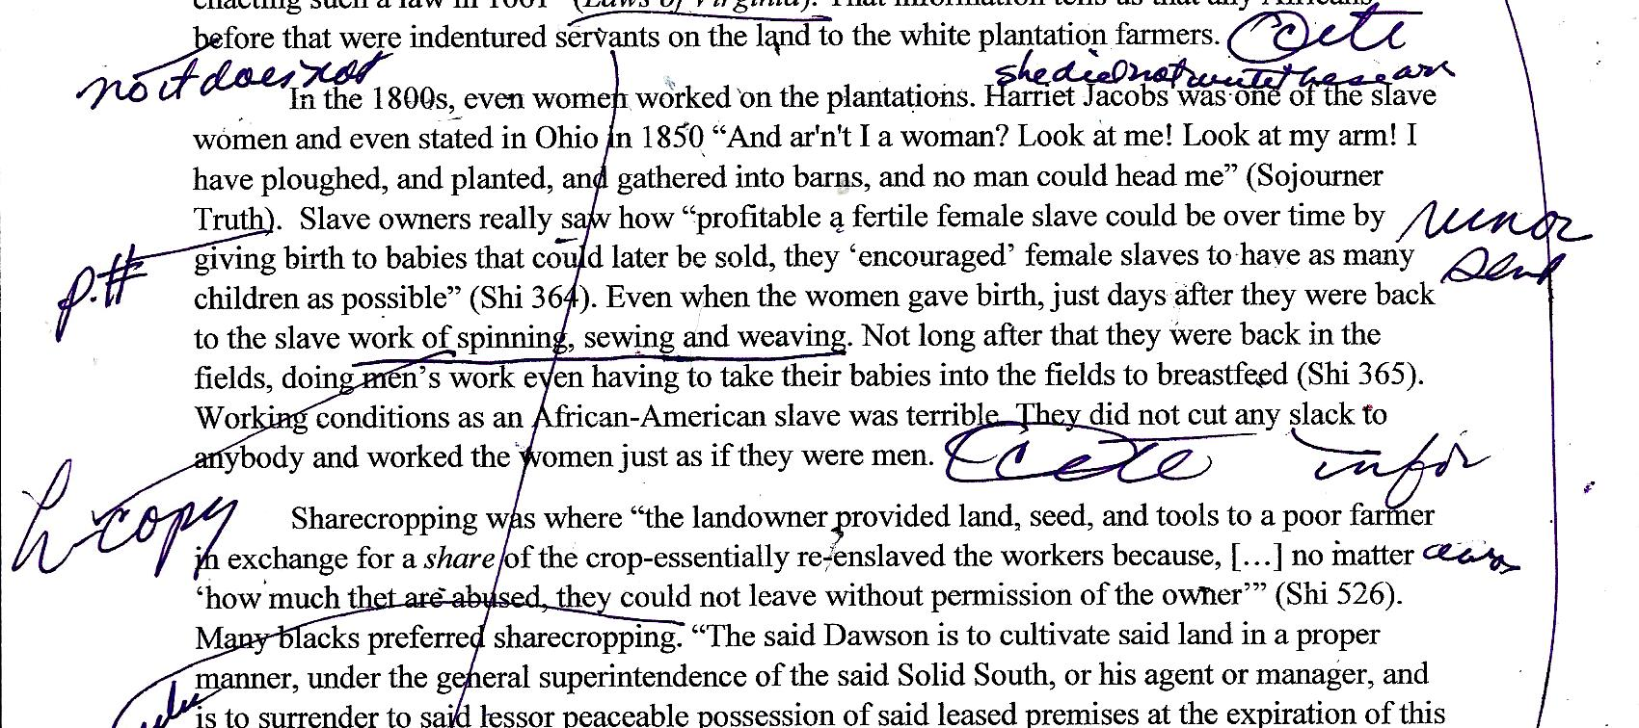
spinning, sewing, and weaving – and the English teacher and I agreed the student could have avoided
“half-copy” plagiarism if the student had not written it exactly or if she had:
- Used only 1 example such as weaving
- Used quotation marks accurately to show who created the words: “spinning, weavng, or sewing.”

Caution: The fundamental problem with “half-copy” plagiarism is:
- not just a little bit of cheating
- but also a lot of NOT paying attention.

Experts in Your Future – Without Answers
GH = Good Habit
If the writer/speaker | Would a teacher expert in composition notice? | Would a boss who pays you who is expert in the business notice? | Would an upper-level professor who can write a letter of reference for you and who is expert in the discipline notice? | Would an instructor using my method notice? | Will you notice if you use my method with the 2nd Part F.I.O. Project?
GH1: used reliable source
GH2: used a source page that fits the question
GH3: proofed very rigorously
GH4: plagiarized or “half-copy” plagiarized
GH5: changed the meaning of the author or made the author incompetent with language

Evidence-Based Grading and Experts in Your Future – With Answers
This is what I have seen in work and academic experiences. FYI: Bosses may not notice from your writing that you did a bad job, but they will know if what you argue for loses the company money or customers.
If the writer/speaker | Would a teacher expert in composition notice? | Would a boss who pays you who is expert in the business notice? | Would an upper-level professor who can write a letter of reference for you and who is expert in the discipline notice? | Would an instructor using my method notice? | Will you notice if you use my method with the 2nd Part F.I.O. Project?
GH1: used reliable source | No | Probably | Probably | Yes | Yes
GH2: used a source page that fits the question | No | Perhaps | Probably | Yes | Yes
GH3: proofed very rigorously | No | Perhaps | Probably | Yes | Yes
GH4: plagiarized or “half-copy” plagiarized | No | Probably not | Probably | Yes | Yes
GH5: changed the meaning of the author or made the author incompetent with language | No | Probably not | Probably on meaning and perhaps on language errors varying from the author | Yes | Yes

- When you do any written assignment, you need to do everything listed in Question 2.
- *True
- False

- When you do the 2nd Part F.I.O. Projects (work that earns large points in this course) and if you want those large points, you must look for everything listed in Question 2 and you must grade using the same method explained in Question 3.
- *True
- False

- Question 2 and Question 3 together—an admitted accident—combined with my long experience in academia and industry where people had to understand new things meant that your instructor realized that any teacher using this method can give the same type of feedback on your understanding of reality that you will experience from:
- A boss—one you hope will want to keep paying you.
- A professor in your career field—one you hope will write a reference for you.
- *Both of the above.

- Question 2 (actually the 5 Good Habits for Evidence) and Question 3 together plus the content already required by the History Department let you practice habits for figuring out something small that requires similar habits needed for larger tasks such as:
- Making a personal decision that could change your career, health, money—your life
- Doing a job that requires you to solve problems and not just repeat other peoples’ solutions
- Completing an academic assignment for an upper level professor in your career field
- Succeeding at your own business
- *All of the above.

- What is different in these history assignments from the real world is that:
- In industry you will probably not place citations within your written work, but you can better know exactly your proof for every fact that you say or write.
- In academics, different disciplines follow different standards for citation.
- *Both of the above

- Your instructor is willing to try to help every student because practicing these habits can make every student’s future easier. Just ask.
- *True
- False

