Evidence-Based Grading of History, Natural Evidence-Based Grading and Experts in Your Future. and Your Choosing to Become an Expert
A Brief Guess about Why 1
Experts and the 5 Good Habits for Evidence 1
The Evidence Acknowledgement Quiz and Your Questions 1
Issues in Class 6
Content Issues and How to Deal with Them– have some other issues to type 6
The Rubric and Your Graded Paper 6
The Rubric and Your Peer Review and What You Do 7

A Brief Guess about Why
Previously, instructors graded for evidence and plagiarism without having to work at it. Here are possible reasons for the change:
- Previously, few sources in local library to copy/read from
- Previously, no Internet to easily copy/read from
- Previously, segregation of smartest women—Before the late 1980s, those women who wanted to think about their disciplines taught in the public high school.
- And there are more if you want to hear them

Also a boss who knows his or her business will recognize your errors as quickly as those instructors.

Experts and the 5 Good Habits for Evidence
Click here for common sense reasons for why employers will expect you to follow all 5 Good Habits for Evidence. (URL -http://www.cjbibus.com/Getting_Started_Good_Habits_for_Evidence_Would_anyone_pay_you_for_this_skill.htm

The Evidence Acknowledgement Quiz and Your Questions
- The History Department requires that all history courses require 25% of the course grade be for written assignments. With a 1000-point course like this one, that mean writing assignments consist of 250 points. The math shows (and there is a link in the Course Plan to help you realize this), you must try to do writing assignments if you want to make even a C.
- *True
- False

- Your instructor requires that you:
- Use only the required textbook as your source when you write the short papers required in this class. The syllabus tells you its title, author, and ISBN.
- Some writing also requires specific primaries provided in the Blackboard course.
- Cite from those required sources every fact that you write for any writing assignment whether the fact is in your own words or in the author’s words (a quotation).
- If you use the author’s words, use quotation marks correctly and also cite.
- Read and write carefully—and without exaggeration and without unsupported conclusions.
- Carefully select facts for your answer to match the question.
- Proof carefully.
- *All of the above.

- Your instructor takes a long time to grade because she grades every written assignment that every student does side-by-side with the page of the textbook or the page from the primary that the student cited.
- *True
- False

- Question 2 and question 3 together mean that not only can anyone (whether instructor instructor using this method,easily recognize if you used a source other than the required ones, but also she can quickly prove that you did.
- *True
- False

Examples to How Instructors and Peer Reviewers (and Bosses Who Need You to Solve Problems) Can Easily Recognize—and Prove—the Student Made Avoidable Errors
If you follow the method your instructor uses in grading your papers when you grade your peer review, you can easily recognize errors and can prove them.
Example 1: Yellow highlighting shows tWhen you compare the paper on the leftand the source on the yellow issue, the meaning for mercantilism is different. There is nothing in the textbook author’s work what I marked with yellow on the left.On the other hand, when I entered “traAde generates wealth,” Google displayed—as I expected—websites that phrase.
What the Prior Textbook Provided on this Subject | What the Student Wrote
Page 112: ‘As Britain’s new ruler, Cromwell ended the tradition of ‘salutatory neglect’ in favor of mercantilism, a political and economic policy adopted by most of the European monarchs during the seventeenth century. In a mercantile system, the government would take control of all economic activities….[ The section goes on to discuss colonies providing] “raw materials,”… “a captive marked of colonial consumers who would be forced to buy goods created in the home country,”… and “a new home for the growing numbers of poor, unemployed, and imprisoned.” [Further, countries believing in mercantilism stopped] “colonies from producing goods that would compete with manufacturers in the ‘mother country.’” | One major event that lead to the American Revolution was the sugar act. The British government had a policy known as Mercantilism which is idea that trade generates wealth, this policy lead the British government to form new ideas on how to enhance their treasury. (Essentials p,112)  [There is nothing about “trade generates wealth” on page 112, but entering the phrase in Google shows many pages.]
Page 122:  “Sugar Act cuts the import tax on molasses in an attempt to deter colonial distillers from smuggling molasses from the French…” | This was when the Sugar act came to be. This act imposed a tax of six pence per gallon of molasses. (Essentials p, 122)  [There is nothing about a 6 pence tax on page 122. To make the error worse, p. 123 says the tax on molasses was “cut in half.”
Page 125 is too long to type given | The British Government also came up with the Stamp act which imposed all American colonists to pay a tax on ever piece of printed paper they used. (Essentials p, 125) These new policies angered the colonists to the point were they responded violently and added to the big conflict of the American Revolution. (Essentials p, 125)

One major event that lead to the American Revolution was the sugar act. The British government had a policy known as Mercantilism which is idea that trade generates wealth, this policy lead the British government to form new ideas on how to enhance their treasury. (Essentials p,112) This was when the Sugar act came to be. This act imposed a tax of six pence per gallon of molasses. (Essentials p, 122) The British Government also came up with the Stamp act which imposed all American colonists to pay a tax on ever piece of printed paper they used. (Essentials p, 125) These new policies angered the colonists to the point were they responded violently and added to the big conflict of the American Revolution. (Essentials p, 125) | 112  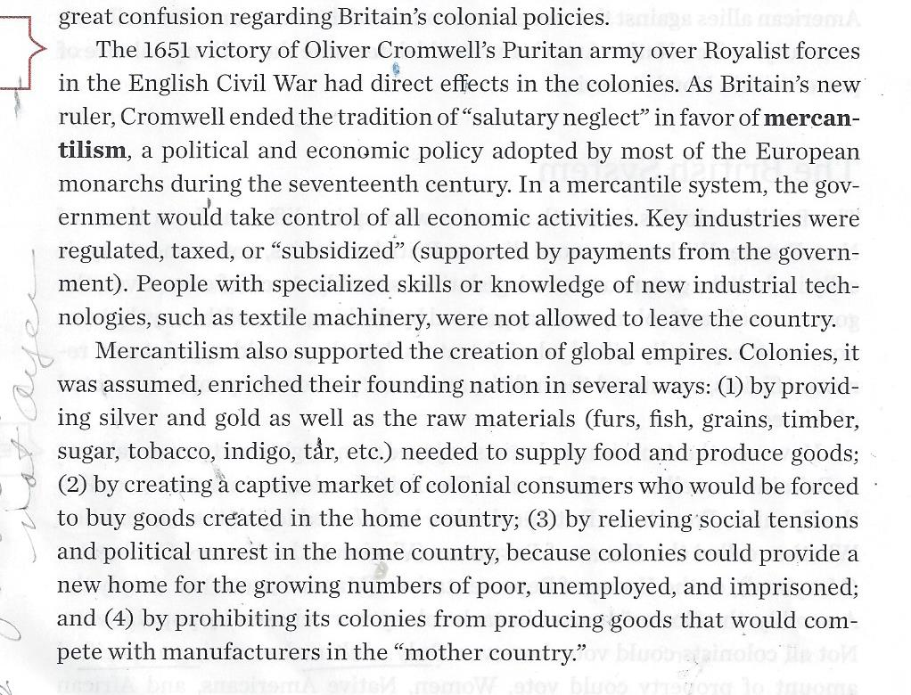

When you compare the paper (above) and the source (below) on the grey issue, you find nothing about six-pence so the student was using something other than the required reliable sources.

- Question 2 and Question 3 together mean that the instructor can easily recognize and quickly prove if you copied the words from our required sources without quotation marks. According to standard rules for evidence, your doing that means you plagiarized or, at a minimum, did what the Bedford Handbook calls “half-copy” plagiarism.
- *True
- False

Background: lovely student who was trying to replace her habit of just passively moving words around. She said her English teacher said it was right. I knew her English teacher so I showed the textbook and the student’s paper to the teacher.
spinning, sewing, and weaving and my label of it as h-copy
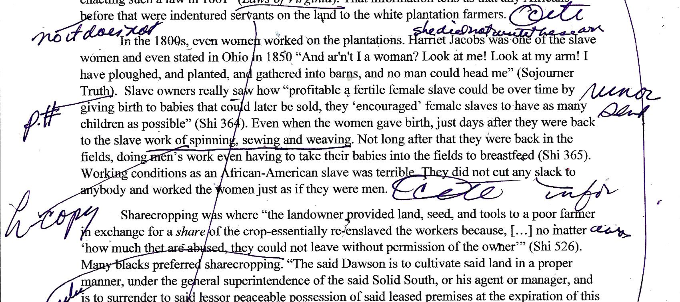

spinning, sewing, and weaving – she could have avoid “half-copy” plagiarism if she had not written it or used only 1 example or if she had quoted it exactly “spinning, weavng, or sewing.”
Caution: The fundamental problem with “half-copy” plagiarism is not a little bit of cheating but a lot of not paying attention.

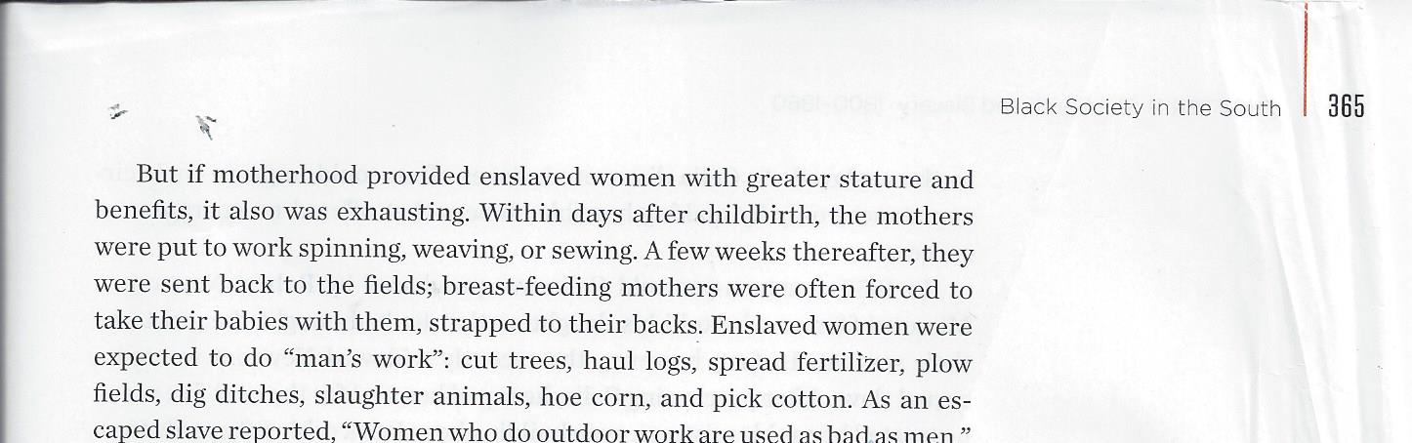

If the writer/speaker | Would a teacher expert in composition notice? | Would a boss who pays you who is expert in the business notice? | Would a upper-level professor who can write a letter of reference for you and who is expert in the discipline notice? | Would an instructor using my method notice? | Will you notice if you use my method with peer review?
GH1: used reliable source
GH2: used a source page that fits the question
GH3: proofed every rigorously
GH4: plagiarized or “half-copy” plagiarized
GH5: changed the meaning of the author or made the author incompetent with language

- When you do any written assignment, you need to do everything listed in Question 2.
- *True
- False

- When you do peer reviews (work that earns large points in this course) and if you want those large points, you must look for everything listed in Question 2 and you must grade using the same method explained in Question 3.
- *True
- False

- Question 2 and Question 3 together—an admitted accident—combined with my long experience in academia and industry where people had to understand new things meant that your instructor realized that any teacher using this method can give the same type of feedback on your understanding of reality that you will experience from:
- A boss—one you hope will want to keep paying you.
- A professor in your career field—one you hope will write a reference for you.
- *Both of the above.

- Question 2 (actually the 5 Good Habits for Evidence) and Question 3 together plus the content already required by the History Department let you practice habits for figuring out something small that requires similar habits needed for larger tasks such as:
- Making a personal decision that could change your career, health, money—your life
- Doing a job that requires you to solve problems and not just repeat other peoples’ solutions
- Completing an academic assignment for an upper level professor in your career field
- *All of the above.

- What is different in these history assignments from the real world is that:
- In industry you will probably not place citations within your written work, but you can better know exactly your proof for every fact that you say or write.
- In academics, different disciplines follow different standards for citation.
- *Both of the above

- Your instructor is willing to try to help every student because practicing these habits can make every student’s future easier. Just ask.
- *True
- False

- You earn 12 extra credit points. If you do not try to follow the 5 Good Habits for Evidence in your writing, you may lose these points. (With distance learning classes, students cannot see written assignments with Turnitin or Blackboard's exam tool for writing if they have not made those 12 points.)
- *True
- False

Issues in Class
On your paper:
- Highlighted colors
- % on your paper
- Handwriting – for you but also for me (why?)
- Grammar and mechanics – you can succeed without these – will type tips

Content Issues and How to Deal with Them– have some other issues to type
- Word responsibility – the obligation to act (see State of Illinois) but notice a governor’s powers in 1895
- Impartial witness – closest thing is Altgeld

The Rubric and Your Graded Paper
Note:
- If you have marks in the “F” and/or “D” columns, the highest you could make is 6.9, a D. BUT see the offer in the small box on the right of the rubric.
- The 6.9 + that full 10 for the Good Habits for Evidence = 16.9, a B.
Name_________________ |  |  | 1st Primary Writing ___ out of 10 points for content. Its Good Habits for Evidence __ out of 10.
 | Requirement | "F" Paper Criteria |  | "D" Paper Criteria | "C" Paper Criteria | "B" Paper Criteria | "A" Paper Criteria
 | Reading FOR Evidence (60%) | 1: Used an unreliable source. 2: Used an incorrect or incomplete part of the source required for the question asked. 2&3: Assumed. |  | 2: Misread or read passively. 3: Made errors such as cherry-picking facts or embellishing facts. | Accurately read the parts, but did not try to evaluate or to synthesize the interconnections. | Accurately read the parts and analyzed each one. Tried to evaluate and synthesize interconnections. | Accurately read the parts and analyzed each one. Evaluated and synthesized the interconnections.
 | Writing WITH Evidence (30%) | 2: Did not answer all parts of the question.  2&3: Wrote assumptions.  3: Did not cite accurately and according to the directions.  5. Used "" inaccurately and changed meaning. |  | 2. Wrote passively.  4. Plagiarized or did “half-copy” plagiarism (also called “patchwrite”).  5. Used "" inaccurately, including making the author's sentences look grammatically incorrect. | Only summarized separately each of the parts of the question, but did not cover interconnections. | Revealed each part and covered some interconnections. Provided few examples. | Understood each part and revealed the parts’ interconnections. Provided clear and representative examples.
 | Following Directions for Evidence (5%) | Did not follow directions above or with the questions (such as maximum length). |  | Did not follow directions. | Followed the directions. | Followed the directions carefully. | Followed the directions exactly.
 | Mechanics (Language and Punctuation) (5%) | Many mechanical errors. |  | Several mechanical errors. | Two or more mechanical errors. | One or more mechanical errors. | No more than one minor mechanical error.

 | ↓ |  | ↓
 | Grade for its Good Habits for Evidence:  * 0 = If any marks in “D” or “F” columns  * full points = If no marks in “D” or “F” |  | Grade for the content: If you made a “C” or “B” or “A,” you also had no marks in the “D” or “F” columns. You also earn full points for the Good Habits for Evidence.

Directions:. If a # is underlined in the rubric, put an X below. Example: If your instructor underlined 1. Used an unreliable source on your rubric, then put an X beside Habit 1 below. You also go look at Habit 1’s preventions. Tip: It is in Evidence Requirements. |  |  | Opportunity  If you have a 0 for the 5 Good Habits for Evidence, you can change that to a 10 by marking the yellow sections on the left
 | Habit 1. Reliable Sources Only
 | Habit 2. Factual Accuracy That You Verify with the Reliable Source Before You Write
 | Habit 3. Factual Accuracy That Is Verifiable for Every Statement You Make
 | Habit 4. No “Half-Copy” Plagiarism or “Patchwriting”
 | Habit 5. Quotation Changes Revealed Clearly

The Rubric and Your Peer Review and What You Do
Caution: BOTH RUBRIC AND PAPER MUST BE RETURNED. You may separate them, but staple them back together.
Instructions: Keep visible the link shown in the class session. Underline in the rubric any errors the student made. Add a page number or something like that so the person (or your instructor) could see why you marked it. Mark the paper as needed to show the student (or your instructor) the errors you see.
Caution: Do not write any suggestions for style or grammar. That’s why Mechanics is in gray.

Your Name ________________________________________________ Date turned in: _________________
Put a check in the yellow box for the letter the student earned.
Reminder: if there are underlined problems in the F or D columns, the student can’t earn more than a D.
Requirement | "F" Paper Criteria | "D" Paper Criteria | "C" Paper Criteria | "B" Paper Criteria | "A" Paper Criteria
Reading FOR Evidence (60%) | 1: Used an unreliable source. 2: Used an incorrect or incomplete part of the source required for the question asked. 2&3: Assumed. | 2: Misread or read passively. 3: Made errors such as cherry-picking facts or embellishing facts. | Accurately read the parts, but did not try to evaluate or to synthesize the interconnections. | Accurately read the parts and analyzed each one. Tried to evaluate and synthesize interconnections. | Accurately read the parts and analyzed each one. Evaluated and synthesized the interconnections.
Writing WITH Evidence (30%) | 2: Did not answer all parts of the question.  2&3: Wrote assumptions.  3: Did not cite accurately and according to the directions.  5. Used "" inaccurately and changed meaning. | 2. Wrote passively.  4. Plagiarized or did “half-copy” plagiarism (also called “patchwrite”).  5. Used "" inaccurately, including making the author's sentences look grammatically incorrect. | Only summarized separately each of the parts of the question, but did not cover interconnections. | Revealed each part and covered some interconnections. Provided few examples. | Understood each part and revealed the parts’ interconnections. Provided clear and representative examples.
Following Directions for Evidence (5%) | Did not follow directions above or with the questions (such as maximum length). | Did not follow directions. | Followed the directions. | Followed the directions carefully. | Followed the directions exactly.
Mechanics (Language and Punctuation) (5%) | Many mechanical errors. | Several mechanical errors. | Two or more mechanical errors. | One or more mechanical errors. | No more than one minor mechanical error.

 | ↓ |  | ↓
 | Grade for its Good Habits for Evidence:  * 0 = If any marks in “D” or “F” columns  * full points = If no marks in “D” or “F” |  | Grade for the content: If you made a “C” or “B” or “A,” you also had no marks in the “D” or “F” columns. You also earn full points for the Good Habits for Evidence.

After completing my peer review of this paper and marking the rubric above, this is what I’d write to the student about the work done. ______________________________________________________________________________________ _________________________________________________________________________________________________________________________________________________________________________________________________________________________________________________________________________________________________________

Do not mark below.

Criteria | Needs Improvement (11 or less) | Basic Usefulness of Your Review (12 +) | Good Review (14 +) | Active Review (16 +) | Exemplary Review (18 +)
Your Review of the Student’s Content | Did not focus on the history content and did not examine the student’s content compared to the sources used. | Accurately underlined content issues in the rubric. Marked with a brief phrase the content issues in the rubric and paper. | Not only met the criteria of Basic Usefulness, but also wrote 1 specific comment about content for the question answered. | Not only did what was listed in Good Review but also wrote more than 1 specific comment about content. | Not only did what was listed in Active Review, but also identified a key issue in the student’s content.
Your Review of the Student’s Use of the 5 Good Habits for Evidence | Did not focus on history and use of evidence as measured by the 5 Good Habits for Evidence. | Accurately underlined content issues in the rubric. Marked with a brief phrase the evidence issues in the rubric and paper. | Not only met the criteria of Basic Usefulness, but also wrote 1 specific comment about the student’s use of evidence. | Not only did what was listed in Good Review but also wrote more than 1 specific comment about content. | Not only did what is listed for Active Review, but repeatedly focused on the 5 Good Habits for Evidence.
 |  |  |  |  | Total

