Getting Started
Course Orientation
Welcome to Class!

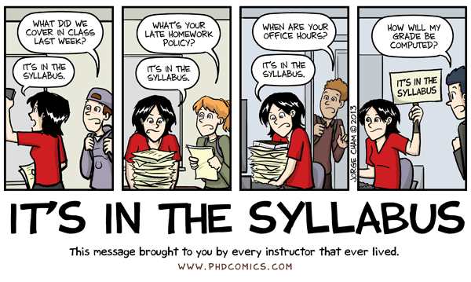
This document, along with the syllabus, provides very important information regarding how this course will function and what will be expected of you. So, please take the time to read all of the material provided.
After you have read the material in this section you will be required complete several graded introductory tasks. If you have additional questions after completing this section, please post them to the 'Course Questions' discussion topic on the discussion board. Don't be shy about asking your question(s). Remember, if something is not clear to you...it is probably not clear to others as well! Also, if someone posts a question for which you have an answer, feel free to help them out!

Tip: This Course Orientation provides lots of How-To examples with videos that are short (usually under 4 minutes), but that require lots of pages when placed in Soft Chalk at 1 video per page. In case you want to look again at one or more of the How-To videos, you do not have to return to this Course Orientation. I have copied this Soft Chalk lesson and broken it in small sets of pages, such as "How-To Videos about Using Check Your Knowledge Quizzes." You will find those small sets available at several locations in the course.
With thanks to WCJC's Director of Distance Education, Professor Michele Betancourt, for her permission to use her Getting Started documents (including her exact words) in the Getting Started sections of our WCJC courses.

About Your Instructor
Welcome to this online section of United States History II. My name is C.J. Bibus, and I will be your instructor this semester. I have been teaching online history since 2003 and both on-campus and online history for WCJC since 2004.
I am a native Texan who attended a community college. I received my MA in history at the University of Virginia and completed an additional year of work in history and in an internship in community college teaching. I taught in Virginia community colleges for several years and later returned to Texas to earn my doctorate at Texas Tech University. My doctorate emphasized teaching in the community college and the history of the early junior college just after 1900.
I also worked in industry before returning to teaching in the community college in 2003. Much of my emphasis on evidence and accuracy comes from my experience in industry. I found that getting or keeping a job that paid well required skills with evidence and factual accuracy.
I have a perfect daughter—all parents should feel that way about their children. To quote the family joke, my daughter "brought her Mom up as best she could."
I am always trying to improve the course each semester. For those of you who have taken my classes in the past, I hope you like the changes this semester. If anyone has suggestions to improve this course, feel free to let me know, I value and appreciate the input.

About History As an Investigation into Real Life Events (Not "Real Movie Events")
Sometimes a discipline needs an introduction as much as an instructor. The word discipline means a field that people study. Disciplines usually have rules, including for what is considered evidence. The etymology of the word history is a clue to history's rules for evidence. The word history comes "from historein, to inquire, from histor, learned man [bold added]." Notice that bolded word inquire or, to use a more current word, investigate. In a freshman course, inquiry into real life events in the past can help you learn history as a useful discipline that is about how things work in reality. Basing your plans on investigations of real life events will bring success, but—as the cartoon shows—basing them on "REAL MOVIE EVENTS" fails.
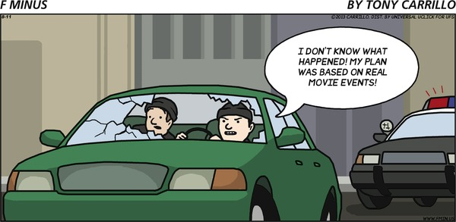
If You Want More: If you would like more on history as a discipline (including the source of the etymology used above) and on professional associations for teaching and researching history, click on Resources for History on the left menu.

How History Will "TURN UP IN REAL LIFE"
History is not only a discipline that requires evidence and that lets you investigate real life events in the past so you can plan your own actions, but—to quote the cartoon below—history will "TURN UP IN REAL LIFE." History is a required course because it provides useful information that can help you in all of the roles you will have in your life—family member, student, worker who may have to retrain many times in a rapidly changing world, decision maker about your own life and your own vote, and perhaps parent. Learning history not only provides useful information, but also useful skills. It requires the types of skills in reading and analysis and writing that are necessary for all of those roles. What makes history provide all those benefits? History is about real life events of the past so it is useful in surviving in the real world of today. History will "TURN UP IN REAL LIFE."
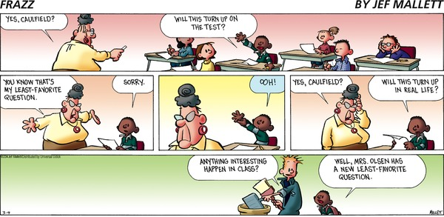
The General Layout of the Course
On the left, you see the Course Menu; on the right, brief explanations. To move quickly to a specific Course Tool or Web Resource, click on the item in the Course Menu. To learn quickly, click on Learning Modules.
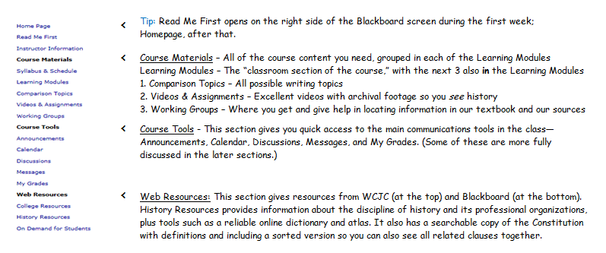

What's in Each Unit? (Unit = a Learning Module Covering a Major Time Period)
In this course, each Unit, or major time period, is in a Learning Module because this Blackboard tool lets instructors provide everything a student needs in one place. Blackboard automatically makes visible each Unit on the date in the Course Schedule at the end of the syllabus. The course is split into three Units that reveal shifts in our history. To make your work more manageable, each Unit is divided into 3 smaller time periods, or Parts. For example, Unit 1 is divided into Part A, Part B, and Part C. Each Part has its own major theme, resources at "Everything You Need for This Unit (except the maps)," maps, and quiz (Quiz A, Quiz B, and Quiz C).
On the left, you see the table of contents for Unit 1; on the right, brief explanations for the items in the Unit. Each of the 3 Units is organized in exactly the same way—the only difference is the letters used to name the Parts of a Unit. In other words, Unit 1 consists of Parts A, B, and C; Unit 2 consists of Parts D, E, and F; and Unit 3 consists of Part G, H, and I.
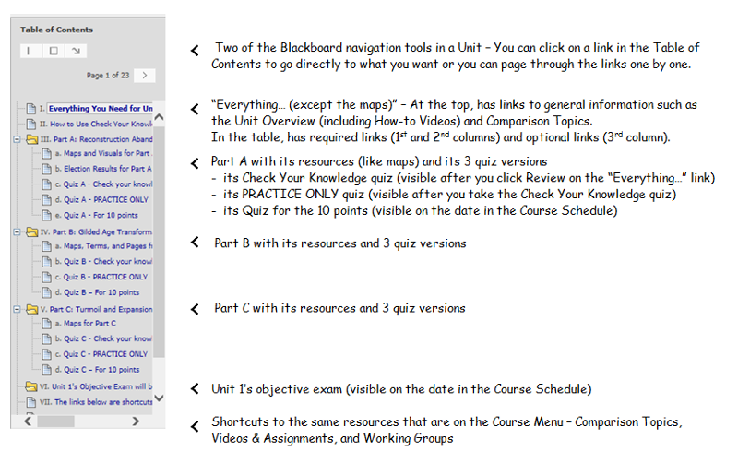

5 Things—(1st), (2nd), (3rd), (4th), and (5th)—To Help You Reduce Your Time to Learn and Find What You Need
These statements, briefly stated in the syllabus, cover some things that are best understood with examples in the course. To identify those things best shown as examples, I have added a blue number such as (1st)to them. Those examples are provided in the next pages—with those pages identified with the numbers below.
While the course tries to help you learn history's useful information and skills, it also tries to do two things for each of you.
1. The course tries to reduce the time it takes each of you to learn this useful information and skills in several ways:
- With self-testing (1st) - From the Getting Started to the review for the Final Exam, you can self-test. With no loss in points using quizzes or visual resources, you can test your own knowledge to identify what you know and don't know and you can then plan what you have to read and to learn. You have not only self-tests, but pre-built tools for recording what you learn so you save time and avoid rework (such as having to look up the same information repeatedly).
- By letting you know from the beginning of major time period (called Units), every fact you need to know and everything you need to read and write about:
- For objective tests, such as multiple choice, you know not only the chapters you read, but you also have interactive study guides (called Check Your Knowledge quizzes) (5th) that let you know the required facts from those chapters. The quizzes also show you whether you already know those facts (and don't need to read those pages) or you don't know them (and must read carefully). If a fact in the quiz is not listed in the index at the end of the textbook, you also have details about finding the information.
- For written work (called Comparisons), you know all possible topics and exactly what you need to read for each topic. The topics require you to figure out how something changed from the beginning of a Unit to its end. You read the required sources, figure things out, and write simply, briefly (maximum of 1 page), and accurately. (See Good Habits for Evidence.)
2. The course also tries to match different kinds of students with different preferences for learning, different backgrounds, and different goals. Because the course does try to match different students, Course Orientation tries to help you recognize:
- Resources in the course that are required (All must use these resources.) (2nd)
- Resources that you use only in cases such as these: (4th )
- If you missed a question on a Check Your Knowledge quiz and the Tips for that question say to use this resource
- If you don't understand something and want to see if one of the existing visual resources (3rd ) can help you
- If you want additional information just because you are curious

(1st) What Is Self-Testing and How Can It Help You?
Self-testing lets you measure yourself with no loss in points so you can tell what you know and you don't know and so you can plan your work. You can increase success and save time by fixing what you don't know.
There are 4 main ways that you have an opportunity to self-test in this course:
1. In the Getting Started Learning Module, in this link and in the link for Good Habits for Evidence, you see small self-tests (like the one below). Answer as best you can.
- If you answer the question correctly, keep going forward.
- On the other hand, if you miss the question, then look again at the prior pages to see if you know why you missed it. If you still don't know, ask me by email or post in the Course Questions forum. You want to understand what is available to you in the course so you can succeed—and save time.
2. Within each Unit, 3 interactive study guides (called Check Your Knowledge quizzes) that let you know the required facts from the chapters. The quizzes also show you whether you already know those facts (and don't need to read those pages) or you don't know them (and must read carefully). – There is more on this in the next pages.
3. Within each Unit, visual resources specifically for self-testing
4. At the Final Exam, a review for self-testing (For details, see the syllabus.)

(2nd) What Resources Are Required From the Link "Everything You Need for This Unit (except the maps)"?
In many ways, students over the last 10 years created the link "Everything You Need for This Unit (except the maps)." Why? Because students are the ones who asked:
- For help understanding something and I'd build a resource. (If the resource helped that student, I made it available to everyone.)
- For all required and optional resources to be on 1 web page. (The only things that aren't there are resources created by others such as the textbook publisher's maps.)
Not only are each of the 3 Units organized in exactly the same way, but also each of the "Everything…" links for each Unit is organized in exactly the same way. Each of
the "Everything..." links for each unit have exactly the same things at the top:
- If you want to look How-To Videos, what's makes this time period, and exactly what you do in writing, quizzes and exams, and reading, you use the Unit Overview.
- If you want a way to quick see the Comparison Topics for the unit, you click on those links.
The How-To video covers the required resources at the "Everything…" Link (Required means all must use these resources.)

(3rd) What Are Visual Resources and (4th) How Do They Help Learning in Specific Cases?
In this course, visual resources means the presentation of facts—usually the same facts as in your textbook and in most textbooks—in a form (such as a table) that makes it easier to see changes in history, whether those changes are over time (such as from 1865 to 1896) or space (such as the North or South) or both (such as over the same time period the North and South changed but in different ways or perhaps with different groups).
If you use the visual resources, you can see that your memory or your reading was inaccurate and you can get things straight.
The syllabus listed these cases when some resources are needed:
- If you missed a question on a Check Your Knowledge quiz and the Tips for that quiz question say to use this resource
- If you don't understand something and want to see if one of the existing visual resources can help you
- If you want additional information just because you are curious
The easiest way to show you how to use a few of the visual resources is in How-To video:
<insert widget here on 3rd column>
for video covering the multi-ways to view info (row-column-cell)l and showing briefly these examples
1. A chronology to show who hit whom and in what order (In this class, you don't memorize dates; you notice order. Why? Because who hits first matters and because nothing can cause something if it happened after.)
2. A chronology as a study tool—with all of them organized in the same way—so you can see events in context of all of the major institutions as you read
3. A chronology with color coding, and the Purpose beneath the link explains what to look for
4. A table to show the traits of 2 or more things that students have frequently misunderstand—with that table available for self-testing (This link, also available from the "Everything..." link for each of the Units, explains how to make the best use of Self-Testing.)
5. Optional Reference—usually from a prior period or additional information that students asked for>
Tip: You are welcome to copy (download) the Check Your Knowledge quizzes and any other resource at the "Everything..." link to your computer or flash drive. In general, you only need to print required resources, not optional ones. The optional ones are almost always best used online or used on your own computer as a file.
Some students can't afford to print the required Check Your Knowledge Quizzes. For those who can't afford to print and need to record in an easy to use file their own information (such as the answer they chose or the correct answer that they missed or the page numbers where they found information), the Basic Tips include how you can copy the contents of a Check Your Knowledge link with the tips. Using this file--or a paper copy if you can afford it--can take the busy work out of systematically learning what you don't know. If you don't know how to do these Basic Internet tips, click here.

(5th) How Do You Use the Check Your Knowledge Quizzes As Interactive Study Guides?
This begins a set of pages showing you each Step in how to use the Check Your Knowledge Quizzes as Interactive Study Guides. It covers both Blackboard steps and tips that have helped others. Of course, no one is required to use this exact method, but it has worked before for other students (and for myself). Consider trying it. If you need help, please ask.
YELLOW stuff = notes to reviewers
Current tests seem to show that the max # of widgets with an embedded video is 2 on a page.
1. 6 Reasons Why How You Work May be Sabotaging How Smart You Are <VERY Brief (each of these things was obvious to all 15 years ago and is an ah-ha moment when I talk students through it.)
2. Where to locate the Check Your Know ledge quizzes as tests and as links
3. How to Decide your Answers--with some cheap tips for doing this first step
4. Displaying the 3 Check Your Knowledge Quizzes < in the widget below
5. How to take a Check Your Knowledge Quiz
6. How and What to Record and Why It Matters
7. Using the Version of the Check Your Knowledge With the Tips to Shorten Your Search Time
8. Relying on, and Helping, Your Working Group
9. Retesting (With and Without Clicking) to Confirm Your Understanding before the Exam

The widget below is the procedure in Step 4: Displaying the 3 Check Your Knowledge Quizzes
FYI: had problems with the timing on the captions below so I'll have to try again.

Course Communications
As this is an online course, our primary means of communication will be through Blackboard Messages ( email) and Discussion forums.
I also am glad to meet with distance learning students face to face or by phone. All of my contact information--including Online Office Hours--is listed in my syllabus and is posted in the "Contact Instructor Information." This weekly calendar helps some students to understand where I am--something necessary because I am at the Sugar Land campus on Tuesday and Thursday and at the Richmond campus on Monday, Wednesday, and Friday. I am also willing to try to work with you to schedule other hours by appointment.

Online and Off-Campus Office Hours
During my Online Office hours, I check Blackboard Messages and postings and also answer calls. Additionally I try to log in each day when you are taking Unit Exams or submitting Comparisons.

Email/Telephone
Reaching me through Blackboard's Messages (email) is the best way to reach me. I check Messages at least after my last class each day and during my Online Office hours. I have also scheduled my Online Office Hours where you can call me directly at 281-239-1577.

Discussion Forums for Communications with Everyone in the Class
The Discussion section of the course is used for a variety of purposes. With this course, you can use Discussion forums in Working Groups (the graded area) to get help or give it--covered specifically on the next page. You also can communicate with other members of the class—and not just in the graded area. I hope this section will help to create a sense of community for people learning history.
All of you are encouraged to answer questions if you know the answer. One thing I learned in academics—but more in business—is to always double check anything you are about to say is true. It is a good habit that takes a few minutes but always pays off.
I regularly read through the questions and answers. If there is any particular area of confusion or "bad" answers, I may remove the posting or may send out the correct information as a general email.

Discussions (Available on the Course Menu and in the Getting Started Learning Module)
Course Questions: You should post general questions that you have related to course in this area. This is generally the fastest way to receive a response. I will review and respond frequently. Students are welcome to post responses to questions if they so choose. Your participation in this discussion topic is optional.
Suggestions For Improvement: About halfway through the semester you will see a new forum appear called "Technology Feedback / Suggestions for Improvement." I am constantly trying to improve the navigation and design of the course to provide a better learning environment for students. Please feel free to offer constructive feedback or suggestions for improvement in this area. Anonymous posts are allowed.
Student Lounge: A place to discuss issues not related to the course. Your participation in the Student Lounge is optional. Please note that I rarely go into this area, therefore it would be a bad place to post questions for the instructor.
Student Introduction: A place to post a little bit about yourself so that other students and the instructor can know a little bit about you.
Shareables from the Working Group: The Sharable forum in the public Discussion area provides examples of postings for how to ask for help and give it. It is also used to share useful postings from one Working Group with all the other Working Groups.

Guidelines for Communications with Everyone in the Class (including in Working Groups)
Use Net Etiquette in your Discussion posts and in any emails. Do not send emails to everyone--if you are wrong (and you will be sooner or later), you have let everyone see your error. These are good habits to develop not just for your academic life, but for your success in the workplace.
DO
- Make comments and questions that are relevant to the issue being covered.
- Use respectful and polite language in your comments.
- Make comments that are thoughtful but to the point.
- Be sure to include your name at the end of the message.
- If responding to a comment or message, be sure to include enough information so that the context of your response is understood.
- Use appropriate upper and lower case and punctuation.
DON'T
- Do not write anything when you are angry or that you would not share in person in front of a full classroom on campus.
- Do not write in all CAPITALS because this makes your message more difficult to read and because some people use all CAPITALS as a way to shout at each other.
- Do not use unexplained acronyms or strange notations that may be unfamiliar to readers.
- Do not make rambling and off-the-topic comments.
- Do not post a message to point out other people's errors in typing or spelling unless they have asked for the correct spelling of a name or unfamiliar concept.
- Do not post your response as an attachment.

Discussion Forums and Guidelines for Working Groups

The Purpose of Working Groups
Sometimes students feel like the cartoon figure on the right. They are puzzled and don't know how to 2 key things:
1. Find the right information for the question being asked (whether a quiz question or a Comparison)
2. Figure that information out in such ways as:
- Having a dialog with careful, evidence-centered postings by several students
- Having one of you find additional information in the textbook or in the visual resources at "Everything You Need for This Unit (except the maps)" and tell the others about the resource
- Asking your instructor for more information (If you need it, that's what I'm here for.)
Sometimes, it seems easier just to memorize something without understanding or just try to fake it, and students may get by with that. Faking learning is, however, a lousy habit--to be blunt--to develop for your immediate future and certainly not for your long-term future. What the Working Groups are for is to help you help each other with those 2 things.

Working Groups (Available on the Course Menu and in the Learning Modules for Units 1, 2, and 3)
Working Groups use Blackboard's Discussion tool, but the only ones who can see your group are members of it. Each of you has been randomly assigned to a small group. Once the purge rolls are available I will make adjustments so the groups are about the same size and so that everyone is in a Working Group.
Participating in a Working Group is a required assignment with each Unit. In the grades, participating in Working Groups is classified as written work. Not participating means an alternative quiz that does require writing. The syllabus covers the details.
How Do You Find Your Working Group
Working Groups will open on the date in the Course Schedule. If you have not used Groups before, this link may help you find your working group.
How Do You Find Examples of What to Do You Do and Find Out about Grading
After Unit 1 starts, you will see a Unit 1 forum for your Working Group. Within each Working Group, the first thread in the forum for each Unit:
- Provides instructions
- Shows the Rubric used in grading
You can also see examples of how you can post to ask or answer a question in the forum Shareables from the Working Groups.
You are to help each other learn history and practice Good Habits for Evidence. These Working Groups let you ask or answer questions about the current content, current Comparison Topics, and about current quiz questions. You can earn those points by asking or answering.
Guidelines for Working Group Postings
Read Working Group forums on Blackboard often. Reflect on these comments and contribute. Online discussions are learning opportunities that are equivalent to study groups or class projects with other participants. By reflecting on and responding to questions and comments, you will develop your ability to articulate your knowledge and to learn from others. We are here to learn the material, to help each other, to have fun, and to discuss matters of importance (at least I think history is important) with others.
With graded Working Groups:
- Let the facts you have reveal the evidence so that others can decide for themselves. Do not state your opinion.
- The Good Habits for Evidence apply to these assignments as well. For example, you must correctly use pairs of quotation marks ("") if you type exact words from the textbook, not just identify the exact location of the information.
- Always provide the exact location of the information in our textbook so others can read the information for themselves. Your first task as a member of a Working Group is to reply to a posting from me asking what edition of the textbook you use.
- If all of your group members have the current edition of our textbook (the 4th edition paperback), you can state the location just as a page number.
- If some of your group members use an earlier edition, my next posting will tell you an easy way to specify the location.
Post Early: The longer you wait to post your question, the harder it is for others to answer you in time for you to do your work. If you post so close to the closing date and hour, that no one--except your instructor--can help you with a response or make use of your response, your grade will be very low. If you try to post after the due date and hour, the responses are no longer accepted.
Opportunities for Extra Credit with Working Group Postings
You not only can see examples of how you can post to ask or answer a question in the forum Shareables from the Working Groups, but also see useful postings from other Working Groups. The Shareables forum is used to share information—and to earn extra credit. When I see postings in your Working Group that can help other Working Group, I do two things:
1. I copy and post your work into the Shareable forum for each Unit (available at Discussions).
2. I enter 2 extra credit points for each posting that can help the other Working Groups and for each person involved in that posting.

Grading and How Long It Takes
I know everyone is always anxious to receive feedback on your completed work, so I will make every effort to give you prompt feedback. I review your posting in the Discussion Working Groups as you work and sometimes I will reply or make suggestions. I generally:
• Review and, if needed, reply to Discussion postings visible to all students and those visible only to Working Groups. With Working Groups, you will know how you are doing as you work. Check replies to posts and, if necessary, private emails to you in Blackboard Messages.
• Enter Getting Started grades on the weekend at the end of the first week. During the week itself, I try to give feedback and get inexperienced students on track by conferences, both phone and face-to-face.
• Enter extra credit grades for students making 9 or 10 on quizzes before the date in the Course Schedule on the day after the DUE date in the Course Schedule. Frequently, I can't do that until after my last class on that day.
• Enter grades for the Working Groups' postings and the optional extra credit Video Assignments after each Unit ends. Rubrics are used to grade both.
• Post feedback and grades on Comparisons using a Rubric and as rapidly as I can, but I am slow because of how I grade written work:
o I try to give students the kind of feedback my history teachers gave me. That feedback made a great difference in my success, not just in college but also in making a living in industries.
o To do that, I sort the class answers and grade all answers to the same question and using the same version of the textbook (such as all who used the 4th edition paperback or all who used the 2nd edition hardback) at the same time.

While I'm grading the Comparison for the Unit, I do these two things to help you estimate your Unit letter grade:
1. After the Unit's objective exam scores are visible, I announce the number of points required for each letter grade (an A, B, C, D, or F) for the Unit before the Comparison grades are added in.
2. After those grades are added in, I update the number of points for each letter grade and say where to find feedback.

Success in the Online Environment

Although this is a distance learning course, it is NOT a correspondence course; nor is it an independent study course. Specific deadlines are provided and must be met. Class participation, in the form of Working Groups, is required and will be factored into your final grade. While I try to build in a great deal of flexibility for you to work ahead in each unit, you cannot complete the course in a single weekend, but are expected to be part of the course for the whole semester.
This online version of History is designed to require roughly the same amount of time a student would spend in a 3 credit hour, face-to-face class. You will be expected to complete all of the learning activities and maintain an active presence in the Working Group forums. Time commitment consists of two parts: interaction with other students (Working Group participation) and interaction with content (course material).

General points to remember:
- Communicate clearly in writing.
- Be self-motivated and self-disciplined.
- Speak-up if you have trouble.
- Set aside sufficient time for course.
- Have and be able to use a reliable computer.
.
Introductory Tasks
Great! You are almost finished. Before you get started with the content for this course, I would like you to take care of some "housekeeping" items that are graded tasks. The first to third tasks are due before the end of Getting Started in the Course Schedule. The fourth task you may complete a bit later. See the Course Schedule for the exact time. There is also a recommended task, but it is not graded.
1. I want you to provide me with some additional contact information. For example, you might be missing something that will result in your having a lower final letter grade and I need to reach you quickly. E-mail me through Blackboard's email. First, select the Messages link from the Course Menu - then choose create message. Under recipients - click on "To" then scroll down to C.J. Bibus (Instructor). On the subject line, put "Contact Information." In the text of your message, please provide me with an alternate e-mail address and a good contact phone number. Please let me know when a good time to call is, and whether or not it is ok to leave messages. Feel free to also, provide me with any other information that you would like to share with me.
2. Go to the Discussion Board and post a personal introduction in about 150 words. Eventually the class will begin posting to the Working Groups and it is always nice to know a little about the people that you are "conversing" with. Be sure to post your introduction in the Student Introductions topic. Please do not attach a file to the discussion board as it makes it difficult for others to view.
3. If you have not already done it, click on the Syllabus Acknowledgement Quiz in the Getting Started module and choose True. This is required to continue in the course. If you do not understand something, ask now. You can post in the Course Questions forum or email me. Glad to help.
4. Click on the folder "Good Habits for Evidence" in the Getting Started module and then click on the 1st link inside the folder. Follow the directions on the last page of the link on what to write and how to send it to me. You then earn 20 points. Note: You will not be able to see the Turnitin Assignments that you use to submit your Comparisons throughout the course until you do this task.
Remember that these 4 tasks are a graded component of the course. Please complete tasks 1, 2, and 3 as soon after logging in as possible so that I know a little about each of you enrolled in the course. Please complete task 4 by the date in the Course Schedule.
I am looking forward to a great semester. If you have any general questions, please go to Discussions and post it in the Course Questions forum. If the question is of a more personal nature, feel free to email me.

Below is something that may help you but, unlike the 4 things above, it is not required and not for a grade.
I was really impressed by the Readiness Assessment. I took it twice—each time pretending to be 2 different students I had known well in the prior term. The results and recommendations were completely different and amazingly accurate. Based on that and on many students' positive feedback, I do suggest that--if you have never taken this--you consider trying it. (Obviously, first complete the required assignments.)
The Assessment is long, but you can click on the button that lets you save and resume later.
1. Click http://wcjc.smartermeasure.com/ You will see the user name and password WCJC's students use.
2. When you finish, select "Print/Download the Report" on the left side of the screen and be sure to download it to a location you can find again. Note: You do not want the Summary. Only the Report has recommendations for you and the resources to help you act on those recommendations.
4. What seems to help is your identifying 4 to 5 of their recommended changes that you believe you should make and then looking for the resources they provide for you to make that change. If you need help, just ask. FYI: fast typing is the only thing in the assessment that you don't need for this online class.

