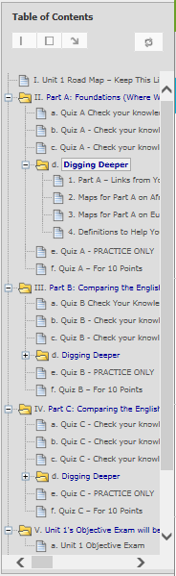 | <  <  <  <  <  <  < | Two of the Blackboard navigation tools in a Unit – Click on a link in the Table of Contents to go to what you want or page through links.  All Units and All Parts Are Organized in the Same Way  1st Unit 1 Road Map – What you do in what order  2nd Each Part with its  - Preview link so you can decide your answers  - Check Your Knowledge quiz – an interactive study guide  - Tips link so you can find information on what you missed  - Digging Deeper resources to help you think about history  and to find information if you missed a question.  - PRACTICE ONLY quiz  - Quiz for the 10 points  The + sign indicates more resources in the folder.  The + sign indicates more resources in the folder.  Unit 1’s objective exam (visible on the date in the Course Schedule)  Shortcuts to the same resources that are on the Course Menu – Comparison Topics, Videos & Assignments, and Working Groups

