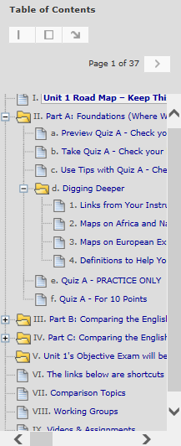 | <  <  <  <  <  < | Two of the Blackboard navigation tools in a Unit – Click on a link in the Table of Contents to go to what you want or page through links.  All Units and All Parts Are Organized in the Same Way  1st Unit 1 Road Map – What you do in what order  2nd Each Part with its  - Preview link so you can decide your answers  - Check Your Knowledge quiz – an interactive study guide  - Tips link so you can find information on questions you missed  - Digging Deeper resources to help you think about history  and to find information if you missed a question.  - PRACTICE ONLY quiz  - Quiz for the 10 points  Part B and Part C are organized in the same way as Part A.  Unit 1’s objective exam (visible on the date in the Course Schedule)  Shortcuts to the same resources that are on the Course Menu – Comparison Topics, Videos & Assignments, and Working Groups

