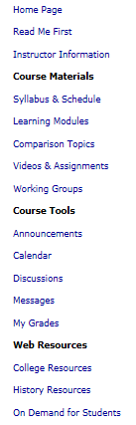 | <  <  <  <  < | Read Me First opens on the right side if the Blackboard screen in the first week; Homepage, after that.  Learning Modules – The “classroom section of the course”  Comparison Topics – All possible writing topics  Videos & Assignments – Excellent videos with archival footage so you see history  Working Groups – Where you get and give help in locating information in our textbook and our sources  This section gives you quick access to the main communications tools in the class—Announcements, Calendar, Discussions, Messages, and My Grades. (Some of these are more fully discussed in the later sections.)

Above Course Materials
Read Me First opens the course in the first week; Homepage, after that.

Course Materials – last 3 are also IN the Learning Modules

Course Tools: Web Resources: History Resources where you find a reliable online dictionary and atlas, the Constitution with definitions and other aids to help your understanding, and information about the discipline of history and its professional organizations. Above that, you have links from WCJC; below it, links from Blackboard.

