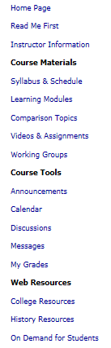 | <  <  <  < | Tip: Read Me First opens on the right side of the Blackboard screen during the first week;  Homepage, after that.  Course Materials – All of the course content you need, grouped in each of the Learning Modules  Learning Modules – The “classroom section of the course,” with the next 3 also in the Learning Modules  1. Comparison Topics – All possible writing topics  2. Videos & Assignments – Excellent videos with archival footage so you see history  3. Working Groups – Where you get and give help in locating information in our textbook and our sources  Course Tools - This section gives you quick access to the main communications tools in the class—Announcements, Calendar, Discussions, Messages, and My Grades. (Some of these are more fully discussed in the later sections.)  Web Resources: This section gives resources from WCJC (at the top) and Blackboard (at the bottom). History Resources provides information about the discipline of history and its professional organizations, plus tools such as a reliable online dictionary and atlas. It also has a searchable copy of the Constitution with definitions and including a sorted version so you can also see all related clauses together.

Above Course Materials
Read Me First opens the course in the first week; Homepage, after that.

Course Materials – last 3 are also IN the Learning Modules

Course Tools:

With the pictures in the table can’t make table rules to create a side line to set off groups

 | <  <  <  <  < | Read Me First opens on the right side if the Blackboard screen in the first week; Homepage, after that.  Learning Modules – The “classroom section of the course”  Comparison Topics – All possible writing topics  Videos & Assignments – Excellent videos with archival footage so you see history  Working Groups – Where you get and give help in locating information in our textbook and our sources  This section gives you quick access to the main communications tools in the class—Announcements, Calendar, Discussions, Messages, and My Grades. (Some of these are more fully discussed in the later sections.)

