Layout of Each Unit
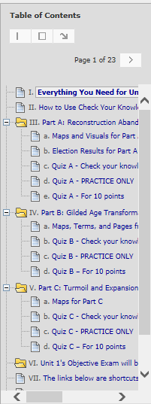

< Two of the navigation tools in a Unit

< “Everything… (except the maps)” – At the top, has links to general information such as the Unit Overview (including How-to Videos). In the table, has links to required and optional information
< Part A and its maps and
its Check Your Knowledge quiz
its PRACTICE ONLY quiz
its Quiz for the 10 points

< Part B with its resources and quizzes

< Part C with its resources and quizzes

< On the date in the Course Schedule, Unit 1’s objective exam < Begins the Shortcuts to the same resources on the Course Menu – Comparison Topics, Videos & Assignments, and Working Groups
[Make video links below]
If You Want More: If you want videos on How to Use "Everything You Need for This Unit (except the maps)," How to Use Check Your Knowledge Quizzes As Interactive Study Guides, and How to Make the Quizzes Visible, click on the links. You can also find these videos (and more) in each Unit Overview.

< Two of the Blackboard navigation tools in a Unit
<“Everything… (except the maps)” – At the top, has links to general information such as the Unit Overview (including How-to Videos). In the table, has links to required and optional information
< Part A with its resources (maps and visuals) and its 3 versions of its
its Check Your Knowledge quiz
its PRACTICE ONLY quiz
its Quiz for the 10 points

< Part B with its resources and quizzes

< Part C with its resources and quizzes

< On the date in the Course Schedule, Unit 1’s objective exam < Begins the Shortcuts to the same resources on the Course Menu – Comparison Topics, Videos & Assignments, and Working Groups
[Make video links below]

If You Want More: If you want videos on How to Use "Everything You Need for This Unit (except the maps)," How to Use Check Your Knowledge Quizzes As Interactive Study Guides, and How to Make the Quizzes Visible, click on the links. You can also find these videos (and more) in each Unit Overview.

