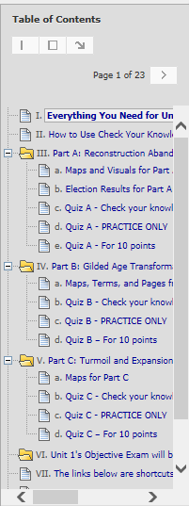 | <  <  <  <  <  <  < | Two of the Blackboard navigation tools in a Unit – You can click on a link in the Table of Contents to go directly to what you want or you can page through the links one by one.  “Everything… (except the maps)” – At the top, has links to general information such as the Unit Overview (including How-to Videos) and Comparison Topics.  In the table, has required links (1st and 2nd columns) and optional links (3rd column).  Part A with its resources (like maps) and its 3 quiz versions  - its Check Your Knowledge quiz (visible after you click Review on the “Everything…” link)  - its PRACTICE ONLY quiz (visible after you take the Check Your Knowledge quiz)  - its Quiz for the 10 points (visible on the date in the Course Schedule)  Part B with its resources and 3 quiz versions  Part C with its resources and 3 quiz versions  Unit 1’s objective exam (visible on the date in the Course Schedule)  Shortcuts to the same resources that are on the Course Menu – Comparison Topics,  Videos & Assignments, and Working Groups

