Layout of Each Unit
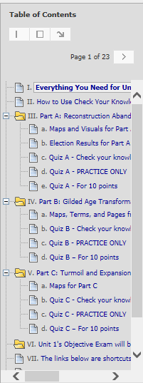

< Two of the navigation tools in a Unit

< “Everything… (except the maps)” – At the top, has links to general information such as the Unit Overview (including How-to Videos). In the table, has links to required and optional information
< Part A and its maps and
its Check Your Knowledge quiz
its PRACTICE ONLY quiz
its Quiz for the 10 points

< Part B with its resources and quizzes

< Part C with its resources and quizzes

< On the date in the Course Schedule, Unit 1’s objective exam < Begins the Shortcuts to the same resources on the Course Menu – Comparison Topics, Videos & Assignments, and Working Groups
[Make video links below]
If You Want More: If you want videos on How to Use "Everything You Need for This Unit (except the maps)," How to Use Check Your Knowledge Quizzes As Interactive Study Guides, and How to Make the Quizzes Visible, click on the links. You can also find these videos (and more) in each Unit Overview.

 | <  <  <  <  <  <  < | Two of the Blackboard navigation tools in a Unit – You can click on a link in the Table of Contents to go directly to what you want or you can page through the links one by one.  “Everything… (except the maps)” – At the top, has links to general information such as the Unit Overview (including How-to Videos) and Comparison Topics.  In the table, has required links (1st and 2nd columns) and optional links (3rd column).  Part A with its resources (like maps) and its 3 quiz versions  - its Check Your Knowledge quiz (visible after you click Review on the “Everything…” link  - its PRACTICE ONLY quiz (visible after you take the Check Your Knowledge quiz)  - its Quiz for the 10 points (visible on the date in the Course Schedule)  Part B with its resources and 3 quiz versions  Part C with its resources and 3 quiz versions  Unit 1’s objective exam (visible on the date in the Course Schedule)  Shortcuts to the same resources that are on the Course Menu – Comparison Topics,  Videos & Assignments, and Working Groups

If You Want More: If you want videos on How to Use "Everything You Need for This Unit (except the maps)," How to Use Check Your Knowledge Quizzes As Interactive Study Guides, and How to Make the Quizzes Visible, click on the links. You can also find these videos (and more) in each Unit Overview.

