Orientation to the Course
DONE--------------New Page
Welcome to Class!
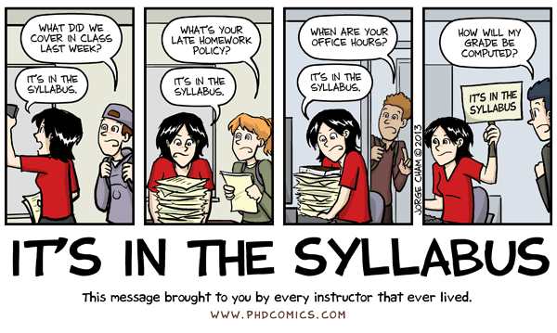
This document, along with the syllabus, provides very important information regarding how this course will function and what will be expected of you. So, please take the time to read all of the material provided.
After you have read the material in this section you will be required to complete several graded introductory tasks. If you have additional questions after completing this section, please post them to the “Course Questions” discussion forum on the discussion board. Don't be shy about asking your question(s). Remember, if something is not clear to you, it is probably not clear to others as well! Also, if someone posts a question for which you have an answer, feel free to help them out!

With thanks to WCJC’s Director of Distance Education, Professor Michele Betancourt, for her permission to use her Getting Started documents (including her exact words) in the Getting Started sections of our WCJC courses.

DONE--------------New Page

Introducing Your Instructor
Welcome to this online section of United States History II. My name is C.J. Bibus, and I will be your instructor this semester. I have been teaching online history since 2003 and both on-campus and online history for WCJC since 2004.
I am a native Texan who attended a community college. I received my MA in history at the University of Virginia and completed an additional year of work in history and in an internship in community college teaching. I taught in Virginia community colleges for several years and later returned to Texas to earn my doctorate at Texas Tech University. My doctorate emphasized teaching in the community college and the history of the early junior college just after 1900.
I also worked in industry before returning to teaching in the community college in 2003. Much of my emphasis on evidence and accuracy comes from my experience in industry. I found that getting or keeping a job that paid well required skills with evidence and factual accuracy.
I have a perfect daughter—all parents should feel that way about their children. To quote the family joke, my daughter “brought her Mom up as best she could.”
I am always trying to improve the course each semester. For those of you who have taken my classes in the past, I hope you like the changes this semester. If anyone has suggestions to improve this course, feel free to let me know, I value and appreciate the input.

Done --------------New Page

About History As an Investigation into Real Life Events (Not “Real Movie Events”)
Sometimes a discipline needs an introduction as much as an instructor. The word discipline means a field that people study. Disciplines usually have rules, including for what is considered evidence. The etymology of the word history is a clue to history's rules for evidence. The word history comes “from historein, to inquire, from histor, learned man [bold added]." Notice that word inquire or, to use a more current word, investigate. In a freshman course, inquiry into real life events in the past can help you learn history as a useful discipline that is about how things work in reality. Basing your plans on investigations of real life events will bring success, but—as the cartoon shows—basing them on "REAL MOVIE EVENTS" fails.

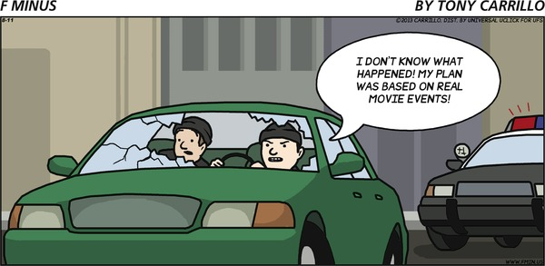
If You Want More: If you would like more on history as a discipline (including the source of the etymology of the word history used above) and on professional associations for teaching and researching history, click on Resources for History on the Course Menu and then the folder Introduction to the Discipline of History.

Done plus quiz--------------New Page

How History Will “TURN UP IN REAL LIFE”
History is not only a discipline that requires evidence and that lets you investigate real life events in the past so you can plan your own actions, but—to quote the cartoon below—history will "TURN UP IN REAL LIFE." History is a required course because it provides useful information that can help you in all of the roles you will have in your life—family member, student, worker who may have to retrain many times in a rapidly changing world, decision maker about your own life and your own vote, and perhaps parent. Learning history not only provides useful information, but also useful skills. It requires the types of skills in reading and analysis and writing that are necessary for all of those roles. What makes history provide all those benefits? History is about real life events of the past so it is useful in surviving in the real world of today. History will “TURN UP IN REAL LIFE.”
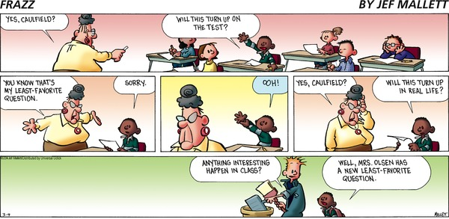

The word history comes from
a. The root word for a story
b. The root word to inquire

answer is b If you are correct, that’s great so keep going forward. If you missed the question, go back to the page with the cartoon about the failed bank robbery. Look at the words above the cartoon. With this and all other self-test questions in Course Orientation, if you still need help, please post in the Course Questions forum or talk to me by phone or in person.
This question is also an example of self-testing. Self-testing lets you measure yourself with no loss in points so you can tell what you know and you don’t know as you work.
--------------New Page
General Layout of the Course
On the left below (and also on the left on the Blackboard screen), you see the Course Menu. On the right, you see brief explanations for the items on the Course Menu. These two tips can help in using the Course Menu:
- To save yourself time in getting to a specific Course Tool or Web Resource, click on the item in the Course Menu.
- To save yourself time in learning, however, click on Learning Modules. Learning Modules are a Blackboard tool that lets instructors provide everything a student needs to learn or do something in one place—content (including maps), quizzes and exams, comparison topics, videos, and the group you work with.
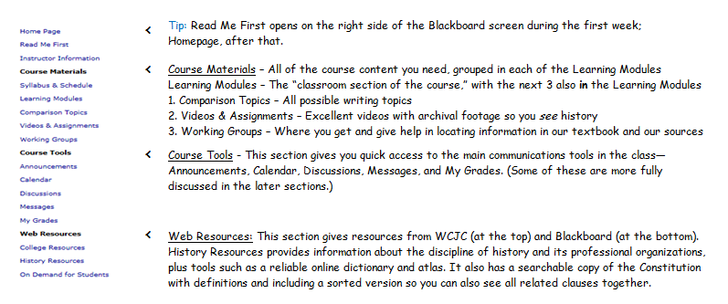

For success in learning, click on Learning Modules on the Course Menu.

True
If your answer is correct, keep going forward in Course Orientation. If you missed the question, look at the next few pages of Course Orientation. If you still don’t see why clicking on Learning Modules will help you succeed, please post in the Course Questions forum or talk to me by phone or in person.
--------------New Page

What’s in Each Unit (a Learning Module for a Major Time Period)?
In this course, each Unit, or major time period, is in a Learning Module because this Blackboard tool lets instructors provide everything a student needs in one place. Blackboard automatically makes visible each Unit on the date in the Course Schedule at the end of the syllabus. The course is split into three Units that reveal shifts in our history. The three time periods are:
- Unit 1: Creating a New America - How America Changed from the 1860s to 1900
- Unit 2: Moving to the World Stage - America from 1900 to 1940
- Unit 3: Transformations – America from 1940 to the 21st Century

To make your work more manageable, each Unit is divided into 3 smaller time periods, or Parts. For example, Unit 1 is divided into Part A, Part B, and Part C. Each Part has its own major theme, resources at "Everything You Need for This Unit (except the maps)," maps, and quiz (Quiz A, Quiz B, and Quiz C).

On the left below, you see the table of contents for Unit 1. On the right, you see brief explanations for the items in the Unit. Each of the 3 Units is organized in exactly the same way—the only difference is the letters used to name the Parts of a Unit. In other words, Unit 1 consists of Parts A, B, and C; Unit 2 consists of Parts D, E, and F; and Unit 3 consists of Part G, H, and I.
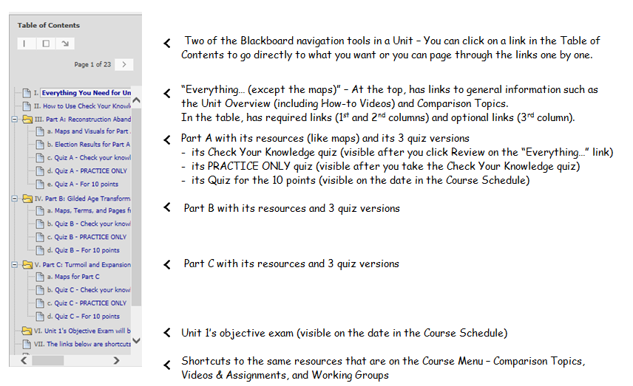

All Units are in Learning Module, and all Units are organized in exactly the same way. The only difference is the letters used for the Parts. Unit 1 consists of Parts A, B, and C; Unit 2, Parts D, E, and F; and Unit 3, Parts G,H, and I.
True

If you answered correctly, that’s good!. Now, move to the next page of Course Orientation. If you missed the question, look at the introduction at the top of this page. If you still need help, please post in the Course Questions forum or talk to me by phone or in person.

--------------New Page
Bringing It All Together: How Can You Reduce Your Time to Learn and Find What You Need?
These statements from the syllabus have some things—shown in blue with a number added—that are best understood with examples from the course. Those examples are provided in the next pages—with those pages having the numbers below.

The course also tries to do two things for each of you.
1. The course tries to reduce the time it takes each of you to learn this useful information and skills in several ways:
- With self-testing (1) - From the Getting Started to the review for the Final Exam, you can self-test. With no loss in points using quizzes or visual resources, you can test your own knowledge to identify what you know and don’t know and you can then plan what you have to read and to learn.
- By letting you know from the beginning of major time period (called Units), every fact you need to know and everything you need to read and write about:
  - For objective tests, such as multiple choice, you know not only the chapters you read, but you also have interactive study guides (called Check Your Knowledge quizzes) (5) that let you know the required facts from those chapters. The quizzes also show you whether you already know those facts (and don’t need to read those pages) or you don’t know them (and must read carefully). If a fact in the quiz is not listed in the index at the end of the textbook, you also have details about finding the information.
  - For written work (called Comparisons), you know all possible topics and exactly what you need to read for each topic. The topics require you to figure out how something changed from the beginning of a Unit to its end. You read the required sources, figure things out, and write simply, briefly (maximum of 1 page), and accurately. (See Good Habits for Evidence.)

2. The course also tries to match different kinds of students with different preferences for learning, different backgrounds, and different goals. Because the course does try to match different students, Course Orientation tries to help you recognize:
- Resources in the course that are required (All must use these resources.) (2)
- Resources that you use only in cases such as these: (3)
- If you missed a question on a Check Your Knowledge quiz and the Tips for that quiz question say to use this resource
- If you don’t understand something and want to see if one of the existing visual resources (4) can help you
- If you want additional information just because you are curious
--------------New Page
- What Is Self-Testing and How Can It Help You?
Self-testing lets you measure yourself with no loss in points so you can tell what you know and you don’t know and so you can plan your work.

There are 4 main ways that you have an opportunity to self-test in this course:
- In the Getting Started Learning Module, in this link and in the link for Good Habits for Evidence, you see small self-tests (like the one below).
Answer as best you can.
- If you answer the question correctly, keep going forward.
- On the other hand, if you miss the question, then look again at the prior pages to see if you know why you missed it. If you still don’t know, ask me by email or post in the Course Questions forum. You want to understand what is available to you in the course so you can succeed—and save time.
- Within each Unit, 3 interactive study guides (called Check Your Knowledge quizzes) that let you know the required facts from the chapters. The quizzes also show you whether you already know those facts (and don’t need to read those pages) or you don’t know them (and must read carefully). – There is more on this in the next pages.
- Within each Unit, visual resources specifically for self-testing
- At the Final Exam, a review for self-testing (For details, see the syllabus.)

In this course, self-testing:
- Lets you find out what you know (and don’t have to read) and don’t know (and must read) with no loss in points.
- Lets you create your own plan what you need to do
- Is available throughout the course, including with the Check Your Knowledge quizzes
- All of items above

If you are correct, keep moving forward. If you missed the question, look at the prior page and at this page.
--------------New Page
- What Resources Are Required and How Can the Link "Everything You Need for This Unit (except the maps)" Help You?
In many ways, students over the last 10 years created the link "Everything You Need for This Unit (except the maps).” Students are the ones who asked for help understanding something and I’d build a resource. If the resource helped that student, I made it available to everyone. Students are the ones who asked for all required and optional resources to be on 1 webpage. The only things that are not on that webpage are resources created by others (such as the textbook publisher’s maps).

Not only are each of the 3 Units is organized in exactly the same way, but also each of the “Everything…” links for each Unit is organized in exactly the same way.

Click on the links below to see these How-to Videos:
- How to Use What’s Available at the Top of the “Everything…” Link
- Covers the “Unit Overview” link: Access to How-To Videos; what’s unique about Unit 2; chapters numbers, Check Your Knowledge quizzes, and quizzes for 10 points for each Part; and the exam and writing for the Unit.
- Provides another way to access the Comparison Topics.
- How to Find Required Resources in the “Everything…” Link (Required means all must use these resources.)
- Provides in the 1st column the theme or title of each Part, its chapter numbers, and—if any—its required links to use
- Provides in the 2nd column for each Part two versions of the link with all of the questions in the Check Your Knowledge quiz in the same order as in the quiz—one with tips (used after you Check Your Knowledge quiz) and one without tips (used before you Check Your Knowledge quiz
Tip: You are welcome to copy (download) the Check Your Knowledge quizzes and any other resource at the "Everything..." link to your computer or flash drive. If you don’t know how, click here for Basic Internet Tips, including downloading.

One of these items is not in the required resources in the 1st and 2nd columns of the table in "Everything You Need for This Unit (except the maps)" are all except:
a. A link to visual resources for self-testing
b. A link with all of the questions in the Check Your Knowledge quiz in the same order as in the quiz you take so you can decide your answers before you click on the test
c. A link with all of the questions in the Check Your Knowledge quiz with tips for locating information in the textbook (If you can find what you need by using the index at the back of the textbook, no additional tips are provided.)

a

If you are correct, go to the next page. If you missed the question, click on the 2nd video.
--------------New Page
- What Resources at the “Everything…” Link Do You Use in Specific Cases and (4) What Are “Visual Resources”?
The specific cases when you use resources in the 3rd column of the "Everything You Need for This Unit (except the maps)" link are probably obvious when you look at the first and last statements in this list copied from the syllabus:
Resources that you use only in cases such as these:
- If you missed a question on a Check Your Knowledge quiz and the Tips for that quiz question say to use this resource
- If you don’t understand something and want to see if one of the existing visual resources can help you
- If you want additional information just because you are curious

What may puzzle you the statement in the middle about visual resources. The heading of the 3rd column provides a clue: “Seeing How History Changes Over Time, Over Space, and Sometimes Both Simultaneously at One Time (The Purpose below the link says what you look for in the link.) In this course, visual resources means the presentation of facts—usually the same facts as in your textbook and in most textbooks—in a form (such as a table) that makes it easier to see changes in history. If you use the visual resources, you can see that your memory or your reading was inaccurate and you can get things straight.

The easiest way to make this clearer is to show you some examples in this How-To Video:
- A chronology to show who hit whom and in what order (In this class, you don’t memorize dates; you notice order. Why? Because who hits first matters and because nothing can cause something if it happened after.)
- A chronology as a study tool—with all of them organized in the same way—so you can see events in context of all of the major institutions as you read
- A chronology with color coding, and the Purpose beneath the link explains what to look for
- A table to show the traits of 2 or more things that students have frequently misunderstand—with that table available for self-testing (This link, also available from the "Everything..." link for each of the Units, explains how to make the best use of Self-Testing.)
- Optional Reference—usually from a prior period or additional information that students asked for

The 3rd column of the "Everything..." link contains resources to help you in specific cases such as:
- If you missed a question on a Check Your Knowledge quiz and the Tips for that quiz question say to use this resource
- If you don’t understand something and want to see if one of the existing visual resources can help you
- If you want additional information just because you are curious

True
If you are correct, that’s great. If you missed the question, look again at this page.
--------------New Page
- How Do You Use the Check Your Knowledge quizzes As Interactive Study Guides?
You certainly don’t have to do things the way listed here, but experience with many students shows it works. Consider trying it.
Some Basics about Learning Well and Fast That I Have Found Most Students Don’t Seem Know - Brief
Downloading Check Your Knowledge quiz
Deciding—piece of notebook paper
Recording and why it matters
Using the version of with the tips
Testing and re testing

--------------New Page

Course Communications
As this is an online course, our primary means of communication will be through email and discussion board areas.
Online and On-campus Office Hours
Each semester I post my online office hours. These will be posted in Instructor Information on the Course Menu and as an announcement during the first week of the semester. During my online office hours, I check Blackboard Messages and postings and also answer calls. Additionally I try to log in each day when you are taking Unit Exams.
I also am glad to have a phone conference or meet with any of you on campus during my office hours. My office is at the Richmond campus where I have a phone and voice mail and teach on Monday, Wednesday, and Friday. I also teach at the Sugar Land campus on Tuesday and Thursday. At Sugar Land, I work in a public area (not private) with an unreliable phone so emailing for an appointment is best. This weekly calendar shows where I am.
Email and Telephone
Reaching me through my Blackboard email (Messages on the Course Menu) is the BEST way to reach me. I can rarely check my WCJC email except at the beginning of the day. If you mail me within Blackboard email, I will generally respond within 36 hours (holidays and weekends being exceptions). At a minimum, I check the Blackboard Messages at least after my last class on campus.
If you want to talk by phone during my online office hours, then the fastest way is to use Blackboard email to tell me your phone number and ask me to call you.

--------------New Page as Betancourt did
Discussion Forums
The Discussion section of the course is used for a variety of purposes. With this course, you can use Discussion forums in Working Groups (the graded area) to get help or give it. You also can communicate with other members of the class—and not just in the graded area. I hope this section will help to create a sense of community for people learning history.
All of you are encouraged to answer questions if you know the answer. One thing I learned in academics—but more in business—is to always double check anything you are about to say is true. It is a good habit that takes a few minutes but always pays off.
I regularly read through the questions and answers. If there is any particular area of confusion or "bad" answers, I may remove the posting or may send out the correct information as a general email.

Types of Discussion Forums in This Course
Discussions (Available on the Course Menu and in the Getting Started Learning Module)
The forums located in Discussions are ones that can be seen by anyone in the class. They are:
- Course Questions: You should post general questions that you have related to the course in this area. This is generally the fastest way to receive a response. I will review and respond frequently. Students are welcome to post responses to questions if they so choose. Your participation in this discussion forum is optional.
- Suggestions For Improvement: About halfway through the semester you will see a new forum appear called "Technology Feedback / Suggestions for Improvement." I am constantly trying to improve the navigation and design of the course to provide a better learning environment for students. Please feel free to offer constructive feedback or suggestions for improvement in this area. Anonymous posts are allowed.
- Student Lounge: A place to discuss issues not related to the course. Your participation in the Student Lounge is optional. I rarely go into this area. If you have a question for your instructor, post in Course Questions or email me if it is a private question.
- Student Introduction: A place to post a little bit about yourself so that other students and the instructor can know a little bit about you.
- Shareables from the Working Groups: The Sharable forum in the public Discussion area provides examples of postings for how to ask for help and give it. It is also used to share useful postings from one Working Group with all the other Working Groups.
Working Groups (Available on the Course Menu and in the Learning Modules for Units 1, 2, and 3)
Working Groups use Blackboard’s Discussion tool, but the only ones who can see your group are members of it. Each of you has been randomly assigned to a small group. Once the purge rolls are available I will make adjustments so the groups are about the same size and so that everyone is in a Working Group.
Participating in a Working Group is a required assignment with each Unit. In the grades, participating in Working Groups is classified as written work. Not participating means an alternative quiz that does require writing. The syllabus covers the details.
After Unit 1 starts, you will see a Unit 1 forum for your Working Group. Within each Working Group, the first thread in the forum for each Unit provides instructions and shows the Rubric used in grading. You are to help each other learn history and practice Good Habits for Evidence. These Working Groups let you ask or answer questions about the current content, current Comparison Topics, and about current quiz questions. You can earn those points by asking or answering.
You can see examples of how you can post to ask or answer a question in the forum Shareables from the Working Groups. It also used to share information—and to earn extra credit. When I see postings in your Working Group that can help other Working Group, I do two things:
1. I copy and post your work into the Shareable forum for each Unit (available at Discussions).
2. I enter 2 extra credit points for each posting that can help the other Working Groups and for each person involved in that posting.

Points to Remember about Working Group Postings

Read Working Group forums on Blackboard often. Reflect on these comments and contribute. Online discussions are learning opportunities that are equivalent to study groups or class projects with other participants. By reflecting on and responding to questions and comments, you will develop your ability to articulate your knowledge and deepen your understanding. We are here to learn the material, to help each other, to have fun, and to discuss matters of importance (at least I think history is important) with others. With graded Working Groups:
- Let the facts you have reveal the evidence so that others can decide for themselves. Do not state your opinion.
- Always provide the exact location of the information in our textbook so others can read the information for themselves. Your first task as a member of a Working Group is to reply to a posting from me asking what edition of the textbook you use.
  - If all of your group members have the current edition of our textbook (the 4th edition paperback), you can state the location just as a page number.
  - If some of your group members use an earlier edition, my next posting will tell you an easy way to specify the location.
- Post Early: The longer you wait to post your question, the harder it is for others to answer you in time for you to do your work.

Points to Remember about All Postings
Follow these Do and Don’t lists.
DO
- Make comments and questions that are relevant to the discussion topic
- Use respectful and polite language in your comments
- Make comments that are thoughtful but to the point
- If responding to a comment or message, be sure to include enough information so that the context of your response is understood
- Use appropriate upper and lower case and punctuation
DON'T
- Do not write anything that you would not share in person in a class.
- Do not write in all CAPITALS because this makes your message more difficult to read and some people use all CAPITALS as a way to shout at each other.
- Do not use unexplained acronyms or strange notations that may be unfamiliar to readers.
- Do not make rambling and off the topic comments.
- Do not post a message to point out other people's errors in typing or spelling unless they have asked for the correct spelling of a name or unfamiliar concept.
- Do not post your response as an attachment.

Grading and How Long It Takes
I know everyone is always anxious to receive feedback on your completed work, so I will make every effort to give you prompt feedback. I review your posting in the Discussion Working Groups as you work and sometimes I will reply or make suggestions. I generally:
- Review and, if needed, reply to Discussion postings visible to all students and those visible only to Working Groups. With Working Groups, you will know how you are doing as you work. Check replies to posts and, if necessary, private emails to you in Blackboard Messages.
- Enter Getting Started grades on the weekend at the end of the first week. During the week itself, I try to give feedback and get inexperienced students on track by conferences, both phone and face-to-face.
- Enter extra credit grades for students making 9 or 10 on quizzes before the date in the Course Schedule on the day after the DUE date in the Course Schedule. Frequently, I can’t do that until after my last class on that day.
- Enter grades for the Working Groups’ postings and the optional extra credit Video Assignments after each Unit ends. Rubrics are used to grade both.
- Post feedback and grades on Comparisons using a Rubric and as rapidly as I can, but I am slow because of how I grade written work:
  - I try to give students the kind of feedback my history teachers gave me. That feedback made a great difference in my success, not just in college but also in making a living in industries.
  - To do that, I sort the class answers and grade all answers to the same question and using the same version of the textbook (such as all who used the 4th edition paperback or all who used the 2nd edition hardback) at the same time.

While I’m grading the Comparison for the Unit, I do these two things to help you estimate your Unit letter grade:
- After the Unit’s objective exam scores are visible, I announce the number of points required for each letter grade (an A, B, C, D, or F) for the Unit before the Comparison grades are added in.
- After those grades are added in, I update the number of points for each letter grade and say where to find feedback.

Success in the Online Environment
Although this is a distance learning course, it is NOT a correspondence course; nor is it an independent study course. Specific deadlines are provided and must be met. Your remaining current in your work is required—and measured. While I try to build in a great deal of flexibility for you to work ahead in each unit, you cannot complete the course in a single weekend, but are expected to be part of the course for the whole semester.
This online version of United States History is designed to require roughly the same amount of time a student would spend in a 3-credit-hour, on-campus class. You will be expected to complete all of the learning activities and maintain an active presence in the class.
General points to remember:
- Communicate clearly in writing.
- Be self-motivated and self-disciplined.
- Speak up if you have trouble.
- Set aside sufficient time for the course.
- Have and be able to use a reliable computer with reliable access to the Internet

Introductory Tasks
Great! You are almost finished. Before you get started with the content for this course, I would like you to take care of some "housekeeping" items. The first to third tasks are due before the end of Getting Started in the Course Schedule. The fourth task you may complete a bit later. See the Course Schedule for the exact time. There is also a recommended task, but it is not graded.
I’ve tried to include in these steps preventions for every problem students have had. The steps make it long. If you’d prefer a 1-page version as a PDF, here is a link. Tip: Leave the link open until you finish all the tasks.
First (5 points), provide how to contact you in an emergency. Example of an emergency: there is something that will result in your having a lower final letter grade and I need to reach you quickly.
1. Select the Messages link from the Course Menu or within the Getting Started Module.
2. Choose “Create Message.”
3. Under recipients, click on "To" and select C.J. Bibus (Instructor). Note: (Instructor) is essential.
4. On the Subject line, please put "Your Name – Emergency Contact Information."
5. In the Message box, provide an emergency e-mail address and phone number. Please say if it is OK to leave messages at that number. Also add any information that you would like for me to know about you.

Second (4 points), introduce yourself to the other students.
1. Select Discussions from the Course Menu or within the Getting Started module.
2. Click on the forum Student Introductions
3. Choose “Create Thread.”
4. On the Subject line, type “Your Name” or a short phrase that identifies you. If you write the short phrase, remember Discussions are a public place, so don’t get yourself (or me) in trouble, OK?
5. In the message box, type about 150 words to introduce yourself to the class. Eventually the class will begin posting to the Working Groups and it is always nice to know a little about the people that you are working with. Please do not attach a file in Discussions (or in an email). It makes it difficult to read.
6. While you are in these forums, check postings in other discussions forums, such as Course Questions.

Third (1 point), if you have not already done it, click on the Syllabus Acknowledgement Quiz in the Getting Started module and choose True. Note: Required to continue in the course. If you do not understand something, ask now. You can post in the Course Questions forum or email me. Glad to help.

Fourth (20 points), complete the task in the 1st link in the Good Habits for Evidence folder.
1. Click on the folder “Good Habits for Evidence,” and then click on the 1st link inside the folder.
2. Use the 1st link and, if needed, use the definitions and The Bedford Handbook pages in the folder.
3. Follow the directions on the last page of the link on what to write and how to send it to me. You then earn 20 points. Note: You will not be able to see the Turnitin Assignments that you use to submit your Comparisons throughout the course until you do this task.
-------------------------------------------------------------------------------------------------------------
Recommended: Use the Readiness Assessment to find out about yourself in online classes and to find ways that you can improve your skills for each of the weaknesses that it identifies.
I was first impressed by the Readiness Assessment when I took it twice—each time pretending to be 2 different students I had known well in the prior term. The results and recommendations were completely different and amazingly accurate. Based on students’ feedback, if you have never taken this, I would try to find time to take it. Obviously, first complete the required assignments.

The Assessment is long, but you can click on the button that lets you save and resume later.
1. Click http://wcjc.smartermeasure.com/ You will see the user name and password WCJC’s students use.
2. When you finish, select “Print/Download the Report” on the left side of the screen and be sure to download it to a location you can find again. Note: You do not want the Summary. Only the Report has recommendations for you and the resources to help you act on those recommendations.
4. Identify 4 to 5 recommended changes that you believe you should make. If you need help, just ask. FYI: fast typing is the only thing in the assessment that you don’t need for this online class.

Remember that these tasks are a graded component of the course. Please complete them as soon after logging in as possible so that I know a little about each of you enrolled in the course. I am looking forward to a great semester. If you have any general questions, please go to Discussions and post it in the Course Questions forum. If the question is of a more personal nature, feel free to email me.
And always, if you need help, just ask.

WCJC Department: | History – Dr. Bibus
Contact Information: | 281.239.1577 or bibusc@wcjc.edu
Last Updated: | 2014
WCJC Home: | http://www.wcjc.edu/

