Orientation to the Course
To try to make this where you can give feedback on the plan even though it is NOT yet in SoftC:
- [ ] is note to me OR description of visual
- --- and New Page marks planned breaks
- Visuals are in here even though not in proper position.
--------------New Page
Welcome to Class!
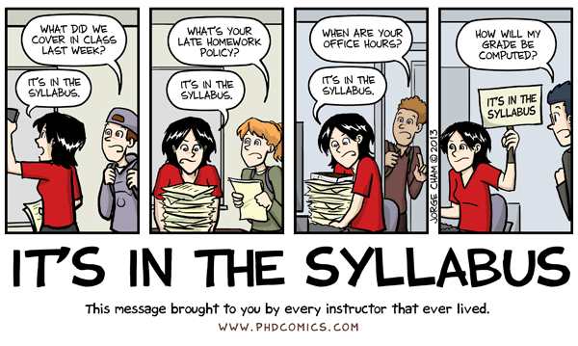
This document, along with the syllabus, provides very important information regarding how this course will function and what will be expected of you. So, please take the time to read all of the material provided.
After you have read the material in this section you will be required to complete several graded introductory tasks. If you have additional questions after completing this section, please post them to the “Course Questions” discussion forum on the discussion board. Don't be shy about asking your question(s). Remember, if something is not clear to you, it is probably not clear to others as well! Also, if someone posts a question for which you have an answer, feel free to help them out!

With thanks to WCJC’s Director of Distance Education, Professor Michele Betancourt, for her permission to use her Getting Started documents (including her exact words) in the Getting Started sections of our WCJC courses.

--------------New Page

Introducing Your Instructor
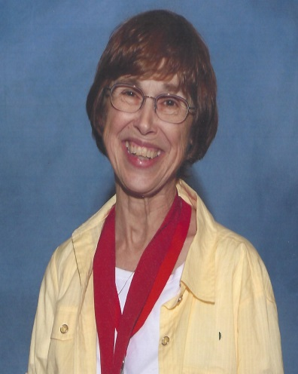
Welcome to this online section of United States History II. My name is C.J. Bibus, and I will be your instructor this semester. I have been teaching online history since 2003 and both on-campus and online history for WCJC since 2004.
I am a native Texan who attended a community college. I received my MA in history at the University of Virginia and completed an additional year of work in history and in an internship in community college teaching. I taught in Virginia community colleges for several years and later returned to Texas to earn my doctorate at Texas Tech University. My doctorate emphasized teaching in the community college and the history of the early junior college just after 1900.
I also worked in industry before returning to teaching in the community college in 2003. Much of my emphasis on evidence and accuracy comes from my experience in industry. I found that getting or keeping a job that paid well required skills with evidence and factual accuracy.
I have a perfect daughter—all parents should feel that way about their children. To quote the family joke, my daughter “brought her Mom up as best she could.”
I am always trying to improve the course each semester. For those of you who have taken my classes in the past, I hope you like the changes this semester. If anyone has suggestions to improve this course, feel free to let me know, I value and appreciate the input.

--------------New Page

About History As an Investigation into Real Life Events (Not “Real Movie Events”)
Sometimes a discipline needs an introduction as much as an instructor. The word discipline means a field that people study. Disciplines usually have rules, including for what is considered evidence. The etymology of the word history is a clue to history's rules for evidence. The word history comes “from historein, to inquire, from histor, learned man [bold added]." Notice that word inquire or, to use a more current word, investigate. In a freshman course, inquiry into real life events in the past can help you learn history as a useful discipline that is about how things work in reality. Basing your plans on investigations of real life events will bring success, but—as the cartoon shows—basing them on "REAL MOVIE EVENTS" fails.

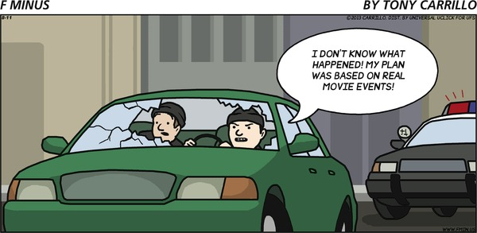
If You Want More: If you would like more on history as a discipline (including the source of the etymology of the word history used above) and on professional associations for teaching and researching history, click on Resources for History on the Course Menu and then the folder Introduction to the Discipline of History.

--------------New Page

How History Will “TURN UP IN REAL LIFE” [need better heading]
History is not only an investigation into real life events in the past that will help you plan and understand and a discipline that requires evidence, but—to quote the cartoon—history will "TURN UP IN REAL LIFE." History is not only a required course, but it also provides useful information that can help you in all of the roles you will have in your life—family member, student, worker who may have to retrain many times in a rapidly changing world, decision maker about your own life and your own vote, and perhaps parent. Learning history not only provides useful information, but also useful skills. It requires the types of skills in reading and analysis and writing that are necessary for all of those roles. What makes history provide all those benefits? History is about real life events of the past so it is useful in living in the real world of today. In other words, history will “TURN UP IN REAL LIFE.”
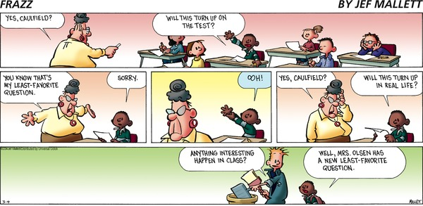
--------------New Page
These statements from the syllabus have some things—shown n blue—that are best understood with examples from the course. Those examples are provided in the next pages.

The course also tries to do two things for each of you.
1. The course tries to reduce the time it takes each of you to learn this useful information and skills in several ways:
- From Getting Started to the review for the Final Exam, you can self-test. With no loss in points using quizzes or visual resources, you can test your own knowledge to identify what you know and don’t know and you can then plan what you have to read and to learn. For example, with objective tests, such as multiple choice, you know not only the chapters you read, but you also have interactive study guides (called Check Your Knowledge quizzes) that let you know the required facts from those chapters. The quizzes also show you whether you already know those facts (and don’t need to read those pages) or you don’t know them (and must read carefully).
- For written work (called Comparisons), you know all possible topics and exactly what you need to read for each topic. The topics require you to figure out how something changed from the beginning of a Unit to its end. You read the required sources, figure things out, and write simply, briefly (maximum of 1 page), and accurately. (See Good Habits for Evidence.)

2. The course also tries to match different kinds of students with different preferences for learning, different backgrounds, and different goals. Because the course does try to match different students, Course Orientation tries to help you recognize:
- Resources in the course that are required (All must use these resources.)
- Resources that you use only in cases such as these:
- If you missed a question on a Check Your Knowledge quiz and the Tips for that quiz recommend this resource
- If you don’t understand something and want to see if one of the existing visual resources can help you
- If you want additional information just because you are curious
--------------New Page
What Is Self-Testing and How Can It Help You?
Self-testing are ways to measure yourself with no loss in points so you can tell what you know and you don’t know and so you can plan your work. There are four main ways you have an opportunity to self-test in this course:
- In the Getting Started Learning Module, in this link and in the link for Good Habits for Evidence, you see small self-tests (like the one below).
Answer as best you can.
- If you answer the question correctly, keep going forward.
- On the other hand, if you miss the question, then look again at the prior pages to see if you know why you missed it. If you still don’t know, ask me by email or post in the Course Questions [checkname] forum. You want to understand what is available to you in the course so you can succeed—and save time.
- Within each Unit, 3 interactive study guides (called Check Your Knowledge quizzes) that let you know the required facts from the chapters. The quizzes also show you whether you already know those facts (and don’t need to read those pages) or you don’t know them (and must read carefully). – There is more on this in the next pages.
- Within each Unit, visual resources that include ones labeled as for self-testing and with the answers

The word history comes from
a. The root word for a story
b. The root word to inquire

answer is b If you missed it go back to the page with the cartoon about the failed bank robbery. Look at the words above the cartoon.
--------------New Page
[This one got weird in SoftC—have screen prints. I have no idea what I did here.
Expect text must be shorter. Text for this is above the illustration until I can get help.]
General Layout of the Course

ART IS in separate file WITH callouts

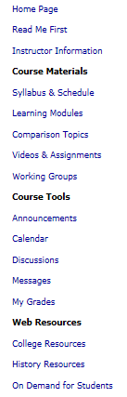

--------------New Page

ART IS in separate file WITH callouts
Layout of Each Unit
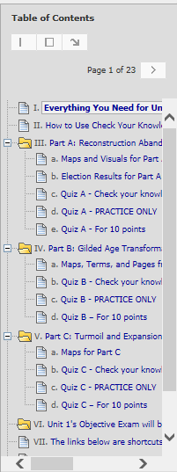

If You Want More: If you want videos on How to Use "Everything You Need for This Unit (except the maps)," How to Use Check Your Knowledge Quizzes As Interactive Study Guides, and How to Make the Quizzes Visible, click on the links. You can also find these videos (and more) in each Unit Overview.

If You Want More: If you want videos on How to Use "Everything You Need for This Unit (except the maps)," How to Use Check Your Knowledge Quizzes As Interactive Study Guides, and How to Make the Quizzes Visible, click on the links. You can also find these videos (and more) in each Unit Overview.

--------------New Page

Course Communications
As this is an online course, our primary means of communication will be through email and discussion board areas.
Online and On-campus Office Hours
Each semester I will post my virtual office hours. These will be posted as an announcement during the first week of the semester. During my virtual office hours I will be available to respond to student questions. Additionally I try to log in each day when you are taking Unit Exams.
I also am glad to have a phone conference or meet with any of you on campus during my office hours. My office is at the Richmond campus where I have a phone and voice mail and teach on Monday, Wednesday, and Friday. I also teach at the Sugar Land campus on Tuesday and Thursday—where I hold office hours in an area without a phone that is reliable.
Because I teach in both Sugar Land and Richmond, it is clearer to show where I am during the week than write about it. This link shows you in weekly calendar format how to reach me when you need me.
Email and Telephone
Reaching me through my Blackboard email (Messages on the Course Menu) is the BEST way to reach me. I can rarely check my WCJC email except at the beginning of the day. If you mail me within Blackboard email, I will generally respond within 24 hours (holidays and weekends being exceptions). At a minimum, I check the course messages at least after my last class on campus.
If you want to talk by phone during my online office hours, then the fastest way is to use Blackboard email to tell me your phone number and ask me to call you.

--------------New Page—re the remaining breaks, will follow the pattern
Discussion Boards
The Discussion Section of the course is used for a variety of purposes. With this course, you can use the Discussion Board to get help or give it. You also can communicate with other members of the class—and not just in the graded area. I hope this section will help to create a sense of community for people learning history.
Everyone is encouraged to answer questions if they know the answer. One thing I learned in academics—but more in business—is to always double check anything you are about to say is true. It is a good habit that takes a few seconds but always pays off.
I regularly read through the questions and answers. If there is any particular area of confusion or "bad" answers, I may remove the posting or may send out the correct information as a general email.

Types of Discussion Boards in This Course
Discussions – Class
The forums located in Discussions are ones that can be seen by anyone in the class. They are:
- Course Questions: You should post general questions that you have related to the course in this area. This is generally the fastest way to receive a response. I will review and respond frequently. Students are welcome to post responses to questions if they so choose. Your participation in this discussion forum is optional.
- Suggestions For Improvement: About halfway through the semester you will see a new forum appear called "Technology Feedback / Suggestions for Improvement." I am constantly trying to improve the navigation and design of the course to provide a better learning environment for students. Please feel free to offer constructive feedback or suggestions for improvement in this area. Anonymous posts are allowed.
- Student Lounge: A place to discuss issues not related to the course. Your participation in the Student Lounge is optional. I rarely go into this area. If you have a question for your instructor, post in Course Questions or email me if it is a private question.
- Student Introduction: A place to post a little bit about yourself so that other students and the instructor can know a little bit about you.
- Shareables from the Working Groups: The purpose of this forum is covered in the syllabus. It is graded as an extra credit activity.
Working Groups
Working Groups use Blackboard’s Discussion tool, but the only ones who can see your group are members of it. Each of you has been randomly assigned to a small group. I have seen some real benefit to random assignments to groups. Once the purge rolls are available I will make adjustments so the groups are about the same size and so that everyone is in a Working Group.
After Unit 1 starts, you will see a Unit 1 forum for your working group. You are to help each other learn history and practice Good Habits for Evidence. These working groups let you ask or answer questions about the current content, current Comparison Topics, and about current quiz questions. You can earn those points in several ways.
You can see examples of how you can post to ask or answer a question in the forum Shareables from the Working Groups. It also used to share information and to earn extra credit. When I see postings in your Working Group that can help other groups, I do two things:
1. I copy and post your work into the Shareable forum for each Unit (available at Discussions).
2. I enter 2 extra credit points for each posting that can help the other Working Groups and for each person involved in that posting.

Points to Remember about All Postings
This link provides guidelines for posting, including politeness. It also has a section on the value of threads. These guidelines are necessary for:
- students posting in the general types of discussion boards
- those posting in the graded Unit forums

Grading and How Long It Takes
I know everyone is always anxious to receive feedback on your completed work, so I will make every effort to give you prompt feedback. I review your posting in the Discussion Working Groups as you work and sometimes I will reply or make suggestions. I generally post:
- Getting Started grades - on the weekend at the end of the first week. During the week itself, I try to give feedback and get inexperienced students on track by conferences (both phone and face-to-face).
- Extra credit grades for quizzes with a score of 9 or 10 - the next morning after the date in the Course Schedule.
- Grades for submitted Video Assignments and Working Group postings – done with rubrics and frequently not started until the weekend
- Grades for Comparison topics – done with rubrics, but I admit I am very slow at grading this kind of written work partly because
* I try to give students the kind of feedback that my history teachers gave me. That feedback made a great difference in my success, not just in academics but also in my work in business and industry.
* I sort the answers and grade all answers to the same question and using the same version of the textbook (such as all who used the 4th edition paperback or all who used the 2nd edition hardback) at the same time.
To make it easier for you to estimate your current letter grades for a Unit until I can finish the Comparisons, I provide an Announcement so you can temporarily estimate your Unit letter grade without the Comparison

Success in the Online Environment
Although this is a distance learning course, it is NOT a correspondence course; nor is it an independent study course. Specific deadlines are provided and must be met. Your remaining current in your work is required—and measured. While I try to build in a great deal of flexibility for you to work ahead in each unit, you cannot complete the course in a single weekend, but are expected to be part of the course for the whole semester.
This online version of United States History is designed to require roughly the same amount of time a student would spend in a 3-credit-hour, on-campus class. You will be expected to complete all of the learning activities and maintain an active presence in the class.
General points to remember:
- Communicate clearly in writing.
- Be self-motivated and self-disciplined.
- Speak up if you have trouble.
- Set aside sufficient time for the course.
- Have and be able to use a reliable computer with reliable access to the Internet

Introductory Tasks
Great! You are almost finished. Before you get started with the content for this course, I would like you to take care of some "housekeeping" items. The first to third tasks are due before the end of Getting Started in the Course Schedule. The fourth task you may complete a bit later. See the Course Schedule for the exact time. There is also a recommended task, but it is not graded.
I’ve tried to include in these steps preventions for every problem students have had. The steps make it long. If you’d prefer a 1-page version as a PDF, here is a link. Leave the link open until you finish all the tasks.
First (5 points), provide how to contact you in an emergency. Example of an emergency: there is something that will result in your having a lower final letter grade and I need to reach you quickly.
1. Select the Messages link from the Course Menu or within the Getting Started Module.
2. Choose “Create Message.”
3. Under recipients, click on "To" and select C.J. Bibus (Instructor). Note: (Instructor) is essential.
4. On the Subject line, please put "Your Name – Emergency Contact Information."
5. In the Message box, provide an emergency e-mail address and phone number. Please say if it is OK to leave messages at that number. Also add any information that you would like for me to know about you.

Second (4 points), introduce yourself to the other students.
1. Select Discussions from the Course Menu or within the Getting Started module.
2. Click on the forum Student Introductions
3. Choose “Create Thread.”
4. On the Subject line, type “Your Name” or a short phrase that identifies you. If you write the short phrase, remember Discussions are a public place, so don’t get yourself (or me) in trouble, OK?
5. In the message box, type about 150 words to introduce yourself to the class. Eventually the class will begin posting to the Working Groups and it is always nice to know a little about the people that you are working with. Please do not attach a file in Discussions (or in an email). It makes it difficult to read.
6. While you are in these forums, check postings in other discussions forums, such as Course Questions.

Third (1 point), if you have not already done it, click on the Syllabus Acknowledgement Quiz in the Getting Started module and choose True. Note: Required to continue in the course. If you do not understand something, ask now. You can post in the Course Questions forum or email me. Glad to help.

Fourth (20 points), complete the task in the 1st link in the Good Habits for Evidence folder.
1. Click on the folder “Good Habits for Evidence,” and then click on the 1st link inside the folder.
2. Use the 1st link and, if needed, use the definitions and The Bedford Handbook pages in the folder.
3. Follow the directions on the last page of the link on what to write and how to send it to me. You then earn 20 points. Note: You will not be able to see the Turnitin Assignments that you use to submit your Comparisons throughout the course until you do this task.
-------------------------------------------------------------------------------------------------------------
Recommended: Use the Readiness Assessment to find out about yourself in online classes and to find ways that you can improve your skills for each of the weaknesses that it identifies.
I was first impressed by the Readiness Assessment when I took it twice—each time pretending to be 2 different students I had known well in the prior term. The results and recommendations were completely different and amazingly accurate. Based on students’ feedback, if you have never taken this, I would try to find time to take it. Obviously, first complete the required assignments.

The Assessment is long, but you can click on the button that lets you save and resume later.
1. Click http://wcjc.smartermeasure.com/ You will see the user name and password WCJC’s students use.
2. When you finish, select “Print/Download the Report” on the left side of the screen and be sure to download it to a location you can find again. Note: You do not want the Summary. Only the Report has recommendations for you and the resources to help you act on those recommendations.
4. Identify 4 to 5 recommended changes that you believe you should make. If you need help, just ask. FYI: fast typing is the only thing in the assessment that you don’t need for this online class.

Remember that these tasks are a graded component of the course. Please complete them as soon after logging in as possible so that I know a little about each of you enrolled in the course. I am looking forward to a great semester. If you have any general questions, please go to Discussions and post it in the Course Questions forum. If the question is of a more personal nature, feel free to email me.
And always, if you need help, just ask.

WCJC Department: | History – Dr. Bibus
Contact Information: | 281.239.1577 or bibusc@wcjc.edu
Last Updated: | 2014
WCJC Home: | http://www.wcjc.edu/

