Orientation to the Course
Welcome to Class!
This document, along with the syllabus, provides very important information regarding how this course will function and what will be expected of you. So, please take the time to read all of the material provided.
After you have read the material in this section you will be required to complete several graded introductory tasks. If you have additional questions after completing this section, please post them to the “Course Questions” discussion forum on the discussion board. Don't be shy about asking your question(s). Remember, if something is not clear to you, it is probably not clear to others as well! Also, if someone posts a question for which you have an answer, feel free to help them out!

With thanks to WCJC’s Director of Distance Education, Professor Michele Betancourt, for her permission to use her Getting Started documents (including her exact words) in the Getting Started sections of our WCJC courses.
With thanks to WCJC’s Director of Distance Education, Professor Michele Betancourt, for her permission to use her Getting Started documents (including her exact words) in the Getting Started sections of our WCJC courses.

About Your Instructor
Welcome to this online section of United States History II. My name is C.J. Bibus, and I will be your instructor this semester. I have been teaching online history since 2003 and both on-campus and online history for WCJC since 2004.
I am a native Texan who attended a community college. I received my MA in history at the University of Virginia and completed an additional year of work in history and in an internship in community college teaching. I taught in Virginia community colleges for several years and later returned to Texas to earn my doctorate at Texas Tech University. My doctorate emphasized teaching in the community college and the history of the early junior college just after 1900.
I also worked in industry before returning to teaching in the community college in 2003. Much of my emphasis on evidence and accuracy comes from my experience in industry. I found that getting or keeping a job that paid well required skills with evidence and factual accuracy.
I have a perfect daughter—all parents should feel that way about their children. To quote the family joke, my daughter “brought her Mom up as best she could.”
I am always trying to improve the course each semester. For those of you who have taken my classes in the past, I hope you like the changes this semester. If anyone has suggestions to improve this course, feel free to let me know, I value and appreciate the input.

About the Value of Learning History
Sometimes the discipline of history needs an introduction as much as an instructor. For those students who are not actively involved in STEM courses or do not yet have to write for those courses, freshman history may be their first time to write about something that is real.

What is different about writing about something is real? When you write about your opinion or your feelings, whatever you write is true because you are the expert on yourself. On the other hand, when you write something for your job or in a class about biology or history (or anything else that is real), you can be wrong—and the person reading your work will be an expert and will know instantly that you are wrong. They can prove you are wrong or tell you that you must provide verifiable evidence from sources they have required you to use. United States history is a freshman class, but—at any level—learning and writing about something that is real is a challenge.

This course is set up to help you meet that challenge and to try to do three things.
1) To help you learn history as a useful discipline that is about how things work and you always want to what is real in life
2) To reduce the time it takes each of you to learn
3) To make the course work for different kinds of students with different preferences for learning, different backgrounds, and different goals

The rest of this Orientation is meant to show how the course can help you in those three ways.

If you would like more on history as a discipline, on the terms associated with the discipline (such as historiography), and on professional associations for teaching and researching history, click on Resources for History on the left hand menu.

[decide if put reality cartoon in here]

Course Communications
As this is an online course, our primary means of communication will be through email and discussion board areas.
Online and On-campus Office Hours
Each semester I will post my virtual office hours. These will be posted as an announcement during the first week of the semester. During my virtual office hours I will be available to respond to student questions. Additionally I try to log in each day when you are taking Unit Exams.
I also am glad to have a phone conference or meet with any of you on campus during my office hours. My office is at the Richmond campus where I have a phone and voice mail and teach on Monday, Wednesday, and Friday. I also teach at the Sugar Land campus on Tuesday and Thursday—where I hold office hours in an area without a phone that is reliable.
Because I teach in both Sugar Land and Richmond, it is clearer to show where I am during the week than write about it. This link shows you in weekly calendar format how to reach me when you need me.
Email and Telephone
Reaching me through my Blackboard email (Messages on the left menu) is the BEST way to reach me. I can rarely check my WCJC email except at the beginning of the day. If you mail me within Blackboard email, I will generally respond within 24 hours (holidays and weekends being exceptions). At a minimum, I check the course messages at least after my last class on campus.
If you want to talk by phone during my online office hours, then the fastest way is to use Blackboard email to tell me your phone number and ask me to call you.
Blackboard’s Learning Modules, Differences in Students, and That This Is a Reading Course
Blackboard’s Learning Modules and Which Ones Are in This Course
Blackboard provides a tool called Learning Modules and—like the model for instruction that the Distance Learning Department provided to faculty—we use it in this course. Learning Modules let students have access in one place to everything they need for the current jobs they have to do. In each of our Learning Modules for this course, we cover a time period where history changes a lot. The nation starts out one way and becomes something recognizably different. This instructor’s view of everything you would see if you clicked on Learning Module (on the left menu) shows you the learning modules for the 3 Units—and the date in the title and the “It will be available after…” tells you when you will see them.
Click here for a brief oral explanation of this section.

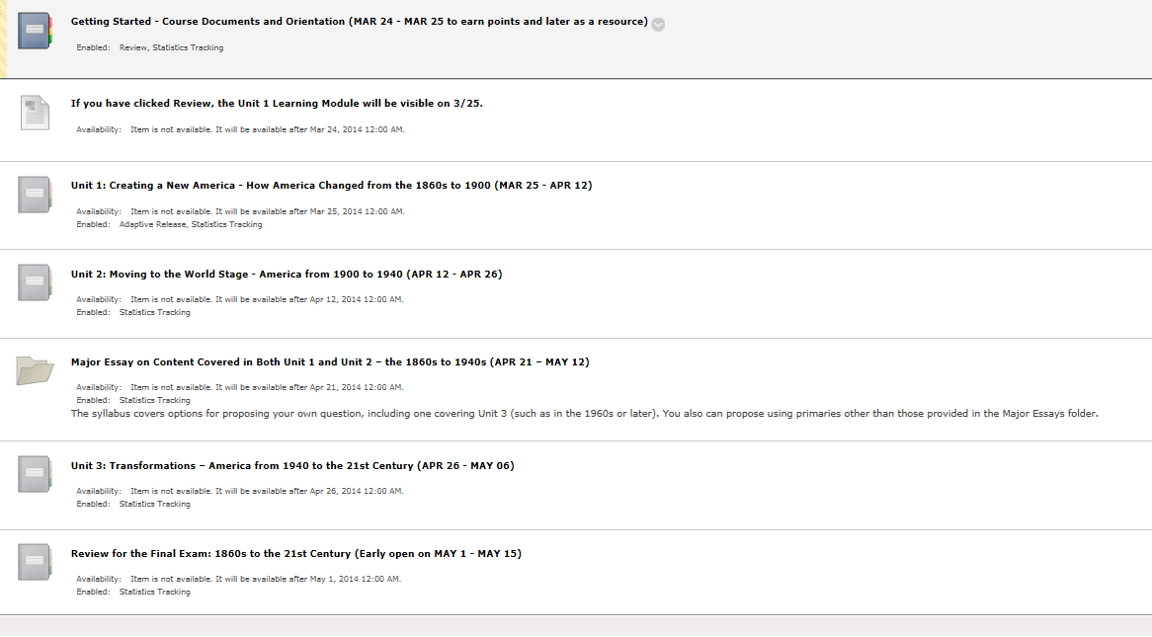
How All Learning Modules Are Organized
Each of our Learning Modules for Units is organized in exactly the same way. All Units are split in Parts so that the content is a manageable size. What resources are in each Unit (each Learning Module in for learning a period of history) and in this order:
- At the top on the left is a table of contents
- At the top on the right are all Parts of the Unit, the link “Everything You Need for This Unit (except the maps)”
- In the middle and for specific Parts of the unit, maps from the textbook publisher
- Shortcuts so you can use Blackboard tools on the left-hand menu within the Module
Click here for a brief oral explanation of this section.

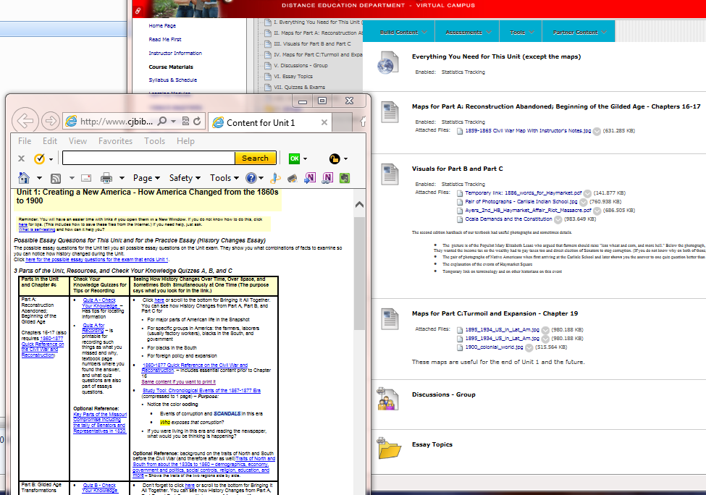

A Reading Course That Helps You Read Less—and Better
Because reading and writing are challenging, I provide in the Learning Modules things to reduce your time and increase your success in reading. There are several but these two are most important:
- A way to know every possible Unit Exam Essay question that Blackboard might display at the beginning of the Unit plus tips on where to find the information for that question and tips in the event students before had trouble understanding it.
What do you look for to take advantage of this?
* Either look for the link to the list of all possible Comparison Topics provided in each Learning Module in a link called “Everything You Need for This Unit (except the maps)” – visible in the right part of the screen above.
* Or click on Essay Topics (on the left menu or in each Unit learning module) –visible in the right part of the screen above.
- A way to identify before you read and before I test you at the end of the Unit, the things you know and those things you don’t know (but may think you know). This lets you read very efficiently—read what you don’t know.
What do you look for to take advantage of this? Look for the Check Your Knowledge quizzes.
Because the results from a Check Your Knowledge quiz tell you what you don’t know, but those results don’t show the whole question so you really can’t learn efficiently (but only memorize), I provide printable versions of Check Your Knowledge quizzes without answers. I try to take the busy work out of learning so you have a pre-built place to record which ones you missed. I also provide a version of the links to the quizzes with tips.
What do you look for to take advantage of this? Look for these resources in each Learning Module in a link called “Everything You Need for This Unit (except the maps).”

Click here for a brief oral explanation of this section. – The Check Your Knowledge quiz on the left and the link on the right showing the questions available from "Everything You Need for This Unit (except the maps)" are the same.

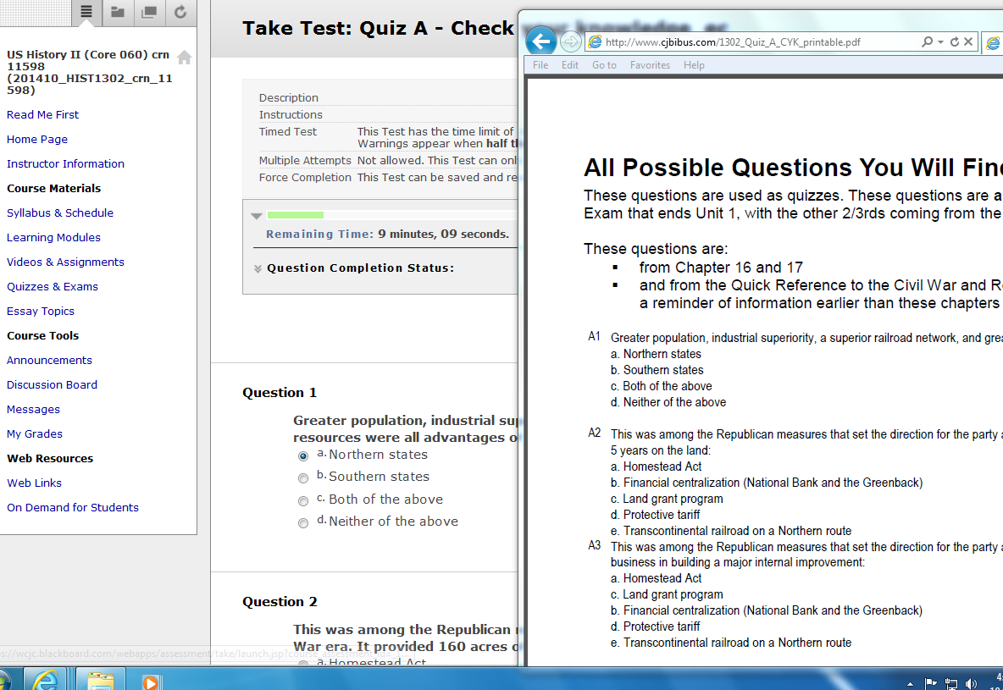

Two Steps in Using Check Your Knowledge Quizzes
Click here for a brief oral explanation of this section.
FIRST, after you take the Syllabus Acknowledgement Quiz, you begin with the Check Your Knowledge quizzes for each part of the Unit. You see a box similar to the one at the top telling you when the Unit Exam occurs. If you want to know why, click Why you can’t see exams and why the boxes of information shown at Quizzes& Exams (whether on the left menu or in Learning Module).

SECOND, after you take Check Your Knowledge quiz for Quiz A, you click on the shortcut to Quizzes & Exams (or use the one on the left menu). You now see the other two versions of Quiz A. You begin with the Check Your Knowledge quizzes for each part of the Unit.
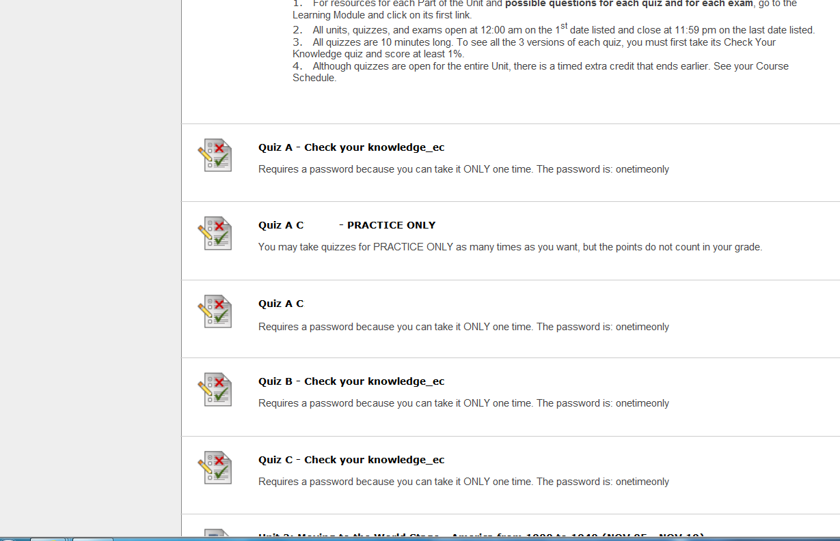

These tips may also help you. Ask if you have some question that needs tips:
How to find all possible objective and Comparison Topics | How to prepare for objective and essay exams | How the printable quiz works with the 3 versions of each quiz | Before you click on a quiz, why you want to decide your answers on paper first | About the confusing prompt and what to do – the one saying you can return to a quiz or exam | Why you do not want to study the results and what’s the alternative
About the Percentage of Your Grade That Requires Reading For Evidence and Writing With Evidence
There are some things, however, that all students need to do if they want an A. All have to read. Essays (short, evidence-based answers to specific questions) and the Major Essay and your Discussion Working Groups count for 250 points out of 1000. That is the minimum percentage that the History Department uses.
If you were perfect (and few of us are) at everything else, you’d score 750 points and that is a C. Having a substantial part of the grade for history be from writing is a departmental requirement and a WCJC requirement.
How is it a WCJC requirement? History is classified as a “gateway” course (not a gatekeeper—a whole different word) and in history we are expected to try to prepare you for what it is like after community college. Now I don’t grade you at a junior and senior level, but I use the traditional rules for evidence and use them at a freshman level. What you will see as you go forward is that my intent is not to hurt your grades over the essays, but to help you safely have the experiences that you need to practice for the future you are choosing. Community college teachers did that for me and I am glad to do that for you.
Reading and writing are hard—and they are hard for me as well. Reading for evidence and writing with evidence (not just opinion) are harder, but they will help you learn history and that’s my job. My experience in industry says that the skills it takes to learn history can also help you in jobs that will pay well. The Getting Started task of introducing yourself to the Good Habits for Evidence deals habits that will help you succeed.

Discussion Boards
The Discussion Section of the course is used for a variety of purposes. With this course, you can use the Discussion Board to get help or give it. You also can communicate with other members of the class—and not just in the graded area. I hope this section will help to create a sense of community for people learning history.
Everyone is encouraged to answer questions if they know the answer. One thing I learned in academics—but more in business—is to always double check anything you are about to say is true. It is a good habit that takes a few seconds but always pays off.
I regularly read through the questions and answers. If there is any particular area of confusion or "bad" answers, I may remove the posting or may send out the correct information as a general email.

Types of Discussion Boards in This Course
Discussions – Class
The forums located in Discussions - Class are ones that can be seen by anyone in the class. They are:
- Course Questions: You should post general questions that you have related to the course in this area. This is generally the fastest way to receive a response. I will review and respond frequently. Students are welcome to post responses to questions if they so choose. Your participation in this discussion forum is optional.
- Suggestions For Improvement: About halfway through the semester you will see a new forum appear called "Technology Feedback / Suggestions for Improvement." I am constantly trying to improve the navigation and design of the course to provide a better learning environment for students. Please feel free to offer constructive feedback or suggestions for improvement in this area. Anonymous posts are allowed.
- Student Lounge: A place to discuss issues not related to the course. Your participation in the Student Lounge is optional. I rarely go into this area. If you have a question for your instructor, post in Course Questions or email me if it is a private question.
- Student Introduction: A place to post a little bit about yourself so that other students and the instructor can know a little bit about you.
- Shareables from the Working Groups: The purpose of this forum is covered in the syllabus. It is graded as an extra credit activity.
Working Groups
Working Groups use Blackboard’s Discussion tool, but the only ones who can see your group are members of it. Each of you have been randomly assigned to a small group. I have seen some real benefit to random assignments to groups. Once the purge rolls are available I will make adjustments so the groups are about the same size and so that everyone is in a Working Group.
After Unit 1 starts, you will see a Unit 1 forum for your working group. You are to help each other learn history and practice Good Habits for Evidence. These working groups let you ask or answer questions about the current content, current Comparison Topics, and about current quiz questions. You can earn those points in several ways.
You can see examples of how you can post to ask or answer a question in the forum Shareables from the Working Groups. It also used to share information and to earn extra credit. When I see postings in your Working Group that can help other groups, I do two things:
1. I copy and post your work into the Shareable forum for each Unit (available at Discussions – Class).
2. I enter 2 extra credit points for each posting that can help the other Working Groups and for each person involved in that posting.

Points to Remember about All Postings
This link provides guidelines for posting, including politeness. It also has a section on the value of threads. These guidelines are necessary for:
- students posting in the general types of discussion boards
- those posting in the graded Unit forums

Grading and How Long It Takes
I know everyone is always anxious to receive feedback on your completed work, so I will make every effort to give you prompt feedback. I review your posting in the Discussion Working Groups as you work and sometimes I will reply or make suggestions. I generally post:
- Getting Started grades - on the weekend at the end of the first week. During the week itself, I try to give feedback and get inexperienced students on track by conferences (both phone and face-to-face).
- Extra credit grades for quizzes with a score of 9 or 10 - the next morning after the date in the Course Schedule.
- Grades for submitted Video Assignments and Working Group postings – done with rubrics and frequently not started until the weekend
- Grades for Comparison topics – done with rubrics, but I admit I am very slow at grading this kind of written work partly because
* I try to give students the kind of feedback that my history teachers gave me. That feedback made a great difference in my success, not just in academics but also in my work in business and industry.
* I sort the answers and grade all answers to the same question and using the same version of the textbook (such as all who used the 4th edition paperback or all who used the 2nd edition hardback) at the same time.
To make it easier for you to estimate your current letter grades for a Unit until I can finish the Comparisons, I provide an Announcement so you can temporarily estimate your Unit letter grade without the Comparison

Success in the Online Environment
Although this is a distance learning course, it is NOT a correspondence course; nor is it an independent study course. Specific deadlines are provided and must be met. Your remaining current in your work is required—and measured. While I try to build in a great deal of flexibility for you to work ahead in each unit, you cannot complete the course in a single weekend, but are expected to be part of the course for the whole semester.
This online version of United States History is designed to require roughly the same amount of time a student would spend in a 3-credit-hour, on-campus class. You will be expected to complete all of the learning activities and maintain an active presence in the class.
General points to remember:
- Communicate clearly in writing.
- Be self-motivated and self-disciplined.
- Speak up if you have trouble.
- Set aside sufficient time for the course.
- Have and be able to use a reliable computer with reliable access to the Internet

Introductory Tasks
Great! You are almost finished. Before you get started with the content for this course, I would like you to take care of some "housekeeping" items. The first to fourth tasks are due before the end of Getting Started in the Course Schedule. The fifth task you may complete a bit later. See the Course Schedule for the exact time.

First, provide additional information, including how to contact you. I rarely use it unless there is something that might result in your having a lower final letter grade and I need to reach you quickly.
1. Select the Messages link from the left hand menu or within the Getting Started Module.
2. Choose “Create Message.”
3. Under recipients, click on "To" and select C.J. Bibus (Instructor). The word (Instructor) is essential.
4. On the Subject line, please put "Your Name – Emergency Contact Information."
5. In the Message box, provide an emergency e-mail address and phone number. Please say if it is OK to leave messages at that number. Also add any information that you would like for me to know about you.

Second, introduce yourself to the other students.
1. Select Discussions – Class from the left hand menu or within the Getting Started module.
2. Click on the forum Student Introductions
3. Choose “Create Thread.”
4. On the Subject line, type “Your Name” or a short phrase that identifies you. If you write the short phrase, remember Discussions are a public place, so don’t get yourself (or me) in trouble, OK?
5. In the message box, type about 150 words to introduce yourself to the class. Eventually the class will begin posting to the Working Groups and it is always nice to know a little about the people that you are working with. Please do not attach a file in Discussions. It makes it difficult for others to view.
6. While you are in these forums, check postings in other discussions forums, such as Course Questions.

Third, use the Readiness Assessment to find out about yourself and online classes and to find ways that you can improve your skills for each of the weaknesses that it identifies. If you took the Readiness Assessment in the last 4 months and you still have the Report (not the summary), you may use it for this assignment, but you must follow steps 5 and 6.
1. To see the instructions on this webpage while taking the assessment, copy this URL into another Internet window: http://wcjc.smartermeasure.com/ If you know how to use the right mouse menu to open a URL in a new window or tab, that method also works.
2. If you run out of time, you can click on the button that lets you save and resume later.
3. When you finish, select “Print/Download the Report” on the left side of the screen.
4. Save the Report to a location you can find again.
5. Review your Report and identify 4 to 5 statements that are recommended changes that you believe you should make. (FYI: fast typing is not necessary for this online class.)
6. Using the instructions above for how to email your instructor in Blackboard Messages,
* On the Subject line, type “Your Name – Readiness Report”
* In the message box, copy those 4 to 5 statements.
* Attach the file containing the Report

Fourth, if you have not already done it, click on the Syllabus Acknowledgement Quiz in the Getting Started module and choose True. If you do not understand something, ask now. You can post in the Course Questions discussion forum or email me. Glad to help you.

Fifth, review the Good Habits for Evidence rubric used with Comparison Topics.
1. Click on the folder “Good Habits for Evidence,” and then click on the link inside the folder.
2. Follow the steps in the link and use the definitions and The Bedford Handbook pages in the folder.
3. Send the email described at the end of the link. You then earn 20 points. Those points cause Blackboard to make visible the Turnitin Assignments you use to submit your Comparison Topics.

Remember that these tasks are a graded component of the course. Please complete them as soon after logging in as possible so that I know a little about each of you enrolled in the course. I am looking forward to a great semester. If you have any general questions, please go to Discussions - Class board and post it in the Course Questions forum. If the question is of a more personal nature, feel free to email me.
And always, if you need help, just ask.

WCJC Department: | History – Dr. Bibus
Contact Information: | 281.239.1577 or bibusc@wcjc.edu
Last Updated: | 2014
WCJC Home: | http://www.wcjc.edu/

