If you come in through some of the shortcuts available from the upper right part of the screen below, you may fail the course. Most of the students who were failing and who I was able to reach that is how always enter the course. To put together the explanations from several people, they:
- Jump right to the assignment (whether quiz or Turnitin)
- Do it on the spot
- And believe they save so much time, but my guess is they do not know there are other ways to enter Blackboard and reason they need to.

Knowing the other way to enter Blackboard is important because in this course, I give you instructions and other resources right above those quizzes and Turnitins so you can prepare and succeed. The reality is, when they come through those shortcuts, they are doing assignments without realizing what they are. It is no surprise that they fail. They do probably save time but the time they used was wasted because they earned so few points.

There are 3 ways to work so you succeed by taking advantage of the course’s giving you instructions and resources to do well. The covered below.

- Once in Blackboard, enter your course by clicking on the course name under the Course List—and no other way.
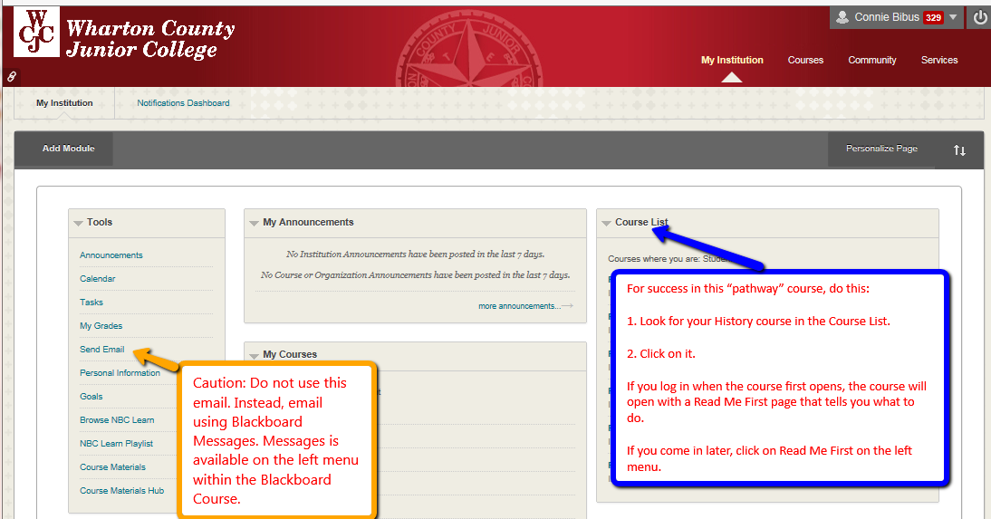

- The course opens on Lesson Units. Do the Units from top to bottom.
Example: You start with Getting Started, the first module (). In Getting Started, work until you finish the last item in Getting Started.
When you finish Getting Started, then go to next item on Lesson Units—Unit 1.
- When you are in a Blackboard folder () or a Blackboard module (), use the resources from top to bottom.
Example: with you are working in Evidence Requirements, work from top to the Evidence Quiz 1.
When you finish Evidence Quiz 1 Quiz and if you make the full points, then begin the next resources and conclude that with Evidence Quiz 2.
With any work assignment whether in a Blackboard folder () or a Blackboard module (), use the resources from top to bottom.

