Success Checklist for Distance Education’s 3rd Video + Tips to Avoid Points Off
Making Sure You Understand Your Responsibility to Examine Your Video and—If Not Correct—Try Again 1
1st Prepare Your Test Area (Same as the 1-page Feedback Checklist, but with More Space and with Bullets) 1
2nd Do the 9 STEPS Respondus Displays Before You Can Begin an Exam 3
Help for STEP 4: Quick Solutions to Prevent Darkness and Backlighting 7
Help for STEPS_5_&_6: Quick Solutions for Different Situations and Different Types of IDs 8
What If You Do Not Have a Texas Driver’s License 8
What You Can Do in THIS CLASS If You Have Problems with Creating a Clear PHOTO ID 8
What You Can Do in THIS CLASS If Your ID Is Longer Than Wide 8
What Does WCJC Require Profs to Do You Can Do n THIS CLASS If You Are Having Trouble Fitting Your Photo ID—The trick is in the fingertips. 8
To make sure students do not have another person take their tests, WCJC requires profs to compare these 2 things to determine: 8
Caution: Do NOT Rotate Your PHOTO ID or You Lose 30% 9

Making Sure You Understand Your Responsibility to Examine Your Video and—If Not Correct—Try Again
Respondus lets you look at your own work in two places:
- STEP 5 & 6 where you do two things correctly or lose 30%:
- Take a PHOTO of your face
- Place your PHOTO ID close to the webcam.
- STEP 7 where you show a complete environmental video with all 3 parts (30%): `
- All parts of the hard surface where you will take your exam or lose 10%
- Your lap and the floor below the hard surface or lose 10%
- All 4-walls (a 360-degree) view of your room or lose 10%
In this course, you are required:
- To look carefully at your own work in the 2 places (and Respondus shows your prof if your looked [TRUE for step 5/6?])
- And, if you did not do all actions correctly, to click Try Again and--after Respondus deletes that video[TRUE --you do it again.

1st Prepare Your Test Area (Same as the 1-page Feedback Checklist, but with More Space and with Bullets)
This are required STEPs. s and penalties if you do not do them are the same as in your syllabus, but in this table they have tips and are in the order you do them in Respondus. Need help? Just ask your prof.
STEP | Student’s Required Actions to Prepare the Test Area and Yourself for Each STEP with Respondus | Minus 30% | 0 for Exam
STEP 2 | You place the external webcam so it shows the test area completely. | X
STEP 2 | Caution: You must remain in the webcam view during the whole exam to the last question. |  | X
STEP 2 | You turn on the microphone so it records and you make sure it continues to record. | X
STEP 4 | You turn on sufficient lighting and places lights so no backlighting. | X
STEP 4 | You sit with your computer on a hard surface (desk, table, TV tray, etc.) (Caution: Not with the computer on your lap and not sitting or lying on a bed or a couch.) .Have nothing on the hard surface except your computer and Photo ID. | X
STEP 4 | You remove all unauthorized materials near your test area. Examples:  - No phone  - No papers  - No clutter of any type.  To quote the video, all “out of reach.”  Caution: You must make a) your test environment and b) your actions look like the person in WCJC’s 3rd video, but you may not be able to do that quickly in your bedroom.  Tip: To avoid picking up their bedrooms or figuring out how to get good lighting or quiet, some students take exams in such places:  - At a cleared end of a kitchen table when no one is there  - On a folding table in a garage  - Or on a table on the patio.  All are fine with your prof. If you have a different problem, email or call your prof. One of my prior students may have figured out a solution. |  | X
STEP 4 | You do not  - Talk with others during the exam  - Play music or other audio recordings  Tip: That also means no headphones. |  | X
STEP 5 & 6  ID needs to be on the right  here and step 5 below  MB- did I remember correcly this could b a cheap fix. | You must have a valid PHOTO ID. If you have a Texas Driver’s License, that qualifies.  Caution: You must do your job so your prof can do her job or your prof will deduct 30%.  To make sure students do not have another person take their tests, WCJC requires profs to compare these 2 things to determine:  - If the photo of the person taking the test is the person in the picture on the PHOTO ID.  - If the name on the PHOTO ID matches the name you used in registering for the class (and that Banner name is visible to profs in Respondus).  Notice the face in the example on the left and the PHOTO ID on the right. There is nothing in the “frame”:  - On the left nothing but the PHOTO she took in Respondus  - On the right nothing but the PHOTO and name on her name on her ID.  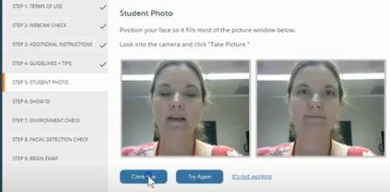 | X
STEP 7 | You show a complete environment video with 10% each for showing clearly all 3 parts: `  - All parts of the hard surface where you will take your exam  - Your lap and the floor below the hard surface  - All 4-walls (a 360-degree) view of your room. | X

2nd Do the 9 STEPS Respondus Displays Before You Can Begin an Exam
STEP | Short Reminders of What WCJC’s Demonstrator Did and You Must To. Caution: Look at WCJC’s 3rd Video.
STEP 1 | TERMS OF USE – Just click.
STEP 2 | Recognizing Where You Should Be in WCJC’s 3rd Video Starting Your Test  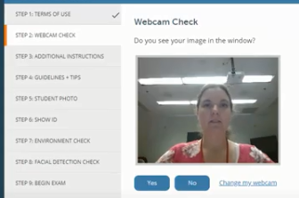
STEP 2 | WEBCAM CHECK – You do what WCJC’s Demonstrator did on the screen:  Caution:  - If you have an internal webcam, you must change your webcam to external.  - Then speak aloud (alphabet or count to 10) to check the microphone.  - Then check your webcam to be sure your image is in the right place.
STEP2 | Recognizing Where You Should Be in WCJC’s 3rd Video Starting Your Test  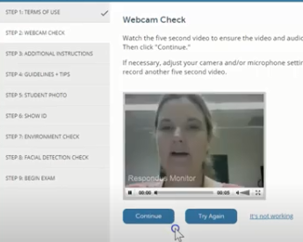< Notice the Try Again button if you were not correct.  Tip and Caution:  - In many locations, Respondus lets you click on Try Again to correct your work. Use it.  - Your prof can tell if you checked your own work and corrected it. Do not ignore your responsibility.
STEP 3 | Recognizing Where You Should Be in WCJC’s 3rd Video Starting Your Test  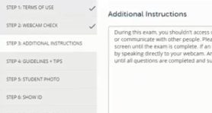  In this and most classes, this screen lists solutions for possible problems.
STEP 3 | ADDITIONAL INSTRUCTIONS – Read this and notice what you may need to explain in the video when you take a test.
STEP 4 | Recognizing Where You Should Be in WCJC’s 3rd Video Starting Your Test 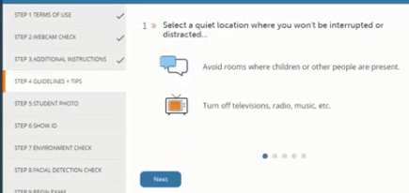  Caution: Meaning matters!  - Guidelines = ropes that help you avoid falling off mountains.  - Tips = “expert information.” Use both!
STEP 4 | GUIDELINES + TIPS –If you read a TIP that you have not done, do it now and then resume. Caution: The syllabus says an external webcam is required for this course.
STEP 5 | Recognizing Where You Should Be in WCJC’s 3rd Video Starting Your Test <NOTICE! Make your face fill the frame (the rectangle).  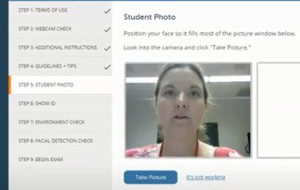
STEP 5

Michele
Possible
To Replace 2ns
picture with Photo ID?

STEP 6 | Recognizing Where You Should Be in WCJC’s 3rd Video Starting Your Test  If this could be fixed fast, put the corrected snippet with Kim’s PHOTO on left and Kim’s ID on the right here.
STEP 6 | SHOW ID – You show the Photo ID that you determined you could use above.  Caution about STEP 5 and STEP 6: Respondus shows your PHOTO and your ID and the prof is required to determine:  - If the photo of the person taking the test is the person in the picture on the PHOTO ID  - If the name on the PHOTO ID matches the name you used in registering for the class.
STEP 7 | Recognizing Where You Should Be in WCJC’s 3rd Video Starting Your Test  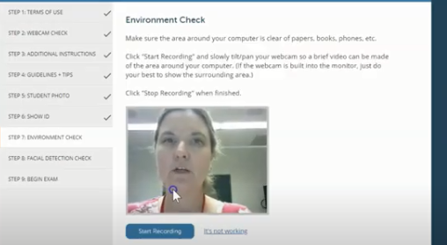

STEP 7-1st | ENVIRONMENTAL CHECK – Do all that the Demonstrator does.  - Remove the external webcam  - Use it to point slowly, moving the webcam from one side of the workspace to the other to each of these locations:  1st, have nothing on the workspace except your computer and your Photo ID. 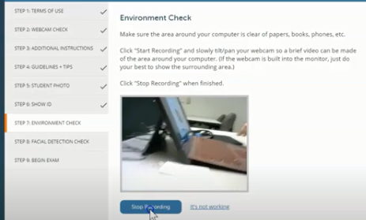  Lift up the mouse pad and the keyboard or laptop so the prof can see under them.  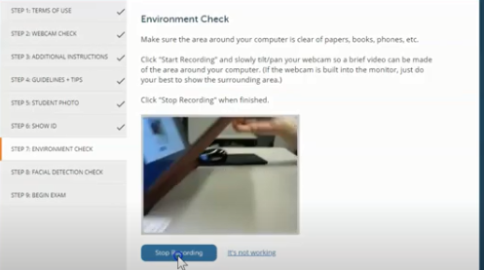  Not shown here, but in WCJC’s 3rd video, show:  - Your computer  - The space on both its left and right sides and behind the computer.
STEP 7-2nd | 2nd, show lap and feet and under workspace below the hard surface on both left and right sides.  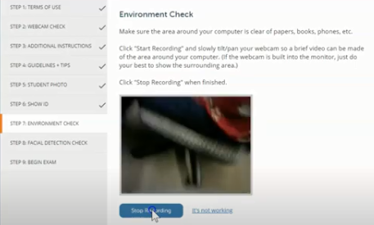
STEP 7-3rd | 3rd, show an all 4-walls (360-degree) view of your room. Michele, when I saw your statement on the lower right hand corner of Blackboard about the 360 degree, I realized I needed to make that fact more prominent in this section.  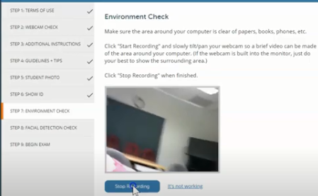  For this class, if the workspace is a large table, then show the far side of the workspace and the chair seats.  Tip to slow down: Show things from left to right and said aloud what you are showing. No blurs.
STEP 8 | Recognizing Where You Should Be in WCJC’s 3rd Video Starting Your Test <Once you complete your 4-walls (360 degree)view of your environmental, then do this:  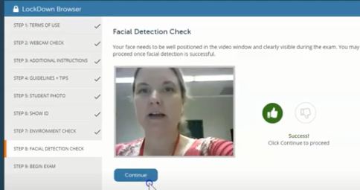
STEP 8 | FACIAL DETECTION CHECK – Restore your external webcam to its correct position. When doing the exam, you can scratch your nose, and twist your neck, but keep in the frame (the Respondus rectangle).  Tip: Blackboard displays this number for the prof.
STEP 9 | BEGIN EXAM – You follow the steps in the video to start the Sample Respondus Exam—or any other exam you must use with Respondus Monitor.

Help for STEP 4: Quick Solutions to Prevent Darkness and Backlighting
Set up your lights in your testing area as though you were taking a test—because you are. o a practice test to see how lighting works in Respondus. If the test area is dark or if all you see of your face and body is a silhouette, then use the tips below. Be sure:
- Your testing area is as well-lighted as the one in WCJC’s 3rd video. (Notice the picture provided in the snippets from the 3rd video.)
- Your hard surface (top of the table or desk) and the area below are equally well-lighted.
- If your face and body are only a silhouette and if you have a ceiling light, try these tips:
  - Alter where you chair is from the ceiling light
  - Place a small lamp near your computer. [TRUE}
- make you practice with Respondus, including
then, at the beginning of the Environmental Check, video yourself starting the test. If your face is dark (called backlighting), change your lights. If you have problems, ask your prof for tips before you take an exam.

Help for STEPS_5_&_6: Quick Solutions for Different Situations and Different Types of IDs

What If You Do Not Have a Texas Driver’s License
If you have a PHOTO ID (a picture of your face and your accurate name) from an institution such as a college or a high school or the equivalent, then 1) take a picture of it with your phone and 2) mail the scan to Connie Bibus (Instructor) in your Blackboard course to ask me if it will qualify as your PHOTO ID in Respondus. I will reply

What You Can Do in THIS CLASS If You Have Problems with Creating a Clear PHOTO ID
Your prof is fine with this solution instead of wasting your time on making the PHOTO ID clearer:
- Use your phone to take a picture of your PHOTO ID, being sure you clearly show your full name and your picture on the ID. Tip: It is fine if you temporarily place dark tape on spots of your license to cover over private information.
- Email it to Connie Bibus (Instructor) in Course Messages with the subject line Respondus PHOTO ID. Your prof will file it in a Blackboard email folder for all scanned IDs. Favor: on the Exam, say aloud that you sent me your picture of your PHOTO ID in Course Messages.

What You Can Do in THIS CLASS If Your ID Is Longer Than Wide
If you have—for example—a Texas license that is longer than wide, place your license close to the webcam with only two things clearly visible:
- Your name
- Your photo
In other words, in THIS class, you do not need to show the decorative areas at the top and the bottom.

What Does WCJC Require Profs to Do You Can Do n THIS CLASS If You Are Having Trouble Fitting Your Photo ID—The trick is in the fingertips.

To make sure students do not have another person take their tests, WCJC requires profs to compare these 2 things to determine:
- If the photo of the person taking the test is the person in the picture on the PHOTO ID.
- If the name on the PHOTO ID matches the name you used in registering for the class (with that name visible to profs in Respondus).

Here is the method that a smart student from a prior class used.
 |  |  | ↓ ↓ ↓ (Fingertips)
 | 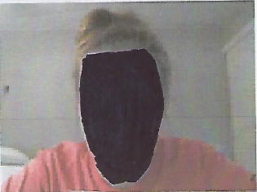 |  | 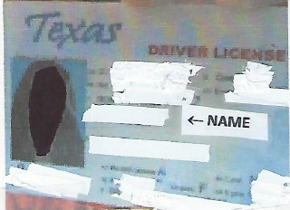
 | Student Photo |  | Student ID ↑ (Thumbtip)

To make the profs’ jobs possible, WCJC requires:
- Students take a picture of themselves within Respondus. Caution: Notice her face (and yours) must “fill the frame.” Your face must be big enough the prof can see it, and there is NOTHING of your body in that picture.
- Students place their Texas Driver’s License next to the webcam and take a picture. Notice the position of the fingertips and thumb-tip that let you put your license closer to the webcam.

Caution: Do NOT Rotate Your PHOTO ID or You Lose 30%
In this class, you will lose 30% if you rotate your PHOTO ID to make it fit.
Think about it a minute. WCJC requires profs to do what is written above. If your ID is on its side, does a prof have time to make a snippet of students’ rotated PHOTO IDs and rotate them so the prof can compare as required?
If you are thinking no one will notice a prof or a student, also remember Respondus stores all videos for 5 years.

