Success Checklist for WCJC’s 3rd Video + Tips to Avoid Points Off
Hi,
The Success Checklist does not tell you how to do what is covered in WCJC’s 3rd Video. Instead, the Success Checklist consists of 2 Parts:
- The 1st Part lists for you the syllabus penalties that apply to the specific STEPS in Respondus. Your prof also uses the 1st Part as a way to give you feedback so you can tell where you lost the points (in the STEP #) and which syllabus requirement meant that you had points taken off. Tip about your prof: I’ll be really happy if you do it right and you keep all of the points.
- The 2nd Part shows you the beginning screenshot for each STEP you must do in Respondus before you can start an Exam:
  - In the screenshots in the 2nd Part, the STEP number is highlighted on the left side of the screen.
  - In the table in the 2nd Part, the left column shows the STEP number.

Tip: You may want to have this link open while you watch WCJC’s 3rd Video. Why?
- If you are experienced with Respondus, this link can help you realize that you did not do something in the video when you did Respondus in prior times. Change now, OK?
- If you are not experienced, see quickly what you need to do. Save time now, OK?

A Clickable Table of Contents of What’s in the Success Checklist?
In THIS Course, You MUST Examine Your Work in Respondus and—If Not Correct—Try Again 3
1st Part: Prepare Your Test Area and Yourself So You Avoid the Syllabus Penalties 3
2nd Part: Do Correctly Each of the STEPS in Respondus Exactly As the Demonstrator Does Them 4
STEP 2: WEBCAM CHECK 4
STEP 3: ADDITIONAL INSTRUCTIONS 4
STEP 4: GUIDELINES + TIPS 4
STEP 5: STUDENT PHOTO 5
STEP 6: SHOW IDENTIFICATION 5
IF YOU HAVE A PROBLEM DOING STEP 4: Quick Solutions to Prevent Darkness and Backlighting 9
IF YOU HAVE A PROBLEM Doing STEPS_5_&_6: Quick Solutions for Different Situations and Types of IDs 9
What Does WCJC Require Profs to Do with YOUR Name and YOUR Face on YOUR PHOTO and YOUR PHOTO ID 9
What If You Do Not Have a Texas Driver’s License – Do This EARLY in Getting Started 10
What You Can Do in THIS CLASS If You Have Problems with Creating a Clear PHOTO ID 10
What You Can Do in THIS CLASS If Your ID Is Longer Than Wide 10
If You Are Having Trouble Fitting Your Photo ID—The trick is in the fingertips. 10
Caution: Do NOT Rotate Your PHOTO ID or You Lose 30% 10

In THIS Course, You MUST Examine Your Work in Respondus and—If Not Correct—Try Again
In many of the STEPs, Respondus lets you look at your own work and—if you realize you were not correct—redo it. How do you redo it? Click the Try Again button. To help you, on the right of the screen print you see:
< Notice the Try Again button if you were not correct.
In this course, as the 6th question in the Sample Respondus Exam tells you, if the Try Again button is displayed, you are required:
- to look carefully at your work in the STEPs before you begin the Sample Respondus Exam (or any other Exam)
- and, if you did not do all actions correctly, to click Try Again
- and then redo it correctly.

1st Part: Prepare Your Test Area and Yourself So You Avoid the Syllabus Penalties
Your prof also uses this as a Feedback Checklist by highlighting in orange in the right column of any row where you did something that results in a penalty in the syllabus. The required actions and the consequences are the same as the penalties list in your syllabus, but here they are in the order of the STEPs in Respondus.

Caution: On the Left, Your Required Actions – On the Right, How Many Points You Will Lose on Your Exam
STEP # | Exam Conduct Requirement: | Consequences for Violation of Exam Conduct:
STEP 2 | Correct placement of webcam | Penalty up to minus 30 percentage points
STEP 2 | Microphone turned on and recording | Penalty up to minus 30 percentage points
STEP 2 | Student remains in webcam view during exam. (Caution: stay in that frame.) | Penalty up to 0 for the Exam
STEP 4 | Sufficient lighting of the testing environment (Caution: avoid backlighting and no hats or sunglasses. Favor: “dress appropriately, as if you were in the classroom.”) Tip for backlighting: See the Table of Contents for IF YOU HAVE A PROBLEM WITH STEP 4 | Penalty up to minus 30 percentage points
STEP 4 | Student is in seated position with computer on hard surface (desk, table, TV tray etc.) (Caution: Not with computer on your lap; not sitting or laying on a bed or a couch.) | Penalty up to minus 30 percentage points
STEP 4 | No unauthorized materials near desk area (Examples and a Tip: no phone, no papers, and no clutter of any type. All “out of reach.” Some students take their tests on an empty table in another room or outside.) | Penalty up to 0 for the Exam
STEP 4 | No talking with others during the exam or playing of music or other audio recordings. | Penalty up to 0 for the Exam
STEP 5 & STEP 6 | Valid photo ID shown (Caution: your prof is required to compare your Photo ID with your name in Blackboard and with the picture you take of yourself. Place your PHOTO ID so your prof can do that.) | Penalty up to minus 30 percentage points
STEP 7 | Complete environment scan (Caution: You must show each action shown in this section. Notice the narrator listens to and watches herself in the video. You should too--and do it over if you are not correct.) | Penalty up to minus 30 percentage points, with 10% each for showing clearly 1) all parts of the hard surface where you will take your test, 2) your lap and the floor below, and 3) an all-4 walls (a 360-degree) view of your room.

Caution: Our division requires all faculty to deduct points as shown in the right column if you do not meet the Exam Conduct Requirements in the left column.

2nd Part: Do Correctly Each of the STEPS in Respondus Exactly As the Demonstrator Does Them
You see the opening screen print for each STEP. The penalties are shown in the 2 right columns. .
STEP | Student’s Required Actions to Prepare the Test Area and Do Correctly Each STEP with Respondus | Minus 30% | 0 for Exam
STEP 1 | Terms of Use | - | -
STEP 2 | STEP 2: WEBCAM CHECK  Recognizing Where You Start This STEP in WCJC’s 3rd Video Starting Your Test  The demonstrator points to instructions on the screen and tells you what to do on this and the next screens, including using webcam and microphone and recording a 5 second video.  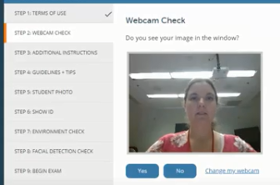  Recognizing Where You Continue STEP 2 in WCJC’s 3rd Video Starting Your Test  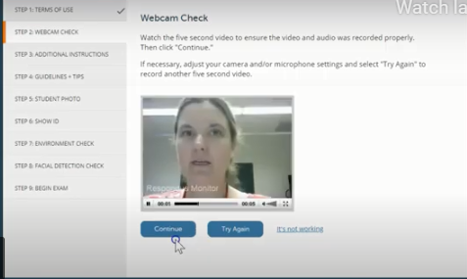 < Notice the Try Again  button if you were not correct | X
STEP 2 | Student remains in webcam view during exam. (Caution: stay in that frame.) |  | X
STEP 3 | STEP 3: ADDITIONAL INSTRUCTIONS  Read it. Profs can also write instructions in this screen. | - | -
STEP 4 | STEP 4: GUIDELINES + TIPS  Recognizing Where You Start This STEP in WCJC’s 3rd Video Starting Your Test  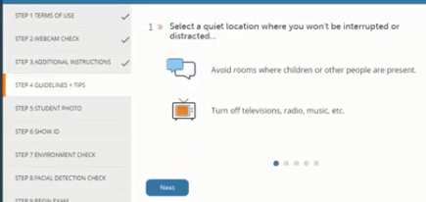  Caution about the meaning of these 2 powerful words:  - Guidelines = ropes that help climbers avoid falling off mountains.  - Tips = “expert information.”  Read the Guidelines on the screens. These are also listed in the syllabus penalties:  - Sufficient lighting of the testing environment (Caution: avoid backlighting and no hats or sunglasses. Favor: “dress appropriately, as if you were in the classroom.”) Tip for backlighting: See IF YOU HAVE A PROBLEM WITH STEP 4 in the Table of Contents. | X
 | - Student is in seated position with computer on hard surface (desk, table, TV tray etc.) (Caution: Not with computer on your lap; not sitting or laying on a bed or a couch.) | X
 | - No unauthorized materials near desk area (Examples and a Tip: no phone, no papers, and no clutter of any type. All “out of reach.” Some students take their tests on an empty table in another room or outside. ) |  | X
 | - No talking with others during the exam or playing of music or other audio recordings. |  | X
STEP 4 | Caution: You must make your a) test environment and b) actions look like WCJC’s 3rd video. For some students that is hard to do. Tip: To avoid picking up their bedrooms or figuring out how to have quiet or get good lighting, some students take exams:  - At a cleared end of a kitchen table when no one is there  - On a folding table in a garage  - On a table on the patio. - All are fine with your prof. | -- | --
STEP 5 | STEP 5: STUDENT PHOTO  Recognizing Where You Start These STEPs in WCJC’s 3rd Video Starting Your Test  The demonstrator points to instructions on the screen and tells you click Take Picture.  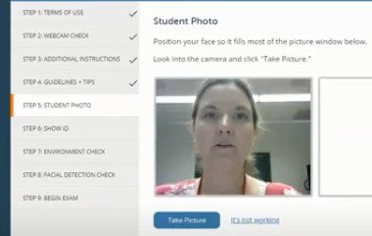  Recognizing Where You Continue STEP 5 in WCJC’s 3rd Video Starting Your Test  The demonstrator’s picture is now in the frame on the right.  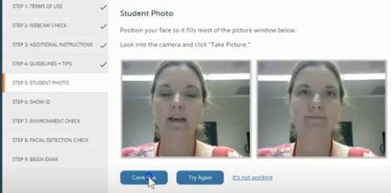< Notice  the Try Again button if you were not correct
I | STEP 6: SHOW IDENTIFICATION  If this could be fixed fast, put the corrected snippet with Kim’s PHOTO on left and Kim’s WCJC ID on the right here.  Recognizing Where You Start These STEPs in WCJC’s 3rd Video Starting Your Test  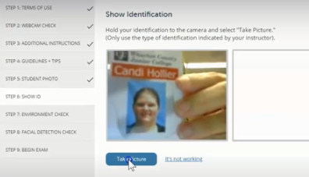  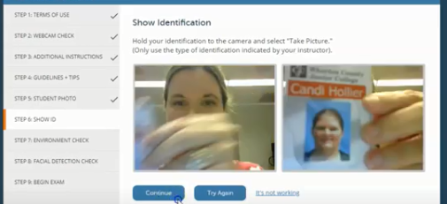  The demonstrator covers instructions on the screen and tells you to click Take Picture.  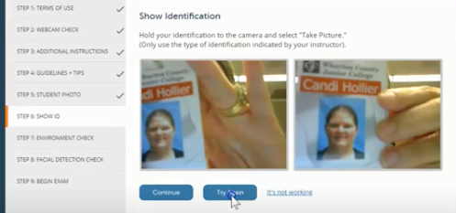
STEP 6 | Recognizing Where You Start This STEP in WCJC’s 3rd Video Starting Your Test
SHOW ID – You show the Photo ID that you determined you could use above.

Caution about STEP 5 and STEP 6: Respondus shows your PHOTO and your PHOTO ID. Your prof is required to determine:
- If the photo of the person taking the test is the person in the picture on the PHOTO ID
- If the name on the PHOTO ID matches the name you used in registering for the class.

STEP 7 | STEP 7: ENVIRONMENT CHECK  You show a complete ENVIRONMENT CHECK for showing clearly all 3 Parts: `  - All parts of the hard surface where you will take your exam at 10%  - Your lap and the floor below the hard surface at 10%  - All 4-walls (a 360-degree) view of your room at 10% | X
STEP 7-1st Part | ENVIRONMENTAL CHECK – Do all that the Demonstrator does.  - Remove the external webcam  - Use it to point slowly, moving the webcam from one side of the workspace to the other to each of these locations:  1st, have nothing on the workspace except your computer and your Photo ID. 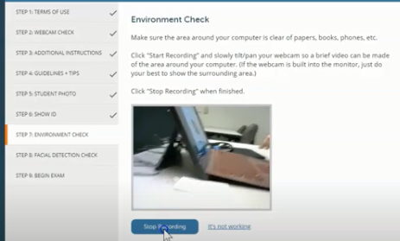  Also, lift up the mouse pad and the keyboard or laptop so the prof can see under them.  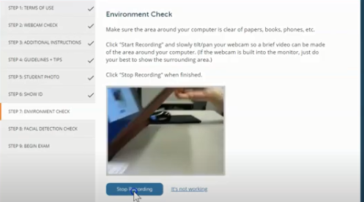  Not shown here, but in WCJC’s 3rd video, show:  - Your computer  - The space on both its left and right sides and behind the computer.
STEP 7-2nd Part | 2nd, show lap and feet and under workspace below the hard surface on both left and right sides.  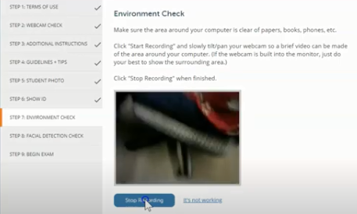
STEP 7-3rd Part | 3rd, show an all 4-walls (360-degree) view of your room.  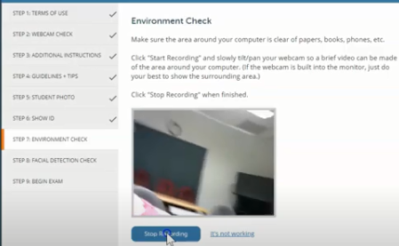  For this class, if the workspace is a large table, then show the far side of the workspace and the chair seats. Tip to slow down: Show things from left to right and said aloud what you are showing. No blurs.
STEP 8 | Recognizing Where You Start This STEP in WCJC’s 3rd Video Starting Your Test  Once you complete your 4-walls (360 degree)view of your environmental, you do this:  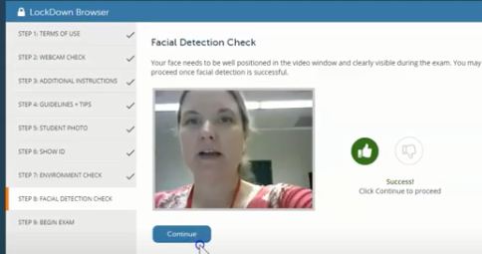  Then restore your external webcam to its correct position. When doing the exam, you can scratch your nose, and twist your neck, but keep your face in the frame (the Respondus rectangle).  Tip: Blackboard displays the Facial Detection number for the prof.
STEP 9 | BEGIN EXAM – You follow the steps in the video to start the Sample Respondus Exam—or any other exam you must use with Respondus Monitor.

IF YOU HAVE A PROBLEM DOING STEP 4: Quick Solutions to Prevent Darkness and Backlighting
Set up your lights in your testing area as though you were taking a test—because you are. o a practice test to see how lighting works in Respondus. If the test area is dark or if all you see of your face and body is a silhouette, then use the tips below. Be sure:
- Your testing area is as well-lighted as the one in WCJC’s 3rd video. (Notice the picture provided in the screenshots from the 3rd video.)
- Your hard surface (top of the table or desk) and the area below are equally well-lighted.
- If your face and body are only a silhouette and if you have a ceiling light, try these tips:
  - Alter where you chair is from the ceiling light
  - Place a small lamp near your computer. [TRUE}
- make you practice with Respondus, including
then, at the beginning of the Environmental Check, video yourself starting the test. If your face is dark (called backlighting), change your lights. If you have problems, ask your prof for tips before you take an exam.

IF YOU HAVE A PROBLEM Doing STEPS_5_&_6: Quick Solutions for Different Situations and Types of IDs

What Does WCJC Require Profs to Do with YOUR Name and YOUR Face on YOUR PHOTO and YOUR PHOTO ID
So students cannot have another person take their tests, WCJC requires profs to compare these things to determine:
- If the photo of the person taking the test is the person in the picture on the PHOTO ID.
- If the name on the PHOTO ID matches the name you used in registering for the class (with that name visible to the prof in Respondus).

What Respondus shows the prof is not like what you see in WCJC’s 3rd Video, but the two are next to each other with: the PHOTO on the left and the PHOTO ID on the right. The 2 snippets your prof made of a student’s PHOTO and PHOTO ID shows that she paid attention to what would help profs to do their job to compare. Her trick holding the license on the edge with the end of her fingertips and thumb works.

 | For the PHOTO, only the biggest view of the face possible within the “frame.” |  | For the PHOTO ID, only the name and the face.  Tip: better if she made the face bigger.
 |  |  | ↓ ↓ ↓ (Fingertips)
 | 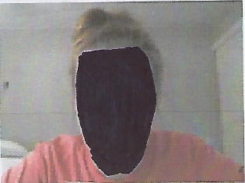 |  | 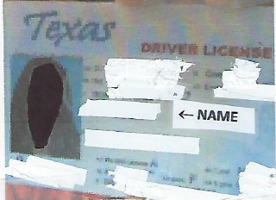
 | Student Photo |  | Student ID ↑ (Thumbtip)

What If You Do Not Have a Texas Driver’s License – Do This EARLY in Getting Started
If you have a PHOTO ID (a picture of your face and your accurate name) from an institution such as a college or a high school or the equivalent, then 1) take a picture of it with your phone and 2) mail the scan to Connie Bibus (Instructor) in your Blackboard course to ask me if it will qualify as your PHOTO ID in Respondus. I will reply

What You Can Do in THIS CLASS If You Have Problems with Creating a Clear PHOTO ID
Your prof is fine with this solution instead of wasting your time on making the PHOTO ID clearer:
- Use your phone to take a picture of your PHOTO ID, being sure you clearly show your full name and your picture on the ID. Tip: It is fine if you temporarily place dark tape on spots of your license to cover over private information.
- Email it to Connie Bibus (Instructor) in Course Messages with the subject line Respondus PHOTO ID. Your prof will file it in a Blackboard email folder for all scanned IDs. Favor: on the Exam, say aloud that you sent me your picture of your PHOTO ID in Course Messages.

What You Can Do in THIS CLASS If Your ID Is Longer Than Wide
If you have—for example—a Texas license that is longer than wide, place your license close to the webcam with only two things clearly visible:
- Your name
- Your photo
In other words, in this class, you do not need to show the decorative areas at the top and the bottom.

If You Are Having Trouble Fitting Your Photo ID—The trick is in the fingertips.

To make profs’ jobs possible, WCJC requires:
- Students take a picture of themselves within Respondus. Caution: Notice her face (and yours) must “fill the frame.” Your face must be big enough the prof can see it, and there is NOTHING of your body in that picture.
- Students place their Texas Driver’s License next to the webcam and take a picture. Notice the position of the fingertips and thumb-tip that let you put your license closer to the webcam.

Caution: Do NOT Rotate Your PHOTO ID or You Lose 30%
In this class, you will lose 30% if you rotate your PHOTO ID to make it fit.
Think about it a minute. WCJC requires profs to do what is written above. If your ID is on its side, does a prof have time to make a snippet of students’ rotated PHOTO IDs and rotate them so the prof can compare as required?
If you are thinking no one will notice a prof or a student, also remember Respondus stores all videos for 5 years.

Discard/rewrite
You must have a valid PHOTO ID. If you do not have a Texas Driver’s License, then send your prof in Blackboard Course Messages a scan of a current ID that has both your photo and name.

Caution: You must do your job so your prof can do her job or your prof will deduct 30%.
To make sure students do not have another person take their tests, WCJC requires profs to compare these 2 things to determine:
- If the photo of the person taking the test is the person in the picture on the PHOTO ID.
- If the name on the PHOTO ID matches the name you used in rgistering for the class (FYI: that Banner name is visible to profs in Respondus.).

Notice the face in the example on the left and the PHOTO ID on the right. There is nothing else (no part of her face or body) in the “frame”:
- On the left nothing but the PHOTO she took in Respondus
- On the right nothing but the PHOTO and name on her ID.

