Success Checklist for WCJC’s 3rd Video + Tips to Avoid Points Off
This does not tell you how to do what is covered in WCJC’s 3rd Video Starting Your Test. It helps you use that video. Have this link open while you watch WCJC’s 3rd Video whether you are experienced with Respondus or not: Why?
- If you are experienced, realize you didn’t do something when you did Respondus in prior times. Change now!
- If you are not experienced, see quickly what you need to do. Save time now!
What’s in the Success Checklist?-- In THIS class, you can print this page, show it to me in Respondus, and use it to remember each Respondus step.
Success Checklist for WCJC’s 3rd Video + Tips to Avoid Points Off 1
In THIS Course, You MUST Look at What You Did in Respondus and—If Not Like WCJC’s 3rd Video—Try Again 3
1st Part: Prepare Your Test Area and Yourself So You Avoid the Syllabus Penalties (Listed here.) 3
2nd Part: Do Correctly Each of the STEPS in Respondus Exactly As the Demonstrator Does Them 4
STEP 2: WEBCAM CHECK 4
STEP 2: Student remains in webcam view during exam. 4
STEP 3: ADDITIONAL INSTRUCTIONS 4
STEP 4: GUIDELINES + TIPS 4
Caution: You must make your a) test environment and b) actions look like WCJC’s 3rd video 5
STEP 5: STUDENT PHOTO 5
STEP 6: SHOW IDENTIFICATION 5
STEP 6: SHOW ID 6
STEP 7: ENVIRONMENT CHECK (10% off for each of the 3 Parts) 6
X 6
1st, have nothing on the workspace except your computer and your Photo ID. 6
Also, lift up the mouse pad and the keyboard or laptop so the prof can see under them. 7
Show your a) computer, b) space on both its left and right, and c) backside of the computer. 7
2nd, show lap and feet and under workspace below the hard surface on both left and right sides. 7
3rd, show an all 4-walls (360-degree) view of your room. 8
X 8
3rd Part: IF YOU HAVE A PROBLEM DOING STEP 4: Quick Solutions to Prevent Darkness and Backlighting 9
3rd Part: IF YOU HAVE A PROBLEM Doing STEPS_5_&_6: Quick Solutions for Different Situations and ID Types 9
What If You Do Not Have a Texas Driver’s License – Do This EARLY During Getting Started 9
What Does WCJC Require Profs to Do with YOUR Name and YOUR Face on YOUR PHOTO and YOUR PHOTO ID 9
If You Are Having Trouble Fitting Your Photo ID in “the Frame”—The trick is in the fingerTIPS. 9
What You Can Do in THIS CLASS If You Have Problems with Creating a Clear PHOTO ID 10
What You Can Do in THIS CLASS If Your ID Is Longer Than Wide 10
Caution: Do NOT Rotate Your PHOTO ID or You Lose 30% 10

In THIS Course, You MUST Look at What You Did in Respondus and—If Not Like WCJC’s 3rd Video—Try Again
In many of the STEPs, Respondus lets you look at your own work and—if you realize you were not correct—redo it. How do you redo it? Click the Try Again button. To help you notice, look for the word on the right side of a screen < Look! And then followed on that line or below with the words: If NOT correct, click Try Again and do it OVER.
In this course, as the 6th question in the Sample Respondus Exam tells you, if the Try Again button is displayed, you are required:
- to look carefully at your work in the STEPs before you begin the Sample Respondus Exam (or any other Exam)
- and, if you did not do all actions correctly, to click Try Again
- and then redo it correctly.

1st Part: Prepare Your Test Area and Yourself So You Avoid These Syllabus Penalties
Your prof also uses this as a Feedback Checklist by highlighting in orange in the right column of any row where you did something that results in a penalty in the syllabus. The required actions and the consequences are the same as the penalties list in your syllabus, but here they are in the order of the STEPs in Respondus.

Caution: On the Left, Your Required Actions – On the Right, How Many Points You Will Lose on Your Exam
STEP # | Exam Conduct Requirement: | Consequences for Violation of Exam Conduct:
STEP 2 | Correct placement of webcam | Penalty up to minus 30 percentage points
STEP 2 | Microphone turned on and recording | Penalty up to minus 30 percentage points
STEP 2 | Student remains in webcam view during exam. (Caution: stay in that frame.) | Penalty up to 0 for the Exam
STEP 4 | Sufficient lighting of the testing environment (Caution: avoid backlighting and no hats or sunglasses. Favor: “dress appropriately, as if you were in the classroom.”) Tip for backlighting: See the Table of Contents for IF YOU HAVE A PROBLEM WITH STEP 4 | Penalty up to minus 30 percentage points
STEP 4 | Student is in seated position with computer on hard surface (desk, table, TV tray etc.) (Caution: Not with computer on your lap; not sitting or laying on a bed or a couch.) | Penalty up to minus 30 percentage points
STEP 4 | No unauthorized materials near desk area (Examples and a Tip: no phone, no papers, and no clutter of any type. All “out of reach.” Some students take their tests on an empty table in another room or outside.) | Penalty up to 0 for the Exam
STEP 4 | No talking with others during the exam or playing of music or other audio recordings. | Penalty up to 0 for the Exam
STEP 5 & STEP 6 | Valid photo ID shown (Caution: your prof is required to compare your Photo ID with your name in Blackboard and with the picture you take of yourself. Place your PHOTO ID so your prof can do that.) | Penalty up to minus 30 percentage points
STEP 7 | Complete environment scan (Caution: You must show each action shown in this section. Notice the narrator listens to and watches herself in the video. You should too--and do it over if you are not correct.) | Penalty up to minus 30 percentage points, with 10% each for showing clearly 1) all parts of the hard surface where you will take your test, 2) your lap and the floor below, and 3) an all-4 walls (a 360-degree) view of your room.

Caution: Our division requires all faculty to deduct points as shown in the right column if you do not meet the Exam Conduct Requirements in the left column.

2nd Part: Do Correctly Each of the STEPS in Respondus Exactly As the Demonstrator Does Them
You see the opening screen print for each STEP. The penalties are shown in the 2 right columns. .
STEP | Student’s Required Actions to Prepare the Test Area and Do Correctly Each STEP with Respondus | Minus 30% | 0 for Exam
STEP 1 | Terms of Use | - | -
STEP 2 | STEP 2: WEBCAM CHECK  Recognizing Where You Start This STEP in WCJC’s 3rd Video Starting Your Test  The demonstrator points to instructions on the screen and tells you what to do on this and the next screens, including using webcam and microphone and recording a 5 second video.  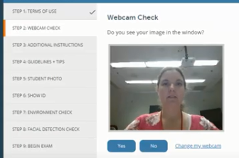  Recognizing Where You Continue STEP 2 in WCJC’s 3rd Video Starting Your Test  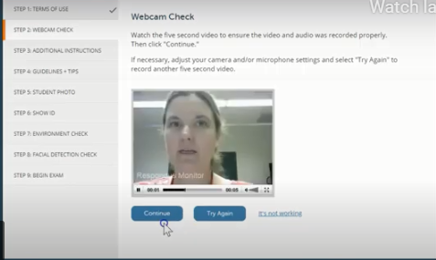 < Look!  If NOT correct, click Try Again and do it OVER.  Caution: Correct placement of webcam (30%); Microphone turned on and recording (30%) | X & X
STEP 2 | STEP 2: Student remains in webcam view during exam. (Caution: stay in that frame.) |  | X
STEP 3 | STEP 3: ADDITIONAL INSTRUCTIONS  Read it. Profs can also write instructions in this screen. | - | -
STEP 4 | STEP 4: GUIDELINES + TIPS  Recognizing Where You Start This STEP in WCJC’s 3rd Video Starting Your Test  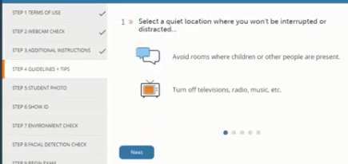  Caution about the meaning of these 2 powerful words:  - Guidelines = ropes that help climbers avoid falling off mountains.  - Tips = “expert information.”
 | Read the Guidelines on the screens. These are also listed in the syllabus penalties:  - Sufficient lighting of the testing environment (Caution: avoid backlighting and no hats or sunglasses. Favor: “dress appropriately, as if you were in the classroom.”) Tip: See 3rd: IF YOU HAVE A PROBLEM WITH STEP 4 in the Table of Contents. | X
 | - Student is in seated position with computer on hard surface (desk, table, TV tray etc.) (Caution: Not with computer on your lap; not sitting or laying on a bed or a couch.) | X
 | - No unauthorized materials near desk area (Examples and a Tip: no phone, no papers, and no clutter of any type. All “out of reach.” Some students take their tests on an empty table in another room or outside. |  | X
 | - No talking with others during the exam or playing of music or other audio recordings. |  | X
 | Caution: You must make your a) test environment and b) actions look like WCJC’s 3rd video. For some students that is hard to do. Tip: To avoid picking up their bedrooms or figuring out how to have quiet or get good lighting, some students take exams:  - At a cleared end of a kitchen table when no one is there  - On a folding table in a garage  - On a table on the patio. - All are fine with your prof. | -- | --
STEP 5 | STEP 5: STUDENT PHOTO  Recognizing Where You Start These STEPs in WCJC’s 3rd Video Starting Your Test  The demonstrator points to instructions on the screen and tells you click Take Picture.  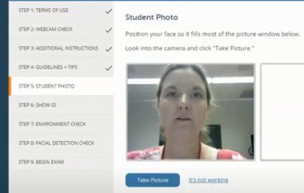  Recognizing Where You Continue STEP 5 in WCJC’s 3rd Video Starting Your Test  The demonstrator’s PHOTO is now in the frame on the right.  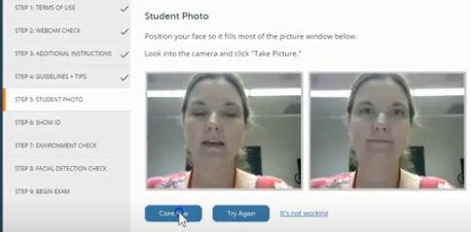<Look!  If NOT correct, click Try Again and do it OVER.
STEP 6 | STEP 6: SHOW IDENTIFICATION  If this could be fixed fast, put the corrected snippet with Kim’s PHOTO ID on the right below  Recognizing Where You Start These STEPs in WCJC’s 3rd Video Starting Your Test  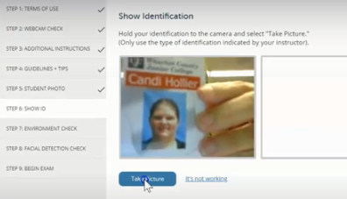  Recognizing Where You Continue STEP 6 in WCJC’s 3rd Video Starting Your Test  The demonstrator’s PHOTO ID is now in the frame on the right.  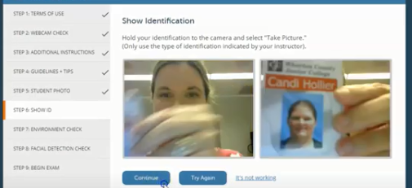 < Look!  If NOT correct, click Try Again and do it OVER.
 | Caution about STEP 5 and STEP 6:  Put nothing in the PHOTO or PHOTO ID other than what your prof needs to compare. No fingers. (Hold the edges of the license with fingerTIPs and thumbTIP). No parts of your body or your room. No rotation of a PHOTO ID or 30% off in this class. For examples, see the 3rd Part IF YOU HAVE A PROBLEM DOING STEPS 5 & 6.  Respondus shows your PHOTO and your PHOTO ID. You must have nothing in the PHOTO or PHOTO ID to make those visuals smaller and therefore harder for your prof to compare the PHOTO and PHOTO ID to determine:  - If the photo of the person taking the test is the person in the picture on the PHOTO ID  - If the name on the PHOTO ID matches the name you used in registering for the class. (Respondus displays that name.) | - | -
STEP 7 | STEP 7: ENVIRONMENT CHECK (10% off for each of the 3 Parts)  You show a complete ENVIRONMENT CHECK for showing clearly all 3 Parts (30%): `  - All parts of the hard surface where you will take your exam at 10%  - Your lap and the floor below the hard surface at 10%  - All 4-walls (a 360-degree) view of your room at 10% | X
STEP 7-1st Part | STEP 7-1st Part: ENVIRONMENTAL CHECK 1st Part – To be successful, move as the demonstrator does.  - Remove the external webcam  - Use it to point slowly, moving the webcam from one side of the workspace to the other to each of these locations:  1st, have nothing on the workspace except your computer and your Photo ID.  If you have a longer workspace than shown here, be sure to show the entire left and right sides of the space and under that space.  I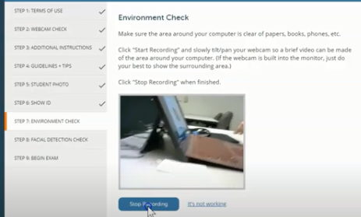  Also, lift up the mouse pad and the keyboard or laptop so the prof can see under them.  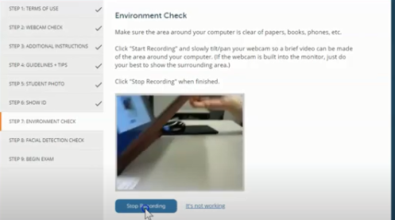  Show your a) computer, b) space on both its left and right, and c) backside of the computer.  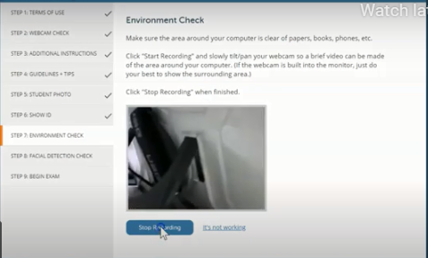
STEP 7-2nd Part | 2nd, show lap and feet and under workspace below the hard surface on both left and right sides.  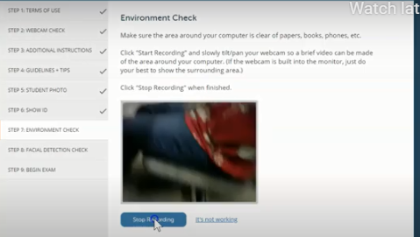
STEP 7-3rd Part | 3rd, show an all 4-walls (360-degree) view of your room.  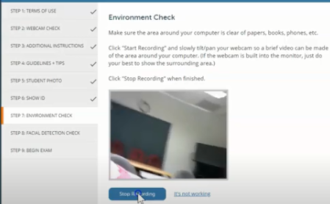  For this class, if the workspace is a large table, then show the far side of the workspace and the chair seats. Tip to slow down: Show things from left to right and said aloud what you are showing. If the video is blurry, then Try Again! | X
STEP 8 | Recognizing Where You Start This STEP in WCJC’s 3rd Video Starting Your Test  Once you complete your 4-walls (360 degree)view of your environmental, you do this:  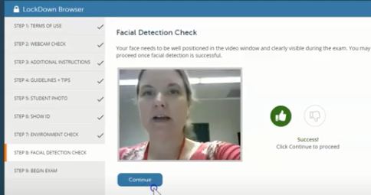  Then restore your external webcam to its correct position. When doing the exam, you can scratch your nose, and twist your neck, but keep your face in the frame (the Respondus rectangle).  Tip: Blackboard displays the Facial Detection number for the prof. | - | -
STEP 9 | BEGIN EXAM – You follow the steps in the video to start the Sample Respondus Exam—or any other exam you must use with Respondus Monitor. | - | -

3rd Part: IF YOU HAVE A PROBLEM DOING STEP 4: Quick Solutions to Prevent Darkness and Backlighting
Set up your lights in your testing area as though you were taking a test—because you are. o a practice test to see how lighting works in Respondus. If the test area is dark or if all you see of your face and body is a silhouette, then use the tips below. Be sure:
- Your testing area is as well-lighted as the one in WCJC’s 3rd video. (Notice the pictures provided from the 3rd video.) If your room is dark, consider a well-lighted, temporary location for testing. On a patio works for some.
- Your hard surface (top of the table or desk) and the area below are equally well-lighted.
- Practice before the real test. At the beginning of the Environmental Check, video yourself starting the test.L ook at that video. If your room is dark, turn on more lights. If the area at your feet is dark, try a flashlight or a small lamp. If your face is dark, see the tips in # 4.
- If your face and body are only a silhouette and if you have a ceiling light, try these tips:
  - Alter where you chair is from the ceiling light. [TRUE?]
  - Place a small lamp near your computer. [TRUE?]

3rd Part: IF YOU HAVE A PROBLEM Doing STEPS_5_&_6: Quick Solutions for Different Situations and ID Types

What If You Do Not Have a Texas Driver’s License – Do This EARLY During Getting Started
If you have a PHOTO ID (a picture of your face and your accurate name) from an institution such as a school or the equivalent, then 1) take a picture of it with your phone and 2) email the scan to Connie Bibus (Instructor) in your Blackboard course to ask me if it will qualify as your PHOTO ID in Respondus. Use the Subject: Will this PHOTO ID work for Respondus? If I do not reply back quickly, check your Sent folder to confirm you sent it to the exact name in orange.

What Does WCJC Require Profs to Do with YOUR Name and YOUR Face on YOUR PHOTO and YOUR PHOTO ID
So students cannot have another person take their tests, WCJC requires profs to compare these things to determine:
- If the photo of the person taking the test is the person in the picture on the PHOTO ID.
- If the name on the PHOTO ID matches the name you used in registering for the class (with that name visible to the prof in Respondus).

If You Are Having Trouble Fitting Your Photo ID in “the Frame”—The trick is in the fingerTIPS.
What Respondus shows the prof is not like what you see in WCJC’s 3rd Video, but the two are next to each other with: the PHOTO on the left and the PHOTO ID on the right. The 2 snippets your prof made of a student’s PHOTO and PHOTO ID shows that the student paid attention to what would help profs to do their job to compare. Her trick holding the license on the edge with the end of her fingertips and thumb works.

 | For the PHOTO, only the biggest view of the face possible within the “frame.” |  | For the PHOTO ID, only the name and the face.  Tip: It would have been better if she showed less of the word Texas and made the face bigger.
 |  |  | ↓ ↓ ↓ (FingerTIPS)
 | 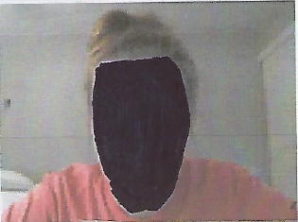 |  | 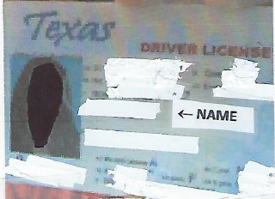
 | Student Photo |  | Student ID ↑ (ThumbTIP)

What You Can Do in THIS CLASS If You Have Problems with Creating a Clear PHOTO ID
Your prof is fine with this solution instead of wasting your time on making the PHOTO ID clearer:
- Use your phone to take a picture of your PHOTO ID, being sure you clearly show your full name and your picture on the ID. Tip: It is fine if you temporarily place dark tape on spots of your license to cover over private information.
- Email it to Connie Bibus (Instructor) in Course Messages with the subject line Respondus PHOTO ID. Your prof will file it in a Blackboard email folder for all scanned IDs.
- Favor: on the Exam, say aloud that you sent me your picture of your PHOTO ID in Course Messages.

What You Can Do in THIS CLASS If Your ID Is Longer Than Wide
If you have—for example—a Texas license that is longer than wide, place your license close to the webcam with only two things clearly visible:
- Your name
- Your photo
In other words, in this class, you do not need to show the decorative areas at the top and the bottom.
To make profs’ jobs possible, WCJC requires:
- Students take a picture of themselves within Respondus. Caution: Notice her face (and yours) must “fill the frame.” Your face must be big enough the prof can see it, and there is NOTHING of your body in that picture.
- Students place their Texas Driver’s License next to the webcam and take a picture. Notice the position of the fingertips and thumb-tip that let you put your license closer to the webcam.

Caution: In This Class, Do NOT Rotate Your PHOTO ID or You Lose 30%
In this class, you will lose 30% if you rotate your PHOTO ID to make it “fit.”
Think about it a minute. WCJC requires profs to do what is written above. If your ID is on its side, does a prof have time to make snippets of multiple students’ rotated PHOTO IDs and rotate them so the prof can compare as required?
Caution: If you are thinking no one will notice a student—or a prof—who tries to “fake it,” also remember Respondus stores all videos for 5 years and that is enough time for “fake” behavior to be noticed.

